Hospitals & Asylums

Gas Export Tax (GET) HA-26-9-14

By Anthony J. Sanders
sanderstony@live.com

Introduction
A. Fossil Fuel Exports
B. Highway Trust Fund
C. Hydrofracking
D. Electricity
E. Natural Gas
F. Petroleum Oil
G. Coal
H. Nuclear
I. Biofuel, Geothermal, Water and Wind
J. Solar

Introduction
A BILL

To tax gas, oil, coal and electricity exports 6% to finance the Highway Trust Fund with 3%, U.S. Customs’ “refugee fund” with 1%, solar technology panel and rooftop subsidies with 1% and United Nations Official Development Assistance with 1% to pay for the development of hydrocarbon infrastructure to supply least developed countries at prices equal to those paid in industrialized nations, focusing on urban cooking fuel and charcoal company sponsored reforestation programs due carbon emission credit for forest growth in the Third Millennium.

To get the revenues from this gas export tax without the need for Congress under Art. I Section 8(1) whereas the Speaker of the House of Representatives John Boehner betrayed the United States to Dick Cheney to recidivate in Iraq and Syria under Military and Paramilitary Activities in and against Nicaragua (Nicaragua v. United States of America) ICJ No. 70 (1986) although there is reason to believe Halliburton is a more accurate name for the smugglers of contraband oil in those Islamic States, than my sis and the in-laws. This bill for revenues did originate in the House of Representatives as monopolized by Art. I Section 7(1) and the good faith thereunder should be sufficient because U.S. Customs has a duty to regulate the export of hydrocarbons to prevent illegal heating and cooling of the ocean monitored by the NOAA Sea Surface Temperature (SST) Anomaly satellite map and can surely get a loan against tariffs collected at this arbitrary rate and impounded by the Treasurer against a solvent Congress, if the Court of Competent Jurisdiction which was necessary to eliminate bioterrorism from the Homeland Security Act of 2002 is not sufficient to convince the Treasurer of the United States of the need for the United States to GET.

To compensate BP for the excessive fines with the acquisition by hostile takeover of Halliburton who overcharged for the lethal cement job on Deepwater Horizon, most recently with the abuse of a fictional Presidential District Court temporarily inserted into the Natural Gas Act to intrude on the Presidential prerogative as noted in Cheney v. U.S. District Court for the District of Columbia No. 03-475 (2004) very similar to the Crisis Manufacturing Grant that circulated in the federal register shortly before the 9-11 terrorist attacks. Halliburton must be dissolved under the rule against perpetuities more than 50 years since the death of Erle P. Halliburton in 1953, and 11 years since the unauthorized invasion of Iraq exactly 50 years after his death, to redress the bribery and wool over the Internet laws, energy and trade statistics, intruding on the Presidential prerogative, with the conspiracy of Senator Rob Portman, from the zombie law firm of Sanders, Squire and Demsey that needs to elect the names of living partners, having fired Rob Portman, the worst U.S. trade representative in history and worst Director of Office and Management and Budget (OMB) taking into consideration the gravity of his false personation of Anthony J. Sanders, author of Hospitals & Asylums, who mothballs the truth for a time when the Millennials have reestablished democracy after the tyranny of the baby boomers, sabotage of OMB and enslavement of the White House Intellectual Property (WHIP) Enforcement Coordinator .

To abolish the White House Intellectual Property (WHIP) Enforcement Coordinator under the Slavery Convention of 1926.

To recuse the Secretaries of Transportation and Education under 18USC(11)§205(a)(c)(e) for robbing Blagojevich’s “federal bailout” to finance the President’s war or attempt to conceal its worthlessness by interfering with and annoying petitioners with noisy highway contracts in lieu of, or in conjunction with pedestrian hazards and more violent tortures unbefitting the global positioning system (GPS) of civil engineers, and most of all to immediately free Rod Blagojevich from the crimes of his racketeering prosecutors and Ray Nagin from arbitrary detention forbidden under Art. 9 of the Universal Declaration of Human Rights as permitted by§205(d)(1)(e)(h).

To abolish the Department of Homeland Security (HS) and create "Customs" in Title 6 of the United States Code and Code of Federal Regulations.

To amend Title 22 Foreign Relations and Intercourse (a-FRAI-d) to Title 22 Foreign Relations (FR-EE).

To abolish the Court of International Trade of the United States (COITUS) and create a Customs Court (CC).

To abolish U.S. Citizenship and Immigration Service (USCIS) and create a U.S. Naturalization Service (USNS).

To rule the necessity for and disclaimer on Freedom of Information Act (FOIA) naturalization papers a novel discrimination against naturalized U.S. citizens in violation of Arts. 27 and 29 of the 1951 Convention Relating to the Status of Refugees, to grant identification documents, equally to all refugees, citizens and non-citizen alike under the 1967 Protocol. The fundamental principles of the 1951 Convention are non-discrimination, non-penalization and non-refoulement. The 1951 Convention is the high law commissioning travel documents, family reunification, and welfare services benefitting the Central American child refugees reported to detained by the Customs Secretary in abnormally high numbers this 2014.

To amend federal torture statute to comply with Arts. 2, 4 and 14 of the Convention against Torture and Other Cruel, Inhuman or Degrading Treatment or Punishment of 1984. The phrase “outside the United States” must be repealed from 18USC(113C)§2340A(a) and Exclusive Remedies at 18USC(113C)§2340B amended so: (1) The legal system shall ensure that the victim of an act of torture obtains redress and has an enforceable right to fair and adequate compensation, including the means for as full rehabilitation as possible. In the event of the death of the victim as a result of an act of torture, his dependants shall be entitled to compensation. (2) Nothing in this article shall affect any right of the victim or other persons to compensation which may exist under national law.

To abolish federal police finance, the White House Intellectual Property (WHIP) Enforcement Coordinator, Federal Bureau of Investigation (FBI), Alcohol, Tobacco and Firearms (ATF) and Drug Enforcement Administration (DEA) and employees preferentially transferred to the Department of Justice and the FDA Center for Tobacco Products abolished and a new Drug Evaluation Agency (DEA) and Center for Alcohol, Tobacco and Marijuana (ATM) in the Food and Drug Administration (FDA) under 5USCIIIB(35)I§3503.

To hold prosecutions and political ambitions arising from, or in behalf, of Washington DC, Texas and Louisiana in contempt under paragraphs 14-16 of the Guidelines on the Role of Prosecutors unless they are both fair, non-warlike, non-soldiering, non-slaving, non-torturing and non-robbing, and have reduced their incarceration rates, to achieve the current national norm of 750 detainees per 100,000 residents while the nation achieves the international legal norm, the legal limit of 250 detainees per 100,000 residents.

To agree to repeal Sections 2-5 of Amendment XIV of 1868 protecting tribal tax exemptions under Section 1 this 2014.

Be it enacted in the House and Senate, Abolished, Referred to the United Nations Assembly

A. Fossil Fuel Exports

There is a temporary shortage of information on the balance of trade in petroleum, natural gas and coal. An estimate for a 6% export tax on crude oil, natural gas, coal and electricity exported from the United States can be calculated from U.S. Census Bureau Report FT900 by averaging June and July 2014 export and import data and projecting that for the next twelve months. In one year total mineral fuels and electricity would immediately yield nearly $10 billion tax revenues and satisfy agency budget requests - $5 billion for the highway trust fund, and more than $1.5 billion for U.S. Customs “refugee fund”, $1.5 billion for a solar technology subsidy, and $1.5 billion for equal price urban cooking gas initiative to reverse deforestation.

Fuel and Energy Export Tax Estimates for 2015
(in millions)

 | Exports | 6% | 3% | 1%
Total: Mineral Fuels and Electricity: | 165,222 | 9,913 | 4,957 | 1,652
Coal, coke and briquettes | 8,490 | 509 | 255 | 84.9
Petroleum products | 139,116 | 8,347 | 4,174 | 1,391
Gas, natural and manufactured | 17,316 | 1,039 | 520 | 173
Electric current | 294 | 17.6 | 8.8 | 2.9
Source: U.S. Census Bureau Report FT900 June – July 2014

Customs Secretary Jeh Johnson, is asked to represent this Act which supports his claim for refugee assistance, by copying the first paragraph from the introduction and first table from this chapter pertaining to estimated export revenues and submitting the letter to the Treasurer to get the revenues from this gas export tax without the need for Congress under Art. I Section 8(1). We have serious doubts about his qualification for diplomatic office as former General Counsel for the Department of Defense and also as a lawyer prosecuting the privileges and immunities of the diplomat of international relations however we vest a weak confidence in his law firm Paul, Weiss, Rifkind, Wharton & Garrison because they claim to continue to represents the Weiss family and the dissolution of zombie firms is the highest priority of the United States of Sanders, Squire and Demsey, a Halliburton subsidiary. It is also necessary to not repeat the boldfaced Fuskushima meltdown and tsunami and involuntary penal fraud of the Haitian earthquake both triggered by the President appointed Officer of Civil Rights and Civil Liberties. Trusting, however, that both his request for refugee assistance and the DIRT Act of July 4th , 2014 were plagiarized by the second major excessive use of force against Palestine, and continuing conflict in the Middle East, this bill for revenues did originate in the House of Representatives as monopolize by Art. 7(1) but John Boehner betrayed the United States to Dick Cheney to recidivate in Iraq and Syria under Military and Paramilitary Activities in and against Nicaragua (Nicaragua v. United States of America) ICJ No. 70 (1986) that states ‘Intervention is wrongful when it uses, in regard to such choices, methods of coercion, particularly force, either in the direct form of military action or in the indirect form of support for subversive activities in another State’. There is reason to believe Halliburton is a more accurate name for the smugglers of contraband oil in those Islamic States, than my sis and the in-laws, who can’t confess to having read the Universal Declaration of Human Rights. U.S. Customs has a duty to better regulate the export of hydrocarbons to prevent illegal heating and cooling of the ocean monitored by the NOAA Sea Surface Temperature (SST) Anomaly satellite map and can surely get a loan against tariffs collected at this arbitrary rate and impounded by the Treasurer against a solvent Congress, if the Court of Competent Jurisdiction which was necessary to eliminate bioterrorism from the Homeland Security Act of 2002 is not sufficient to convince the Treasurer of the United States of the need for the United States to GET. In the Case Concerning Nationals of the United States of America in Morocco (France v. United States of America) (1950), according to the Government of the French Republic, the actual meaning of the principle of economic liberty without any inequality must be determined in the light of the information revealed by international practice, as it is shaped by economic development and as it results from the interpretation of other treaties containing the same principle. The great international instruments by which the States, after the last conflict, tried to restore the freedom of exchanges and to eliminate discrimination (in particular, the Agreements of Bretton Woods of July 22nd 1944 and the Agreements on customs tariffs and trade of October 30th 1947) authorize a State to take such measures as are necessary to avoid a crisis which would gravely threaten the foundations of its economic equilibrium and its monetary stability.

New technologies – including advanced horizontal drilling and hydraulic fracturing – are letting companies develop oil and natural gas from vast U.S. shale reserves. Oil output rose 30 percent between 2011 and 2013 to nearly 7.4 million barrels per day (mbd), according to the U.S. Energy Information Administration in February 2014, which projects output will near 9.6 mbd, a historic high, in 2016. The value of petroleum exports—a category that includes gasoline, kerosene, lubricants, solvents and other products—reached a full-year peak in 2013. Petroleum imports, by value, were the lowest since 2010 and the volume of crude-oil imports, at 2.8 billion barrels, were the lowest since 1995. In 2008, natural gas amounted to about 20 percent of the nation’s energy production; by 2012 it amounted to over 30 percent, a number that is likely to keep growing. The EIA forecasts that domestic natural gas production will grow 44 percent – from 23 trillion cubic feet (tcf) to 33.1 tcf- between 2011 and 2040. Natural gas emits less CO₂ than other fossil fuels and requires less processing (or refining, to remove the other elements) than oil, and so it has been promoted as a “bridge fuel” – a cleaner-burning alternative to oil and coal that will ease the transition to renewable energy supplies such as wind, solar, and hydropower (Prud’homme ’14: 17, 18). In the midst of a shale revolution, the United States is soon expected to surpass both Russia and Saudi Arabia as the world's largest producer of natural gas (Valcovici ’14). In 2010 the United States was not even ranked in the top ten producers of natural gas. The newfound success of the United States in natural gas production can be attributed to the investment of the excessive fines against BP’s Deepwater Horizon settlement in hydraulic fracturing, technology which is not yet approved in other nations due to seismicity and water contamination issues. 90% of new natural gas wells in the United States are accessed through hydrofracking.

Crude Energy – U.S Current Account Balance for 2014
(in millions of U.S. dollars)

 | Exports | Imports | Balance
Mineral Fuels and Lubricants | 165,222 | 367,038 | -201,816
Coal, coke and briquettes | 8,490 | 1,290 | 7,200
Petroleum products | 139,116 | 348,564 | -209,448
Gas, natural and manufactured | 17,316 | 14,424 | 2,892
Electric current | 294 | 2,754 | -2,460
U.S. Census Bureau Report FT900

It is important to note that this report has been ruthlessly plagiarized internationally, by who turns out to be Halliburton, from the first book on mining that was checked out from the college library, when the President wrongfully imposed patently illegal economic sanctions against Russia in the spring of 2014 and Halliburton crudely continues to intrude on the Presidential prerogative, preying upon the conflict of interest between the Secretaries of Transportation and Education and innocent Rod Blagojevich, to switch the laws and statistics to bait war with semi-fictional Islamic State smugglers of contraband oil in Iraq and escape conviction for domestic abuse of the White House Intellectual Property (WHIP) Enforcement Coordinator. This plagiaristic practice was noticed in Cheney v. U.S. District Court for the District of Columbia No. 03-475 (2004) who must be recused along with the Secretaries of Transportation and Education. To do this tragic state of affairs justice the United States, or more precisely, Texas, Louisiana and Washington DC with greater 1% of the population behind bars, who must be recused from legal, must understand that the United States overcharged BP for Halliburton’s defective cement job on Deepwater Horizon and BP is due compensation for their overpayment. It was exactly 50 years after Erle P. Halliburton’s death in Los Angeles in 1953 that the United States arbitrarily attacked Iraq and there is a high likelihood that Halliburton financed both the terrorist attacks of 9-11 and Islamic State militants, to make war with Iraq. Greater enforcement of the rule against perpetuities against zombie firms is needed. It is not that TARP bailed out firms that were “too big to fail” but that they were and continue to be “too dead to survive”. It seems fitting to give Halliburton to BP as a hostile takeover under the rule against perpetuities, in lieu of having to pay BP tax-dollars or suffer any more plagiarism from Halliburton. By hostile takeover it is meant that the assets and liabilities, which are currently in balance are acquired, the militarist, lawyer and spy executives fired, and both employees and shareholders, monitored for conflicts of interest, and war crimes, shareholder voting power diminished by the takeover of $20 billion Halliburton by $250 billion BP. It must be noted that we are disturbed by the ease with which the British Prime Minister is seduced to international war by the U.S. President’s semi-automatic email decaptitator, and there are a number of large U.S. oil and gas firms that could also take over Halliburton, but we feel obligated to redress the BP overpayment.

On April 20, 2010, the Deepwater Horizon oil platform, located in the Mississippi Canyon about 40 miles off the Louisiana coast, suffered a catastrophic explosion; it sank a day-and-a-half later. At the time of the explosion, the Deepwater Horizon was drilling an exploratory well at a depth of approximately 5,000 feet (1,500 m) in the Macondo Prospect, in United States waters about 41 miles (66 km) off the Louisiana coast in the Gulf of Mexico. The rig was in the final phases of drilling a well in which casing is cemented in place, reinforcing the well. At approximately 10:00 p.m. on April 20, 2010, a blowout preventer failed and an explosion occurred on the rig and she caught fire. Eleven people died and seven workers were airlifted to the Naval Air Station in New Orleans and were then taken to hospital. Support ships sprayed the rig with water in an unsuccessful bid to douse the flames. On April 19, 2010 Halliburton workers had finished pumping cement to fill the space between the pipe and the sides of the hole and had begun temporarily plugging the well with cement; the cement job was finished, and pressure testing occurred. Despite there being problems with the pressure testing, Transocean and BP chose to continue displacing the mud, as if the cement job had been successful. This was a grave error. For cementing to be effective, the right mix must be used, and the cement must have time to harden. Most blowouts that occur offshore historically are the result of a cementing issue, or a BOP failure. Deepwater Horizon seems to have been the result of both. According to eyewitnesses, prior to the pressure "kick," no alarms sounded. On April 20, at around 10 p.m. (central time) a fire was reported on the rig. Eleven workers were killed. The rig had been drilling 8,000 barrels of oil per day, and had 700,000 gallons of diesel fuel on board. After a large conflagration on April 22 the Deepwater Horizon sank. The BOP is a huge block of steel and valves that that holds the well pipe. The BOP has the ability to slice through the pipe and seal the well. The BOP used by the Deepwater Horizon was with the rig for nine years and had passed inspection 10 days before the accident. The $600 million oil rig is Transocean’s. BP leases it for some $500,000 a day. Most of the 100+ people on the rig are Transocean’s. At the time of the explosion, the rig was actively drilling but was not in production according to a spokesman for Transocean Ltd. On April 20, 2010, the Deepwater Horizon, an offshore drilling rig owned by Transocean Limited, exploded with at least 126 people onboard. 11 people were killed. At the time of the accident executives were reported to have come aboard to celebrate the high marks the platform had earned on a recent safety inspection.

Deepwater Horizon was a fifth-generation, RBS-8D design, ultra-deepwater, dynamically positioned, column-stabilized, semi-submersible drilling rig. This type of rig does the initial drilling, then other rigs are used to produce oil from the completed wells. The rig was 396 feet (121 m) long and 256 feet (78 m) wide and according to Billy Nungesser, the president of Plaquemines Parish, Louisiana, was "one of the largest deep-water off-shore drilling rigs." She could operate in waters up to 8,000 feet (2,400 m) deep, and had a maximum drill depth of 30,000 feet (9,100 m). The rig could accommodate up to 130 crew members. The semi-submersible rig floated to the drilling location. She had pontoons and a column that submerge when they are ballasted with sea water, lowering the rig. The rig is moored in place by anchor chains and computer-controlled propellers. Designed originally for R&B Falcon, Deepwater Horizon was built by Hyundai Heavy Industries in Ulsan, South Korea. Construction started in December 1998 and was delivered in February 2001 after the acquisition of R&B Falcon by Transocean. She was the second semi-submersible rig constructed of a class of two, although the Deepwater Nautilus, her predecessor, is not dynamically positioned. Since arriving in the Gulf of Mexico, Deepwater Horizon was under contract to BP Exploration. Her work included wells in the Atlantis and Thunder Horse fields, a 2006 discovery in the Kaskida field, and the 2009 Tiber oilfield. On September 2, 2009, Deepwater Horizon drilled on the Tiber oilfield the deepest oil and gas well ever drilled with a vertical depth of 35,050 feet (10,680 m) and measured depth of 35,055 feet (10,685 m), of which 4,132 feet (1,259 m) was water. In 2002, the rig was upgraded with "e-drill," a drill monitoring system whereby technicians based in Houston, Texas, received real-time drilling data from the rig and transmitted maintenance and troubleshooting information to it.

BP Financial Information 2007-2009 in millions
 | 2007 | 2008 | 2009
Revenues | 291,438 | 367,053 | 246,138
Profit | 21,169 | 21,666 | 16,759
Source: BP Financial and Operating Information 2005-2009 http://www.bp.com/assets/bp_internet/globalbp/STAGING/ global_assets/downloads/F/FOI_2005_2009_full_book.pdf

The Coast Guard sent BP a bill on June 3rd for $69 million giving it until July 1 to reimburse the government for military, National Guard and federal agency efforts to cope with the oil spill. As a rule of thumb it costs $1,000 in 1990 dollars to clean up one +/- $70 barrel of oil, if it spills. It should not be difficult for BP to bear the $10 billion cost of the cleanup. It will however take more than half of their 2010 profits. In 2009 BP made $16.76 billion in profits, had a market capitalization of $181 billion, revenues of $239 billion, employing 80,300, not including contractors. Oil, natural gas and energy revenues declined dramatically in 2009, after a two year surge in oil and energy prices. Despite a 9-10 percent rise worldwide in 2010 demand versus 2009, demand is still 10 percent below the peak in 2008. The International Energy Association projected, there will not be much of an increase in exploration and development investments in the next five years. Hit by investor jitters, oil tumbled 26 percent to a low of $64.24 in intraday trade on May 20, from a year-high of $87.15 a barrel on May 3. On Friday, U.S. crude for July delivery was down 32 cents at $74.31. BP had been on a rebound in the third quarter 2009, with profits of $4.295 billion, and first quarter 2010, $6.079 billion, from a low of $2.562 billion in the first quarter of 2009. Provided, the market for petroleum and energy continues to grow in 2010, the Gulf oil spill should not take more than half of their profits. Not to encourage lax environmental standards, in 2010 BP will show the lowest profit margin since they merged with Amoco in 1998 (Sanders’10).

Founded in 1919, Halliburton is one of the world’s largest providers of products and services to the energy industry. With more than 80,000 employees, representing 140 nationalities in approximately 80 countries, the company serves the upstream oil and gas industry throughout the lifecycle of the reservoir – from locating hydrocarbons and managing geological data, to drilling and formation evaluation, well construction and completion, and optimizing production through the life of the field. Halliburton's fascinating and proud history reveals a continuous focus on innovation and expansion that began with the company's founder, Erle P. Halliburton. After borrowing a wagon, a team of mules and a pump, he built a wooden mixing box and started an oil well cementing business in Duncan, Oklahoma.
In the 1930s, Halliburton established its first research laboratories where the company tested cement mixes, began offering acidizing services to break down the resistance of limestone formations and increase the production of oil and gas, and performed its first offshore cementing job using a barge-mounted cementing unit at a rig in the Creole Field in the Gulf of Mexico. This was the beginning of what was to become the world's most extensive offshore service. Halliburton took the initial steps toward becoming a worldwide company in 1926. We sold five cementing units to an English company in Burma, the start of our Eastern Hemisphere operations, and Erle P. Halliburton sent his brothers to open our business in Alberta, Canada. We opened in Venezuela in 1940. By 1946, the company – using its innovative technology – had expanded into Colombia, Ecuador, Peru and the Middle East and began performing services for the Arabian-American Oil Company, the forerunner of Saudi Aramco. In 1951, Halliburton made its first appearance in Europe as Halliburton Italiana SpA., a wholly owned subsidiary in Italy. In the next seven years, Halliburton launched Halliburton Company Germany GmbH, set up operations in Argentina and established a subsidiary in England. In 1984, Halliburton provided all of the well completion equipment for the first multiwell platform offshore China. Two years later, Halliburton became the first American company to perform an oilfield service job on the China mainland. The final decade of the 20th century brought more changes and growth to Halliburton. The company opened a branch office in Moscow in 1991. The company realigned its work into Eastern and Western Hemisphere operations in 2006, and in 2007, divided its service offerings into two divisions: Completion and Production, and Drilling and Evaluation.

Financial Information
Comparative Highlights
(Millions of dollars & shares, except per share data)
2013 | 2012 | 2011 | 2010
Revenue | $29,402 | $28,503 | $24,829 | $17,973
Operating Income | 3,138 | 4,159 | 4,737 | 3,009
Amounts Attributable to Company Shareholders:
Income from Continuing Operations | 2,106 | 2,577 | 3,005 | 1,795
Net Income | 2,125 | 2,635 | 2,839 | 1,835
Diluted Income per Share Attributable to Company Shareholders:
Income from Continuing Operations | 2.33 | 2.78 | 3.26 | 1.97
Net Income | 2.36 | 2.84 | 3.08 | 2.01
Cash Dividends per Share | 0.525 | 0.36 | 0.36 | 0.36
Diluted Common Shares Outstanding | 902 | 928 | 922 | 911
Working Capital¹ | 8,678 | 8,334 | 7,456 | 6,129
Capital Expenditures | 2,934 | 3,566 | 2,953 | 2,069
Long-Term Debt | 7,816 | 4,820 | 4,820 | 3,824
Debt to Total Capitalization² | 37% | 24% | 27% | 27%
Depreciation, Depletion, and Amortization | 1,900 | 1,628 | 1,359 | 1,119
Return on Average Capital Employed³ | 11% | 15% | 19% | 15%
Total Capitalization⁴ | 21,569 | 20,764 | 18,097 | 14,241

¹ Calculated as current assets minus current liabilities.
² Calculated as long-term debt divided by long-term debt plus shareholders' equity.
³ Calculated as net income attributable to company before interest expense divided by average capital employed. Capital employed includes total shareholders' equity and total debt.
⁴ Total Capitalization is defined as total debt plus total shareholders’ equity.

The Mineral Leasing Act of 1920 (MLA) authorizes the Secretary of the Interior to lease public-domain lands to private parties for the production of oil and gas under 30USC§181. MLA lessees are obligated to pay a royalty of at least "12.5 percent in amount or value of the production removed or sold from the lease." §226(b)(1)(A). BP America Production Company v. Burton No. 05-669 (2006) presents the question whether administrative payment orders issued by the Department of the Interior's Minerals Management Service (MMS) for the purpose of assessing royalty underpayments on oil and gas leases fall within 28USC§2415(a), which provides in relevant part: "Every action for money damages brought by the United States or an ... agency thereof which is founded upon any contract ... , shall be barred unless the complaint is filed within six years after the right of action accrues or within one year after final decisions have been rendered in applicable administrative proceedings. The Key Provisions of the Oil Pollution Act provides at Title 33 USC (40) §2702, that the responsible party for a vessel or facility from which oil is discharged, is liable for removal costs and damages, including damage to natural resources, to real or personal property, to subsistence use of natural resources, to revenues lost, profits and earning capacity, and the cost of public services used to redress the damage caused by the oil spill. Under 33 USC (40) §2718 States may impose additional liability (including unlimited liability), funding mechanisms, requirements for removal actions, and fines and penalties for responsible parties.

The District Court in this case against BP, like many American Courts of late, has been in error to impose excessive fines against BP while not imposing any against the actual saboteur – Halliburton. On April 19, 2010 Halliburton workers had finished pumping cement to fill the space between the pipe and the sides of the hole and had begun temporarily plugging the well with cement; the cement job was finished, and pressure testing occurred. Despite there being problems with the pressure testing, Transocean and BP chose to continue displacing the mud, as if the cement job had been successful. This was a grave error. For cementing to be effective, the right mix must be used, and the cement must have time to harden. Most blowouts that occur offshore historically are the result of a cementing issue, or a BOP failure. Deepwater Horizon seems to have been the result of both. According to eyewitnesses, prior to the pressure "kick," no alarms sounded. On April 20, at around 10 p.m. (central time) a fire was reported on the rig. Eleven workers were killed. The Halliburton cementing job is to blame. BP, like the United States, needs to be more careful regarding their absolute confidence in Halliburton’s work which BP and the United States should hold liable in a case, hopefully Halliburton’s last, titled BP v. Halliburton, to which the U.S. government is entitled its fair share of the hostile takeover of Halliburton.

In Cheney v. U.S. District Court for the District of Columbia No. 03-475 (2004) the court held that petitioners, in order to guard against intrusion into the President's prerogatives, must first assert executive privilege with particularity in the District Court. If the lower court sustained the privilege, the appeals court observed, petitioners would be able to obtain all the relief they sought; but if the District Court rejected the claim, mandamus might well be appropriate. Mandamus is a "drastic and extraordinary" remedy "reserved for really extraordinary causes." While the conditions for obtaining it may be demanding, they are not insuperable. The Supreme Court has issued mandamus to, inter alia, restrain a lower court whose actions would threaten the separation of powers by embarrassing the Executive Branch. Ex parte Peru, 318 U. S. 578, 588. The new action in the District Court for excessive fines against BP needs to be quickly dismissed for the United States to avoid liability for returning what is already known to be BPs overpayment which the United States hopes to offset by fining Halliburton for their defective cementing job. Nearly everyone is offended by the Halliburton policy of secrecy regarding hydrofracking chemicals which are known to contaminate groundwater and Dick Cheney’s war crimes in Iraq so rife with corruption and secret damages to the law to incite presidential prerogative to include violence in Iraq, which the vast majority of people, and even the President with his now toned down non-violent non-combat deployment to Iraq, find so offensive that the U.S. Government is highly compelled to consider both (1) fining Halliburton for their failed cementing job which caused the Deepwater Horizon oilspill and (2) dissolving the Halliburton corporation because of their legal irresponsibility and continuing intrusion of Cheney’s war in Iraq into the President’s prerogative (to abolish the White House Intellectual Property (WHIP) Enforcement Coordinator under the Slavery Convention of 1926) and hostile takeover of Halliburton by the industry leader BP or other responsible party under the rule against perpetuities so long after the death of Erle P. Halliburton in 1953.

The Natural Gas Act of 1938 states that anyone who imports or exports natural gas into the country has to have an authorization from the federal government. On January 1, 1994, the Canada-United States Free Trade agreement (FTA) eliminated all fees and tariffs on Canadian natural gas coming into our country. However, natural gas imported from Mexico, Algeria, and other sources, must still pay a small merchandise processing fee to the U.S. Customs Service. On January 1, 1994, the Canada-United States Free Trade agreement (FTA) eliminated all fees and tariffs on Canadian natural gas coming into our country. However, natural gas imported from Mexico, Algeria, and other sources, must still pay a small merchandise processing fee to the U.S. Customs Service. Like natural gas imports, the Canadian-United States FTA eliminated all tariffs and fees on natural gas exports from the United States to Canada. On August 16, 1999, the Mexican government abolished its four percent duty on natural gas imported into Mexico. Based on NAFTA, this duty was scheduled to be phased out by January 1, 2003. Political disturbances aside, the petroleum is too damaging the environment to go untaxed. The tax freedom conferred to Native Americans in Section 2 of the 14th Amendment to the U.S. Constitution does not extend to the Jim Crow oil exporters. The peculiar privilege and immunities conferred to enemies in Sections 2-5 of the 14th Amendment (1868), we know as Jim Crow, needs to be repealed because Sections 2-5 clause the undermining the equal protection of section one of the 14th Amendment. American legal customs regarding tax freedom arising from the sabotage of the 14th amendment, nearly as severe as the sabotage of the 1st amendment by the 2nd and 3rd, were reviewed by the International Court of Justice in the Case Concerning Nationals of the United States of America in Morocco (France v. United States of America) (1950). The United States government was found to not only refuse to pay import taxes and other taxes at every turn but to demand a refund of their consumer taxes in the form of cash payment. The Government of the United States based this claim on the principle that any Shereefian regulations to which it had not agreed in advance were inapplicable to its nationals. According to the Government of the French Republic, the actual meaning of the principle of economic liberty without any inequality must be determined in the light of the information revealed by international practice, as it is shaped by economic development and as it results from the interpretation of other treaties containing the same principle. The great international instruments by which the States, after the last conflict, tried to restore the freedom of exchanges and to eliminate discrimination (in particular, the Agreements of Bretton Woods of July 22nd 1944. the Agreements on customs tariffs and trade October 30th 1947. and the Charter of Havana of 24th March 1948) authorize a State to take such measures as are necessary to avoid a crisis which would gravely threaten the foundations of its economic equilibrium and its monetary stability. That is why the Government of the United States, in a note delivered to the French Embassy on 29th July 1949, itself recognized "the need for French Morocco to control its imports, in view of the present economic conditions of the world"'.

New supplies would be welcome in South Korea, which relies on imports to cover 97 percent of its energy needs and has been pressured to curb purchases from OPEC member Iran -- once one of its primary suppliers -- due to U.S. and EU sanctions introduced in 2012. In March, the U.S. Department of Commerce approved exports from two domestic companies, Pioneer Natural Resources and Enterprise Product Partners, of lightly processed condensate. A first cargo of 500,000 barrels was loaded in Texas City, Texas at the end of July and is expected to reach South Korea on Sept. 10. But since the Commerce Department's decision became public in June, at least three further applications have been put on hold as the Obama administration sorts out policy on the ban. The Bureau of Industry and Security at the Department of Commerce, in charge of granting the approvals, had no comment on the Congressional delegation's talks. Early this year the parties pressing for change were limited mainly to lawmakers from energy-rich states led by Senator Lisa Murkowski, a Republican from Alaska, and by U.S. oil producers. European countries have also pushed for U.S. energy exports as an alternative to supplies from Russia where President Vladimir Putin has shown he can restrict natural gas supplies. Washington is facing growing international pressure to ease its long standing ban on crude oil exports, with South Korea and Mexico joining the European Union in pressing the case for U.S. oil shipments overseas. Exporting oil and natural gas from the United States should help ensure a more stable global energy sector, the head of Royal Dutch Shell said from New York. Crude oil exports are restricted by legislation enacted in response to the oil embargo from Arab members of the Organization of Petroleum Exporting Countries in the 1970s. Exports in the form of liquefied natural gas require an approval process that supporters say is mired in red tape. South Korean President Park Geun-hye told a visiting U.S. delegation of lawmakers on the House of Representatives energy committee on Aug. 11 that tapping into the gusher of ultra-light, sweet crude emerging from places like Texas and North Dakota was a priority, the lawmakers said. One of South Korea's leading refiners has opened discussions with the government in Seoul over how to encourage Washington to sell oil. Mexico is also eagerly awaiting word from the U.S. Department of Commerce on possible shipments and the EU wants U.S. oil and natural gas exports covered by a proposed trade agreement with Washington, the Transatlantic Trade and Investment Partnership. Lifting the ban would boost the U.S. economy, but also provide allies with a reliable energy trading partner. Oil drillers such as Continental Resources are stepping up their own campaign to loosen - or better yet eliminate -- a ban imposed after the Arab oil embargo of the 1970s, which they argue is now obsolete (Valcovici ’14). It is time for the United States to tax fossil fuel exports and cease the patently illegal bilateral economic sanctions with Russia to stop trying the patience of our allies and allow for free market competition in the free market for energy.

Russia is the second-largest producer of dry natural gas and third-largest liquid fuels producer in the world. Despite its significant reserves of coal, it produces only modest amount of coal. Russia's economy is highly dependent on its hydrocarbons, and oil and gas revenues account for more than 50% of the federal budget revenues. Russia is a major producer and exporter of oil and natural gas, and its economy largely depends on energy exports. Russia's economic growth continues to be driven by energy exports, given its high oil and gas production and the elevated prices for those commodities. Oil and gas revenues accounted for 52% of federal budget revenues and over 70% of total exports in 2012, according to PFC Energy. Russia was the world's third-largest producer of oil (after Saudi Arabia and the United States) Preliminary data for 2013 show that Russia still is the third-ranked producer of total liquids, with average production at 10.5 million barrels per day (bbl/d) through September 2013. Russia was the second-largest producer of natural gas in 2012 (second to the United States). Russia is the third-largest generator of nuclear power in the world and fourth-largest in terms of installed capacity. With ten nuclear reactors currently under construction, Russia is the second country in the world in terms of number of reactors under construction in 2012, according to the International Atomic Energy Agency. Russia consumed 32.77 quadrillion British thermal units (Btu) of energy in 2011, the majority of which was in the form of natural gas (56%). Petroleum and coal accounted for 19% and 14%, respectively. Most of Russia's production remains dominated by domestic firms. Following the collapse of the Soviet Union, Russia initially privatized its oil industry, but Russia's oil and gas sector has reverted to state control over the past few years.

In 2012, Russia exported approximately 7.4 million bbl/d of total liquid fuels, with 5 million bbl/d of crude oil and 2.4 million bbl/d of petroleum products. The majority (79%) of Russia's crude oil exports went to European countries (including Eastern Europe), particularly Germany, Netherlands, and Poland. Around 18% of Russia's crude oil exports were destined for Asia, while the remainder went mostly to the Americas. Russia's crude oil exports to North America and South America have been largely displaced by increases in crude oil production in the United States, Canada, and, to a lesser extent, in Brazil, Colombia, and other countries on the continent. More than 80% of Russia's oil is exported via the Transneft pipeline system, and the remainder is shipped via rail and on vessels that load at independently-owned terminals. Russia also exports fairly sizeable volumes of oil products. According to Eastern Bloc, Russia exported about 1.3 million bbl/d of fuel oil and an additional 677,000 bbl/d of diesel in 2012, as well as smaller amounts of gasoline, liquefied petroleum gas, and other products. The biggest importers of Russian products are Indonesia (389,000 bbl/d) and the United States (376,000 bbl/d). Russia sends about 76% of its natural gas exports to customers in Western Europe, with Germany, Turkey, Italy, France, and the United Kingdom receiving the bulk of these volumes. Smaller volumes of natural gas are also shipped via the Gazprom pipeline network to Austria, Finland, and Greece.

Since the mid-1970s, the United States has run a deficit in merchandise trade, meaning that payments for imports exceeded receipts for exports. This large and growing deficit on the merchandise trade balance reached a maximum of $883 billion in the second quarter of 2008. As a result of the recession, dramatic declines of imports in excess of exports during the fourth quarter of 2008 and the first quarter of 2009 reduced the merchandise trade deficit by 49%, to $449 billion in the second quarter of 2009. This trend of declining imports resulted in the lowest quarterly deficit level since early 2002. The merchandise trade deficit then increased to $686 billion in the fourth quarter of 2013, with much of the difference from the 2008 level ($131 billion) attributable to a $158 billion increase in net exports of crude oil and petroleum products. Crude oil and petroleum products play a significant role in the balance of U.S. trade accounts, and the value of petroleum trade is sensitive to both changes in price and volume. The United States has historically imported more petroleum and petroleum products than it has exported. The deficit reached a maximum of $452 billion in the third quarter of 2008, as a result of a sharp run-up in prices. By the first quarter of 2009 the petroleum trade deficit improved to $174 billion as energy prices and domestic demand fell and U.S. production increased. From the first quarter of 2009 to the second quarter of 2011, the deficit increased to $346 billion, because of continued economic recovery in the United States and higher crude oil prices. Since then, prices have remained high as exports of petroleum products have increased while crude oil imports have declined. As of the fourth quarter of 2013, the deficit was $203 billion. Trade in petroleum and petroleum products contributes to the overall U.S. goods deficit, but this deficit would exist even if the United States did not import oil. The graph below shows the effects of petroleum imports and exports on the goods trade deficit. Since 2009, exports of petroleum and petroleum products have played a growing role in reducing the overall merchandise trade deficit. While there have been recent increases in crude oil exports, nearly all of the petroleum exports through 2013 were refined petroleum products.

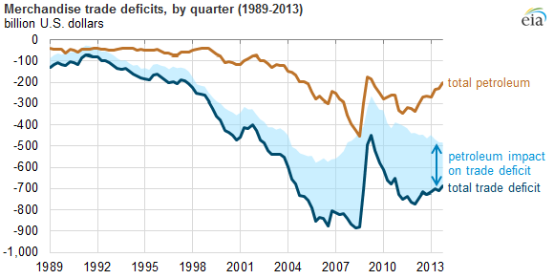
Source: U.S. Bureau of Economic Analysis (BEA)

Currently, gas and oil supplies more than 40% of our total energy demands and more than 99% of the fuel we use in our cars and trucks. Energy trade has long been a key component of overall U.S. trade flows. Recent developments in U.S. energy production, notably the rapid growth of oil and shale gas output, and the 250% increase in the price at the pump, are leading to significant changes in the nation's energy trade flows. In 2013, as in other recent years, the United States was a net importer of goods and a net exporter of services. Energy accounted for 15% of gross U.S. goods imports in 2013, while energy exports, which have grown significantly in recent years, accounted for 7% of overall U.S. goods exports. Focusing on the net U.S. trade position, shown by the black line in the chart above, net energy imports account for nearly half of the total U.S. trade deficit in goods and services. The value of energy trade flows can move rapidly as a result of changes in production, consumption, and prices. In 2013, the value of energy fuels exports increased 8% relative to 2012, while the value of energy fuels imports fell 11%. Given the prominent role of energy fuels in U.S. trade accounts, this shift pushed the total U.S. trade deficit in 2013 to the lowest level in four years. Crude oil was the largest single U.S. import by value among all goods in 2013, as it has been for many years. Crude oil and petroleum products hold a dominant share of U.S. energy trade, relative to other energy commodities such as natural gas, coal, nuclear fuels, and electricity.

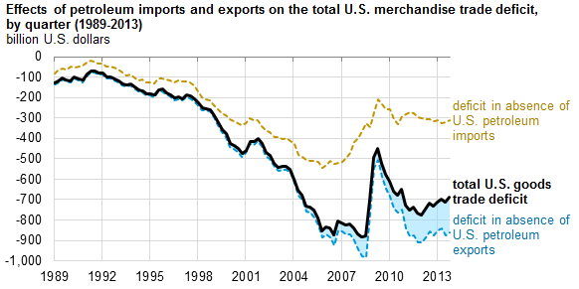
Credit: Energy Information Administration July 21, 2014

In 2013, the value of U.S. energy net imports was 19% below its year-ago level, falling from $304 billion to $246 billion. A number of factors contributed to the decreased value of net energy imports, including: A 16% decrease in the value of net crude oil imports, from $310 billion to $268 billion. A 55% increase in the value of net exports of fuel oil and other refined petroleum products, from $21 billion to $33 billion. A 14% decrease in the value of net natural gas imports, from $10.3 billion to $8.8 billion. A 16% decrease in the dollar value of net coal exports, from $3.9 billion to $3.2 billion. Net energy imports as a share of total U.S. energy consumption have decreased from 30% in 2006 to less than 20% in 2012. In the 2014 Annual Energy Outlook Reference case projections, net energy imports as a share of total U.S. energy consumption fall to 6% by 2020 and to 3% by 2035. Increasing onshore oil and natural gas production, aided by horizontal drilling and hydraulic fracturing technologies, will allow the United States to continue to reduce its net imports of crude oil and to increase refined product exports (such as diesel fuel to Europe) and become a net natural gas exporter later this decade (Ford & McManmon ’14).

The drop in net imports of oil (crude and petroleum products combined) was the major contributor to the United States reaching its lowest net trade deficit in November 2013 since 2009, although the trade deficit increased in the final month of 2013. U.S. oil trade, by far the dominant component of overall U.S. energy trade, has seen major changes in recent years. In both absolute and percentage terms, U.S. net import dependence measured volumetrically (in terms of barrels or barrels per day) has been declining since 2005. Although the volume of net oil imports peaked in 2005, the value of monthly net oil imports generally continued to rise through July 2008, when it exceeded $40 billion due to the sharp run-up in oil prices through the first half of that year. Net import values fell sharply in the second half of 2008, as volumes fell modestly and prices fell sharply. From early 2009 through early 2011, rising prices drove the value of net oil imports higher, even as import volumes remained flat. Since early 2011, a falling volume of crude oil imports as domestic production has risen sharply and the emergence of net product exports have driven the volume and value of net oil imports lower. These reductions occurred even though the annual average oil prices in 2012 and 2013 were at their highest historical levels. While the United States has historically been a significant net importer of both crude oil and petroleum products, stagnating domestic product demand combined with very competitive refinery infrastructure and strong global product demand turned the United States into a significant net exporter of petroleum products starting in 2011.

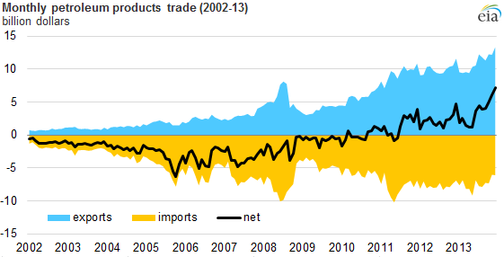
Source: U.S. Census Bureau: Foreign Trade Division
By value, crude oil imports were down 16% year-over-year in 2013. EIA's February Short-Term Energy Outlook forecasts continued rapid growth in domestic crude oil production in both 2014 and 2015, which should further reduce the volume of net crude oil imports over this period. Given the continued flatness in domestic demand and continued access of U.S. refiners to domestic crude streams and relatively low-cost natural gas to fuel their refineries, the country is likely to maintain its current role as a major net exporter of distillate fuels and other products to external markets, especially those in the Atlantic Basin. The upper limits to near-term product export growth are likely to be defined by refinery capacity, while the lower limits to product exports likely depend on potential weakness in foreign product demand, perhaps responding to weaker-than-expected economic conditions. Domestic production of crude oil, including lease condensate, is projected to increase sharply in the AEO2014 Reference case, with annual growth averaging 0.8 million barrels per day through 2016, before leveling off and declining slowly after 2020. Net imports are also reduced by the continuing decline in U.S. oil use as fuel economy standards for cars and light trucks become steadily more stringent through 2025. The combination of higher oil production and lower oil consumption in the United States has already reduced net imports as a share of U.S. liquid fuels use from 60% in 2005 to 40% in 2012, with a further decline of the net import share to 27% in 2015 and 26% in 2020 projected in the AEO2014 Reference case. Net import volumes of crude oil and liquid fuels on a volume basis are projected to decline by 55% between 2012 and 2020.
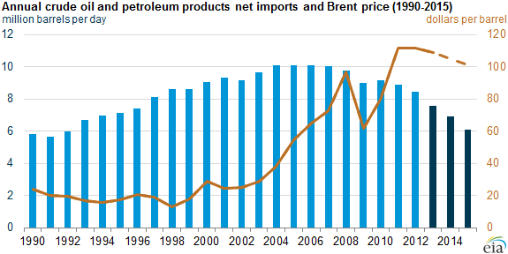
Source: Ford, Michael; U.S. Energy Information Administration Monthly Energy Review

Currently the 12 member nations of OPEC produce over 40 percent of the world’s oil, which gives the group tremendous control over the price of crude oil, the biggest factor in gasoline costs. As the United States adds to its energy reserves through hydrofracking shale, OPEC’s influence on prices at the pump will weaken. U.S. oil production could expand to 15 million barrels a day, more than double the current rate. This would reduce domestic oil prices, increase U.S. economic activity by 2 percent, add 3 million jobs, and could turn the United States into a major oil exporter by 2020. A separate Energy Department analysis found that the United States now has sufficient natural gas supplies to make it a major exporter. Natural gas could have its biggest impact by replacing gasoline in the world’s cars, trucks and buses. At the moment transportation accounts for 70 percent of America’s petroleum use, and 30 percent of its carbon emissions. The combustion of natural gas produces 30 percent less carbon dioxide than oil, and could be used instead – either directly, as compressed natural gas or liquid natural gas, or indirectly by converting natural gas into liquid fuel or power for electric vehicles. At the moment, just 1.5 percent of the world’s cars and trucks – about 16 million vehicles – are powered by natural gas. (Prud’homme ’14: 61, 62).



At the time of the U.N. Climate Change Conference for the Equinox 2014, where we successfully prayed for rain on the wildfire stricken West Coast, the heating and cooling off the American East coast seemed to have cleared up, except a hot spot by New York City. The hot spot has spread from off the coast of Alaska to off the coast of Columbia also. Except for Rio de Janeiro the Southern and Eastern hemispheres are cool. The Arctic Ocean is extremely hot. To monitor the current weather anomalies regular sea surface temperature a (SST) nomaly charts are created by the NOAA Satellite and Products Operations to explain weather patterns and direct maritime efforts to detect, remove and manage fields of metallic hydrocarbon fueled heating and cooling pumps of container size placed in ocean waters without informing the public. According to the current NOAA Sea Surface Temperature Anomaly map the drought and high pressure system which has caused a drought emergency declaration in California seems to be caused by high levels of warming at around 47°N 100°W, out to sea off the southern coast of Alaska, which blows winds, including the Santa Ana's warmed in the mountains, towards a cooling along the California coast. There are no known declarations of emergency in other parts of the world to warrant the commission of maritime searches for hydrocarbon heating and cooling pumps, with remote thermostats. Detection involves this satellite study of anomalous ocean temperature on the surface, anomalous temperature at depths as compared to previous charts and sonar images of shipping container size metallic heat pumps on the seafloor. Removal may be complicated by the possibility of the mining of a hostile hydrocarbon fueled heat pump with remote thermostat but they should not be much more difficult to remove than transoceanic cable. Henceforth, any unpermitted placing of heating and cooling pumps, and resulting thermal pollution, is ruled pollution for the purposes of corporate liability and state responsibility under the Clean Water Act of 1972 and 1982 Law of the Sea.


On August 28, 2005, the day before Hurricane Katrina struck New Orleans on August 29, 2005, a parked railroad tanker car owned by Westlake Chemical Corp leaked styrene into the air; more than 800 people in Cincinnati's East End had to be evacuated for over two days and received a class action settlement for the cost of forced relocation. The venting occurred because of an increase in pressure inside the tank. Styrene has a boiling point of 145 degrees Celsius and exists as a liquid under standard conditions. The vapour pressure is small at 5 hPa = 5 mbar at standard conditions. The flash point is at 31 degrees Celsius and a mixture with air is ignitable within 1 to 9 Vol %. The increase in pressure was due to heat generated within the tank which was attributed to polymerization of the styrene monomer within the tank. Normally, a chemical inhibitor such as 15 parts per million of 4-tertiary-butyl-catechol (TBC) is added to the tank during transport to prevent polymerization, but this lasts only three months and the tanker was idle for 9 months. This inhibitor scavenges rust and other impurities within the tank that can act to initiate polymerization. Oxygen (about 10 ppm) is also required to be dissolved in the styrene monomer for the TBC to do its job. The TBC concentration decreases with time as it scavenges impurities; 15 ppm concentration would probably be mostly used up in possibly 3 months (even less time if ambient temperatures are warmer). Without the inhibitor, the styrene monomer can polymerize with oxygen to form a styrene-oxygen copolymer or benzaldehyde and/or formaldehyde and polymerize with the release of heat. The heat further accelerates the polymerization releasing more heat. While any hydrocarbon may been used to cause heating and cooling of bodies of water using modern heat pump technology, its dual use in fracking, drilling with expansive Styrofoam that further cracks the earth, styrene can cause earthquakes, and requires extra consideration in a national hazardous substance report on all hydrocarbons that could be diverted into oceanic heating and cooling under 42USC(103)I§9605. Other chemicals that can undergo self-polymerization releasing heat are: Hydrogen cyanide, UN1051, Vinyl acetate, UN1301, Furural or furfuraldehydes, UN1199, Propyleneimine, UN1921, and Ethyleneimine, UN1185, Ethylene oxide, UN1040, and Butadienes, UN1010 (Aristatek '08).

Heat pumps need a source of heat to transfer from, either the outside air, the ground, or a large body of water. Systems that transfer heat from the ground or water are called “geothermal heat pumps” and systems that transfer from the outside air are called “air-source heat pumps”. The vast majority of heat pumps installed today are air-source, as geothermal heat pumps require deep drilling, large land lots, or permitted access to a body of water. Hydrocarbon refrigerants include a number of products including R290 (propane), R600a (isobutane), R1150 (ethene/ethylene), R1270 (propene/propylene), R170 (ethane) and various blends of these products. Hydrocarbon refrigerants have a wide range of applications. This includes commercial refrigeration, chill cabinets and vending machines, cold storage and food processing, industrial refrigeration, transport refrigeration, small air conditioning systems, large air conditioning and chiller systems, heat pumps and water heaters. Hydrocarbon refrigerants have some different chemical properties than fluorocarbon refrigerants; the primary difference are their classification
as extremely flammable. A.S. Trust & Holdings has been awarded a U.S. patent for the formula of a blend of pure hydrocarbons that has been designated R441A by the American Society of Heating, Refrigerating and Air-Conditioning Engineers (ASHRAE).R441A has been certified by independent testing laboratory Intertek (an) as having a very low Global Warming Potential (GWP) as well as a zero Ozone Depletion Potential (ODP). Illicitly placed in the ocean in large quantities these industrial hydrocarbon fueled heating and cooling units do pose a serious threat to global warming. The new cooling function also presents an opportunity to prevent global warming and potentially dissipate hurricanes by cooling the water below 80°F (Sanders ’14).

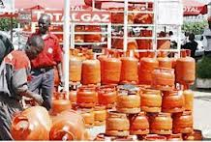
As of 2015 the U.S. is expected to be the world’s largest oil exporter, after rising prices led to dramatic and unsung decline in domestic consumption, so great as to rob the Highway Trust Fund, counterfeit appropriations being non-negotiable. Gas prices are too high already, new domestic gas taxes are not advised. The Highway Trust Fund needs to capitalize on the United States’ new advantageous position in oil exportation to exploit new oil export taxes on industrialized nations, with negotiable current rates for developing nations and no export tariff to least developing nations, promising to all nations equal fuel prices. Least developed nations show high rates of deforestation driven by urban firewood and charcoal consumption. Gas and propane alternatives for heating and cooking, are many times more expensive in least developed nations than in industrialized nations and should be subsidized to conserve the tropical rainforest. Until such a day that all the oil is exploited, and the petroleum interests who finance alternative energy research stop suppressing effective solar technology; new U.S. oil export tax revenues shall go to the Highway Trust Fund and oil exporters shall get tax breaks and earn official development assistance credit for fossil fuel cooking assistance to least developed nations, U.S., Russian and O.P.E.C. nations alike. Carbon emission credit for polluting corporations are granted for successful native species reforestation programs with the fossil cooking fuel not to cut them down (Sanders ’14).

B. Highway Trust Fund

Prior to the 1956 Highway Revenue Act and the establishment of the Highway Trust Fund roads were financed directly from the General Fund of the U.S. Treasury. The 1956 Act directed federal fuel tax to the fund to be used exclusively for highway construction and maintenance. The Highway Revenue Act mandated a tax of three cents per gallon. The original Highway Revenue Act was set to expire at the end of fiscal year 1972. In the 1950s the gas tax was increased to four cents. The 1982 Surface Transportation Assistance Act, approved by President Ronald Reagan in January 1983, increased the tax to nine cents with one cent going into a new Mass Transit Account to support public transport. In 1990 the gas tax was increased by President George H. W. Bush with the Omnibus Budget Reconciliation Act of 1990 to 14 cents - with 2.5 cents of the increase going to the Highway Fund and the other 2.5 cents going towards deficit reduction. In 1993 President Clinton increased the gas tax to 18.4 cents with the Omnibus Budget Reconciliation Act of 1993 with all of the increase going towards deficit reduction. The Taxpayer Relief Act of 1997 redirected the 1993 increase to the Fund.

Federal Highway User Excise Taxes and the Percentage Allocations to the Highway Account and the Mass Transit Account of the Highway Trust Fund, as of March 1, 2006 Motor fuel taxes
Distribution of tax
Type of Excise Tax | Tax rate (cents) | Highway Account | Mass Transit Account
Gasoline | 18.3 per gallon | 84% | 16%
Diesel | 24.3 per gallon | 88% | 12%
Gasohol | 18.3 per gallon | 84% | 16%
Liquefied petroleum gas | 13.6 per gallon | 84% | 16%
Liquefied natural gas | 11.9 per gallon | 84% | 16%
M85 (from natural gas) | 9.15 per gallon | 84% | 16%
Compressed natural gas | 48.54 per thousand cubic feet | 80% | 20%
Truck-related Taxes - All proceeds to Highway Account
Tires | 9.45 cents for each 10 pounds (so much of the maximum rated load capacity thereof as exceeds 3,500 pounds)
Truck and trailer sales | 12 percent of retailer’s sales price for tractors and trucks over 33,000 pounds Gross Vehicle Weight (GVW) and trailers over 26,000 pounds GVW
Heavy-vehicle use | Annual tax for trucks 55,000 pounds and over GVW: $100 plus $22 for each 1,000 pounds (or fraction thereof) in excess of 55,000 pounds. Maximum tax: $550
Credit: Siggerud ’08: 4

Most of the excise taxes credited to the HTF are not collected by the Federal government directly from the consumer. They are, instead, paid to the Internal Revenue Service by the producer or importer of the taxable product (except in the cases of the tax on trucks and trailers, which is paid by the retailer, and the heavy vehicle use tax, which is paid by the heavy vehicle owner). As a result, most of the Federal fuel taxes come from a handful of States, those where major oil companies are headquartered, and most tire taxes are paid from Ohio, the home of the U.S. tire industry. Of course, these taxes become part of the price of the product and are ultimately paid by the highway user. Another important characteristic of the HTF is that it was set up as a pay-as-you-go fund. In other words, there must be enough money in the HTF to make reimbursements. For the Highway Account of the HTF, the control mechanism that ensures this is the Byrd Amendment. Under the Byrd Amendment, as modified by the STAA of 1982, unfunded authorizations (unpaid commitments in excess of amounts available in the Highway Account of the HTF) at the end of the fiscal year in which the apportionment is to be made must be less than the revenues anticipated to be earned in the following 24 month period. For example, to determine the status of FY 1999, at the close of FY 1998 the Secretary of the Treasury must determine if the balance of the Highway Account of the HTF as of September 30, 1998, plus the anticipated income in FYs 1999, 2000, and 2001, will be greater than the sum of the authorizations to be distributed for FY 1999 and the authorizations distributed, but not paid, as of September 30, 1998. If there will be a shortfall in funds, then all Highway Account funded program apportionments for FY 1999 will be reduced proportionately. In the HTF’s history, the Byrd Amendment has been triggered only once, resulting in the reduction in the Interstate System construction apportionments for FY 1961.

The nature of the Highway Trust Fund’s receipts collection and disbursement processes is such that estimates are needed not only to project the fund’s future balance but also to determine its current balance. Changing circumstances—for example, shifts in motor fuel usage—can affect the accuracy of past estimates of receipts that will flow into the Highway Trust Fund, rendering it necessary to make regular adjustments. Treasury’s estimates of Highway Trust Fund receipts are used to make these regular adjustments to the Highway Trust Fund balance, and DOT uses these estimates in turn to calculate what is called the Revenue Aligned Budget Authority (RABA) adjustment, which can increase or decrease the levels of funding enacted by legislation and funded through the Highway Account. The collection and allocation of the receipts is complex and involves several organizations. Twice a month, business taxpayers make deposits of excise taxes—including the highway user excise taxes levied for the Highway Trust Fund—generally through Treasury’s Electronic Federal Tax Payment System. When these semimonthly deposits are made, Treasury does not obtain data from business taxpayers on the type of excise taxes (highway user or otherwise) that these deposits are intended to cover; therefore, the deposits flow into Treasury’s General Fund. On a semimonthly basis, Treasury’s Financial Management Service (FMS) and Bureau of Public Debt (BPD) use estimates made by the Treasury’s Office of Tax Analysis (OTA) based on historical tax receipts certified by Internal Revenue Service (IRS) data and actual total current excise tax revenue collections to make an initial transfer into the Highway Trust Fund. Treasury later adjusts these initial deposits based on actual tax receipts, which are certified by IRS on a quarterly basis 6 months after each quarter has ended.

Both the Highway Account and the Mass Transit Account of the Highway Trust Fund are nearing insolvency. The Highway Account is expected to become insolvent by the end of August, the Department of Transportation will implement a cash management plan beginning August 1 to manage the flow of federal dollars. Under this plan, reimbursements to states for infrastructure work will be limited to the available cash in the Trust Fund. Incoming funds are distributed in proportion to each state’s federal formula apportionment in the fiscal year. Based on current spending and revenue trends, the U.S. Department of Transportation estimates that the Highway Account of the Highway Trust Fund will encounter a shortfall before the end of fiscal year (FY) 2014. The Highway Account began FY 2014 with approximately $1.6 billion in cash. A $9.7 billion transfer from the General Fund to the Highway Account was processed shortly after the start of the fiscal year ($10.4 billion authorized in MAP-21, reduced by sequestration). The cash balance has dropped by nearly $5.4 billion since the General Fund transfer occurred. As of June 27, 2014, the Highway Account cash balance was $6.5 billion.

The Senate Committee on Commerce, Science and Transportation, formed in 2005, discussed raising the federal gas tax to 40 cents per gallon over five years, rising 5-8 cents annually for five years and then also indexed to inflation. During 2008 the fund required support of $8 billion from general revenue funds to cover a shortage in the fund. This shortage was due to lower gas consumption as a result of the recession and higher gas prices. Further transfers of $7 billion and $19.5 billion were made in 2009 and 2010 respectively. From 2008 to 2010, Congress authorized the transfer of $35 billion from the General Fund of the U.S. Treasury to keep the trust fund solvent. The Congressional Budget Office (CBO) projected in January 2012 that the fund's Highway Account will become insolvent during 2013, and the Mass Transit Account insolvent in 2014. CBO said that although vehicles will travel more miles in the future (therefore consuming more taxable fuel), rising fuel efficiency standards and congressional refusal to increase the fuel tax or tie it to the rate of inflation means that the fund receives less money. CBO's insolvency projection assumed that Congress will not increase transportation spending beyond inflation-adjusted 2012 levels. In 2013, the U.S. Chamber of Commerce supported raising the federal gasoline tax to keep the fund solvent. After concerns that funding would not be extended by the United States Congress before funds dried up in August 2014, Congress passed a stopgap plan on July 31, 2014 to prevent a funding lapse. The Fund receives hypothocated tax revenues derived from excise taxes on highway motor fuel and truck related taxes on truck tires, sales of trucks and trailers, and heavy vehicle use. Money goes to the general treasury but is then credited to the fund.

Since 2008, the Congress has avoided such imaginary shortfalls by transferring $41 billion from the general fund of the Treasury to the Highway Trust Fund. An additional transfer of $12.6 billion is authorized for 2014. If lawmakers chose to continue such transfers, they would have to transfer an additional $14 billion to prevent a projected shortfall in 2015. Lawmakers could also address that shortfall by substantially reducing spending for surface transportation programs, by boosting revenues, or by adopting some combination of the two. The Moving Ahead for Progress in the 21st Century (MAP-21, Public Law 112-141) is the most recent authorization for highway and transit programs. (It expires on September 30, 2014.) A total of about $51 billion in contract authority has been provided for fiscal year 2013, and the obligation limitations for this year amount to about $50 billion. Most obligations for the highway and transit accounts involve capital projects that take several years to complete. (The Federal-Aid Highway program, for example, typically spends about 25 percent of its budgetary resources in the year funds are first made available for spending; the rest is spent over the next several years.) Most of the Highway Trust Fund’s current obligations will therefore be met using tax revenues that have not yet been collected because the existing obligations of the fund far exceed the amounts currently in the fund. For example, at the end of 2012, the total obligated amounts of contract authority in the highway account were equal to about two years of collections of excise taxes. That amount totaled about $67 billion at the end of 2012, and tax receipts dedicated to the highway account are projected to be about $33 billion a year over the next two years. A 3% gas export tax might contribute $5 billion in revenues. Because the demands of the Highway Trustfund are distorted by Congressional subsidies overall expenditures must be reduced from $50 billion to $40 billion over the next couple of years by eliminating the barbaric practice of “tarring and feathering” petitioners and not performing scheduled maintenance that is not necessary, expecting 3% annual growth from 2008 when the fund was distorted by congressional subsidies.

Highway Account Receipt and Outlay Estimates for 2006 through 2011 (in billions)

 |  | 2006 | 2007 | 2008 | 2009 | 2010 | 2011 | Average ‘06-‘11
Treasury/DOT | Receipts | $34.1 | $34.6 | $35.4 | $36.2 | $36.9 | $37.6 | $35.8
 | Outlays | $34.5 | $38.2 | $39.7 | $40.8 | $41.8 | $42.3 | $39.6
 | Difference | -$0.40 | -$3.60 | -$4.30 | -$4.60 | -$4.90 | -$4.70 | -$3.80
CBO | Receipts | $34.9 | $35.9 | $36.9 | $37.9 | $38.8 | $39.7 | $37.4
 | Outlays | $34.9 | $37.9 | $40.5 | $41.7 | $42.7 | $43.8 | $40.3
 | Difference | $0.00 | -$1.94 | -$3.58 | -$3.81 | -$3.89 | -$4.07 | -$2.90

The Highway Account, which makes up about 84 percent of the Highway Trust Fund receipts, is projected to have a negative balance by the President’s Budget estimates in 2009 and by CBO in 2010. Projected outlays are outpacing estimated receipts, which leads to the projected negative balances in the Highway Account and ultimately the Highway Trust Fund. For example, for 2006 through 2011, the Highway Account receipts are estimated to average $35.8 billion by Treasury and $37.4 billion by CBO. For that same period, average outlays are estimated at $39.6 billion by DOT and $40.3 billion by CBO. Both the President’s Budget and CBO’s estimates currently show a continuing downward trend of cash balances in the Highway Trust Fund, and both estimates show a negative balance in the Highway Trust Fund by fiscal year 2011. Differences between the estimates are greater in the later years because the uncertainty of estimates increases as the projections extend into the future. CBO estimates higher year-end balances for every year through 2011, projecting a balance of negative $2.4 billion at the end of 2011, while the President’s Budget estimates project a negative balance occurring first in 2010 and reaching an estimated negative $10 billion by 2011. It should be noted, however, that legislative or economic changes affecting Highway Trust Fund receipts occurring in the interim could change these projected negative balances. For example, a number of changes, such as provisions to reduce tax evasion that provided increased receipts to the Highway Trust Fund, were adopted in the American Jobs Creation Act of 2004 (Siggerud ’08: 9). Because expenditures rose disproportionately thereafter, it seems best to calculate 3% annual growth from 2006 – 10 years in FY2015 - $34.5 billion x 1.3 = $44.85 billion - spending limit and $45 billion revenue target FY 2015-2016

Status of the Highway Trust Fund and Mass Transit Account 2014

 | June  2014 | July  2014 | Fiscal Year  to Date | Percent Change  from Prior Year
Highway Account
Opening Balance | $8,140,402,561 | $5,956,247,313 | $3,771,061,477 | -61.2%
Receipts:
Net Tax Receipts | 2,442,704,041 | 2,840,498,000 | 25,794,201,750 | 6.7%
Interest Income | 132,555 | 77,747 | 2,297,874 | -48.0%
Other Receipts 1/ | 2,287,144 | 1,630,552 | 9,665,866,006 | 55.5%
Total Receipts | 2,445,123,739 | 2,842,206,298 | 35,462,365,630 | 16.7%
Transfers:
To Mass Transit Account | 155,000,000 | 267,000,000 | 1,159,000,000 | 295.4%
From Mass Transit Account | 540,831 | 667,965 | 49,358,370 | 0.9%
Outlays | 4,474,819,818 | 4,599,266,919 | 34,190,930,820 | 4.6%
Closing Balance | 5,956,247,313 | 3,932,854,657 | 3,932,854,657 | -45.2%
Mass Transit Account
Opening Balance | 2,848,262,449 | 2,323,677,319 | 2,492,074,635 | -52.0%
Receipts
Net Tax Receipts | 359,047,641 | 426,183,000 | 3,872,438,119 | 7.8%
Interest Income | 55,394 | 36,047 | 984,419 | -42.7%
Other Receipts 2/ | - | - | 2,041,600,000 | 0.0%
Total Receipts | 359,103,036 | 426,219,047 | 5,915,022,537 | 64.6%
Transfers
To Highway Account | 540,831 | 667,965 | 49,358,370 | 0.9%
From Highway Account | 155,000,000 | 267,000,000 | 1,159,000,000 | 295.4%
Outlays | 1,038,147,334 | 694,734,248 | 7,195,244,649 | 13.1%
Closing Balance | $2,323,677,319 | $2,321,494,153 | $2,321,494,153 | -13.1%
1/ Includes a transfer of $10.4 billion from the General Fund in October pursuant to section 40251 of P.L. 112-141 as reduced by the sequester of $748,800,000.
2/ Includes a transfer of $2.2 billion from the General Fund in October pursuant to section 40251 of P.L. 112-141 as reduced by the sequester of $158,400,000.

CBO estimates that the highway account will end fiscal year 2013 with a balance of $5 billion, compared with a $10 billion balance at the end of fiscal year 2012. By CBO’s estimates, outlays from the highway account will total $44 billion in 2013, while revenues and interest earnings will amount to only $33 billion for the year. To partly bridge that gap, MAP-21 transferred $6 billion of general funds to the highway account in 2013. The transit account will end fiscal year 2013 with a balance of $3 billion, CBO estimates, down from $5 billion a year earlier. Since 2008, $41 billion has been transferred, including $6 billion in 2013; total transfers will grow to almost $53 billion by the end of 2014 under the provisions of MAP-21. In 2015, lawmakers would need to transfer another $14 billion to the Highway Trust Fund if they chose to continue funding surface transportation programs as they have in recent years. Another approach to bringing the trust fund’s finances into balance would be to increase its revenues. Excise taxes credited to the Highway Trust Fund come primarily from an 18.4 cent-per-gallon tax on gasoline and ethanol- blended fuels and a 24.4 cent-per-gallon tax on diesel fuels. Those taxes were last increased in 1993.3 If those excise taxes had been adjusted using the consumer price index (CPI), the tax on gasoline today would be about 29 cents per gallon, and the tax on diesel fuels would be about 39 cents per gallon. According to estimates from staff of the Joint Committee on Taxation, a one-cent increase in the taxes on motor fuels, effective October 1, 2014, would raise about $1.5 billion annually for the trust fund over the next 10 years. Maintaining the current performance of the highway and transit system would require at least $13 billion per year more than current spending, according to the Federal Highway Administration (FHWA). Based on current spending and revenue trends, the U.S. Department of Transportation estimates that the Mass Transit Account of the Highway Trust Fund will have a balance of approximately $1.1 billion at the end of FY 2014. The Mass Transit Account began FY 2014 with approximately $2.5 billion in cash. A $2 billion transfer from the General Fund to the Mass Transit Account was processed shortly after the start of the fiscal year ($2.2 billion authorized in MAP-21, reduced by sequestration). The cash balance has dropped by $2.0 billion since the General Fund transfer occurred. As of June 27, 2014, the Mass Transit Account cash balance was $2.5 billion.

It is time for ARRA to cease distorting Highway Trust fund estimates. Solar technology needs to come to grips with the distortions and enslavement caused by the interim energy market for fossil fuels mined for the altruistic cause of preventing future volcanic eruptions and empowering free moving vehicles that use the highways; but strangely accused of war by Texas and Louisiana penitentiaries in Washington DC, and the current realist balance of power put their boots on the ground along the lines of the balance of trade in petroleum products with the European Union, Africa and Asia and the illegally economically sanctioned exporters in the badly governed nations of the United States, Russia and the Middle East. To make sense of the budget, despite the mathematical insolvency of the Democratic-Republican (DR) two party system and constitutional perpetuation of a slavery economy in general, it is necessary to recuse the Secretary of Transportation (and Education) under 18USC(11)§205(a)(c)(e) and appoint an official who didn’t rob Blagojevich’s congressional funny money to finance the President’s war or attempt to conceal its worthlessness by interfering with and annoying petitioners, or in the case of education the intellectual property of scholars, with noisy highway contracts in lieu of, or in conjunction with pedestrian hazards and more violent tortures unbefitting the global positioning system (GPS) of civil engineers, and most of all to immediately free Rod Blagojevich from the crimes of his racketeering prosecutors as permitted by§205(d)(1)(e)(h). The Department of Motor Vehicles (DMV) discriminates impossibly against naturalization in the issuance of IDs and wastes federal funds annoying petitioners with road maintenance projects that should only be done if they are determined to be necessary after scheduled inspection. Traffic judges are so cruel and unusual, the lawyers must be replaced with licensed social workers who are not so impoverishing. The federal Highway Administration needs to recuse their conflict of interest with Rod Blagojevich’s federal bailout and normalize their estimates for highway trust fund revenues and expenditures. The Congressional “funny money” was never used for anything but usury, it never existed in a legal sense, and continues to spare us panicky statements regarding the existence of any war debt we refuse to recognize in already redacted military accounts, although there is question as to whether T-bonds were actually sold, for the benefit of future public accountants.

As of 2002, there were 590 million automobiles worldwide. Overall, there were an estimated 254.4 million registered passenger vehicles in the United States according to a 2007 DOT study. This number, along with the average age of vehicles, has increased steadily since 1960, indicating a growing number of vehicles per capita. The United States is also home to three large vehicle manufacturers: General Motors, Ford Motor Company and Chrysler, which have historically been referred to as the "Big Three." Chrysler however is no longer among the top three; but is number five, behind Toyota and Honda. The motor car has clearly become an integral part of American life, with vehicles outnumbering licensed drivers. The Republic of India has the largest road system in the world with 4,689,842 kilometres (2,914,133 mi) of road (2013). The United States has the second largest network of roads of any country with 4,050,717 miles (6,518,997 km) as of 2009. The People's Republic of China is third with 3,583,715 kilometres (2,226,817 mi) of road (2007). The Federative Republic of Brazil has the fourth largest road system in the world with 1,751,868 kilometres (1,088,560 mi) (2002).

C. Hydrofracking

Fossil fuels such as coal, oil and natural gas, were formed some 286 to 360 million ago in the Carboniferous period, which predated the dinosaurs and is part of the Paleozoic era. Buried deep in the earth are the remnants of hundreds of millennia of rotting vegetation, decaying animals and marine plankton that has today turned into rock that is laden with carbon, which can be burned for fuel. During the Carboniferous period the earth was populated by trees, large leafy plants, and ferns, and its water bodies were rich with algae, a common phytoplankton. As these plants and animals died, they sank to the bottom of the swamps and oceans, forming layers of spongy earth called peat. Over millions of years, silt, sand and clay covered the peat; the layers of minerals built up, the peat was compressed until the water had been completely squeezed out of it. Eventually the organic material was buried deeper and deeper and turned into rock. Increasing heat and geologic pressure transformed some of the rock into fossil fuels. Unlike “renewable” wind or solar power, fossil fuels are “nonrenewable”, or finite, energy supplies: once they are used they are gone for good; their excavation and burning creates pollution, including greenhouse gases such as carbon dioxide (CO₂). Nevertheless, fossil fuels remain our primary source of energy. Today, the U.S. Energy Information Administration (EIA) estimates that 25 percent of America’s energy comes from petroleum, 22 percent from coal, and 22 percent from natural gas. Nuclear power account for 8.4 percent, and “renewable energy” – such as wind, solar geothermal, or hydropower supplies 8 percent (Prud’homme ’14: 9, 10). Oil and natural gas fuel 9.2 million American jobs, 5.2% of the U.S. total, with a labor income of $558 billion, 6.3% of the U.S. total. Of those jobs 2.1 million were direct and 7.1 million indirect. In 2007, the most recent year for which data is available, the industry supported a total value added to the national economy of more than $1 trillion or 7.5% of the U.S. gross domestic product (Sanders ’10). Over 450,000 workers were employed in the oil and gas extraction and support industries in 2011. From 2003 to 2010, 823 oil and gas extraction workers were killed on the job-a fatality rate seven times greater than the rate for all U.S. industries, about the same as farming, or mining since the Mining Safety and Health Act of 1977. In 2011 the EIA estimated that the nation had 827 trillion cubic feet of shale gas, a few months later, the agency sharply reduced the estimate to 482 trillion cubic feet. As of this writing in 2013, the EIA estimates the United States has roughly 665 trillion cubic feet of technically recoverable shale gas (fourth globally, behind China, Argentina, ad Algeria). The U.S, Geological Survey (USGS) revised its estimates of oil shale oil upward to 7.4 billion barrels of undiscovered oil, double the previous estimate, and 6.7 trillion cubic feet of gas, triple the previous estimate. The EIA adds that the United States now has an estimated 48 billion barrels of shale oil reserves (second worldwide, after Russia’s 58 billion barrels) (Prud’homme ’14: 15, 16, 102). U.S. oil and gas inventories are at an all-time high because of higher consumer gasoline prices and the new use of hydrofracking technology to extract shale oil and gas in the United States. So far, the United States is the only nation known to permit the added expense of hydrofracking shale oil and gas. Hydrofracking is as distinctly American as drone technology.

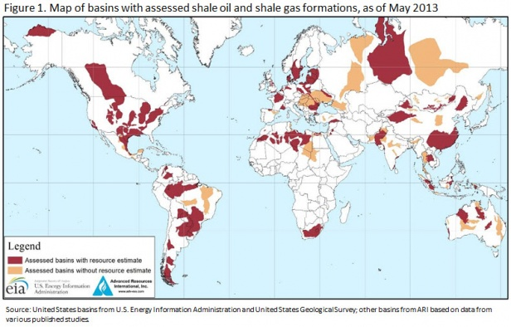
Peat, coal, oil and natural gas are called fossil fuels because they are formed from what was once organic matter. Oil shales and tar sands are also fossil fuels, but are too expensive to process to be marketable while there are still commercial quantities of oil and gas. Petroleum is derived largely from the free-floating (vegetable) phytoplankton which thrives in the seas to a depth of about 120 m. In the organic layer of soil protein and other organic compounds are degraded to form kerogen. When burial has reached 1 km, temperature has risen to about 65°C and katagenesis occurs with the formation of long-chain hydrocarbons. Maximum release of oil is when burial reaches between 1 km and 3 km, with temperature of about 175 °C. Gas is also formed, and as depth increases below 3 km, there is more gas and less liquid oil. At about 4 km deep, dry gas forms. At about 5 km metagenesis occurs and all hydrogen is lost and only carbon, in the form of graphite, is left. To form an oilfield, oil must first be expelled from its impermeable mudstone source rocks and migrate via more permeable rocks to accumulate in reservoirs in recoverable amounts. Oil is recovered by drilling. Only a few oil fields are marked by oil or gas seeps. Most reservoirs lie deep, without surface indications, from depths of 1-2.5 km, some as deep as 3.5 km. Oil fields are confined to sedimentary basins, and 85 percent of all oil is Mesozoic or younger rocks, less than 230 Ma old; 60 percent in rocks less than 50 Ma old. To prove oil, wells must be sunk, sometimes as much as 3 km. Very deep holes may start with a diameter of nearly a metre, reducing in stages to about 18 cm towards the bottom. A well is drilled, cores or chippings of rock penetrated are examined to identify formations and date them from their fossils. Mudlogging is the monitoring of the amount and consistency of the heavy drilling mud used to lubricate the drill and to contain gas pressures which might cause blow-outs (Barnes ’88: 103, 108, 113, 114).

The Federal government did not largely regulate natural gas and oil exploration and development activities in the offshore regions of the United States from the 1880s, when offshore oil production first began, through the mid-1900s. Today, there are around 4,000 platforms producing in Federal waters up to roughly 7,500 feet deep and up to 200 miles from shore. The offshore has accounted for about one-quarter of total U.S. natural gas production over the past two decades and almost 30 percent of total U.S. oil production in recent years. Hydraulic fracturing is used after the drilled hole is completed. Fractures are created by pumping large quantities of fluids at high pressure down a wellbore and into the target rock formation. Hydraulic fracturing fluid commonly consists of water, proppant and chemical additives that open and enlarge fractures within the rock formation. These fractures can extend several hundred feet away from the wellbore. The proppants - sand, ceramic pellets or other small incompressible particles - hold open the newly created fractures. The first use of hydraulic fracturing to stimulate oil and natural gas wells in the United States was in the 1940s. Coalbed methane production began in the 1980s; shale gas extraction is even more recent. The main enabling technologies, hydraulic fracturing and horizontal drilling, have opened up new areas for oil and gas development, with particular focus on natural gas reservoirs such as shale, coalbed and tight sands. Hydraulic fracturing combined with horizontal drilling has turned previously unproductive organic-rich shales into the largest natural gas fields in the world. The Marcellus Shale, Barnett Shale and Bakken Formation are examples of previously unproductive rock units that have been converted into fantastic gas or oil fields by hydraulic fracturing. Experts believe 60 to 80 percent of all wells drilled in the United States in the next ten years will require hydraulic fracturing to remain operating. A variety of environmental risks are associated with offshore natural gas and oil exploration and production, among them such things as discharges or spills of toxic materials whether intentional or accidental, interference with marine life, damage to coastal habitats owing to construction and operations of producing infrastructure, and effects on the economic base of coastal communities (Mastrangelo '05).

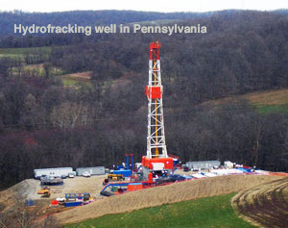
To hydrofrack a shale rock formation boreholes are generally drilled straight down some 5,000 to 20,000 feet deep. The average depth is 7,500 feet deep, which is one-and-a-half miles below the surface. Since the 1990s, hydrofracking has been combined with “directional” drilling, in which a vertical well is drilled thousands of feet deep, whereupon the borehole doglegs and continues horizontally through layers of gas or oil bearing shale. In places like the Bakken Formation, in North Dakota, the lateral leg can extend for one or two miles. A horizontal begins as a standard vertical well. A rig will drill thousands of feet down, until the drill bit is perhaps a few hundred feet above the target rock formation. At this point the pipe is pulled from the well, and a hydraulic motor is attached between the bit and the drill pipe, and lowered back down the well. The hydraulic motor is powered by forcing mud (or slurry) down the drill pipe. The mud rotates the drill bit without rotating the entire length of pipe between the bit and the rig, allowing the bit to change direction, from drilling vertically to horizontally. Horizontal drilling can also be used to install utility lines that cross beneath a city, road, or river, for example. A single borehole can cross beneath numerous pieces of property. In general the royalties from horizontally drilled well are established before drilling begins through a combination of government rules and often complex private royalty-sharing agreements. To obtain the right to drill under private property, an energy firm leases the mineral rights from the federal Bureau of Land Management (BLM). If the lease is granted, the company can drill without the surface property owner’s permission. The total volume of water used to hydrofrack a well ranges between 65,000 gallons, such as for shallow coal bed methane production, to 13 million gallons for deep-shale gas production. Most wells use between 1.2 and 4 million gallons of fluid, with large projects using up to 5 million gallons (equivalent to the amount of water used by approximately 50,000 people during the course of one day). Once the hydrofracking fluid has been injected and pressure for the pumps is released, fracturing fluid known as “flowback” surges back up through the borehole to the surface. “Produced water” is fluid that returns to the surface once the well has started producing natural gas or oil. Collectively, flowback and produced water are known as hydrofracking “wastewater” which is suffused with salts, chemicals, debris scoured from the wellbore, and even naturally occurring radioactive element. In western and southern states injected wastewater has occasionally set off minor tremors. Some communities allow wastewater to be spread on roads or fields, for de-icing. Environmentalists worry that the toxins will wash into freshwater and food supplies. In certain cases, wastewater is recycled for use in other wells. In eastern states like Pennsylvania, much of the wastewater is shipped by pipeline or truck to public sewage treatment plants; but those plants are generally not equipped to process the chemicals or the naturally occurring radioactive material that is sometimes dredged up (Prud’homme ’14: 35-38).

About 33,000 natural gas wells are drilled each year, and 90 percent of them employ hydrofracking. This translates into billions of gallons of potentially hazardous fluids being used annually added to the fluid, and naturally occurring contaminants, such as boron, barium, radium, and salts – including highly saline brine that dates to the Paleozoic era. Salts can kill vegetation. The result is flowback, a murky liquid, thick with salts, sulfur, chemicals, minerals, and proppants; it smells of sulfur, and sometimes contains low levels of radiation. Flowback is comprised of as little as 3 percent and as much as over 8 percent of the total amount of water and other materials used to fracture a well. The flowback generally gets pumped into a pit, then into a separator tank that allows oil to surface; oil is skimmed off and sold. The remaining flowback needed to be carefully disposed, which is where things get tricky. Most states dispose of fluids by pumping them deep underground into injection wells (which are distinct from oil and gas wells). These deposits are regulated by EPA under the Safe Drinking Water Act. But the geologic formations under Pennsylvania are unsuitable for injection wells. Furthermore, Pennsylvania produces so much wastewater that it threatens to overwhelm injection wells in neighboring Ohio. Flowback and produced water are therefore commonly stored in large tanks, holding pond (for evaporation), or, more often, sent by pipeline or truck to public wastewater treatment plants. This raises the chances of spills, traffic accidents, and wear and tear on roads. Yet most sewage treatment plants are not equipped to remove the chemicals, salts, total dissolved solids (TDS), and radioactive elements in the drillers’ wastewater. These contaminants greatly increase the salinity of rivers and streams, which can harm aquatic life, affect the taste, smell and color of tap water, interfere with biological treatment process at sewage plants, and damage industrial and household equipment. In 2013, the federal EPA fined three Pennsylvania treatment plants for accepting hundreds of thousands of gallons of Marcellus Shale flowback that contained “multiple toxins and more than 7 million pounds of salt every month. The plants discharged the water intot he Allegheny River watershed, which provides drinking water to Pittsburgh and dozens of other communities. While the EPA penalty was only $83,000, the company that runs the treatment plants is temporarily banned from accepting further flowback and must invest $30 million to upgrade its facilities in order to comply with newly stringent state regulations. In Texas, wastewater injection wells are becoming common phenomenon. Truckloads of flowback run 24 hours a day, seven days a week, at a rate of 30 to 40 per day in some small south Texas towns. The amount of wastewater disposed of in state wells has jumped from 46 million barrels in 2005 to nearly 3.5 billion barrels in 2011. The state has over 8,000 active disposal wells, far more than Ohio or Pennsylvania. Texas has an additional 25,000 wells that use waste fluids to hydrofrack for additional oil and gas (Prud’homme ’14: 86-89).

Hydrofracking has been blamed for causing earthquakes from Arkansas to England, though most of these tremors have been so minor as to be nearly undetectable. As the number of wastewater injection wells has risen since 2001, the number of earthquakes measuring 3.0 or higher on the Richter scale in midcontinent regions that are usually seismically quiet has surged from 50 in 2009 to 87 in 2010 and 134 in 2011, representing a sixfold increase over last century. Of nearly 198 reports of induced seismicity since 1928 only three earthquakes are believed to have been caused by hydrofracking, all in 2011, one near Blackpool, England, one in the Holt River Basin in Canada (magnitude 3.8) and one in Oklahoma (magnitude 5.7). The Oklahoma quake was caused by the injection of million so f gallons of flowback into deep rock formations. The water pressure built up and weakened the rock; sited near a geologic fault, this apparently set off tremors that hit Prague, Oklahoma, destroying 14 homes, and damaging almost 200 other buildings. The tremors were felt across 17 states. While the magnitude of quakes is generally small, USGS reports their frequency is increasing (Prud’homme ’14: 90). Once a well has undergone hydraulic fracturing natural gas released from shale flows naturally up the borehole to the surface, where most of it is captured and put to use. But some of this gas, most of which is methane, escapes into the atmosphere. These leaks are called “fugitive emissions”. Methane can escape accidentally, through broken pipes, valves, or other equipment (diesel or natural gas powered compressors, drill rigs, pumps). While old, cast-iron pipes make up only 3 percent of U.S. gas mains they are responsible for most of the leaks – 32 percent of methane emissions. In 2012, some 3,300 gas leaks were discovered in Boston alone. Methane is sometimes released on purpose, when it is vented or not fully burned during flaring, in the refining process, and when being piped into homes or businesses. The EPA estimates methane leaks at a rate of 2.3 percent of total production. Leaks in Russian pipelines account for 0.6 percent of the natural gas transported (Prud’homme ’14: 90, 91).

At least 70 billion to 140 billion gallons of H₂O are used annually to frack 35,000 wells a year. In hundreds of small gas projects across Canada, and in a few test well in the United States, drillers have replaced the water in their fluids with liquefied propane in gel form. This substitution preserves water supplies, limits the chance of polluting surface water and groundwater with spilled chemicals, and it removes the chance of setting off earthquakes by injecting wastewater into fault zones. As with water, the gel is pumped deep underground at tremendous pressure, which creates fissures in shale and releases bubbles of natural gas. Like water, the gel carries and or man-made proppants to hold the fractures ajar so that gas can escape. But unlike water, the gel is turned into vapor deep underground b heat and pressure, and then flows to the surface with the natural gas, where it is recaptured; sometimes the used gel is reused or resold. Also, unlike water, propane does not wash chemicals or naturally occurring salts and radioactive elements back to the surface. But wider use of propane gel is hampered by high cost and industry resistance to change (Prud’homme ’14: 114, 115). A 2012 study by a team of researchers at Cornell’s College of Veterinary Medicine suggests that hydraulic fracturing has sickened, killed or caused birth defects in cows, horses, goats, llamas, chickens, dogs, cats, fish and other animals. The researchers recommended that all hydraulic fracturing fluids be disclosed, that animals, and their milk, cheese, eggs, and other products, near wells be tested, that water, soil, and air be monitored before and after drilling begins, and that nondisclosure agreements be limited. In Texas, legislators passed the nation’s first rules requiring public disclosure of fracking chemicals. Designed to promote transparency, the rules were held up as a model for the rest of the country. Yet few drillers complied. Between April 2011 and early December 2012 Texas drillers used terms such as “secret”, “confidential” or “proprietary” 10,120 times out of 12,410 hydraulic fractures reported to FracFocus.org. In 2013, Ken Salazar, the secretary of the interior, stated, “there has to be disclosure…people need to know what’s being injected into the underground (Prud’homme ’14: 95- 97).

Shale wells drilled and completed in 2011 used 135 billion gallons of water, which was equivalent to 0.3 percent of total U.S. freshwater consumption, yet agriculture used 32,840 billion gallons of water annually (243 times more water than hydrofracking for natural gas), and golf courses used about 0.5 percent of U.S. fresh water. Natural gas uses about 60 percent less water than coal and 75 percent less water than nuclear power generation (Prud’homme ’14: 64, 65). In the United States, hydrofracking is suspected in at least 36 cases of groundwater contamination, and in several cases EPA has determined that it was the likely source of pollution A report by the Ground Water Protection Council found that only 4 of the 31 drilling site it surveyed have regulations address fracturing and no state requires companies to track the volume of chemicals left underground. One in five states doesn’t require that the concrete casing used in wells be tested before hydrofracturing begins. And more than half the states allow waste pits filled with fluids to intersect with the water table, even though the pits have allegedly caused water contamination. Drillers have developed methods to reduce spills and seepage of chemicals (Prud’homme ’14: 77). A 2011 congressional report found that of 2,500 hydrofracking chemicals used, over 650 of them contained known or possible human carcinogens, regulated under the Safe Drinking Water Act, or listed as hazardous air pollutants. The report also revealed that between 2005 and 2009, 279 products had at least one component listed as “proprietary” on their Occupational Safety and Health Administration (OSHA) material safety data sheet, meaning that the company that produced and used it chose not to make it public. Every one million gallons of fluid blasted underground contains 10,000 gallons of chemicals. Without knowing what chemicals are being used it is impossible to test a site for them. While under the Safe Drinking Water act the EPA regulated most types of underground fluid injection, the 2005 energy bill – permitting the “Halliburton Loophole” stripped the agency of its authority to regulate hydraulic fracturing and hence to determine whether the chemicals it uses are dangerous. In 1986 Congress enhanced EPCRA, the Emergency Planning and Community Right to Know Act, a statute that requires drillers to maintain detailed information about each additive used in hydrofracking, information that should be available to federal, state and local governments, to help first responders in case of emergency (such as a well blow-out). The Endocrine Disruption Exchange in Colorado identified nearly 1,000 chemical products and some 650 individual chemicals in fracking fluids. At least 59 of these chemicals, and probably more, have been used to frack wells in New York State. Of these, 40 of the 59 chemicals (or 67.8 percent) had “the potential to cause multiple adverse health affects” and 19 (32.2 percent) cause “deleterious effects on the environment”, according to a report by the American Academy of Pediatrics (Prud’homme ’14: 84, 85). Although there are dozens to hundreds of chemicals which could be used as additives, there are a limited number which are routinely used in hydraulic fracturing.

The use of hydraulic fracturing to open underground natural gas formations has a low risk of triggering earthquakes. There's a higher risk of man-made seismic events when wastewater from the fracking process is injected back into the ground, Earthquakes attributable to human activities are called “induced seismic events” or “induced earthquakes.”(1) the process of hydraulic fracturing a well as presently implemented for shale gas recovery does not pose a high risk for inducing felt seismic events; (2) injection for disposal of waste water derived from energy technologies into the subsurface does pose some risk for induced seismicity, and (3) Carbon Capture Storage (CCS), due to the large net volumes of injected fluids, may have potential for inducing larger seismic events. More than 700,000 different wells are currently used for the underground injection of fluids in the United States and its territories. Underground nuclear tests, controlled explosions in connection with mining or construction, and the impoundment of large reservoirs behind dams can each result in induced seismicity. Energy technologies that involve injection or withdrawal of fluids from the subsurface also have the potential to induce seismic events that can be measured and felt. Globally there have been 154 reported induced seismic events, in the United States there have been a total of 49 induced seismic events documents ,respectively caused by Waste water injection 11 (9); Oil and gas extraction (withdrawal) 38 (20); Secondary recovery (water flooding) 27 (18); Geothermal energy 25 (3); Hydraulic fracturing (shale gas) 2 (1); Surface water reservoirs: 44 (6) and Other (e.g. coal and solution mining) 8 (3). There have probably been other events, including catastrophic intentionally caused earthquakes such as the one that levelled Port au Prince in Haiti in 2010 and the Japanese tsunami in 2011.
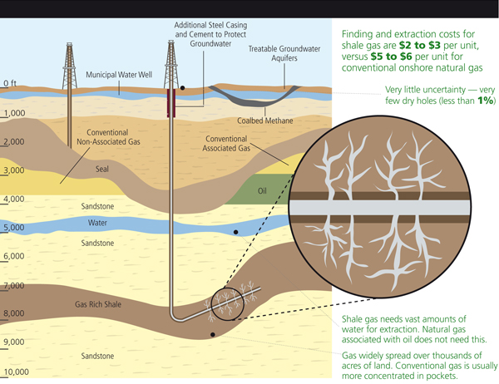
Shale is a dense layer of sedimentary rock that lies a mile or more underground in deposits sprinkled across the country, and around the world. Natural gas or oil trapped in shale formations is known as “shale gas” or “shale oil”, and is chemically identical to gas and oil taken from traditional wells. Geologists have known about shale reserves for years, but until recently they have been too difficult to access. In the last decade, however, industry and government groups have pushed a technology called hydraulic fracturing, or “fracking” which has unlocked enormous quantities of shale oil and gas and set off an environmentalist backlash. Hydrofracking has created jobs, spurred industry, lowered carbon emissions, and provided an economic boon to many communities across the country. Hydrofracking has been commercialized only in North America thus far. Hydrofracking is inherently risky: it uses huge volumes of water requiring regulation in arid states such as Colorado, Texas and California. Shale wells can pollute the air and groundwater. Once hydrofracked each well generates millions of gallons of toxic wastewater which includes secret chemical mixtures and naturally radioactive elements that are difficult to clean and sequester. Oversight of hydrofracking has advanced since 2009 and it has become difficult to ignore the benefits of shale fuels. The scientific consensus holds that natural gas burns more cleanly than coal or oil, and thus reduces greenhouse gases; the economic consensus holds that hydrofracking creates jobs, revenue, and new supplies of energy; and the political consensus holds that natural gas is an effective “bridge fuel” to tide us over until renewable energy sources – such as wind, solar geothermal, and hydropower – have been commercialized. Yet, while the temptations of “fracked” energy are great, critics say that it pollutes the water, ground, and air, and that these costs out-weight its benefits. When exploration first began in New York in the early 2000s residents leased their property for as little as $3 per acre plus a 12.5 percent royalty of 12.5 percent; by 2009, prices had skyrocketed to $6,000 an acre, plus royalties of 20 percent. The United States has abundant natural gas reserves – over 2,203 trillion cubic feet of recoverable reserves, according to the U.S. Energy Information Administration (EIA), a division of the Department of Energy – which some believe could last for 100 years or more. A glut dropped the price of natural gas from nearly $14 per million British Thermal Units (MBTU) to about $4 per MBTU in 2012. American energy companies are cutting back on shale gas production and looking to export gas and fracking technology (Prud’homme ’14: xv, xvi, xviii, 3).

Unconventional gas refers to shale gas, coal bed methane, subterranean coal gasification, or tight gas. Unconventional oil is oil acquired by means other than drilling a traditional borehole in the ground. It includes oil shale, oil sands (tar sands), heavy oil, oil synthetically produced from coal or natural gas, natural gas liquids, and lease condensate (a liquid byproduct of natural gas extraction at the well, or “lease”, site). Thanks to horizontal drilling and hydrofracking, shale oil production has grown to provide 29 percent of total crude oil production in the United States, and 40 percent of total U.S. natural gas production. In a 2013 study of 41 countries EIA raised its estimates of global shale oil and shale gas reserves According to the new report, 10 percent (or some 345 billion barrels) of the world’s recoverable crude oil resources, and 32 percent (or 7,299 trillion cubic feet) of global natural gas resources, are found in shale formations. More than half of the shale oil resources outside the United States are concentrated in four countries: Russia, China, Argentina, and Libya. More than half of the shale gas outside of the United States is found in China, Argentina, Algeria, Canada, and Mexico. For now, the United States and Canada are the only nations producing shale oil and gas in commercial quantities. Shale gas is a natural gas that is trapped in minute deposits embedded in shale rock formations. Shales are fine-grained sedimentary rocks. There are different kinds of shale, but the most common is “black shale”, which formed in deep water and without any form of oxygen present. Shale gas is usually accessed through a combination of vertical and horizontal drilling, and hydrofracking. About 33,000 natural gas wells are drilled in the United States annually, and today nine out of ten of them sue fracking. The recent boom in shale gas has been phenonemonal. As recently as 2000, shale gas provided only 1 percent of the natural gas produced in America. By 2010 it was over 20 percent, and by 2035 the EIA estimates that 46 percent of U.S. natural gas will come from shale gas. Today “Technically recoverable unconventional gas” – which refers to shale gas, tight sands, and coal bed methane – account for 60 percent of America’s onshore reserves. These resources could supply the nation for the next 90 years, or longer (Prud’homme ’14: 19, 20).

Tight gas is natural gas that is trapped in areas of low-porosity silt and sand. Tight gas has less than 10 percent porosity and less than 0.1 millidarcy of permeability. Porosity is the proportion of void space to the total volume of rock. While breach sand has a porosity of about 50 percent, tight gas is trapped in pores up to 20,000 times narrower than a human hair. Permeability is the ability of fluid to move through pore. A person can blow air through rock with 1,000 millidarcies permeability. In certain regions, like the Rocky Mountains, natural gas is mixed with elevated levels of sulfur, which creates the corrosive gas H₂S, or hydrogen sulfide. Known as sour gas, H₂S requires extra processing to purify it. Shale oils are heavy, viscious crude deposits that cannot be produced and refined by conventional methods. Heavy crude oils usually contain high concentrations of sulfur and a number of metals, particularly nickel and vanadium. These properties make them difficult to pump out of the ground or through a pipeline and interfere with refining. These properties also create serious environmental challenges. The best-known reserve of shale oils is Venezuela’s Orinoco heavy oil belt, which contains an estimated 1.2 trillion barrels. Oil shale consists of “tight” (dense) formations of sedimentary rock that are not permeable enough to allow the pumping of the oil trapped inside. This oil is in the form of kerogen, a solid mixture of organic compounds. Extracting oil from kerogen is difficult and expensive, and to date oil shale deposits hae not been widely developed. But there is an estimated 2.8 to 3.3 trillion barrels of oil in oil shale deposits worldwide, 62 percent of which are in the United States. Aside from hydrofracking technology for extracting such oil includes igniting the shale underground, which allows light oil to migrate out of the kerogen to pumping stations (Prud’homme ’14: 19-22).

Tar sands are also known as “oil sands”, are deposits of heavy oil so viscous they do not flow Tar sands are extracted by injecting hot steam into deposits, which heats the sands and makes the tar more liquid so that it can be pumped out. The process requires large amounts of water and energy, is environmentally destructive, and only makes economic sense when oil prices are high. The world’s largest tar sands deposits are in the Athabasca region of Alberta, Canada. If approved the Keystone XL Pipeline would transport oil form the Athabascan fields across the United States to terminals on the Gulf Coast. Coal bed methane is a natural gas extracted from coal beds. It is usually produced by drilling a borehole into a coal seam, reducing the pressure of water flowing through the seam, and allowing the gas held in the seam to flow up the borehole to the surface. Coal gasification is a process used to produce “syngas) (synthesis gas), a fuel mixture of hydrogen, carbon monoxide, and carbon dioxide. Originally used in the eighteenth century to create heat and light, modern gasification plants supply fuel for a wide range of uses. One advantage of gasification is that carbon dioxide (the leading greenhouse gas) and other pollutants can be removed for the gas before it is burned. Yet gasification remains more expensive than coal itself, and while it is used for industrial purposes it has not been widely used as a fuel source yet. Research is ongoing to develop gasification plants that will capture and store carbon dioxide, a process that will raise capital costs but reduce climate-changing emissions, but poses a seismic hazard. Synthetic fuels, or “synfuels” are liquid fuels converted form coal, natural gas, oil shale, or biomass (plant-based fuels, such as wood, sugarcane, or algae). Conversion of coal to synthetic fuel was pioneered in Germany a century ago, and the Nazis greatly expanded the use of synthetic conversion to produce aviation fuel and oil during World War II. There are several methods, primarily the Bergius process, developed in 1913, in which coal is liquefied by mixing it with hydrogen gas and heating it (hydrogenation); the coal is mixed with oil; and catalyst is added to the mixture (Prud’homme ’14: 22, 23).

Natural gas was first extracted from shale rock in Fredonia, New York, in the 1820s by means of conventional drilling. The first fracturing of shallow, hard-rock wells occurred in the 1860s, when prospectors in Pennsylvania, New York, Kentucky, and West Virginia used nitroglycerin (NG) to search for oil in shale formations. Though NG could explode and its use was illegal, the technique was extremely successful. Later, the same methods were employed in water and gas wells. But it was Floyd Farris, of Stanolind Oil and Gas Corporation, which later became Amoco, now part of BP, who conducted experiments in the 1940s and saw the potential of hydraulic fracturing to enhance production from oil and gas wells. The first attempt to “hydrafrac) a well took place in the Hugoton gas field in Grant County, Kansas, in 1947: Stanolind injected 1,000 gallons of gelled gasoline and sand taken from the Arkansas River into a gas-bearing limestone formation 2,400 feet deep. A patent on the process was issued in 1949, and an exclusive license for its use was granted to the Halliburton Oil Well Cementing Company (Howco) of Texas. Howco performed the first two commercial hydraulic (water-based) fracturing treatments, in Stephens County, Oklahoma, and Archer County, Texas. The process was used on 332 wells in 1949 and production increased a surprising 75 percent. At first, crude oil, gasoline, and kerosene were used as fracturing fluids. But in 1953, they were replaced by water. Chemists developed gelling agents to fine-tune the viscosity of fracking fluids, which helped the wells perform more efficiently. A series of advances since then have made the chemistry and engineering of hydrofracking highly sophisticated (Prud’homme ’14: 26-28).

In the 1970s the federal government initiated the Eastern Gas Shales Project and dozens of pilot hydrofracking projects, and supported public-private research. These efforts were spurred by the energy crisis of 1973, when the Arab members of OPEC, the Organization of Petroleum Exporting Countries, imposed an oil embargo to punish the United States for its support of Israel during the Yom Kippur War. It was also spurred by the decline in conventional natural gas production in the United States over the course of that decade. The Ford and Carter administrations prioritized the search for new energy supplies. Industry and federal researchers began to focus on techniques to access “unconventional” resources – coal bed methane, tight sands natural gas, and shale gas. In 1980, a year after the second energy crisis in 1979 caused by the Iranian Revolution, Congress passed the Windfall Profits Tax Act, which created the Section 29 production tax credit for unconventional gas. By providing an incentive of $0.50 per thousand cubic feet of natural gas produced form unconventional resources, the tax credit spurred the growth of shale hydrofracking. In 1997 Mitchell Energy developed “slick-water fracturing”, in which chemicals are added to the water pumped into wells to increase the fluid flow. The chemicals had particular functions – friction reducers, biocides, surfactants and scale inhibitors – to prevent a well from clogging, keep proppants suspended, and accelerate gas pumping. The invention of the slickwater process was the breakthrough that made shale gas economical, and in 1998 Mitchell tapped huge shale gas reserves. As a result of Mitchell’s refinements of fracking techniques, a well that produced 70 barrels a day using conventional (vertical) drilling can now produce 700 barrels a day. And a hydrofracture job that once cost $250,000 to $300,000 now cost about $100,000. Passing this milestone, shale gas became a commercially viable resource. Drilling and hydrofracking techniques continue to evolve and since the 1940s, roughly 1.2 million wells have employed them in the United States By 2009, there were nearly 500,000 active natural gas wells in the United States, double the number in 1990, and the drilling industry reports that about 90 percent of them used hydrofracturing. The Bartnet Shale produces over 6 percent of all domestic natural gas. In 2001, just before the Section 29 production credit expired, George Mitchell sold his company to Devon Energy for $3.5 billion. He died at age 94 in July 2013. (Prud’homme ’14: 27-30).

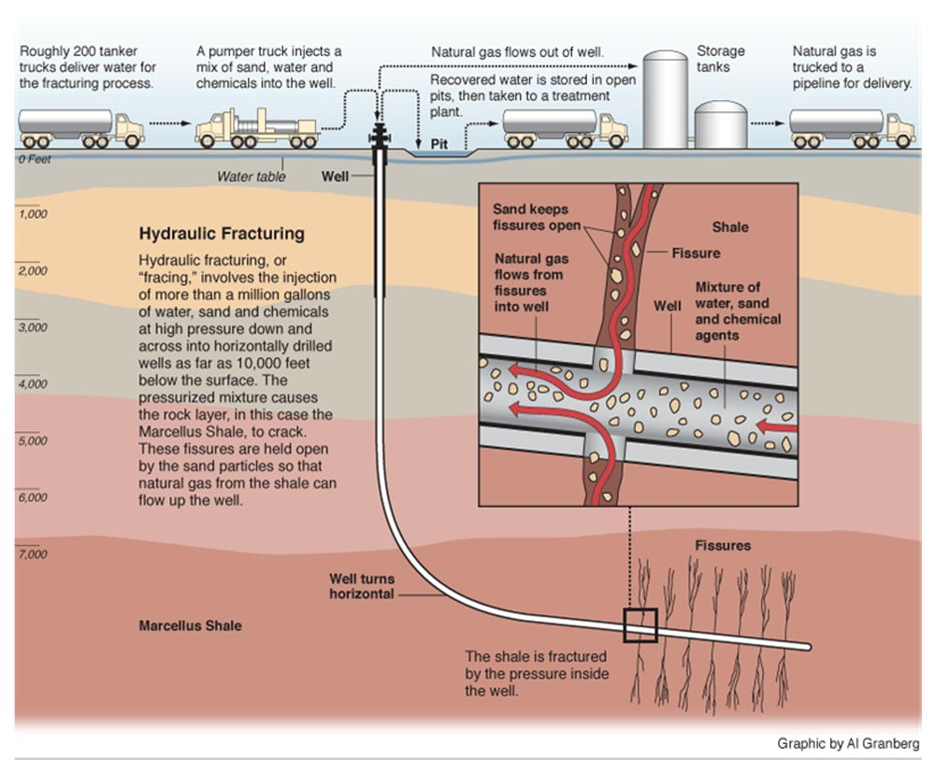

To hydrofracture a well roughnecks rely on tall metal drill rigs that rise up to four stories tall, which lower diamond-tipped drill bits and sections of steel pipe into the borehole. Other equipment includes a slurry blender, high-volume fracturing pumps, a monitoring unit, fracturing tanks, proppant storage and handling units, high-pressure treating iron, a chemical additive unit, low-pressure flexible hoses, and gauges and meters to assess flow rate, fluid density, and treating pressure. Once a drill pad has been built and the equipment is in place, drillers use a series of choreographed steps to hydrofrack an oil or natural gas well. The first step is to drill a vertical borehole into a layer of shale, which typically lies a kilometer (3,280 feet, or 0.62 of a mile) or more beneath the surface. This depth can vary widely, depending on location, geology, stage of drilling, and so on. In the Marcellus Shale, for instance, natural gas wells range from 5,000 to 9,000 feet deep. By comparison most residential water wells lie 200 to 50 feet deep. The second step is to reach that depth and turn the drill bit horizontally and continue drilling, extending the lateral borehole up to a mile or two long. The third step is to line the vertical and horizontal borehole with steel casing, to contain the gas and to protect groundwater from pollution, and cement it in place. The fourth step is to use explosives to perforate holes into the horizontal section of the wall casing. This is done by detonating a small package of ball-bearing like shrapnel with explosives; the shrapnel pierces the pipe with small holes. The fifth step “complete” the process by using powerful pumps to inject “slickwater” fluids – a slurry (a semi liquid mixture of soluble and insoluble matter) consisting of water sand, and chemicals – into the wellbore at extremely high pressure (over 9,000 pounds per square inch). When the pressurized fluid flows through the perforations at the end of the wellbore, it fractures the shale rock in which gas is trapped in tiny bubbles. AS the fluids break open the rock, sand and other “proppants” – materials that hold the fractures open – allow gas to flow out; the chemicals help the natural gas escape the rock and flow up the borehole to the surface. The sixth step is the “flowback” phase, in which pump pressure is released allowing much of the fluid in the well to return to the surface. The seventh step involves cleaning up the borehole and allowing the well to start producing gas. This can take several days. In preparing as well for production ,as many as 25 fracture stages may be used, each of which uses more than 400,000 gallons of water – for a total, in some cases, of over 10 million gallons of water – before a well is fully operational (Prud’homme ’14: 31, 32).

D. Energy and Electricity

Clean, efficient, affordable and reliable energy services are indispensable for global prosperity. Developing countries in particular need to expand access to reliable and modern energy services if they are to reduce poverty and improve the health of their citizens with more affordable water and sewage connections. Worldwide, about 1.5 billion people still lack access to electricity, and around 2.5 billion people rely on traditional biomass, such as dung or wood, for energy. Modern sources of energy include fuels such as natural gas, liquid petroleum gas (LPG), diesel and biofuels such as biodiesel and bioethanol. Technology, such as improved cooking stoves, can also enable cleaner and more efficient delivery of traditional fuels. Currently most power sector investment is made by government-owned or private, usually regulated, electric utilities. The $20 trillion projected to be spent between 2004 and 2030 to meet energy demand could lock the world on to an unsustainable trajectory. Ten percent of this, $200 – 210 billion will be necessary in 2030 to return global greenhouse gas (GHG) emissions to current levels, 0.3 to 0.5% of global domestic product in 2030 and 1.1 - 1.7% of global investment in 2030. About $148 billion out of the $432 billion of projected annual investment in power sector is predicted to be shifted to renewables, carbon dioxide (CO₂) capture and storage (CCS), nuclear energy, wind, hydro and solar power. Raising fuel efficiency standards by 20 miles per gallon would cut oil consumption by 3.5 million barrels a day and save 400 Mt CO2 emissions a year. Carbon Capture and Storage (CSS) is holds out the promise of coal-fired power generation with near-zero emissions. For energy efficiency it is estimated $30-35 billion of capital is required for low-income countries and $140-170 billion for middle-income countries annually until 2030. Implementation can be done with great speed and intensity: In the early 90s, China was electrifying over 30 villages a day Viet Nam granted almost 400 people access to electricity per hour for 15 years, South Africa made a new grid connection every 30 seconds, placed a pole in the correct position every 10 seconds and strung 200m of cable every minute If recent national trends in energy access continue, over the next 20 years an estimated 400 million people will gain access to electricity (Sanders ’10) . Electricity and energy are not part of the millennium development goals but are probably the most significant indicator or industrialization.

Top 10 National Electricity Producers

 | Nation | kWh
1 | China | 5,398,000,000,000 (2013)
2 | United States | 4,099,000,000,000 (2011)
3 | European Union | 3,255,000,000,000 (2011)
4 | Russia | 1,057,000,000,000 (2013)
5 | Japan | 936,200,000.000 (2012)
6 | India | 871,000,000,000 (2012)
7 | Canada | 618,900,000,000 (2011)
8 | France | 561,200,000,000 (2012)
9 | Brazil | 530,700,000,000 (2011)
10 | Germany | 526,600,000,000 (2012)
Source: CIA World Factbook

Total energy consumption in 2008 by the global population of seven billion was 493 quadrillion BTUs or 493,000,000,000,000,000 BTUs. As the global population expands to nine billion by 2040, the demand for affordable reliable plentiful energy supplies will increase exponentially. Electricity consumption in the United States totaled nearly 3,883 billion kilowatthours (kWh) in 2011, more than 13 times greater than electricity use in 1950. The United States has long held the title for the world’s largest economy and has been as well its foremost energy use. With less than 5 percent of the world’s population, the United States consumes 20 to 25 percent of the world’s supply of fossil fuels. But in 2010 China surpassed the United States to become the globe’s biggest energy consumer: the United States uses 19 percent of the world’s energy, and China accounts for 20.3 percent of global energy use. By 2016, the International Monetary Fund (IMF) forecasts, China will eclipse the United States as the world’s leading economy. Residential and commercial buildings account for 40 percent of America’s total energy consumption, in the form of electricity or gas, making up over half the country’s demand for gas (Prud’homme’ ’14: 25, 60).

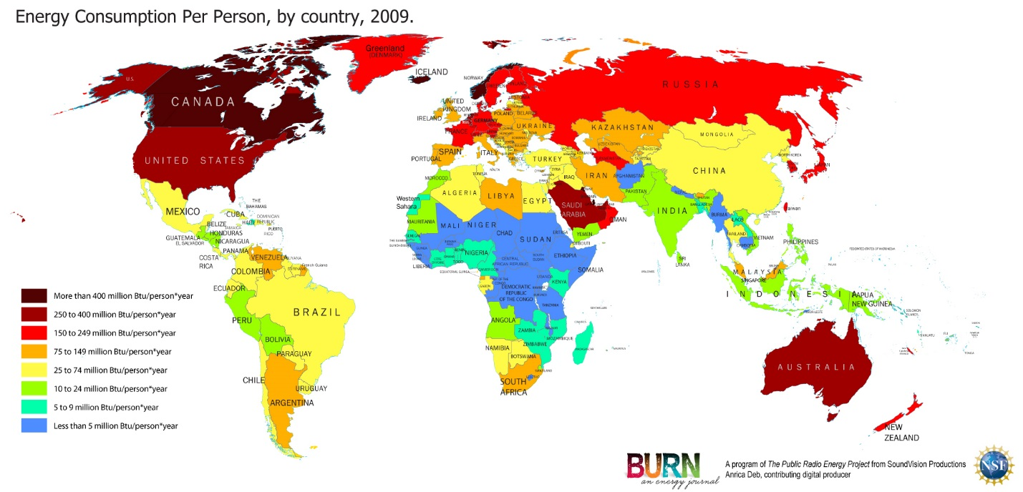

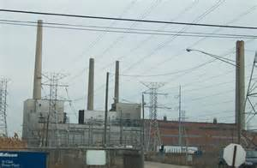
Most electricity in the United States is produced in “conventional” fossil fuel power plants. A fuel is burned to boil water to make steam. The force of steam is what drives the turbine generator. While some plants burn petroleum, or more frequently, natural gas the fuel most used for electricity generation in the U.S. is coal. A 1,000 MW coal-fired power plant burns about 10,000 tons of coal a day, providing electricity to about one million people. Natural gas was the preferred fuel for new power plants in the 1990s. Recent advance in the design of gas turbines mean much greater efficiency and far less pollution. Since about 1985, most new natural gas power plants have been “combined cycle” plants, in which two turbine types work together to produce electricity. First the gas turbine produces electricity using the hot exhaust from the combustion reaction. Then that same extremely hot exhaust is used to boil water to produce steam in a conventional boiler. The steam spins a second turbine that generates even more electricity. Since combined cycle systems produce extra electricity by using what would otherwise be wasted heat, they are exceptionally energy efficient. Coal plants and natural gas power plants are typically large, generating 300 to 1000 MW of electricity or more. Natural gas microturbines of 25 to 500 kW can also be used in small businesses and as standby or peaking power. Coal, oil and natural gas are easy to transport. Fossil fuels have the advantage of a long history. Forecasts differ for how long world oil and natural gas supplies will last at projected rates of consumption. Fossil fuels create air pollution when burned. In the United States regulations require that most fossil-fuel power plants equip their smokestacks with scrubbers. Natural gas has fewer impurities than coal or petroleum and burns cleaner than other fossil fuels. Most of the power plants built in the U.S. in the last 20 years have been natural gas. Over half of all electricity used in the United States is produced from coal. The United States gets almost 70 percent of its electricity from fossil fuels. Worldwide about 65 percent of the electricity produced globally comes from fossil fuels. Russia, the United States, and Canada produce the most natural gas. The countries of the Middle East, the United States and Russia produce the most oil. China, the United States, Australia, India and South Africa produce the most coal (Nemzer ’10: 120-123).

At the moment most electricity is supplied by large, central power stations that feed electricity into a national power grid. Often the fossil fuels are imported. These power stations cause more pollution and are less efficient than some of the newer energy sources (Morgan ’03: 57). Electric power grids have been in place as long as telephone systems, but advances for electricity have come more slowly. New intelligent two way tracking systems can share information about electricity flow among power providers, grid operators and consumers. This conserves grid space and improves use of generation capacity. A smart grid will be able, in the future, to send power to and from advanced storage devices, which can include electric fuel cell cars. Large size can be a disadvantage for grid. Distance brings power loss. Disruptions, whether by bottleneck or malfunction, can cause widespread effects, even brownouts or blackouts. An alternative is to use microgrids, small and operated locally. A microgrid can be linked with other grids for shared power, or it can be “islanded” for protection from others’ disruptions. Another important use is in remote areas with no nearby large grid. Distribution generation (DG) avoids the long distance transmission line power losses – which can be as high as 15 percent. The first DG photovoltaic and wind systems were installed in remote off-grid locations. DG is also now supplied to the grid by small power plants built to serve particular large businesses, or sited near the end of distribution lines It can also be useful as back-up power or hospitals, television stations, internet servers or other critical facilities. These mini power plants can be energy-efficient natural gas micro-turbines, small hydropower plants, modular binary geothermal units, photovoltaics, landfill gas, wind turbines, or banks of fuel cells. Before the 1970s most of the electricity in the U.S. came from large centralized power plants owned by huge utilities regulated directly by government agencies. Federal laws were passed in 1978 requiring certain utilities to use electricity from independent producers. More than half of new electric generation in the U.S. now comes from these independent power producers (Nemzer ’10: 148-150).

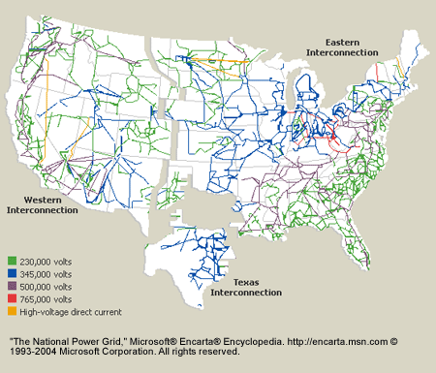

Electricity is not considered radioactive, but it poses a serious workplace hazard, highly associated with radioactivity. Electricity exposes employees to electric shock, electrocution, burns, fires, and explosions. In 1999, for example, 278 workers died from electrocutions at work, accounting for almost 5 percent of all on-the-job fatalities that year. OSHA's electrical safety standards for electric power generation, transmission and distribution are published at 29CFR§1910.269 and for the electricity in general are published in Chapter 17 of Title 29 of CFR, Part 1910.302 through 1910.308 -- Design Safety Standards for Electrical Systems. Shipyard standards cover limited electrical safety work practices in 29CFR§1915.181. Pure water is a poor conductor. But small amounts of impurities in water like salt, acid, solvents, or other materials can turn water itself and substances that generally act as insulators into conductors or better conductors. Dry wood, for example, generally slows or stops the flow of electricity. But when saturated with water, wood turns into a conductor. The same is true of human skin. Dry skin has a fairly high resistance to electric current. But when skin is moist or wet, it acts as a conductor. This means that anyone working with electricity in a damp or wet environment needs to exercise extra caution to prevent electrical hazards. An electric shock can result in anything from a slight tingling sensation to immediate cardiac arrest. Burns are the most common shock-related injury. The longer the exposure, the greater the risk of serious injury. If a person is "frozen" to a live electrical contact, shut off the current immediately. If this is not possible, use boards, poles, or sticks made of wood or any other nonconducting materials and safely push or pull the person away from the contact (Chao & Henshaw ’02).

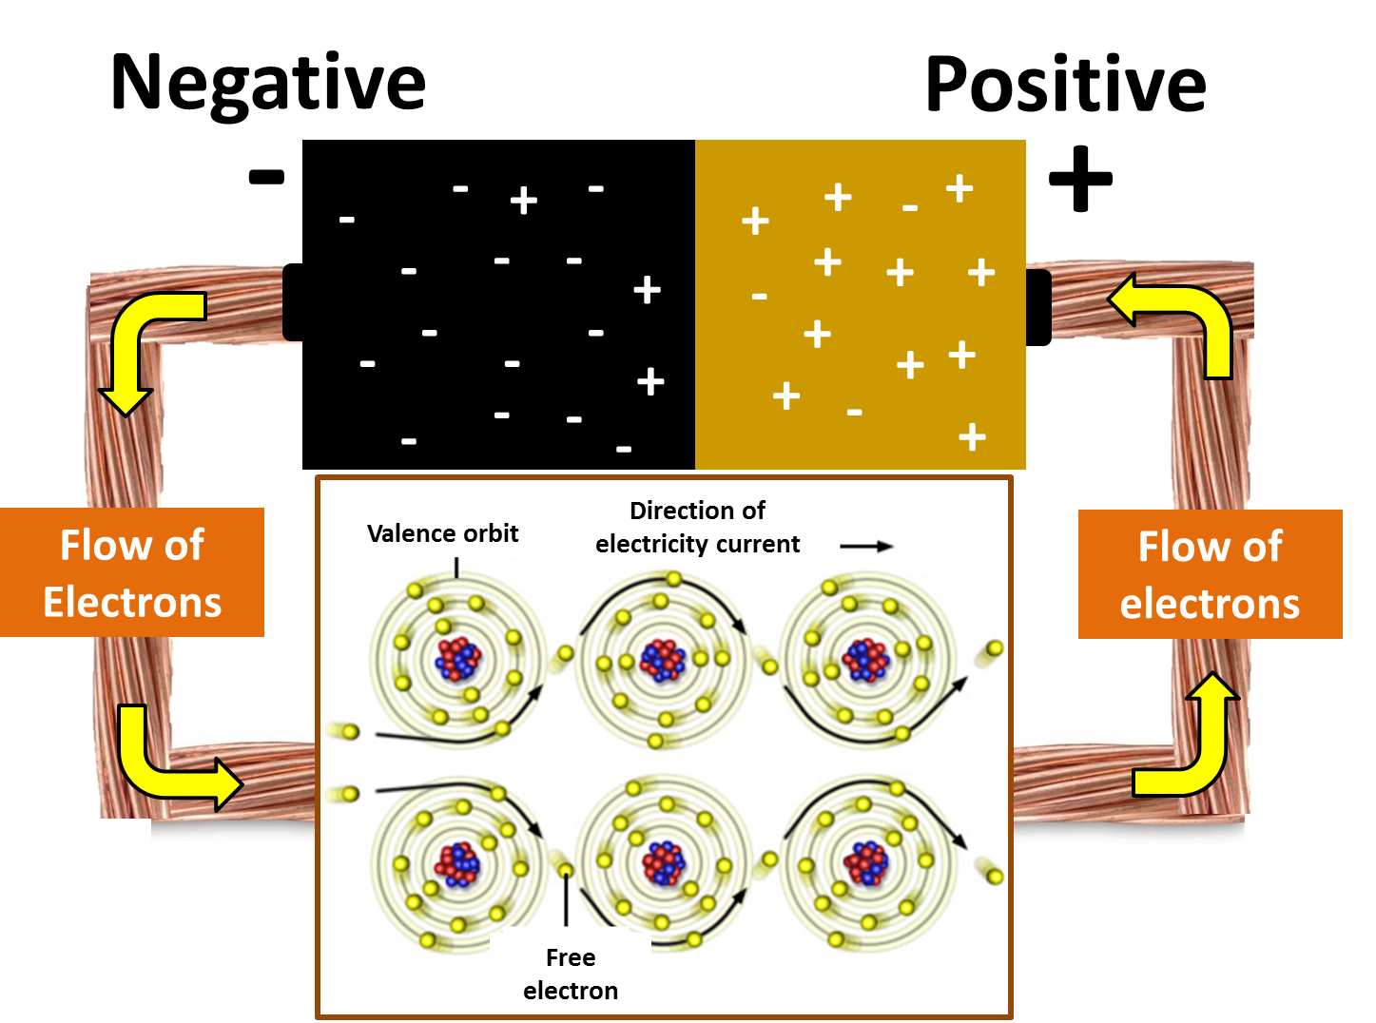
Certain kinds of atoms have electrons that are loosely held. The electrons can be attracted to move from one atom to another. The movement of these electrons over time cause an electric current (electricity). Electricity needs a pathway to follow, called a complete circuit. The electrons flow from negative to positive along this pathway. Some types of metal wire allow electrons to flow from atom to atom more freely than other types. These are good electricity conductors because they have less resistance to the flow of electrons. Copper wire has low resistance and so it is commonly used for electrical wiring. Electricity is known as an energy carrier; the electrons carry energy in a useable form from one place to another. Electricity is sent, or transmitted, from power plants along power lines. Power lines include high-voltage transmission lines and a complex system of small distribution lines serving communities. The power grid distributes electricity from power plants to substations and transformers. Before electricity leaves the power plant, a transformer increases, or steps up, its voltage. Increased voltage improves efficiency over long distances. For safety, high-voltage transmission lines are installed on tall towers or underground. You may have been close enough to one of these to hear the crackle of high voltage electricity in the wires. As the electricity nears its destination, it goes through a substation where the voltage is lowered, or stepped down for distribution. But the voltage is still too high to be used directly. Before entering a building, the current goes through another smaller transformer to drop the voltage again. These small transformers are often mounted high on a utility pole ear the building. Some of us can go outside and see these small transformers, which, in the U.S., normally change the voltage rom several thousand volts to 120 and 240 volts. The lines also pass through a watt-hour meter, usually located on the outside of the building, in kilowatt-hours (Nemzer ’10: 30, 31).
Electrons traveling along a wire can be compared to water molecules flowing through a pipe. Voltage (expressed in volts, named after the scientist Alessandro Volta) is what pushes the electrons, like pressure pushes the water. Voltage is the force with which a source of electric current, such as a generator or battery, moves electrons. At power plants, electricity is usually generated at around 20,000 volts. By comparison, the light bulb in your desk lamp operates at 120 volts. Current is the rate of flow of electric charge. It is the number of electrons flowing past a given point per unit of time (usually one second). The amount of current flowing in a wire is expressed as amperes, or amps (named after Andre Marie Ampere). An ampere is equal to about 6.25 x 10¹⁸ electrons per second. A watt (W) is a unit of power (named after James Watt). It is the rate at which work is performed. One watt is the rate of current flow when on ampere is “pushed”. One watt is needed by a typical string of Christmas lights. A kilowatt (kW) is 1,000 watts, the average amount used by homes in the U.S. One megawatt (MW) is 1,000 kilowatts (1 million watts). In the U.S., 1 MW serves approximately 1,000 homes. The electricity industry also uses the terms watt-hour (Wh) and kilowatt-hour (kWh) to measure electricity use, A watt-hour is the amount of electricity used in one hour by a device that requires on watt of power to operate. A kilowatt-hour is 1,000 watt hours. For example, a 100 watt light bulb that is left on for one hour will use 100 watt-hours of electricity. If left on for ten hours, the same bulb will 1,000 watt hours, or one kilowatt-hour (Nemzer ’10: 30).
Gas burns more cleanly and efficiently than coal. It releases half as much carbon dioxide and more than 1,000 times less sulphur dioxide per unit of energy. The heat released from burning fossil fuels is used to boil water, which produces steam. The steam is heated to very high temperatures so that it is at high pressure and can tur huge steam turbines. Some of the energy of the steam is transformed into movement, or kinetic energy, as the turbines spin. The turbines are connected to the coils of large generators. The coils carry a current and act as electromagnets. As the turbines spin, they produce an electric current in the fixed coils surrounding them. This is fed into a power supply grid and carried to wherever it is needed. Power stations cannot store surplus electricity, so electricity generation has to match demand. If power companies estimates are wrong, people may experience power cuts. Between 50 and 70 percent of the energy contained in fossil fuels is wasted. Some of the heat energy heats the surrounding air and escapes through the boiler chimneys. Not all the heat energy locked in the stream can be transferred to the spinning turbines. Although the steam is cooler when it leaves than when it enters the turbines, it is still warm. The steam is carried to the cooling towers, where it cools sufficiently to condense back into water. The warm water is then emptied into a nearby river or sea, where it can cause thermal, or heat, pollution. Warm water holds less oxygen than cold water. The addition of a large quantity of warm water can cause animals such as fish to suffocate, as they are unable to extract enough oxygen from the water. Burning fossil fuels releases carbon dioxide. Carbon dioxide is described as a greenhouse gas because it traps heat in the atmosphere. The presence of some greenhouse gases keeps Earth at a temperature of approximately 59°F (15°C), which allows life to survive. A recent increase in the use of fossil fuels has caused the levels of carbon dioxide in the atmosphere to increase, too. More carbon dioxide means that more heat is trapped, and this has caused the average global temperature to rise (Morgan ’03: 12, 13, 9).
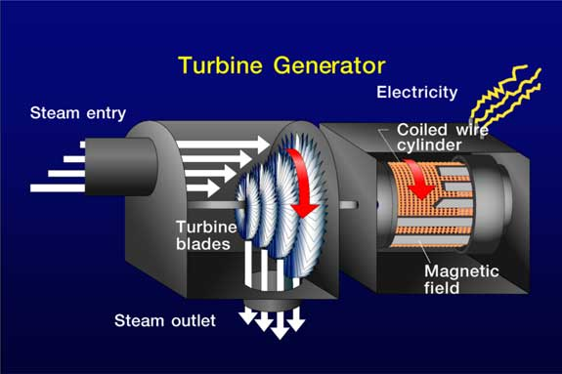

Each of the three main fossil fuels used for electricity generation produces different types of pollutants when burned. Coal puts out the most pollutants: carbon dioxide; particulates such as soot and ash, sulfur and nitrogen gases; unburned hydrocarbons; carbon monoxide; and even small amounts of mercury and radioactive materials. Natural gas mainly produces carbon dioxide and nitrogen oxides. Burning oil results in many of the gases as coal, but not so many of the particulates. The American Lung Association estimates the cost of air pollution, in terms of medical care and days lost at work, to be billions of dollars annually. Acid precipitation, commonly called acid rain, results when sulfur oxides and nitrogen oxides in the air combine with water vapor to form sulfuric and nitric acids. These acids fall back to the earth in many forms, including rain, snow, fog, or even dry particles. Tall smokestacks on fossil-fuel power plants might seem to help local pollution by dispersing it, but they actually end up putting pollutants higher in the atmosphere, where winds can carry them far away to other communities. Wherever acid precipitation falls, it damages and destroys crops and plant life on land and in water. It can also harm or destroy animal life in these natural habitats. There are two main types of smog or haze. Photochemical smog forms when sunlight reacts with pollutants such as nitrogen oxides and hydrocarbons in the air. This type of smog (an unsightly brown color) can cause lung damage, aggravate asthma and emphysema symptoms and harm vegetation. What we call regional haze from sulfate and nitrate particles) scatters and absorbs sunlight, making a clear day smoggy. Regional haze contributes to lung ailments and affects tourism. Greenhouse gases (mainly water vapor, carbon dioxide, methane, and ozone) and particulates in the atmosphere absorb some of the reflected heat and emit some of it back to the planet’s surface. Without the greenhouse effect, the planet would be a cold and lifeless place, but industrial emissions are altering this balance causing what scientists hypothesize is global warming. Pollution from electric power plants can be reduced by requiring the installation pollution control equipment (Nemzer ’10: 136-138).

Until 1880, wood was the principal fuel used in the United States. From 1880 to about 1945, coal was the largest single energy source. Since that time, petroleum (oil and gas) has been the most important energy source, and now constitutes about 65 percent of US energy. The amount of coal far exceeds the energy in the world’s oil and gas. It was the major fuel in the recent industrial past and may be again. Russia appears to hold the largest coal deposits, but the U.S. may have the most economically recoverable coal. China is third in amount of coal resources with western Europe fourth. In China coal is the principle fuel in use. Nuclear energy can be derived from fission or fusion. In fission, the source is uranium, or it could be thorium, both of which are moderately abundant in the U.S., Canada, South Africa, Namibia, and Australia. Weight for weight, uranium has more recoverable energy. One short ton of uranium-235 produces heat equivalent of 22 billion kilowatt hours, approximately the heat equivalent of three billion tons of coal. Fusion, as occurs in the sun, involves the fusion of two isotopes from hydrogen, deuterium, or tritium. Deuterium exists in great quantities in ordinary water, and tritium can be produced in an atomic reactor with lithium, but so far fusion on a commercial scale has eluded scientists. In the U.S. 17 percent of electric power is nuclear in origin.

Far more energy and mineral resources have been used in the world since 1900, than during all previous time. In the case of oil, the first 200 billion barrels of oil in the world were consumed between 1859 and 1968; but it took only the following 10 years to consume the second 200 billion barrels. Currently in the United States about 25 percent of energy produced is used to produce other energy, ie, to drill for oil, mine coal, mine uranium, cut wood, make solar energy conversion devices, and so on, and the cost was estimated to rise to 33 percent by 2000. In industrialized nations petroleum is the major power source. France gets 70 percent of its electricity from nuclear plants, whereas New Zealand has no atomic power, but, instead chiefly relies on hydropower and geothermal energy to generate its electricity. In the United States the energy use is: oil 44 percent, coal 22 percent, natural gas 21 percent, nuclear power 5 percent, hydroelectric power 4 percent, and other (wind, solar, geothermal, wood) 4 percent. In 1984 nuclear power production surpassed hydroelectric power in the United States. Kuwait took over Gulf Oil properties of the Arabian American Oil Company. With the departure of the Shah Iran took over all foreign interests. Peru nationalized (without compensation) the International Petroleum Company, Ltd., an affiliate of what is now Exxon. Creole Petroleum, in Venezuela, also an Exxon affiliate, was nationalized (Youngquist ’88: 230, 228, 231,235, 236, 46, 228).

Geothermal energy was first used to light a lightbulb in 1905. Geothermal energy is heat from the Earth, mostly from radioactivity. These areas tend to occur at plate margins and hot spots usually in regions with active volcanoes. Volcanoes and petroleum do not co-exist well, so areas with volcanoes tend to have little petroleum. Geothermal energy can be used in two ways. It can be used directly for space heating (pipe hot water from wells and run it through radiators and heat exchangers), or it can be converted to electricity. Only the hotter geothermal reservoirs (above 360 degrees Fahrenheit) can be efficiently used to produce electric power, the lower temperature waters can be used in space heating. 60% of Iceland is heated with geothermal space heating. The world’s largest geothermal plants are at the Geysers about 70 miles north of San Francisco since 1960, now some 2,000 megawatts is being generated, enough for the energy needs of about two million people. Klammath Falls, Oregon and Boise, Idaho are largely geothermally heated. Some 15,000 square miles of solar cells could provide all the United States currently needs. So far the cost of solar electric power is more than generated by conventional means. Photovoltaic cells produce electricity directly from sunlight. The most efficient cells cost much more than less efficient cells. In 1988 solar cells produce electricity at a cost of from 30 to 40 cents per kilowatt hour, however new generation thin film cells may bring costs down to 15 cents a kilowatt hour (Youngquist ’88: 154, 157, 163, 165, 167, 177).

One of the main justifications for promoting natural gas is that power plants fueled by gas emit about half the climate-changing gases that coal-fired plants do. Between 2007 and 2012 the United States reduced its greenhouse gas emissions by 450 million tons, the biggest drop of any nation in the world. In 2000 coal powered 52 percent of U.S. electric generation, natural gas provided 16 percent, and renewables were only 9 percent. By 2012 coal has plummeted to 38 percent, gas had jumped to 30 percent, and renewables had risen to 12 percent. There has been a nearly 70 percent reduction in sulfur dioxide and smog-forming nitrogen oxide over the past 20 years, thanks to growing use of natural gas among the nation’s top 100 utilities. Nearly half the reduction came in just a two-year period from 2008 to 2010. U.S. carbon emission from the power sector are at 20-year lows. The European Union, by contrast, has seen its greenhouse gas emissions rise over the same timeframe, despite a more concerted effort to tackle global warming than the United States has made, due to the EU’s increased reliance on coal for generating power. However, methane is the main component of natural gas, and it has a notoriously potent greenhouse effect, with a global warming potential 72 times higher than carbon dioxide – the leading greenhouse gas – over a 20-year period, and 20 times greater over a 100 year period. Natural gas operations represent the leading source of methane leaks in the United States, accounting for 145 metric tons in 2011. The second-largest source of methane was “enteric fermentation” aka gas emitted by cows and other animals, at 137 metric tons. The third-largest source were landfills, which emitted 103 metric tons. Yet the EPA estimates that all sources of methane combine represent just 9 percent of greenhouse gases. The EPA found that tighter pollution controls had resulted in an average decrease of 41.6 million metric tons of methane annually between 1990 and 2010, or over 850 million metric tons in total, a twenty percent reduction from the agency’s previous estimates (Prud’homme ’14: 67, 68).

Electricity generation is a significant source of air emissions in the United States today. Fossil fuel-fired power plants are responsible for 70 percent of the nation's sulfur dioxide emissions, 13 percent of nitrogen oxide emissions, and 40 percent of carbon dioxide emissions from the combustion of fossil fuels. Coal accounts for about 50 per cent of electricity production in the US, and, it remains the lowest cost energy source for US residences. However, coal-fired plants do emit carbon dioxide (CO₂), a greenhouse gas (GHG) into the atmosphere. 'Clean coal technology' describes a new generation of energy processes, some currently available and others being developed, which have the ability to sharply reduce air emissions and other pollutants. Recognizing that carbon sequestration and storage (CCS) technologies hold enormous potential to reduce GHG emissions from coal-fired power plants, DOE has begun funding projects that use CCS technologies and/or beneficial reuse of carbon dioxide. The United States is eager to demonstrate carbon capture and storage technology on commercial plants that when operational, will be the cleanest coal-fired plants in the world. Circulating fluidised-bed (CFB) technology is an existing available technology, already being used to burn coal and other fuels to produce energy in a clean, environmentally responsible way. CFB is a clean coal combustion platform with a unique low temperature combustion process that can burn both traditional fuels and carbon-neutral fuels, including biomass, waste coals, tires, and processed waste materials. The technology can be used to significantly reduce CO₂ emissions to the atmosphere.

Gasification is a manufacturing process that converts any material containing carbon, including coal, into synthesis gas (also known as syngas). The syngas can be burned to produce electricity. Research is being conducted on Integrated Gasification Combined-Cycle (IGCC) systems, in which the syngas is burned as fuel in a combustion turbine, which drives an electric generator. Exhaust heat from the combustion turbine is recovered and used to boil water, creating steam for a steam turbine-generator. The use of these two types of turbines together (combined cycle) is one reason why gasification-based power systems can achieve high power generation efficiencies. Research suggests that future IGCC systems may achieve efficiencies approaching 45 per cent, and the goal is to achieve efficiencies as high as 60 per cent. By comparison, a conventional coal-based boiler plant that uses only a steam turbine-generator is typically limited to efficiencies of 33-40 per cent, although it may achieve 45 per cent or better under some conditions. Higher efficiencies mean that less fuel is used to generate the rated power, resulting in lower costs and the formation of fewer greenhouse gases. For example, a 60 percent-efficient gasification power plant could cut the formation of carbon dioxide by 40 per cent, compared to a typical coal combustion plant. Carbon capture and storage (CCS) means separation and capture of CO₂ from fossil fuel-fired power plants and the recovery of a concentrated stream of that CO₂ that can be transported by pipeline and stored, in either an underground formation, or the sea bed. Most research efforts are focused on systems for capturing CO₂ from coal-fired power plants because they are the largest stationary sources of CO₂ (Giglio ’13).

A carbon footprint is the sum or our primary and secondary footprints. Our primary footprint is a measure of direct emissions of carbon (CO₂) when fossil fuels are burned for the energy needed to heat our building to make electricity for the lights and electrical appliances we used every day, and for the cars, buses, trains and airplanes we used for transportation. The secondary footprint is a measure of the indirect CO₂ emissions created during the life cycle of products we buy and use, from the manufacturing process to disposal and breakdown. Most people agree the earth’s atmosphere has been warming since the 1800s. The earth’s average surface temperatures have set new record highs in recent years. The main cause of the current warming trend is thought to be an increase of carbon dioxide and other greenhouse gases, such as methane, in the atmosphere. Experts agree that the burning of fossil fuels for transportation and electricity production is the primary cause. The amount of carbon dioxide in the atmosphere has risen dramatically since the 1850s, when we began to burn fossil fuels in larger and larger quantities. The United States has historically released the greatest share of carbon dioxide to the atmosphere each year – one fourth of all the CO₂ produced in the world, though it has only 4-5 percent of the world’s population. In recent years, however, China has been producing more than the U.S. Along the Antarctic Peninsula, major ice shelves are starting to break up. In the Arctic, sea ice covers less of the ocean than it did 20 years ago, and the ice has thinned. Greenland’s ice cap, the second largest ice sheet in the world, is melting, and in Alaska, glaciers are retreating. Higher sea surface temperatures have been affecting almost all species of corals and 25 percent have died. The planet has a natural carbon cycle. Plants use carbon during photosynthesis, removing carbon dioxide form the atmosphere. Old-growth forests are excellent sinks, with their mature trees, other vegetation, and their rich forest floor litter (duff). The oceans are the world’s greatest carbon sinks. Carbon dioxide dissolves in ocean water. Tiny ocean-dwelling organisms use it to build their shells or skeletons, and so take the carbon with them when they die and fall to the ocean floor. Limestone, a sedimentary rock (primarily calcium carbonate) is formed on ocean floors form the shells and skeletons of these organisms (Nemzer ’10: 138-141).

A widely used program to promote cleaner energy uses renewable energy certificates (RECs) also known as tradeable renewable energy credits (TRECs) or “green tags”. When a utility or customer buys RECs, the purchase price goes to the construction of renewable power facilities, either locally or at a distance. Most states are adopting standards for the minimum amount of renewable energy that must be included in the utilities portfolio of electricity resources. As of 2010 more than half of the states have enacted laws to specify that a portion of their electricity must come from renewable energy. Under community choice aggregation (CCA a local agency buys power from the producer it chooses, and the area’s utility is required to deliver it for regulated charge. In Ohio, for example, 200 small towns aggregated their power purchases and cut harmful emissions by an estimated 50 percent. Many countries in Europe and several U.S. states are implementing a “feed-in tariff” policy. Under a feed-in tariff program, a utility must buy all renewable power offered at a price set by a governing agency. In some cases, even if the utility has to shut down fossil fuel plants in order to take the renewable power, they must do so or pay a penalty. This helps keep costs down by avoiding expensive bidding competition and gets more renewable electricity into the grid. Government assistance has had a large influence on growth in U.S. energy production. Sometimes the assistance takes the form of research and development funds such as U.S Department of Energy (DOE) programs to promote cleaner coal, safer nuclear technology and more efficient renewable production. Other assistance has been in the form of tax benefits; an example is the Production Tax Credit, which has assisted renewable energy developers. In 2009 assistance to energy development was taken to a new level by the American Recovery and Reinvestment Act (ARRA). ARRA provides a temporary 30 percent tax credit for developers of specified renewable energy technologies and for those developers who don’t owe much tax, ARRA provides that completion of a qualifying project the U.S. Treasury will pay cash in the amount of the credit. Industrial tax benefits are controversial (Nemzer ’10: 154-155).

In September 2000, people in Britain protested the high price of fuel and the tax on gas by blocking oil refineries and storage depots. Gasoline tanker drivers were reluctant to break the blockade so the British public experienced oil shortages. More than three-quarter of the energy used in industrialized countries comes from oil, gas, and coal. These fuels are rich in carbon and hydrogen. They burn in air to form carbon dioxide and water, a process that releases heat energy. Fossil fuels produce a number of pollutants when they are burned, in addition to carbon dioxide and water. Coal often contains sulphur, which is released as sulphur dioxide. Sulphur dioxide is one of the chemicals that cause acid rain. When gasoline and diesel fuels are burned in engines, gases such as nitrous oxide and carbon monoxide are released. The gases and particles from car exhaust can create photochemical smog resulting in a smoggy haze over the city. Los Angeles has suffered badly in the past from smog. The smog was due in part to the exhaust fumes from millions of cars, but the local geography also played a role. The city lies by the coast and is surrounded by mountains. Coal-fired power stations release sulphur dioxide, especially those that burn lignite coal. This gas, together with nitrous oxides from vehicle exhausts, reacts with water in the air to form weak acids. These acids create acid rain. Acid rain has a lower pH than normal. It erodes and damages the outsides of buildings and statues, especially those made of limestone. Acid rain falling on conifer forests in mountainous areas of Scandinavia, North America, and central Europe has caused long-term damage to the trees. The soil becomes more acidic, and this causes toxic compounds such as aluminum to be released. The first signs of damage are a tree’s needles turning brown and whole branches dying. Increased acidity in the soil damages tree’s roots, and this reduces their ability to take up water and nutrients. The trees become more vulnerable to frost and disease. Eventually, they die. Lakes are also at risk. The acidic rainwater drains off soils into the lake, causing it to become more acid. Aluminum in the water causes the gills of fish to produce more mucus, and this prevents them from obtaining sufficient oxygen from the water. In extreme cases, all life in the water may die (Morgan ’03: 5, 8, 9).

Electricity is usually generated at a level that meets demand, as it is difficult to store surplus energy. Batteries and fuel cells both produce electricity by using electrochemical reactions. Flywheels store energy as they spin. A convenient store of energy is the electric cell or battery. The most common form of battery contains carbon and zinc separated by a solution of ammonium chloride. When the battery is connected to an electrical circuit, its stored chemical energy is changed into electrical energy. The battery continues to produce an electric current until all the chemicals have reacted with each other. Then, the battery is said to be flat. Batteries containing nickel and cadmium (Nicads) can be recharged by passing a small electric current through the battery for several hours. Space stations use photovoltaic panels and fuel cells as their source of energy. This energy is stored in batteries. These batteries are large and expensive and have to be replaced every five years. New space stations and satellites may use flywheels to store the energy. These can last up to twenty years. Flywheels are used in engines, but now scientists are designing even more efficient types of flywheels. When energy is used to spin a flywheel, the energy is converted into kinetic energy. The flywheel stores the energy mechanically in the form of kinetic energy. The fast the flywheel spins, the more energy it stores. This kinetic energy can be converted to electricity. New flywheels will be just 5.9 inches (15 centimeters) across and will be made of extremely strong yet lightweight materials. They will spin up to 600,000 times each minute and will store eight times more energy than a battery of the same mass (Morgan ’03: 14, 15).

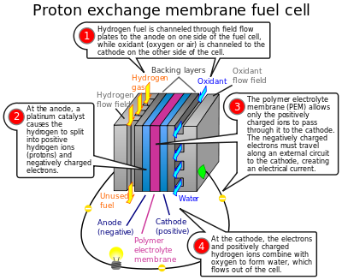
Fuel cells can be used as an alternative, from powering cell phones and laptops to generating electricity on a commercial scale. Potentially, fuel cells could replace every battery and combustion engine in the world. At the moment, fuel cells are expensive, costing thousands of dollars per kilowatt of power, compared with $44 per thousands of dollars per kilowatt of power, compared with $4 per kilowatt for a car engine and $585 per kilowatt for a gas turbine power plant (Morgan ’03: 56). In a fuel cell, hydrogen is introduced into the anode side and oxygen into the cathode side. Electrons are stripped from the hydrogen atoms and flow as an electric current. At the cathode end of the fuel cell the hydrogen joins with the oxygen, resulting in water and heat. Around the country, many cities, utilities, hospitals and industrial facilities are exploring the potential for fuel cells in electricity generation. One example is a fuel cell that runs on hydrogen converted from methane, which was installed in a coal mine in Ohio to reduce dangerous coal mine methane emissions, while it provides electricity for miners. At a wastewater treatment facility in Portland, Oregon, fuel cells using hydrogen produced from waste gas provide back-up power for plant operators. In New York, the Central Park Police Station runs on fuel cell power. Iceland, already a leader in the use of hydropower and geothermal energy, is promoting the use of hydrogen to displace the 30 percent of its energy that comes from imported oil. India is using fuel cells to meet exploding demand for cell phones. Hydrogen is a transportable fuel. If hydrogen escapes from its container, it rapidly disperses into the air rather than puddling on the ground. Hydrogen burns easily and invisibly, so care is needed. With proper precautions, hydrogen is thought to be just as safe as gasoline. Hydrogen burns cleanly, though it does produce some emissions. Used in a fuel cell, the only by-products are heat and water. Hydrogen has about three times the energy of gasoline by weight, yet only one third as much energy by volume (Nemzer ’10: 110-113).

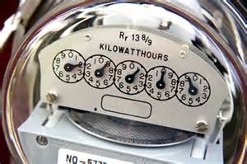
The biggest uses of energy in an average American home are for heating and cooling. These represent about 44 percent of energy used. Refrigerators consume almost 10 percent, and lighting, cooking and other appliances use approximately 33 percent. Water heaters use up most of the rest. Buying appliances that are energy efficient is one way to reduce energy waste. Energy saving strategies include turning up the thermostat a few degrees in summer (if using air conditioning) and down a few notches in winter; changing furnace filters frequently, using shades or curtains to block the sun in summer, using compact fluorescent light bulbs, turning off lights, TVs, stereos and computers when not in use and installing insulation in the attic and walls. Another good energy saving solution is to plant deciduous trees that lose their leaves in winter on the sunny side of the house. Air conditioning in the summer is the peak power use. Heat comes through the roof, raising the temperature of a dark roof to levels that can exceed 150°F (66°C). A light-colored roof will reflect heat and reduce the surface temperature, sometimes by over half, meaning cooler interiors and less electricity use for cooling. A standard, incandescent electric light bulb converts only 5 percent of the energy entering the bulb into light. Compact fluorescent light bulbs are up to 75 percent more efficient and last 10 times longer. 65 percent of coal’s energy is lost in mining, transportation, processing, burning, spinning the turbine and waste disposal and about 10 percent of the remaining 35 percent is lost as heat when the electricity moves along transmission lines (Nemzer ’10: 144-146).

E. Natural Gas

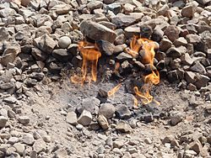
Natural gas is a fossil fuel formed when layers of buried plants, gases, and animals are exposed to intense heat and pressure over thousands of years. Natural gas is a hydrocarbon gas mixture consisting primarily of methane, but commonly includes varying amounts of other higher alkanes and even a lesser percentage of carbon dioxide, nitrogen, and hydrogen sulfide. Natural gas is found in deep underground rock formations or associated with other hydrocarbonreservoirs in coal beds and as methane clathrates. Petroleum is another resource and fossil fuel found in close proximity to, and with natural gas. Most natural gas was created over time by two mechanisms: biogenic and thermogenic. Biogenic gas is created by methanogenic organisms in marshes, bogs, landfills, and shallow sediments. Deeper in the earth, at greater temperature and pressure, thermogenic gas is created from buried organic material. Before natural gas can be used as a fuel, it must be processed to remove impurities, including water, to meet the specifications of marketable natural gas. The by-products of this processing include ethane, propane, butanes, pentanes, and higher molecular weight hydrocarbons, hydrogen sulfide (which may be converted into pure sulfur), carbon dioxide, water vapor, and sometimes helium and nitrogen. Natural gas is often informally referred to simply as "gas", especially when compared to other energy sources such as oil or coal. However, it is not to be confused with gasoline, especially in North America, where the term gasoline is often shortened in colloquial usage to gas. Natural gas is an energy source often used for heating, cooking, and electricity generation. It is also used as fuel for vehicles and as a chemical feedstock in the manufacture of plastics and other commercially important organic chemicals.Natural gas is a pure form of fossil fuel composed of methane, or CH₄, a chemical compound made up of one carbon atom and four hydrogen atoms. Natural gas is lighter than air, has no natural odor (it is mixed with mercaptan, a chemical with a strong sulfur odor, as a warning of leakage), is often found near petroleum deposits deep underground, and is highly flammable. The first discoveries of natural gas were made in what is now Iran, 6,000 to 2,000 years BCE (Before Common Era). Natural gas seeps there were probably ignited by lightning and fueled the “eternal fires” of the fire-worshipping ancient Persians. Natural gas was used by the Chinese in about 500 BC. They discovered a way to transport gas seeping from the ground in crude pipelines of bamboo to where it was used to boil sea water to extract the salt. The world's first industrial extraction of natural gas started at Fredonia, New York, USA in 1825. By 2009, 66 trillion cubic meters (or 8%) had been used out of the total 850 trillion cubic meters of estimated remaining recoverable reserves of natural gas. Based on an estimated 2015 world consumption rate of about 3.4 trillion cubic meters of gas per year, the total estimated remaining economically recoverable reserves of natural gas would last 250 years.
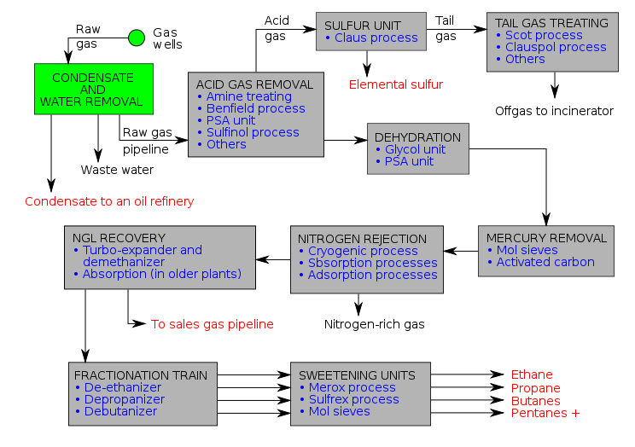
To find gas deposits today, geologists study seismic surveys – using echoes sent by a vibrating pad under specially built truck – to identify natural gas deposits deep below ground. At a promising site, a drill rig bores test wells. Once a productive deposit is found, gas is pumped to the surface and is sent to storage tanks by pipeline. Once stored, natural gas is measured by volume: a cubic foot (cf) of gas is equivalent to the amount of gas that fills a once cubic foot volume, under set conditions of temperature and pressure. A “therm” is equivalent to 100 cf; and “mcf” is equivalent to 1,000 cf. To help compare fuels, energy content is measured in BTUs, British Thermal Units. One BTU is the amount of heat required to raise one pound of water (about a pint) one degree Fahrenheit at its point of maximum density. One cubic foot of natural gas releases approximately 1,000 BTUs of heat energy (and one barrel of oil equals 6,000 cubic feet of natural gas). Natural gas requires minimal processing. “Wet” natural gas contains liquid hydrocarbons and nonhydrocarbon gases, such as butane and propane, which are known as byproducts. Once the byproducts are removed, the methane is classified as “dry” – or “consumer grade” – natural gas, and is widely distributed. The production and use of natural creates fewer emissions than oil and coal. Americans use natural gas to heat their homes and to fuel their power plants. But not until the last decade did it become as important as coal, oil, or nuclear power. Today, natural gas is used for generating electricity (36 percent) and for industrial (28 percent), residential (16 percent), and commercial use (11 percent). The remaining 9 percent is used by energy industry operations, pipelines, and vehicle fuel. Gas is important for manufacturing steel, glass, paper, clothing, and many other goods, and provides raw material for plastics, paints, fertilizer, dyes, medicines, and explosives. It can be converted into ethane, a colorless and odorless gas that is important to the chemical industry. Natural gas provides heat for over half of America’s homes and commercial establishments, and it powers stoves, water heaters, clothes driers, and other appliances (Prud’homme ’14: 15, 16, 17). Natural gas dispensed from a simple stovetop can generate temperatures in excess of 1100 °C (2000 °F) making it a powerful domestic cooking and heating fuel. In much of the developed world it is supplied through pipes to homes, where it is used for many purposes including ranges and ovens, gas-heated clothes dryers, heating/cooling, and central heating. Heaters in homes and other buildings may include boilers, furnaces, and water heaters. Compressed natural gas (CNG) is used in rural homes without connections to piped-in public utility services, or with portable grills. Natural gas is also supplied by independent natural gas suppliers through Natural Gas Choice programs throughout the United States. However, as CNG costs more than LPG, LPG (propane) is the dominant source of rural gas. CNG is a cleaner alternative to other automobile fuels such as gasoline (petrol) and diesel. By the end of 2012 there were 17.25 million natural gas vehicles worldwide, led by Iran (3.3 million), Pakistan (3.1 million), Argentina (2.18 million), Brazil (1.73 million), India (1.5 million), and China (1.5 million). The energy efficiency is generally equal to that of gasoline engines, but lower compared with modern diesel engines. Gasoline/petrol vehicles converted to run on natural gas suffer because of the low compression ratio of their engines, resulting in a cropping of delivered power while running on natural gas (10%–15%). CNG-specific engines, however, use a higher compression ratio due to this fuel's higher octane number of 120–130.
In the 19th century, natural gas was usually obtained as a by-product of producing oil, since the small, light gas carbon chains came out of solution as the extracted fluids underwent pressure reduction from the reservoir to the surface, similar to uncapping a bottle of soda where the carbon dioxide effervesces. Unwanted natural gas was a disposal problem in the active oil fields. If there was not a market for natural gas near the wellhead it was virtually valueless since it had to be piped to the end user. In the 19th century and early 20th century, such unwanted gas was usually burned off at oil fields. Today, unwanted gas (or stranded gas without a market) associated with oil extraction often is returned to the reservoir with 'injection' wells while awaiting a possible future market or to repressurize the formation, which can enhance extraction rates from other wells. In regions with a high natural gas demand (such as the US), pipelines are constructed when it is economically feasible to transport gas from a wellsite to an end consumer. In addition to transporting gas via pipelines for use in power generation, other end uses for natural gas include export as liquefied natural gas (LNG) or conversion of natural gas into other liquid products via gas-to-liquids (GTL) technologies. GTL technologies can convert natural gas into liquids products such as gasoline, diesel or jet fuel. A variety of GTL technologies have been developed, including Fischer-Tropsch (F-T), methanol to gasoline (MTG) and STG+. F-T produces a synthetic crude that can be further refined into finished products, while MTG can produce synthetic gasoline from natural gas. STG+ can produce drop-in gasoline, diesel, jet fuel and aromatic chemicals directly from natural gas via a single-loop process. In 2011, Royal Dutch Shell’s 140,000 barrel per day F-T plant went into operation in Qatar. Natural gas can be "associated" (found in oil fields), or "non-associated" (isolated in natural gas fields), and is also found in coal beds (as coalbed methane). Natural gas extracted from oil wells is called casinghead gas or associated gas. The natural gas industry is extracting an increasing quantity of gas from challenging resource types: sour gas, tight gas, shale gas, and coalbed methane.

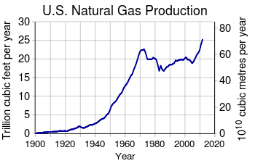
Shale gas is natural gas produced from shale. Because shale has matrix permeability too low to allow gas to flow in economical quantities, shale gas wells depend on fractures to allow the gas to flow. Early shale gas wells depended on natural fractures through which gas flowed; almost all shale gas wells today require fractures artificially created by hydraulic fracturing. Since 2000, shale gas has become a major source of natural gas in the United States and Canada. Following the success in the United States, shale gas exploration is beginning in countries such as Poland, China, and South Africa. Town gas is a flammable gaseous fuel made by the destructive distillation of coal and contains a variety of calorific gases including hydrogen, carbon monoxide, methane, and other volatile hydrocarbons, together with small quantities of non-calorific gases such as carbon dioxide and nitrogen, and is used in a similar way to natural gas. This is a historical technology, not usually economically competitive with other sources of fuel gas today. But there are still some specific cases where it is the best option and it may be so into the future. Most town "gashouses" located in the eastern US in the late 19th and early 20th centuries were simple by-product coke ovens that heated bituminous coal in air-tight chambers. The gas driven off from the coal was collected and distributed through networks of pipes to residences and other buildings where it was used for cooking and lighting. (Gas heating did not come into widespread use until the last half of the 20th century.) The coal tar (or asphalt) that collected in the bottoms of the gashouse ovens was often used for roofing and other waterproofing purposes, and when mixed with sand and gravel was used for paving streets. Huge quantities of natural gas (primarily methane) exist in the form of hydrates under sediment on offshore continental shelves and on land in arctic regions that experience permafrost, such as those in Siberia. Hydrates require a combination of high pressure and low temperature to form. In 2010, the cost of extracting natural gas from crystallized natural gas was estimated to 100–200 per cent the cost of extracting natural gas from conventional sources, and even higher from offshore deposits. In 2013, Japan Oil, Gas and Metals National Corporation (JOGMEC) announced that they had recovered commercially relevant quantities of natural gas from methane hydrate.
Methanogenic archaea are responsible for all biological sources of methane. Some live in symbiotic relationships with other life forms, including termites, ruminants, and cultivated crops. Other sources of methane, the principal component of natural gas, include landfill gas, biogas, and methane hydrate. When methane-rich gases are produced by the anaerobic decay of non-fossil organic matter (biomass), these are referred to as biogas (or natural biogas). Sources of biogas include swamps, marshes, and landfills (see landfill gas), as well as agricultural waste materials such as sewage sludge and manure by way of anaerobic digesters, in addition to enteric fermentation, particularly in cattle. Landfill gas is created by decomposition of waste in landfill sites. Excluding water vapor, about half of landfill gas is methane and most of the rest is carbon dioxide, with small amounts of nitrogen, oxygen, and hydrogen, and variable trace amounts of hydrogen sulfide and siloxanes. If the gas is not removed, the pressure may get so high that it works its way to the surface, causing damage to the landfill structure, unpleasant odor, vegetation die-off, and an explosion hazard. The gas can be vented to the atmosphere, flared or burned to produce electricity or heat. Biogas can also be produced by separating organic materials from waste that otherwise goes to landfills. This method is more efficient than just capturing the landfill gas it produces. Anaerobic lagoons produce biogas from manure, while biogas reactors can be used for manure or plant parts. Like landfill gas, biogas is mostly methane and carbon dioxide, with small amounts of nitrogen, oxygen and hydrogen. However, with the exception of pesticides, there are usually lower levels of contaminants. Landfill gas cannot be distributed through utility natural gas pipelines unless it is cleaned up to less than 3 per cent CO₂, and a few parts per million H₂S, because CO₂ and H₂S corrode the pipelines. The presence of CO₂ will lower the energy level of the gas below requirements for the pipeline. Siloxanes in the gas will form deposits in gas burners and need to be removed prior to entry into any gas distribution or transmission system. Consequently it may be more economical to burn the gas on site or within a short distance of the landfill using a dedicated pipeline. Water vapor is often removed, even if the gas is burned on site. If low temperatures condense water out of the gas, siloxanes can be lowered as well because they tend to condense out with the water vapor. Other non-methane components may also be removed to meet emission standards, to prevent fouling of the equipment or for environmental considerations. Co-firing landfill gas with natural gas improves combustion, which lowers emissions. Biogas, and especially landfill gas, are already used in some areas, but their use could be greatly expanded. Using materials that would otherwise generate no income, or even cost money to get rid of, improves the profitability and energy balance of biogas production. Gas generated in sewage treatment plants is commonly used to generate electricity. For example, the Hyperion sewage plant in Los Angeles burns 8 million cubic feet (230,000 m³) of gas per day to generate power. New York City utilizes gas to run equipment in the sewage plants, to generate electricity, and in boilers. Using sewage gas to make electricity is not limited to large cities. The city of Bakersfield, California, uses cogeneration at its sewer plants. California has 242 sewage wastewater treatment plants, 74 of which have installed anaerobic digesters. The total biopower generation from the 74 plants is about 66 MW.
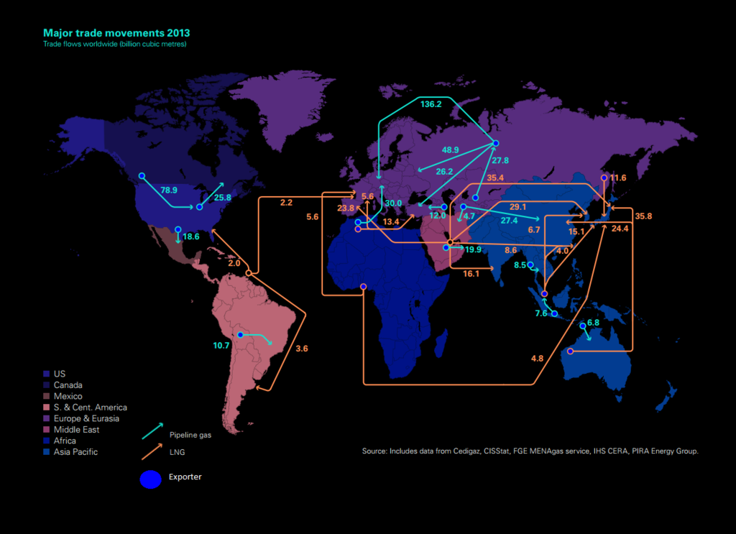
Because of its low density, it is not easy to store natural gas or to transport it by vehicle. Natural gas pipelines are impractical across oceans. Many existing pipelines in America are close to reaching their capacity, prompting some politicians representing northern states to speak of potential shortages. In Western Europe, the gas pipeline network is already dense. New pipelines are planned or under construction in Eastern Europe and between gas fields in Russia, Near East and Northern Africa and Western Europe. LNG carriers transport liquefied natural gas (LNG) across oceans, while tank trucks can carry liquefied or compressed natural gas (CNG) over shorter distances. Sea transport using CNG carrier ships that are now under development may be competitive with LNG transport in specific conditions. Gas is turned into liquid at a liquefaction plant, and is returned to gas form at regasification plant at the terminal. Shipborne regasification equipment is also used. LNG is the preferred form for long distance, high volume transportation of natural gas, whereas pipeline is preferred for transport for distances up to 4,000 km (2,485 mi) over land and approximately half that distance offshore. CNG is transported at high pressure, typically above 200 bars. Compressors and decompression equipment are less capital intensive and may be economical in smaller unit sizes than liquefaction/regasification plants. Natural gas trucks and carriers may transport natural gas directly to end-users, or to distribution points such as pipelines. Floating Liquefied Natural Gas (FLNG) is an innovative technology designed to enable the development of offshore gas resources that would otherwise remain untapped because due to environmental or economic factors it is nonviable to develop them via a land-based LNG operation. FLNG technology also provides a number of environmental and economic advantages: Environmental – Because all processing is done at the gas field, there is no requirement for long pipelines to shore, compression units to pump the gas to shore, dredging and jetty construction, and onshore construction of an LNG processing plant, which significantly reduces the environmental footprint.^{[54]} Avoiding construction also helps preserve marine and coastal environments. In addition, environmental disturbance will be minimized during decommissioning because the facility can easily be disconnected and removed before being refurbished and re-deployed elsewhere. Economic – Where pumping gas to shore can be prohibitively expensive, FLNG makes development economically viable. As a result, it will open up new business opportunities for countries to develop offshore gas fields that would otherwise remain stranded, such as those offshore East Africa. Another way to store natural gas is adsorbing it to the porous solids called sorbents. The best condition for methane storage is at room temperature and atmospheric pressure. The used pressure can be up to 4 MPa (about 40 times atmospheric pressure) for having more storage capacity. The most common sorbent used for ANG is activated carbon (AC). Three main types of activated carbons for ANG are: Activated Carbon Fiber (ACF), Powdered Activated Carbon (PAC), and activated carbon monolith.

With 15 countries accounting for 84 per cent of the worldwide extraction, access to natural gas has become an important issue in international politics, and countries vie for control of pipelines. In the first decade of the 21st century, Gazprom, the state-owned energy company in Russia, engaged in disputes with Ukraine and Belarus over the price of natural gas, which have created concerns that gas deliveries to parts of Europe could be cut off for political reasons. The United States is preparing to export natural gas. There is some disagreement on which country has the largest proven gas reserves. Sources that consider that Russia has by far the largest proven reserves include the US CIA (47.6 trillion cubic meters), the US Energy Information Administration (47.8 tcm), and OPEC (48.7 tcm). However, BP credits Russia with only 32.9 tcm, which would place it in second place, slightly behind Iran (33.1 to 33.8 tcm, depending on the source). With Gazprom, Russia is frequently the world's largest natural gas extractor. Major proven resources (in billion cubic meters) are world 187,300 (2013), Iran 33,600 (2013), Russia 32,900 (2013), Qatar 25,100 (2013), Turkmenistan 17,500 (2013) and the United States 8,500 (2013). It is estimated that there are about 900 trillion cubic meters of "unconventional" gas such as shale gas, of which 180 trillion may be recoverable. The world's largest gas field is the offshore South Pars / North Dome Gas-Condensate field, shared between Iran and Qatar. It is estimated to have 51 trillion cubic meters of natural gas and 50 billion barrels of natural gas condensates.Russia has the world’s largest known gas reserves. As of 1988, the Soviet Union supplied only about three percent of western Europe’s energy, but a survey of total world uncommitted (surplus) natural gas supplies, showed that the rest of the world, not including the USSR, had 598 trillion cubic feet of surplus, whereas the Soviet Union held 763 trillion cubic feet. Russians obtain about 60 percent of their hard currencies through the sale of oil and gas. OPEC membership grew gradually from its beginning in Venezuela in 1960. At that time Venezuela, Iran, Iraq, Kuwait, and Saudi Arabia established OPEC. Qatar joined in 1961, followed by Indonesia and Libya in 1962, the United Arab Emirates in 1967 Nigeria in 1971, Ecuador in 1973, and Gabon in 1975. Currently, countries which export more than 100,000 barrels of oil per day and which are non-OPEC countries are Canada, Mexico, the United Kingdom, Norway, Angola, Egypt, Oman, the USSR, China, Malaysia, and Brunei. Section 12 of the Defense Production Act of 1950 regards ‘strategic’ and ‘critical’ essentially the same, it states: the term ‘strategic and critical materials’ means materials that (A) would be needed to supply the military industrial and essential civilian needs of the United States during a national emergency, and (B) are not found or produced in the United States in sufficient quantities to meet such a need. The act goes on to designate energy as a strategic and critical material (Youngquist ’88: 44, 46, 207).
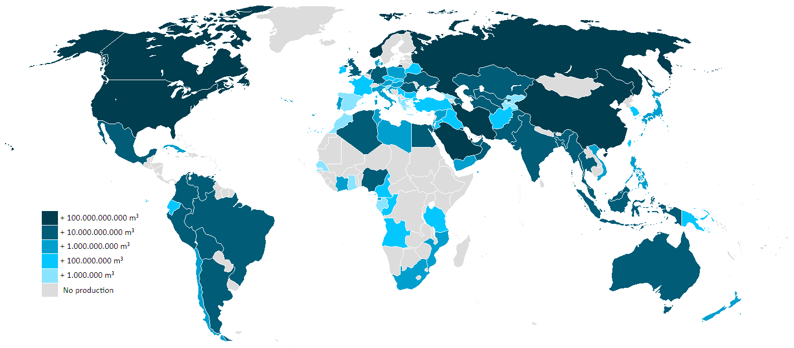
A series of energy-related crises have made natural gas increasingly popular. Coal-fired plants have lost favor because of their sooty emissions. Deep-water oil exploration faced a setback with the blowout of a BP oil well in the Gulf of Mexico in 2010, which set off the largest oil spill in U.S. history. An earthquake and tsunami in Japan in 2011 raised questions about the safety of nuclear plants (nuclear plants are also much more expensive to build, operate, and maintain than equivalent natural as facilities). Traditional concerns about natural gas included limited supplies and volatile prices – until fracking, that is, which has significantly increased known gas reserves and lowered prices. In July 2008 shale gas cost $13.68 per million BTUs (MBTU) at Henry Hub, a concentration of pipelines in Louisiana that serves as the main pricing point for American natural gas. Thanks to the rapid proliferation of hydrofracked wells, natural gas supplies ballooned at just the moment that the economy – and demand – slackd off, sending gas prices plummeting. Between 2008 and 2012, gas prices fell over 60 percent. After tumbling below $2 per MBTU I 2012, prices doubled to $4.04 in mid-2013 and are expected to rise slightly higher in 2014. A number of other factors – including ready capital, a trained workforce, greater access to pipelines by third parties, the ability to hedge the risks of gas exploration, and a robust energy market – helped to accelerate gas’s acceptance. Utilities saw it as a stable, affordable, relatively clean source of power. In 2008, natural gas amounted to about 20 percent of the nation’s energy production; by 2012 it amounted to over 30 percent, a number that is likely to keep growing. The EIA forecasts that domestic natural gas production will grow 44 percent – from 23 trillion cubic feet (tcf) to 33.1 tcf- between 2011 and 2040. Natural gas emits less CO₂ than other fossil fuels and requires less processing (or refining, to remove the other elements) than oil, and so it has been promoted as a “bridge fuel” – a cleaner-burning alternative to oil and coal that will ease the transition to renewable energy supplies such as wind, solar, and hydropower (Prud’homme ’14: 17, 18). The price of natural gas varies greatly depending on location and type of consumer. In 2007, a price of $7 per 1000 cubic feet (about 25 cents per m³) was typical in the United States. The typical caloric value of natural gas is roughly 1,000 British thermal units (BTU) per cubic foot, depending on gas composition. This corresponds to around $7 per million BTU, or around $7 per gigajoule. In April 2008, the wholesale price was $10 per 1,000 cubic feet (28 m³) ($10/MMBTU). The residential price varies from 50% to 300% more than the wholesale price. At the end of 2007, this was $12–$16 per 1000 cubic feet (about 50 cents per m³). Natural gas in the United States is traded as a futures contract on the New York Mercantile Exchange. Each contract is for 10,000 MMBTU (~10,550 gigajoules), or 10 billion BTU. Thus, if the price of gas is $10 per million BTUs on the NYMEX, the contract is worth $100,000. Gas prices for end users vary greatly across the EU. A single European energy market, one of the key objectives of the European Union, should level the prices of gas in all EU member states. Moreover, it would help to resolve supply and global warming issues.

Quantities of natural gas are measured in normal cubic meters (corresponding to 0 °C at 101.325 kPa) or in standard cubic feet (corresponding to 60 °F (16 °C) and 14.73 psia).The gross heat of combustion of 1 m³ of commercial quality natural gas is around 39 MJ (≈10.8 kWh), but this can vary by several percent. This comes to about 49 MJ (≈13.5 kWh) for 1 kg of natural gas (assuming a density of 0.8 kg m⁻³, an approximate value). In US units, one standard cubic foot 1 cubic foot (28 L) of natural gas produces around 1,028 British thermal units (1,085 kJ). The actual heating value when the water formed does not condense is the net heat of combustion and can be as much as 10% less. In the United States, retail sales are often in units of therms (th); 1 therm = 100,000 BTU. Gas meters measure the volume of gas used, and this is converted to therms by multiplying the volume by the energy content of the gas used during that period, which varies slightly over time. Wholesale transactions are generally done in decatherms (Dth), or in thousand decatherms (MDth), or in million decatherms (MMDth). A million decatherms is roughly a billion cubic feet of natural gas. Gas sales to domestic consumers may be in units of 100 standard cubic feet (scf). The typical annual consumption of a single family residence is 1,000 therms or one RCE. Canada uses metric measure for internal trade of petrochemical products. Consequently, natural gas is sold by the Gigajoule, cubic metre (m³) or thousand cubic metres (E3m3). Distribution infrastructure and meters almost always meter volume (cubic foot or cubic meter). Some jurisdictions, such as Saskatchewan, sell gas by volume only. Other jurisdictions, such as Alberta, gas is sold by the energy content (GJ). In these areas, almost all meters for residential and small commercial customers measure volume (m³ or ft³), and billing statements include a multiplier to convert the volume to energy content of the local gas supply. A Gigajoule (GJ) is a measure approximately equal to half a barrel (250 lbs) of oil, or 1 million BTUs, or 1000 cu ft of gas, or 28 m³ of gas. The energy content of gas supply in Canada can vary from 37 to 43 MJ per m³ depending on gas supply and processing between the wellhead and the customer. In the rest of the world, natural gas is sold in Gigajoule retail units. LNG (liquefied natural gas) and LPG (liquefied petroleum gas) are traded in metric tons or MMBTU as spot deliveries. Long term natural gas distribution contracts are signed in cubic metres, and LNG contracts are in metric tonnes (1,000 kg). The LNG and LPG is transported by specialized transport ships, as the gas is liquified at cryogenic temperatures. The specification of each LNG/LPG cargo will usually contain the energy content, but this information is in general not available to the public. In the Russian Federation, Gazprom sold approximately 250 billion cubic metres of natural gas in 2008.
Natural gas is mainly composed of methane. After release to the atmosphere it is removed over about 10 years by gradual oxidation to carbon dioxide and water by hydroxyl radicals (·OH) formed in the troposphere or stratosphere, giving the overall chemical reaction CH₄ + 2O₂→ CO₂ + 2H₂O. While the lifetime of atmospheric methane is relatively short when compared to carbon dioxide, it is more efficient at trapping heat in the atmosphere, so that a given quantity of methane has 84 times the global-warming potential of carbon dioxide over a 20-year period and 28 times over a 100-year period. Natural gas is thus a more potent greenhouse gas than carbon dioxide due to the greater global-warming potential of methane. Current estimates by the EPA place global emissions of methane at 85 billion cubic metres (3.0×10¹² cu ft) annually, or 3.2 per cent of global production. Direct emissions of methane represented 14.3 per cent of all global anthropogenic greenhouse gas emissions in 2004. During extraction, storage, transportation, and distribution, natural gas is known to leak into the atmosphere, particularly during the extraction process. A study in 2011 demonstrated that the leak rate of methane was high enough to jeopardize its global warming advantage over coal. This study was criticized later for its high assumption of methane leakage values. These values were later shown to be close to the findings of the Scientists at the National Oceanic and Atmospheric Administration. Natural gas extraction also releases an isotope of Radon, ranging from 5 to 200,000 Becquerels per cubic meter. Natural gas is often described as the cleanest fossil fuel. It produces about 29% and 44% less carbon dioxide per joule delivered than oil and coal respectively, and potentially fewer pollutants than other hydrocarbon fuels. However, in absolute terms, it comprises a substantial percentage of human carbon emissions, and this contribution is projected to grow. According to the IPCC Fourth Assessment Report, in 2004, natural gas produced about 5.3 billion tons a year of CO₂ emissions, while coal and oil produced 10.6 and 10.2 billion tons respectively. According to an updated version of the Special Report on Emissions Scenario by 2030, natural gas would be the source of 11 billion tons a year, with coal and oil now 8.4 and 17.2 billion respectively because demand is increasing 1.9 percent a year. Total global emissions for 2004 were estimated at over 27,200 million tons. Natural gas produces far lower amounts of sulfur dioxide and nitrous oxides than any other hydrocarbon fuels. The other pollutants due to natural gas combustion are listed below in parts per million (ppm): Carbon monoxide - 40 ppm, Sulfur dioxide - 1 ppm, Nitrogen oxide - 92 ppm and Particulates - 7 ppm.
In mines, where methane seeping from rock formations has no odor, sensors are used, and mining apparatus such as the Davy lamp has been specifically developed to avoid ignition sources. Some gas fields yield sour gas containing hydrogen sulfide (H₂S). This untreated gas is toxic. Amine gas treating, an industrial scale process which removes acidic gaseous components, is often used to remove hydrogen sulfide from natural gas. Extraction of natural gas (or oil) leads to decrease in pressure in the reservoir. Such decrease in pressure in turn may result in subsidence, sinking of the ground above. Subsidence may affect ecosystems, waterways, sewer and water supply systems, foundations, and so on. Another ecosystem effect results from the noise of the process. Releasing the gas from low-permeability reservoirs is accomplished by a process called hydraulic fracturing or "hydrofracking". To allow the natural gas to flow out of the shale, oil operators force 1 to 9 million US gallons (34,000 m³) of water mixed with a variety of chemicals through the wellbore casing into the shale. The high pressure water breaks up or "fracks" the shale, which releases the trapped gas. Sand is added to the water as a proppant to keep the fractures in the shale open, thus enabling the gas to flow into the casing and then to the surface. The chemicals are added to the frack fluid to reduce friction and combat corrosion. During the extracting life of a gas well, other low concentrations of other chemical substances may be used, such as biocides to eliminate fouling, scale and corrosion inhibitors, oxygen scavengers to remove a source of corrosion, and acids to clean the perforations in the pipe. Dealing with fracking fluid can be a challenge. Along with the gas, 30 per cent to 70 per cent of the chemically laced frack fluid, or flow back, returns to the surface. Additionally, a significant amount of brine, containing salt and other minerals, may be produced with the gas.
In order to assist in detecting leaks, a minute amount of odorant is added to the otherwise colorless and almost odorless gas used by consumers. The odor has been compared to the smell of rotten eggs, due to the added tert-Butylthiol (t-butyl mercaptan). Sometimes a related compound, thiophane, may be used in the mixture. Situations in which an odorant that is added to natural gas can be detected by analytical instrumentation, but cannot be properly detected by an observer with a normal sense of smell, have occurred in the natural gas industry. This is caused by odor masking, when one odorant overpowers the sensation of another. Explosions caused by natural gas leaks occur a few times each year. Individual homes, small businesses and other structures are most frequently affected when an internal leak builds up gas inside the structure. Frequently, the blast is powerful enough to significantly damage a building but leave it standing. In these cases, the people inside tend to have minor to moderate injuries. Occasionally, the gas can collect in high enough quantities to cause a deadly explosion, disintegrating one or more buildings in the process. The gas usually dissipates readily outdoors, but can sometimes collect in dangerous quantities if flow rates are high enough. However, considering the tens of millions of structures that use the fuel, the individual risk of using natural gas is very low. Natural gas heating systems are a minor source of carbon monoxide deaths in the United States. According to the US Consumer Product Safety Commission (2008), 56 per cent of unintentional deaths from non-fire CO poisoning were associated with engine-driven tools like gas-powered generators and lawnmowers. Natural gas heating systems accounted for 4 per cent of these deaths. Improvements in natural gas furnace designs have greatly reduced CO poisoning concerns. Detectors are also available that warn of carbon monoxide and/or explosive gas (methane, propane, etc.).

F. Petroleum Oil

Oil, also known as petroleum, is a fossil fuel that was created more than 300 million years ago, when diatoms died and decomposed on the sea floor. Diatoms are tiny sea creatures that convert sunlight directly into stored energy. After falling to the bottom of the ocean, they were buried under sediment and rock; the rock compressed the diatoms, trapping the energy in their pinhead-size bodies. Subjected to great heat and pressure, the carbon eventually turned into liquid hydrocarbons (an organic chemical compound of hydrogen and carbon) that is called “crude oil”. The word “petroleum” means “oil from the earth”, or “rock oil”. As the earth’s geology shifted over millennia, oil and natural gas were trapped in underground pockets. In regions where the rock is porous, oil can be trapped in the rock itself. Many has used oil for approximately 5,500 years to produce heat and power and for many other purposes. The ancient Sumerians, Assyrians, and Babylonians used crude oil and “pitch” (what we call asphalt) from a natural gas seep at what is now Hit, an Iraqi city of the Euphrates River; oil was also used to build ancient Babylon. In North America, Native Americans used oil to treat illness, to waterproof canoes, and to protect themselves against frostbite. As America grew, petroleum was used to fuel lamps for light. When whale oil became expensive petroleum oil began to supplant it as a fuel. At the time, most oil was made by distilling coal into a liquid, or was skimmed off of lakes, when petroleum leaked to the surface from underwater seeps. On August 27, 1859, Edwin L. Drake struck oil in Titusville, Pennsylvania, setting off what has become known as the “Oil Age”. Drake pumped oil from underground into wooden barrels. Oil is measured in “barrels” (bbls), or the equivalent of 42 gallons. As the oil business grew in the nineteenth century, producers emulated distillers, who transported whiskey in 40-gallon barrels; oilmen copied the idea, adding two gallons to account for spillage. Today, oil is the world’s most popular fuel, representing 33.1 percent of global energy use. The EIA predicts global demand will jump from 98 million barrels a day in 2020 to 112 million in 2035. Nevertheless, the use of other fuels is also surging, and oil has been losing market share. According to British Petroleum (BP), oil’s market share in 2012 was at its lowest point since the company began compiling data in 1965 (Prud’homme ’14: 13, 14). The Gulf of Mexico contributes 24 percent to the nation's oil output of 8.37 million barrels a day, the third largest oil producing nation in the world. As the result of high consumption totaling 20.59 million barrels a day the United States is a net importer of 12.22 million barrels a day in 2007 (Sanders ’10). Known oil reserves are typically estimated at around 190 km³ (1.2 trillion (short scale) barrels) without oil sands, or 595 km³ (3.74 trillion barrels) with oil sands. Consumption is currently around 84 million barrels (13.4×10⁶ m³) per day, or 4.9 km³ per year. Which in turn yields a remaining oil supply of only about 120 years, if current demand remain static.

To access oil, energy companies drill deep into the earth, then pump the oil from deposits to the surface. It is sent to refineries by pipeline, ship or barge. Crude oil is considered “sweet” when it contains a small amount of sulfur, and “sour” when it contains a lot of sulfur. Crude is further classified as “light” which flows easily like water, or “heavy” which is thick and vicious like tar. Oil refineries break down hydrocarbons into various commodities, known as “refined products” such as gasoline, diesel fuel, aviation fuel, heating oil, kerosene, asphalt, lubricants, propane and the like. Oil can be converted into naphtha, which is the “feedstock”, or basis, for high-octane gasoline or lighter fluid. Oil is used to produce many other products, including fertilizers and plastics. As it is processed, oil expands. A 42 gallon barrel of crude oil generally produces 45 gallons of petroleum products. The vast majority – about 70 percent – of U.S. petroleum consumption is used for transportation. Gasoline – commonly referred to as “gas” in the United States and “petrol” in Great Britain, but not to be confused with natural gas – is a fuel made from petroleum. At U.S. refineries, gasoline is the main product produced from crude oil. In 2011, Americans used 367 million gallons of gasoline per day, the equivalent of more than a gallon of gas per day for every citizen. One 42-gallon barrel of refined crude oil will produce about 19 gallons of gasoline. Most gas is used by cars and light trucks, but it also fuels boats, farm equipment and recreational vehicles (Prud’homme ’14: 14, 15). The Organization of the Petroleum Exporting Countries (OPEC) is a cartel of oil-producing countries which was established in Baghdad, Iraq, in 1961. The OPEC generates approximately 45 percent of the world’s total crude oil production, and more than 20 percent of the world’s natural gas production. Moreover, the OPEC owns more than four fifths of total global crude oil reserves, and around 48 percent of global natural gas reserves. Given the high dependence of world economy on oil and gas, OPEC’s influence on the fossil fuel market is evident.

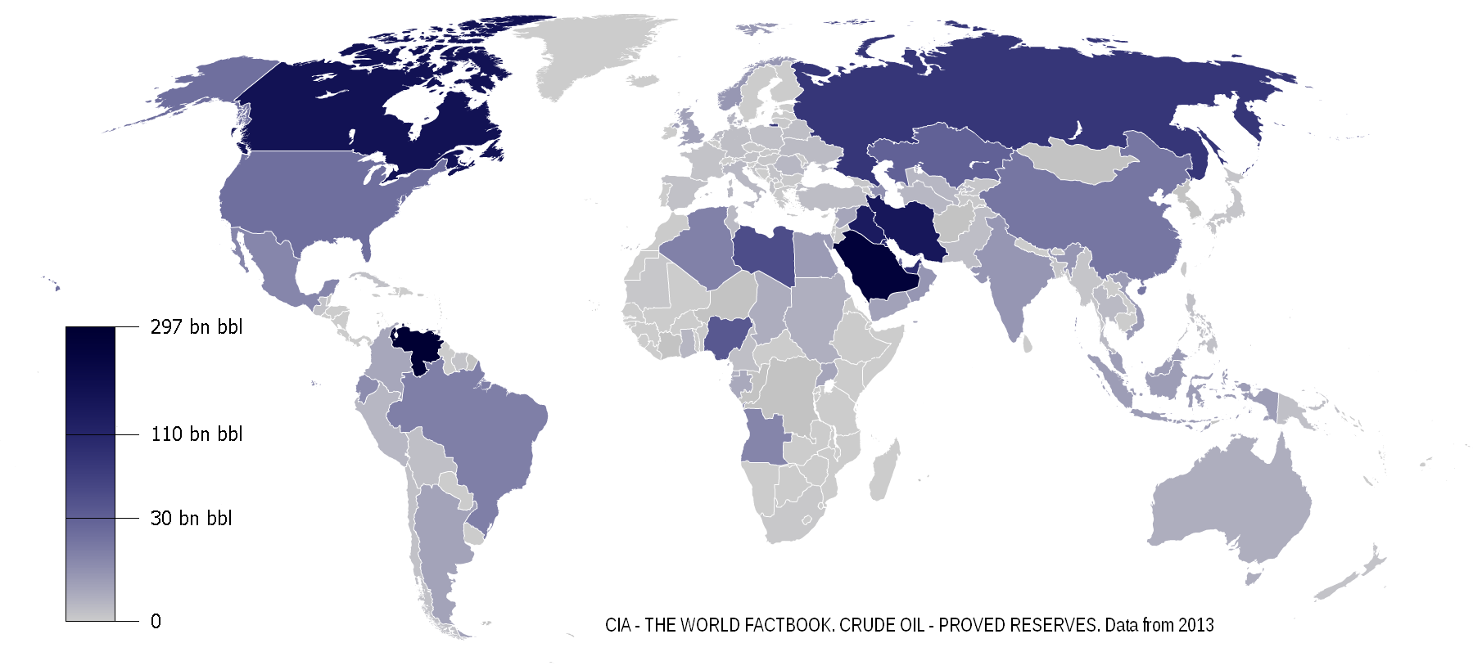

Top World Oil Producers, Exporters, Consumers, and Importers, 2006

(millions of barrels per day)
Producers | Total oil  production | Exporters | Net oil  exports | Consumers | Total oil  consumption | Importers | Net oil  imports
1. Saudi Arabia | 10.72 | 1. Saudi Arabia | 8.65 | 1. United States | 20.59 | 1. United States | 12.22
2. Russia | 9.67 | 2. Russia | 6.57 | 2. China | 7.27 | 2. Japan | 5.10
3. United States | 8.37 | 3. Norway | 2.54 | 3. Japan | 5.22 | 3. China | 3.44
4. Iran | 4.12 | 4. Iran | 2.52 | 4. Russia | 3.10 | 4. Germany | 2.48
5. Mexico | 3.71 | 5. United Arab Emirates | 2.52 | 5. Germany | 2.63 | 5. South Korea | 2.15
6. China | 3.84 | 6. Venezuela | 2.20 | 6. India | 2.53 | 6. France | 1.89
7. Canada | 3.23 | 7. Kuwait | 2.15 | 7. Canada | 2.22 | 7. India | 1.69
8. United Arab Emirates | 2.94 | 8. Nigeria | 2.15 | 8. Brazil | 2.12 | 8. Italy | 1.56
9. Venezuela | 2.81 | 9. Algeria | 1.85 | 9. South Korea | 2.12 | 9. Spain | 1.56
10. Norway | 2.79 | 10. Mexico | 1.68 | 10. Saudi Arabia | 2.07 | 10. Taiwan | 0.94
11. Kuwait | 2.67 | 11. Libya | 1.52 | 11. Mexico | 2.03
12. Nigeria | 2.44 | 12. Iraq | 1.43 | 12. France | 1.97
13. Brazil | 2.16 | 13. Angola | 1.36 | 13. United Kingdom | 1.82
14. Iraq | 2.01 | 14. Kazakhstan | 1.11 | 14. Italy | 1.71
Source: Energy Information Administration (EIA). Country Energy Profiles. www.eia.doe.gov/emeu/cabs/

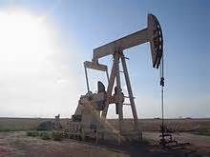
In 1909, the United States produced 500, barrels of oil a day. This was more than the rest of the world combined at the time. The U.S. continued to produce at least one-half of the world’s oil until the early 1950s. In 1960, the United States was a substantial net exporter of oil. However, by 1970, the supply of crude oil was just equal to demand; and by 1977, the United States was importing more crude oil that it produced. During the 1973-74 Arab oil embargo against the United States, the partial cutoff of oil caused the nation’s gross national product to decline $20 billion, and a half million American workers lost their jobs. The oil crisis of the 1979-1980 briefly raised prices and reduced demand for oil, so the United States (for a short time) produced more oil than it imported; but by 1989, crude oil imports again exceeded domestic production. From about 1940 to 1970, the price of Middle East crude oil had held between $1.45 and $1.80 a barrel. But with the discovery that the western world, dominated by the United States, was no longer self-sufficient in oil, the OPEC raised the price (in less than eight years) to more than $35 a barrel. In 1981 with oil prices more than $30 a barrel New Mexico passed the largest tax cut in its history, North Dakota used its taxes on oil and gas to fund schools reducing property value. Alaska, with Prudhoe Bay, had so much money in 1981 that it repealed its state income tax, with oil income about $10,000 per capita, in 1982 it was decided to send each Alaskan citizen, man, woman and child a check for $1,000. In 1990 the U.S. produced 9 million barrels of oil and gas condensate a day, less than 20 percent of world production. In terms of energy there are currently 12 states of the USA which are energy self-sufficient and are energy exporters – Alaska, Kansas, Kentucky, Louisiana, Montana, New Mexico, North Dakota, Oklahoma, Texas, West Virginia, and Wyoming. It was estimated that in 1990 for every $1 increase in oil prices, Texas adds 15,000 jobs and New York loses 11,000 jobs, and the nation as a whole loses 78,000 jobs. Montana and Wyoming control 70% of the nation’s low-sulfur coal. The United States is the most thoroughly oil explored and drilled nation on the planet and of more than 3 million wells drilled in the world, more than two million have been drilled in the United States. Due to permeability the average production per-well per day in the United States is less than 14 barrels, whereas the average daily production per well in some of the major Arabian oil fields is in excess of 10,000 barrels a day. It is interesting that the amount of energy recovered compared to the amount of energy expended has risen from a ratio of about 28 to 1 in 1916 to 2 to 1 in 1985 (Youngquist ’88: vi, 15, 19, 53, 56, 137, 139, 141).

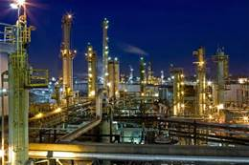
Petroleum is recovered mostly through oil drilling (natural petroleum springs are rare). Oil is refined and separated, most easily by distillation, into a large number of consumer products, from gasoline (petrol) and kerosene to asphalt and chemical reagents used to make plastics and pharmaceuticals. Petroleum is used in manufacturing a wide variety of materials and it is estimated that the world consumes about 90 million barrels each day. In 1847, the process to distill kerosene from petroleum was invented by James Young. He noticed a natural petroleum seepage in the Riddings colliery at Alfreton, Derbyshire from which he distilled a light thin oil suitable for use as lamp oil, at the same time obtaining a thicker oil suitable for lubricating machinery. In 1848 Young set up a small business refining the crude oil. The production of these oils and solid paraffin wax from coal formed the subject of his patent dated 17 October 1850. The first commercial oil well in Canada became operational in 1858 at Oil Springs, Ontario. Access to oil was and still is a major factor in several military conflicts of the twentieth century, including World War II, during which oil facilities were a major strategic asset and were extensively bombed. The German invasion of the Soviet Union included the goal to capture the Baku oilfields. Oil exploration in North America during the early 20th century later led to the US becoming the leading producer by mid-century. As petroleum production in the US peaked during the 1960s, however, the United States was surpassed by Saudi Arabia and the Soviet Union. Today, about 90 percent of vehicular fuel needs are met by oil. Petroleum also makes up 40 percent of total energy consumption in the United States, but is responsible for only 1 percent of electricity generation. The top three oil producing countries are Russia, Saudi Arabia and the United States. About 80 percent of the world's readily accessible reserves are located in the Middle East, with 62.5 percent coming from the Arab 5: Saudi Arabia, UAE, Iraq, Qatar and Kuwait. A large portion of the world's total oil exists as unconventional sources, such as bitumen in Canada and oil shale in Venezuela. While significant volumes of oil are extracted from oil sands, particularly in Canada, logistical and technical hurdles remain, as oil extraction requires large amounts of heat and water, making its net energy content quite low relative to conventional crude oil.

In its strictest sense, petroleum includes only crude oil, but in common usage it includes all liquid, gaseous, and solid hydrocarbons. Under surface pressure and temperature conditions, lighter hydrocarbons methane, ethane, propane and butane occur as gases, while pentane and heavier ones are in the form of liquids or solids. However, in an underground oil reservoir the proportions of gas, liquid, and solid depend on subsurface conditions and on the phase diagram of the petroleum mixture. An oil well produces predominantly crude oil, with some natural gas dissolved in it. A gas well produces predominantly natural gas. However, because the underground temperature and pressure are higher than at the surface, the gas may contain heavier hydrocarbons such as pentane, hexane, and heptane in the gaseous state. At surface conditions these will condense out of the gas to form natural gas condensate, often shortened to condensate. Condensate resembles petrol in appearance and is similar in composition to some volatile light crude oils. The proportion of light hydrocarbons in the petroleum mixture varies greatly among different oil fields, ranging from as much as 97 percent by weight in the lighter oils to as little as 50 percent in the heavier oils and bitumens. The hydrocarbons in crude oil are mostly alkanes, cycloalkanes and various aromatic hydrocarbons while the other organic compounds contain nitrogen, oxygen and sulfur, and trace amounts of metals such as iron, nickel, copper and vanadium. Petroleum is used mostly, by volume, for producing fuel oil and petrol, both important "primary energy" sources. 84 percent by volume of the hydrocarbons present in petroleum is converted into energy-rich fuels (petroleum-based fuels), including petrol, diesel, jet, heating, and other fuel oils, and liquefied petroleum gas. The lighter grades of crude oil produce the best yields of these products, but as the world's reserves of light and medium oil are depleted, oil refineries are increasingly having to process heavy oil and bitumen, and use more complex and expensive methods to produce the products required. Because heavier crude oils have too much carbon and not enough hydrogen, these processes generally involve removing carbon from or adding hydrogen to the molecules, and using fluid catalytic cracking to convert the longer, more complex molecules in the oil to the shorter, simpler ones in the fuels.
Due to its high energy density, easy transportability and relative abundance, oil has become the world's most important source of energy since the mid-1950s. Petroleum is also the raw material for many chemical products, including pharmaceuticals, solvents, fertilizers, pesticides, and plastics; the 16 percent not used for energy production is converted into these other materials.

Petroleum is a mixture of a very large number of different hydrocarbons; the most commonly found molecules are alkanes (paraffins), cycloalkanes (naphthenes), aromatic hydrocarbons, or more complicated chemicals like asphaltenes. Each petroleum variety has a unique mix of molecules, which define its physical and chemical properties, like color and viscosity. The alkanes, also known as paraffins, are saturated hydrocarbons with straight or branched chains which contain only carbon and hydrogen and have the general formula C_{n}H_{2n+2}. They generally have from 5 to 40 carbon atoms per molecule, although trace amounts of shorter or longer molecules may be present in the mixture. The alkanes from pentane (C₅H₁₂) to octane (C₈H₁₈) are refined into petrol, the ones from nonane (C₉H₂₀) to hexadecane (C₁₆H₃₄) into diesel fuel, kerosene and jet fuel. Alkanes with more than 16 carbon atoms can be refined into fuel oil and lubricating oil. At the heavier end of the range, paraffin wax is an alkane with approximately 25 carbon atoms, while asphalt has 35 and up, although these are usually cracked by modern refineries into more valuable products. The shortest molecules, those with four or fewer carbon atoms, are in a gaseous state at room temperature. The cycloalkanes, also known as naphthenes, are saturated hydrocarbons which have one or more carbon rings to which hydrogen atoms are attached according to the formula C_{n}H_{2n}. Cycloalkanes have similar properties to alkanes but have higher boiling points. The aromatic hydrocarbons are unsaturated hydrocarbons which have one or more planar six-carbon rings called benzene rings, to which hydrogen atoms are attached with the formula C_{n}H_{n}. They tend to burn with a sooty flame, and many have a sweet aroma. Some are carcinogenic. These different molecules are separated by fractional distillation at an oil refinery to produce petrol, jet fuel, kerosene, and other hydrocarbons. The number of various molecules in an oil sample can be determined in laboratory. The molecules are typically extracted in a solvent, then separated in a gas chromatograph, and finally determined with a suitable detector, such as a flame ionization detector or a mass spectrometer. Crude oil may be considered light if it has low density or heavy if it has high density; and it may be referred to as sweet if it contains relatively little sulfur or sour if it contains substantial amounts of sulfur. The geographic location is important because it affects transportation costs to the refinery. Light crude oil is more desirable than heavy oil since it produces a higher yield of petrol, while sweet oil commands a higher price than sour oil because it has fewer environmental problems and requires less refining to meet sulfur standards imposed on fuels in consuming countries.
Deepwater Horizon is a massive spill, the worst in U.S. history, whose consequences will depress the fishing and tourism industries in Louisiana, Alabama, Mississippi and Florida dramatically in 2010 and for some years in the future. Furthermore the environmental quality of the Gulf and even Atlantic may jeopardize the safety of seafood from the region.

Oil drilling is a risky occupation, the extraction of volatile substances sometimes under extreme pressure in a hostile environment is dangerous, accidents and tragedies occur regularly. The advent of offshore drilling, in 1891, didn’t cause a problem until the wells became deeper and pumping capacity increased, whereupon safety became a serious issue. Reclaiming oil by hand is not a particularly risky seasonal work by comparison, and no deaths or permanent disabilities amongst clean up crews have been reported. Between 2001 and 2010 the U.S. Minerals Management Service reported 69 offshore deaths, 1,349 injuries, and 858 fires and explosions on offshore rigs in the Gulf of Mexico alone. B.P., with 83,900 employees, rarely goes a year without a fatality amongst their employees and never without a death amongst their contractors. Major catastrophes: In July 1988, 167 people died when Occidental Petroleum's Piper Alpha offshore production platform, on the Piper field in the UK sector of the North Sea, exploded after a gas leak. In March 1980, the 'flotel' (floating hotel) platform Alexander Kjelland capsized in a storm in the North Sea with the loss of 123 lives. In 2001, Petrobras 36 in Brazil exploded and sank five days later, killing 11 people. On April 20, 2010, the Deepwater Horizon platform, 52 miles off-shore of New Orleans, (property of Transocean and leased to BP) exploded, killing 11 people, and sank two days later.

Oil spills of over 100,000 tonnes or 30 million US gallons, ordered by tonnes
Spill / Tanker | Location | Date | *Tons of crude oil
BP Deepwater Horizon, oil platform | Gulf of Mexico, US Federal | April 20, 2010 | 98,000 – 311,040
Exxon Valdez, oil tanker | Prince William Sound, Alaska | 1989 | 35,714  11 million gallons
Fergana Valley | Uzbekistan | March 2, 1992 | 285,000
Gulf War oil spill | Persian Gulf | January 21, 1991 | 116,883,116 (36 billion gallons)
ABT Summer | 700 nautical miles (1,300 km) off Angola | 1991 | 260,000
Amoco Haven tanker disaster | Mediterranean Sea near Genoa, Italy | 1991 | 144,000
Odyssey | 700 nautical miles (1,300 km) off Nova Scotia, Canada | 1988 | 132,000
Castillo de Bellver | Saldanha Bay, South Africa | August 6, 1983 | 252,000
Nowruz oil field | Persian Gulf | February 1983 | 260,000
Irenes Serenade | Navarino Bay,Greece | 1980 | 100,000
Ixtoc I oil well | Gulf of Mexico | June 3, 1979–March 23, 1980 | 454,000–480,000
Atlantic Empress/ Aegean Captain | Trinidad and Tobago | July 19, 1979 | 287,000
Amoco Cadiz | Brittany, France | March 16, 1978 | 223,000
Sea Star | Gulf of Oman | December 19, 1972 | 115,000
Urquiola | A Coruña,Spain | May 12, 1976 | 100,000
Torrey Canyon | Scilly Isles,UK | March 18, 1967 | 80,000–119,000
Source: Wikipedia -* One tonne of crude oil is roughly equal to 308 US gallons, or 7.33 barrels.

Almost 14,000 oil spills are reported each year. Between 2005 and 2009 B.P. spilled an average of between 2- 4.4 million barrels of oil a year. There are thousands of professionals trained to respond to oil spills around the nation. Some oil spills are the result of natural seeping from the ground. Oil spills on water or that seep into the groundwater have the potential to degrade large swatches of the environment. The Deepwater Horizon oil spill is predicted to be the largest oil spill in US history, larger than the 1989 spill from Exxon Valdez that spilled 11 million gallons of oil into an ecologically sensitive area of the Prince William Sound. One difference between the spills is that in 1989 the cause was an oil tanker which holds a finite amount of oil; this spill is tapped to an underwater oil well which may continue to leak for up to 3 months. There is reported one significantly larger spill, a thousand times larger than any other, during the Gulf War in 1991 when 36 billion gallons of crude oil were spilled, ostensibly when the fleeing Iraqi army burnt the oil wells. Of the major spills there is the class of 200,000 tons of oil and the class of 100,000. As of June 6 the Deepwater Horizon spill is just entering the major spill list. By August 2010 when BP will be ready to drill a new well, assured to seal the leak, the question will be whether Deepwater Horizon will beat the record of 450-480,000 tons of oil leaked by the unstoppable Ixtoc Gulf of Mexico oil well June 1979 and March 1980?

An oil spill is the release of a liquid petroleum hydrocarbon into the environment due to human activity, and is a form of pollution. The term often refers to marine oil spills, where oil is released into the ocean or coastal waters. Most human-made oil pollution comes from land-based activity, but public attention and regulation of oil spills has tended to focus most sharply on seagoing oil tankers. Spills take months or even years to clean up. Many spills are contained and cleaned up by the party responsible for the spill; some spills require assistance from local and state agencies, and occasionally, the federal government. Oil also enters the marine environment from natural oil seeps. By observing the thickness of the film of oil and its appearance on the surface of the water, it is possible to estimate the quantity of oil spilled. If the surface area of the spill, and the thickness of the film, is also known, the total volume of the oil can be calculated. Alternatively if the total volume of oil and surface area of the spill are known the thickness of the film can be predicted, although there are other variables such as wind, current and degradation of the oil.

Oil Spill Film Thickness Observation Chart
 | Film thickness |  | Quantity spread
Appearance | in | mm | gal/sq mi | L/ha
Barely visible | 0.0000015 | 0.0000380 | 25 | 0.370
Silvery sheen | 0.0000030 | 0.0000760 | 50 | 0.730
First trace of color | 0.0000060 | 0.0001500 | 100 | 1.500
Bright bands of color | 0.0000120 | 0.0003000 | 200 | 2.900
Colors begin to dull | 0.0000400 | 0.0010000 | 666 | 9.700
Colors are much darker | 0.0000800 | 0.0020000 | 1332 | 19.500
Source: Environmental Protection Agency

The environmental science experiment of the restoration operation involves balancing the utility of clean-up products listed in the National Contingency Plan Subpart J with the capacity of the ecosystem to biodegrade and absorb such chemicals, while coordinating common sense solutions utilizing human labor. The major chemical interventions used to clean up oil spill are dispersants that act as detergents and allow small oil globules to drift away on the water. Dispersents are questionable because the dispersed oil particles, that look like plankton, float under the booms and are probably ingested by plankton eaters and thereby the food chain. Bio-remediation microorganism and biological agents have been proven to dramatically speed up the decomposition of hydrocarbons through a bloom of hydrocarbon eating bacterial life. On the practical side, labor, boats can herd oil slicks with booms and strew sorbent, primitively hay, whereas cat litter would sink, and skim the oil soaked hay off the water, load it onto a trash barge and remove the contaminated debris to environmentally sound sites inland. Through hard work the damage caused by the oil spill on the shoreline and on the currents can be minimized. When oil reaches the shoreline workers generally use surface washing agents to remove the chemicals and dispose of the contaminated surface material. This is however difficult to do, while the oil is still leaking, and the exposed fresh soil is likely to be re-contaminated with oil, but again to minimize damage the restoration effort should be labor intensive from the beginning and booms should be placed defensively around shorelines and sensitive ecosystems, such as oyster colonies, protected with underwater fences made of oil absorbent material.

Dispersants act as detergents, clustering around oil globules and allowing them to be carried away in the water. This improves the surface aesthetically, and mobilizes the oil. Smaller oil droplets, scattered by currents, may cause less harm and may degrade more easily. But the dispersed oil droplets infiltrate into deeper water and can lethally contaminate coral, oyster fields and other underwater ecosystems. Recent research indicates that some dispersant are toxic to corals. A sheen is usually dispersed (but not cleaned up) with detergents which makes oil settle to the bottom. Oils that are denser than water, such as Polychlorinated biphenyls(PCBs), can be more difficult to clean as they make the seabed toxic. When this crisis occurred, Coast Guard and EPA granted BP authorization to use an approved dispersant on oil present on the surface of the water in an effort mitigate the impact of the spill. Should data indicate that the dispersants are causing significant environmental damage that outweighs the benefits of their use, EPA and the Coast Guard reserve the right to discontinue use. Although the crude oil is more toxic than the authorized dispersants, much is unknown about the long term environmental impacts of dispersants when used in these unprecedented volumes on the surface and in the subsea. Because of this and due to the effectiveness of subsea applications, EPA and the U.S. Coast Guard directed BP to significantly ramp down their use of dispersants. BP has complied and has significantly reduced dispersant use. The E.P.A. approved dispersant is SEACARE E.P.A. (see DISPERSIT SPC 1000™) with a 100% effectiveness rating and low toxicity.

The most scientific method of cleaning up oil spills is known as Bio-remediation. In bio-remediation microorganisms or biological agents are used to break down or remove oil. For instance, the human-made, genetically engineered bacterium from the genus Pseudomonas, capable of breaking down crude oil, whose patent was upheld by the U.S. Supreme Court in Diamond, Commissioner of Patents and Trademarks v. Chakarbarty 447 U.S. 303 (1980). To accelerate the bioremediation process Oleophilic, hydrophobic chemical, containing no bacteria, which chemically and physically bonds to both soluble and insoluble hydrocarbons are released. The bio-remediation accelerator acts as a herding agent in water and on the surface, floating molecules to the surface of the water, forming gel-like agglomerations. By over spraying sheen with bio remediation accelerator, sheen is eliminated within minutes. Whether applied on land or on water, the nutrient-rich emulsion, creates a bloom of local, indigenous, pre-existing, hydrocarbon-consuming bacteria. Those specific bacteria break down the hydrocarbons into water and carbon dioxide, with EPA tests showing 98% of alkanes biodegraded in 28 days; and aromatics being biodegraded 200 times faster than in nature. They however have the potential to alter the ecosystem. The E.P.A. offers a variety of competitive bio-remediation solutions with Bioworld Bioremediation Treatment Products getting their best recommendation Source: Environmental Protection Agency. National Contingecy Plan. Subpart J. Toxicity and Effectiveness Summaries. http://www.epa.gov/emergencies/content/ncp/tox_tables.htm

The lay man will have to watch and wait to determine which solutions are effective and which are mad science. In some cases, natural attenuation of oil may be most appropriate, due to the invasive nature of facilitated methods of remediation, particularly in ecologically sensitive areas. There are common sense solutions to an oil spill. The most logical method is a controlled burning to effectively reduce the amount of oil in water, but it can only be done in low wind, causes air pollution and can burn coastal flora. Oils dispersed with detergents and other oils denser than water are cleaned up by the expensive process of dredging. Skimming is most the effective method of environmental reclamation for the converted fishing vessels and barges. Skimming requires calm waters and is reliant upon solidifying the oil through the use of sorbents, large absorbents that absorb oil, which is then herded by Booms: large floating barriers that round up oil and lift the oil off the water. The boats then remove the debris. Workers on the beaches pick up tar balls, use vacuums, detergents, scrubbers, water, shovels and road equiptments to manually remove oil and oil contaminated debris from beaches and water surfaces. It is left to the volunteers to test the effectiveness of surface washing agents but the E.P.A. toxicity tests point towards the safest product - Split Decision SC. It would be nice to see skimming boats in action on the news and hear they promptly dispatched to clean up slicks.

There are of course a number of experimental products used in oil spill cleanup, about whose effectiveness and toxicity to humans, little is known. The E.P.A. generally knows about the basic toxicity of such substances in silverside fish, Menidia, and shrimp, Mysidosis, and is probably willing to co-operate in the analysis of alternate technology for human safety. ‘For instance, animal testing by the E.P.A. warns that PES-51 is a highly toxic oil control agent. The E.P.A. tests air, water and sediment toxicity. Marine and shore contractors and other people living or working in affected areas should acquire E.P.A. tests and training in data collectioln. People living and working in the disaster area must carefully monitor their own health and society for deterioration. Medical screenings should be made available people volunteering in the oil spill clean-up, even for a day, free of charge, to better study the effect of oil and moderate exercise on particular conditions. Petroleum does not seem to aggravate heart disease as does grease and animal fat. Social insurance and social workers should be made available to help dislocated workers avoid mental health and other injustices of the family or employers. For a popular and safe clean-up effort, no drug test should be required to work on the shore, nor use while working on public beaches allowed. The E.P.A. recommended chemical solidifiers for oil are Ciagent and Rapid Grab 2000 ™. Natural sorbents, such as hay, might be more effective sponges, which can be engineered to absorb petroleum and repel water.

The Oil Pollution Act (OPA) was signed into law in August 1990, in response to rising public concern following the Exxon Valdez incident, it has subsequently been amended several times and is much different than when it was written. The OPA improved the nation's ability to prevent and respond to oil spills by establishing provisions that expand the federal government's ability, and through the liability of responsible parties, provides the money and resources necessary, to respond to oil spills. The OPA created the national Oil Spill Liability Trust Fund, which is available to provide up to one billion dollars per spill incident. OPA increased penalties for regulatory noncompliance, broadened the response and enforcement authorities of the Federal government, and preserved State authority to establish law governing oil spill prevention and response. The National Oil and Hazardous Substances Pollution Contingency Plan (NCP) has been expanded in a three-tiered approach whereby the Federal government is required to direct all public and private response efforts for certain types of spill events; Area Committees -- composed of federal, state, and local government officials -- must develop detailed, location-specific Area Contingency Plans; and owners or operators of vessels and certain facilities that pose a serious threat to the environment must prepare their own Facility Response Plans. Under the National Contingency Plan, EPA is the lead federal response agency for oil spills occurring in inland waters, and the U.S. Coast Guard is the lead response agency for spills in coastal waters and deepwater ports. The Key Provisions of the Oil Pollution Act provides at Title 33 USC (40) §2702, that the responsible party for a vessel or facility from which oil is discharged, is liable for removal costs and damages, including damage to natural resources, to real or personal property, to subsistence use of natural resources, to revenues lost, profits and earning capacity, and the cost of public services used to redress the damage caused by the oil spill. Under 33 USC (40) §2718 States may impose additional liability (including unlimited liability), funding mechanisms, requirements for removal actions, and fines and penalties for responsible parties.

G. Coal

Coal is an organic sedimentary rock that forms from the accumulation and preservation of plant materials, usually in a swamp environment. Coal is a combustible rock and along with oil and natural gas it is one of the three most important fossil fuels. Coal has a wide range of uses; the most important use is for the generation of electricity. Coal forms from the accumulation of plant debris, usually in a swamp environment. When plant debris dies and falls into the swamp the standing water of the swamp protects it from decay. Swamp waters are usually deficient in oxygen, which would react with the plant debris and cause it to decay. This lack of oxygen allows the plant debris to persist. In addition, insects and other organisms that might consume the plant debris on land do not survive well under water in an oxygen deficient environment. To form the thick layer of plant debris required to produce a coal seam the rate of plant debris accumulation must be greater than the rate of decay. Once a thick layer of plant debris is formed it must be buried by sediments such as mud or sand. The fifty feet of plant debris needed to make a five-foot thick coal seam would require thousands of years to accumulate. During that long time the water level of the swamp must remain stable. If the water becomes too deep the plants of the swamp will drown and if the water cover is not maintained the plant debris will decay. To form a coal seam the ideal conditions of perfect water depth must be maintained for a very long time. Plant debris is a fragile material compared to the mineral materials that make up other rocks. As plant debris is exposed to the heat and pressure of burial it changes in composition and properties. The "rank" of a coal is a measure of how much change has occurred. Sometimes the term "organic metamorphism" is used for this change. Based upon composition and properties coals are assigned to a rank progression that corresponds to their level of organic metamorphism. The basic rank progression is summarized in the table below:
Rank  (From Lowest  to Highest) | Properties | Photo
Peat | A mass of recently accumulated to partially carbonized plant debris. Peat is an organic sediment. Burial, compaction and coalification will transform it into coal, a rock. It has a carbon content of less than 60% on a dry ash-free basis. | 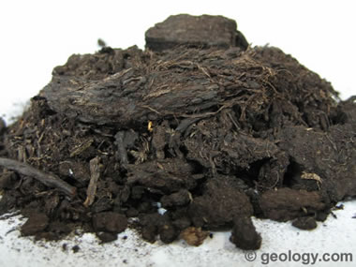
Lignite | Lignite is the lowest rank of coal. It is a peat that has been transformed into a rock and that rock is a brown-black coal. Lignite sometimes contains recognizable plant structures. By definition it has a heating value of less than 8300 British Thermal Units per pound on a mineral matter free basis. It has a carbon content of between 60 and 70% on a dry ash-free basis. In Europe, Australia and the UK some low-level lignites are called "brown coal". | 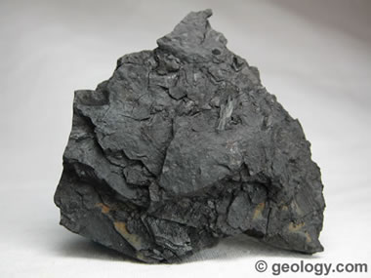
Sub Bituminous | Sub bituminous coal is a lignite that has been subjected to an increased level of organic metamorphism. This metamorphism has driven off some of the oxygen and hydrogen in the coal. That loss produces coal with a higher carbon content (71 to 77% on a dry ash-free basis). Sub bituminous coal has a heating value between 8300 and 13000 British Thermal Units per pound on a mineral matter free basis. On the basis of heating value it is subdivided into sub bituminous A, sub bituminous B and sub bituminous C ranks. | 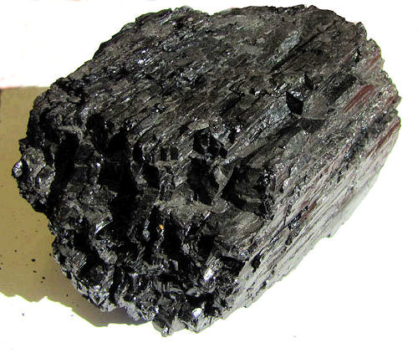
Bituminous | Bituminous is the most abundant rank of coal. It accounts for about 50% of the coal produced in the United States. Bituminous coal is formed when a sub bituminous coal is subjected to increased levels of organic metamorphism. It has a carbon content of between 77 and 87% on a dry ash-free basis and a heating value that is much higher than lignite or sub bituminous coal. On the basis of volatile content, bituminous coals are subdivided into low volatile bituminous, medium volatile bituminous and high volatile bituminous. Bituminous coal is often referred to as "soft coal," however this designation is a layman's term and has little to do with the hardness of the rock. | 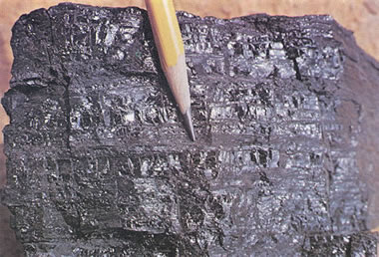
Anthracite | Anthracite is the highest rank of coal. It has a carbon content of over 87% on a dry ash-free basis. Anthracite coal generally has the highest heating value per ton on a mineral matter free basis. It is often subdivided into semi-anthracite, anthracite and meta-anthracite on the basis of carbon content. Anthracite is often referred to as "hard coal"; however this is a layman's term and has little to do with the hardness of the rock. | 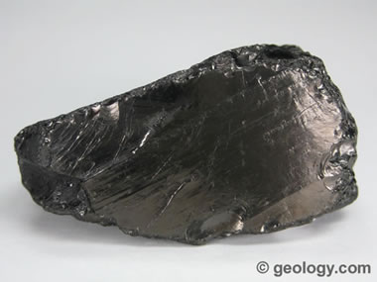

Source: King ‘05
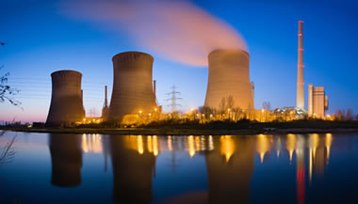
Coal is a combustible, brown or black sedimentary rock made of carbon, hydrogen, oxygen, nitrogen, and sulfur. Plentiful and cheap, coal is the most abundant fossil fuel produced in the United States. Coal is used around the world to fuel power plants and is an important resource for the iron and steel industries. But it is also highly polluting. Coal plants are the nation’s primary source of CO₂, the leading greenhouse gas. A typical coal plant generates 3.5 million tons of CO₂ per year; I 2011 utility coal plants in the United States emitted 1.7 billion tons of CO₂. There are four major types of coal: anthracite, bituminous, sub-bituminous, and lignite. They are classified by the type and amount of carbon they contain, and by the amount of heat energy they produce: Anthracite is a scarce coal found only in Pennsylvania. It is the hardest coal, and has a high carbon content (86-97 percent) that provides more energy than other coals. Bituminous is the most abundant type of coal, containing 45-86 percent carbon, and is between 100 and 300 million years old. It is found in West Virginia, Kentucky, and Pennsylvania. Sub-bituminous coal is the second-most abundant type of coal in the United States. It contains 35-45 percent carbon, is over 100 million years old, and is mined in Wyoming. Lignite is the youngest and softest coal, and tends to be high in moisture. It contains only 25-35 percent carbon, but is high in hydrogen and oxygen. It is mainly used by power plants and is found in Texas and North Dakota. Coal is mined by various methods, including drilling of vertical and horizontal shafts; strip mining, in which enormous shovels excavate surface layers of rock and earth to reveal coal seams; and mountaintop coal mining, in which entire mountaintops are removed, exposing coal deposits, while the waste rock is dumped into valleys and streams. Thanks to hydrofracking the U.S. is reducing coal use. In 1988, coal provided 60 percent of U.S. power, by 2012 that number has been cut in half, and coal generated only a third of U.S. electricity – about the same amount as natural gas. This shift was due in part to high costs and stricter emissions standards. Modern coal-fired plants take twice as long to build and are more expensive to run than gas-fired plants. And gas-fired plants meet environmental regulations far better than coal-fired plants. The Environmental Protection Agency (EPA) has proposed new limits on carbon emissions that would effectively ban new coal-fired plants after 2013 unless they are equipped with carbon capture and storage (CCS) technology. Expensive regulations and cheap gas could result in one-sixth of all coal-fired power plants in the United States – representing 50 gigawatts worth of power – being shuttered by 2017 (Prud’homme ’14: 10-13).


Coal has been used as an energy source around the world for centuries. The Chinese used it to smelt copper some 3,000 years ago. Coal is a cheap and plentiful fuel that has provided employment for millions of people around the world, and yet the carbon dioxide it produces is the most significant greenhouse gas, and it wafts ash into the air. This air pollution is environmentally destructive, and, according the National Research Council, kills more than 10,000 Americans every year. Nevertheless, coal remains popular, and provides two-fifths of the world’s electricity. In the last decade, the world’s electricity production has doubled, and two-thirds of that increase has been powered by coal. If this growth rate continues coal could supplant oil as the world’s primary energy source by 2017. The main drivers of increased coal use have been the surging economies of China and India, and steady demand from Western Europe. In 2001, according to the IEA, China’s demand for coal was roughly equivalent to 6 million tons of oil. By 2011, that demand has tripled, and China surpassed the United States as the largest energy producer in the world. China’s domestic coal industry produces more primary energy than oil from the Middle East. India’s demand for coal is also booming. By 2017, the IEA estimates that India could overtake the United States as the world’s second-largest user of coal. Coal is cheaper than natural gas in Europe, whose domestic gas industries lag far behind America’s. U.S. coal exports to European countries like Britain and Germany were up 26 percent in 2012 over 2011. Coal consumption in economically battered Italy and Spain has also jumped, despite efforts to capitalize on Italy’s wind and Spain’s sunshine (Prud’homme ’14: 12, 13). Coal imports to the U.S. are rising sharply even as coal mines close throughout Central Appalachia. A big reason, price. It costs $26 a ton to ship from a mine in Appalachia to power plants in Florida whereas it only costs $15 a ton to ship from Columbia. Labor costs are lower, so are shipping costs compared to a 100 car train with each car carrying 100 tons of coal. Coal imports surged 44% to 5.4 million metric tons during the first six months of 2014 compared with a year ago. Two-thirds came from Columbia. U.S. coal consumption is expected to increase 3% to 862 million tons this year, due to frigid weather experienced in the beginning of the year (Miller & Sweet ’14).

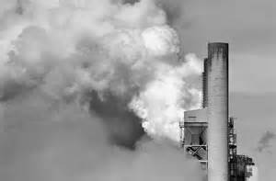
Coal is the dirtiest, most lethal energy source we have, but by most measured it’s also the cheapest. In 2011 21% of global fossil fuel CO₂ came from burning natural gas, mostly for heat and electricity. 35% came from oil, which is used primarily to make various transportation fuels. 44% came from burning coal. Air pollution in China, much of it from burning coal, is blamed for more than a million premature deaths a year. That’s on top of thousands who die in mining accidents, in China and elsewhere. In the late 17th century, when coal from Wales and Northumberland was lighting the first fires of the industrial revolution in Britain, the English writer John Evelyn was already complaining about the “stink and darkness” of the smoke that wreathed London. Three centuries later, in December 1952, a thick layer of coal-laden smog descended on London and lingered for a long weekend, provoking an epidemic of respiratory ailments that killed as many as 12,000 people in the ensuing months. On an October weekend in 1948, in the small Pennsylvania town of Donora, spectators at a high school football game realized they could see neither players nor ball: Smog from a nearby coal-fired zinc smelter was obscuring the field. In the days that followed, 20 people died, and 6,000 people, nearly half the town, were sickened. In spring of 2014 the Environmental Protection Agency (EPA) drafted new rules that would put an end to the limitless dumping of carbon pollution from our power plants under the Clean Air Act that has already been used to dramatically reduce the emission of sulfur dioxide, nitrogen oxides and soot particles form American power plants. In 2012 the world emitted a record 34.5 billion metric tons of carbon dioxide from fossil fuels. Coal was the largest contributor. Cheap natural gas has lately reduced the demand for coal in the U.S., but everywhere else, especially in China, demand is surging. During the next two decades several hundred million people worldwide will get electricity for the first time, and if current trends continue, most will use power produced by coal. Though coal burning has plateaued in countries like the U.S., it has soared in rapidly industrialization countries like China and India. World coal consumption rose by 54 percent from 2000 to 2011 (Nijjuis ’14: 32, 34).
Older coal-fired power plants without effective fly ash capture are one of the largest sources of human-caused background radiation exposure. When coal is burned, uranium, thorium and all the uranium daughters accumulated by disintegration — radium, radon, polonium — are released. According to a 1978 article in Science magazine, "coal-fired power plants throughout the world are the major sources of radioactive materials released to the environment". Radioactive materials previously buried underground in coal deposits are released as fly ash or, if fly ash is captured, may be incorporated into concrete manufactured with fly ash. Radioactive materials are also released in gaseous emissions. The United Nations Scientific Committee on the Effects of Atomic Radiation estimates that per gigawatt-year (GW_{e}a) of electrical energy produced by coal, using the current mix of technology throughout the world, the population impact is approximately 0.8 lethal cancers per plant-year distributed over the affected population. With 400 GW of coal-fired power plants in the world, this amounts to some 320 deaths per year (UNSCEAR ’00). With coal likely to remain one of the nation's lowest-cost electric power sources for the foreseeable future, the United States has pledged a new commitment to even more advanced clean coal technologies. In the late 1980s and early 1990s, the U.S. Department of Energy Clean Coal Initiative has conducted a joint program with industry and State agencies to demonstrate the cleanest coal plants and CO₂ sequestering technologies are being implemented that sequester > 90% of CO₂ emissions as has already been done to eliminate mercury emissions from coal burning plants (DOE ’08).
Capturing carbon dioxide and storing or “sequestering” it underground in porous rock formations has been subjected to some $6.5 billion of Energy Department research. For more than four decades the oil industry has been injecting compressed carbon dioxide into depleted oil fields, using it to coax trapped oil to the surface. On the Canadian Great Plains this practice has been turned into one of the world’s largest underground carbon-storage operations. Since 2000 more than 20 million tons of carbon dioxide have been captured from a North Dakota plant that turns coal into synthetic natural gas, then piped 200 miles north into Saskatchewan. There the Canadian petroleum company Cenovus Energy pushes the CO₂ deep into a sprawling oil patch that had its heyday in the 1960s. Two to three barrels of oil are dissolved out of the reservoir of rock by each ton of CO₂, which is then re-injected into the reservoir for storage nearly a mile underground, trapped under impermeable layers of shale and salt. Some natural deposits of carbon dioxide have been in place for millions of year, and CO2 in some has been mined and sold to oil companies. But large and sudden releases of CO₂ can be lethal to people and animals, particularly when the gas collected and concentrates in a confined space. Venting CO₂ from a smokestack is usually free, like littering. Capturing and storing CO₂ underground would cost up to a quarter of a plant’s energy – and a lot of money. It won’t become the norm unless governments make it happen. Furthermore, there is considerable seismic risk (Nijhuis ’14: 35, 36).

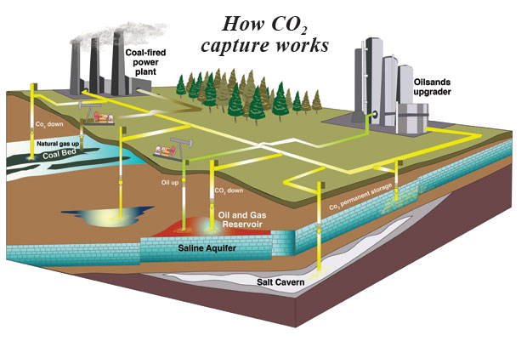The four steps of capturing and storing carbon dioxide are capture, transport, injection and monitoring. Capture: the CO₂ is separated from other stack gases and compressed into a liquid-like state. This is the most costly step in CCS. Transport: Fluid CO₂ is moved to a storage reservoir. Pipelines are the most efficient carrier, but trucks, trains, and ships can do the job. Injection: CO₂ is injected deep underground into a porous formation – an old oil field or a saline aquifer – under a cap rock that deters leaks. Monitoring: The reservoir must be watched in perpetuity for leaks. Even slow ones could defeat the purpose of preventing climate change. It is estimated that 3.5 million metric tons of CO₂ are planned to be captured at the first U.S. power plant equipped for CCS. Currently 1.5 billion metric tons of CO₂ are put out by all U.S. coal-fired power plants. At sites where the rock is brittle and faulted – possibly most sites, the injection of carbon dioxide might trigger small earthquakes that, even if otherwise harmless, might crack the overlying shale and allow CO₂ to leak. Although carbon storage is an extremely expensive and risky strategy carbon can be stored effectively at some sites such as the Sleipner gas field in the North Sea, where for the past 17 years the Norwegian oil company Statoil has been injecting about a million tons of CO₂ a year into a brine-saturated sandstone layer half a mile below the seabed. That formation has so much room that all that CO₂ hasn’t increased its internal pressure, and there’s been no sign of earthquakes or leaks. In 1991 Norway instituted a carbon tax, which now stands at around $65 a metric ton; it costs Statoil only $17 a ton to reinject the CO2 below the seafloor. European researchers estimate that a century’s worth of European power plant emissions could be stored under the North Sea. According to DOE, similar “deep saline aquifers” under the U.S. could hold more than a thousand years’ worth of emissions from American power plants. Other types of rock also have potential as carbon lockers. In experiments now under way in Iceland and in the Columbia River Basin of Washington State, small amounts of carbon dioxide are being injected into volcanic basalt. There the gas is expected to react with calcium and magnesium to form a carbonate rock – thus eliminating the risk of gas escaping. The energy intensive steps of heating the absorbent and compressing the CO₂ for storage create what engineers call a “parasitic load” one that could consume as much as 30 percent of the total energy output of a coal plant that was capturing all its carbon. At Mountaineer power plant the CO₂ absorption system was the size of a ten story apartment building covering 14 acres, and that was just to capture a small fraction of the plant’s carbon emissions. One way to reduce the costly loss is to gasify the coal before burning it. Gasification can make power generation more efficient and allows the carbon dioxide to be separated more easily and cheaply. Existing plants, which are generally designed to burn pulverized coal, require a different approach. One idea is to burn the coal in pure oxygen instead of air. That produces a simpler flue gas from which it’s easier to pull the CO₂ (Nijhuis ’14: 36, 37).

The Intergovernmental Panel on Climate Change report of 2013 estimated an emissions budget for the planet – the total amount of carbon that can be released if we don’t want the temperature rise to exceed 2 degrees Celsius (3.6 degrees Fahrenheit), a level many scientists consider a threshold of serious harm. 84% of U.S. greenhouse gases emitted by human activity is CO₂. It was 800,000 years ago that the CO₂ level was as high as it was today. There has been a 108% increase in global per capita emissions between 1950 and 2000. To limit global warming since the 19th century to 2°C (3.6°F) and thereby avoid its worst effects, scientists estimate we must limit our cumulative emissions of carbon as CO₂ to a trillion metric tons. As of 2012 by burning fossil fuels, making cement, cutting trees, and so one, we had emitted 545 billion tones. We’re on course to pass a trillion by 2040. Changing that course with carbon capture would take a massive effort. To capture and store just a tenth of the world’s current emissions would require pumping about the same volume of CO₂ underground as the volume of oil we’re now extracting. It would take a lot of pipelines and injection wells. But achieving the same result by replacing coal with zero-emission solar panels would require covering an area almost as big as New Jersey (nearly 8,000 square miles). Carbon capture and storage is hoped to reduce global emissions by roughly 80 percent in the next 30 to 40 years. Carbon capture has the potential to deliver big emissions cuts quickly. Capturing the CO₂ from a single thousand-megawatt coal plant, for example, would be equivalent to 2.8 million people trading in pickups for Priuses. The first American power plant designed to capture carbon is scheduled to open at the end of 2014. The Kemper County coal-gasification plant in eastern Mississippi will capture more than half its CO₂ emissions and pipe them to nearby oil fields. The project has been plagued with cost overruns and opposition from both environmentalists and government-spending hawks. But Mississippi Power, has pledged to persist. Company leaders say the plant’s use of lignite, a low-grad coal that’ plentiful in Mississippi, along with a ready market for its CO₂, will help offset the heavy cost of pioneering new technology. If the EPA regulates carbon emissions from both existing and new power plants and if those rules survive court challenges – the carbon capture will get that long awaited boost (Nijhuis ’14: 38, 40).

In the 1990s the EPA used the Clean Air Act to impose a cap on total emissions of sulfur dioxide form power plants, allocating tradable pollution permits to individual polluters. The power industry predicted disastrous economic consequences, instead the scheme produced innovative, progressively cheaper technologies and significantly cleaner air. Century old American power plants are closing and converting to natural gas. With gas prices in the U.S. near record lows, coal can look like yesterday’s fuel, and investing in advanced coal technology can look misguided at best. The view from Yulin, China is different. The sandy plateaus around Yulin are punctuated with the tall smokestacks of coal power plants, and enormous coal-processing plants, with dormitories for live-in workforces, sprawl for miles across the desert. Coal provides about 80 percent of China’s electric power. Coal is also used form making dozens of industrial chemicals, from plastic to rayon, and liquid fuels, like petroleum in other countries. Coal has made China first among nations in total carbon dioxide emissions, though the U.S. remains far ahead in emissions per capita. Although China has not yet begun to retreat from coal, China has invested hundreds of billions of dollars in renewable energy. It’s now a top manufacturer of wind turbines and solar panels; enormous solar farms are scattered among the smokestacks around Yulin. The country is pushing for ultraefficient coal power and simpler, cheaper carbon capture. In Tinajin, about 85 miles from Beijing, China’s first power plant deigned from scratch to capture carbon is schedule to pen in 2016. Called GreenGen, it's eventually supposed to capture 80 percent of its emissions (Nijhuis ’14: 40, 38, 39).

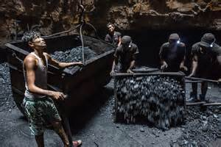
India has 300 million people without electricity and the fifth largest coal reserves in the world. Coal, which accounts for 59 percent of India’s electric capacity. That dependence on fossil fuels is why India ranks fourth behind China, the United States, and the European Union in global greenhouse gas emissions. To move its domestic coal, India relies on a few overburdened rail lines that chug along from production centers in the east of the country to consumption centers in the west and south. Because of that bottleneck and other factors, notably a continually mounting demand, government-owned Coal India—which produces 80 percent of India's supply—has consistently fallen short of production targets. That has left power plants chronically short of coal stocks and producing less electricity than they're capable of. The country is plagued by blackouts, most notably the massive outage that affected more than 600 million people in 2012. The country's net coal import dependency soared "from practically nothing in 1990 to nearly 23 percent in 2012." (Ravindran ’14). The pressure to produce coal is taking its toll on miners, many of whom work in illegal and enormously dangerous mines. Northeastern India has a long history of coal mining and fires ignited by mining accidents almost a century ago still smolder in deeply buried coal deposits. There are hundreds of coal mines in eastern India that are neither sanctioned nor regulated by government. Conditions in these unlicensed facilities are very primitive relying mostly on manual labor. 19th century mines in the U.S. or Europe were similar but they are much safer now (Nijhuis ’14: 41-62). Since the U.S. Mining Health and Safety Act of 1977, that created the Occupational Safety and Health Administration (OSHA) Mining Health and Safety Administration (MHSA) mining fatalities per 100,000 workers declined from over 100 to around 40, about the same as farming, and mining is no longer the nation’s most dangerous profession, that is fishing and then logging (Sanders ’14).

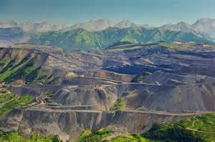
The world gets huge amounts of energy from coal, puts huge energy into extracting it from the ground and significantly pollutes the air. Australia is second only to Indonesia in coal exports. China burns nearly half the world’s coal, mostly to a support a 13 fold increase in electricity generation since 1980. Demand is still growing. So is public outrage over the filthy air in Chinese cities, which has been linked to 1.2 million deaths a year. Workers who pick rocks from low-priced coal in the Shanxi Province often work without masks and earn three dollars for an eleven hour shift. The U.S. mines more than a billion tons of coal a year. Once it came mostly from underground mines in the East; now strip mines in the West dominate. Domestic demand has fallen lately, but exports to Europe and Asia have increased. They call it mountaintop removal. For each ton of coal taken form the Hobet 21 mine, 20 cubic yards of mountain are blasted away, then dumped in valleys. Hundreds of square miles of Appalachian ridges have been dismantled that way. The U.S. produces around 1 billion tons of coal annually.


Both surface and underground mining leads to massive ecosystem degradation. During the process vegetation is destroyed and the topo-sequence of the landscape and physico-chemical properties of the soils are rapidly changed as result f the large scale dumping of mine spoils on the unmined lands. The mine spoils are infertile, biologically inert and toxic to plants. The mine spoil heaps remain barren fro several years due to their unstabled, erodible, and hostile characters. Mine spoils consist of about 60% gravel (>2mm particles) and 40% soil. The soil (<2 mm particles) is mostly composed of sand (about 88-94%). Mine spoils are extremely acidic. The 2 year mine spoils are as acidic as pH 3.2 which does not change significantly up to 5 years of age, but increases significantly when the mine spoils attain 10 years of age. Despite this increase, the pH is still much lower than that of the adjacent soil, and even 20 years is not sufficient for complete recovery of the pH in the mine spoils. Calcium and magnesium carbonate can potentially neutralize acidity in the mine spoils. In the two year old mine spil organic matter, N, P, K, Ca and Mg is around one-third that of surrounding grasslands. By 10 years organic matter and minerals are more than three-fourths that of surrounding grasslands. The degraded land may be restored by revegetating it with plants. Successful reclamation on such lands depends on the adaptive ability of the seedling and topsoil replacement, mulching with sawdusts, hays, and other plant residues, applying sewage, sludge and liming and fertilizer amendments. The coal mine spoils of Dhanpuri coal field in Madhya Pradesh, India, were revegetated by growing plants in the pits after leveling the surface of the coal mine dumps. Pits of 60 cm³ were dug on the slopes and tops and were filled with forest soils and 5 kg of farm yard manure. Of 30 species studies, 24 were suitable for revegetation, including food crops, at one site (Boral & Lyngdoh ’96: 457-466). Although it seemed easier to use much-studied exotics such as grease grass (Melinis minutiflora) and Brachiaria decumbens for achieving rapid ground cover or pine and eucalyptus for reforestation, researchers in Brazil considered native species important. Between 1977-1991 46% of publications concerned natives, 8% exotics and 46% used both native and exotic species for mine replantings (Griffith et al ’96: 485-487) (Sanders ’14: 61).

The break-even price for electricity produced by a modern coal-fired plant is about 5.9 cents per kilowatt-hour. At $5 per million BTUs, the price of electricity from gas is about the same as that from coal; but when natural gas prices drop below $5 per MBTU, then coal cannot compete. The cost of producing wind power is about 8.0 cents per kilowatt-hour. Wind can compete with $5 per MBTU gas only if it can continue to benefit from the government’s production tax credit, currently 2.2 cents per kilowatt-hour. If gas prices were to rise above $8.3 per MBTU, wind would be competitive eve in the absence of the production tax credit(PTC). But in this case coal plants would be cheaper than either gas or wind-generated power. Thus is gas prices rise above $5 per MBTU, a carbon tax may be required to ensure that gas maintains its edge over coal. Similarly, should gas prices drop below $8.3 per MBTU, the production tax credit or similar initiatives might be required to support wind and solar energy. If we are to achieve a low-carbon future, the Harvard researchers write, gas prices must remain low enough to marginalize coal but not so low that renewable energy is rendered uncompetitive (Prud’homme ’14: 126, 127).

H. Nuclear
Uranium was produced in the fiery destruction of ancient stars. These stars exploded to provide “dust” which clustered together to make planets including Earth. Uranium is one of the star-born elements of Earth. The atomic age was born in 1939 when physicists burst apart from the nucleus of a uranium atom, releasing a tremendous amount of energy as heat and light. They called this reaction nuclear fission. Nuclear fission was first used to make atomic bombs during World War II and was soon controlled to produce electricity. Today, nuclear energy is used widely for electricity generation. It is also used to power Navy submarines and some aircraft carriers. Nuclear power plants depend on fissionable materials, which include radioactive elements. These material release the energy bound in their atoms in a nuclear chain reaction. In most cases, these radioactive element used is uranium. Uranium is so reactive that it will produce its own atomic reaction without any human help. Uranium is very hard and dense weighing about 150 pounds per gallon. Uranium is found in many parts of the world, including the United States, but there is a limited supply though scarcity is less of an issue than it is for fossil fuels because uranium is used in much smaller quantities. In a nuclear power plant the process of nuclear fission, splitting uranium nuclei is accelerated. The process produces enough heat for steam to power a turbine generator. High-energy subatomic particle, neutrons are caused to bombard the uranium atom’s nucleus, breaking it apart. When the nucleus splits, it releases heat and light as well as neutrons. These particles strike other uranium atoms, splitting those as well, producing a nuclear chain reaction. The amount of energy produced by splitting one uranium nucleus isn’t much. However, because uranium is so dense, one pound of uranium has billions of nuclei and once a chain reaction is started a lot of energy is released. In a nuclear power plant this reaction is carefully controlled to allow just the right release of heat and energy needed to produce electricity (Nemzer ’10: 125-127).

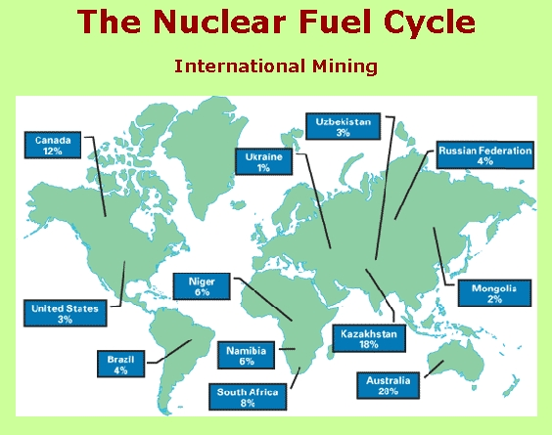

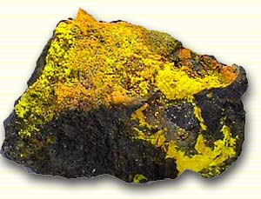
A nuclear reactor is only part of the life-cycle for nuclear power. The process starts with mining. Uranium mines are underground, open-pit, or in-situ leach mines. In any case, the uranium ore is extracted, usually converted into a stable and compact form such as yellowcake, and then transported to a processing facility. Here, the yellowcake is converted to uranium hexafluoride, which is then enriched using various techniques. At this point, the enriched uranium, containing more than the natural 0.7% U-235, is used to make rods of the proper composition and geometry for the particular reactor that the fuel is destined for. The fuel rods will spend about 3 operational cycles (typically 6 years total now) inside the reactor, generally until about 3% of their uranium has been fissioned, then they will be moved to a spent fuel pool where the short lived isotopes generated by fission can decay away. After about 5 years in a spent fuel pool the spent fuel is radioactively and thermally cool enough to handle, and it can be moved to dry storage casks or reprocessed. Uranium is a fairly common element in the Earth's crust. Uranium is approximately as common as tin or germanium in the Earth's crust, and is about 40 times more common than silver. Uranium is a constituent of most rocks, dirt, and of the oceans. The fact that uranium is so spread out is a problem because mining uranium is only economically feasible where there is a large concentration. Still, the world's present measured resources of uranium, economically recoverable at a price of 130 USD/kg, are enough to last for between 70 and 100 years. According to the OECD in 2006, there is an expected 85 years worth of uranium in identified resources, when that uranium is used in present reactor technology, with 670 years of economically recoverable uranium in total conventional resources and phosphate ores, while also using present reactor technology, a resource that is recoverable from between 60-100 US$/kg of Uranium. with a pure fast reactor fuel cycle with a burn up of, and recycling of, all the Uranium and actinides, actinides which presently make up the most hazardous substances in nuclear waste, there is 160,000 years worth of Uranium in total conventional resources and phosphate ore. Current light water reactors make relatively inefficient use of nuclear fuel, fissioning only the very rare uranium-235 isotope. As opposed to current light water reactors which use uranium-235 (0.7% of all natural uranium), fast breeder reactors use uranium-238 (99.3% of all natural uranium). It has been estimated that there is up to five billion years' worth of uranium-238 for use in these power plants. Nuclear reprocessing can make this waste reusable, and more efficient reactor designs, such as the currently under construction Generation III reactors achieve a higher efficiency burn up of the available resources, than the current vintage generation II reactors, which make up the vast majority of reactors worldwide

At a nuclear fuel processing plant, the natural uranium is “enriched” at mechanical process that increased the U-235 concentration by about 4 percent to make the uranium more useful. The enriched uranium is formed into pellets the size of the tip of a finger. Each pellet contains the energy equivalent of a pick-up truck full of coal, 150 gallons of oil, or a house-sized container of natural gas. The pellets are loaded into long metal fuel rods. Many fuel rods are placed into a reactor core, interspersed with moveable control rods holding a material that absorbs neutrons. Pushed in or out of the core, the control rods govern the size of the reaction (and, therefore the amount of energy produced). The fission reaction is started with high-energy neutrons from uranium inserted into the reactor. These neutrons bombard the pellets, splitting some of the uranium nuclei. This releases more neutrons, causing the chain reaction that produces heat and light. A liquid or gas flows past the fuel rods in the reactor core, carrying some of the heat to a heat exchanger. In the heat exchanger, this heat is transferred to water that boils and makes steam to spin the turbines. The rest of the system works like a traditional steam-driven power plant. Uranium requires caution through many stages. It is less hazardous in its natural state than later; but danger of inhaling or swallowing exists while it is mined and milled, and dangers increase as it is enriched. The amount of waste produced from nuclear reactors is small in comparison to the energy produced. The waste from one person’s lifetime use of nuclear power has been estimated to occupy the space of a soda can, whereas waste from coal power over that time can be 68 tons of solids and 77 tons of carbon dioxide. Nuclear waste, even in small doses is lethal and remains hazardous for tens of thousands of years. 72 storage facilities in the U.S. hold an estimated 50,000 tons of spent fuel. Spent fuel is still radioactive. It must be handled carefully and stored safely in a secure place. Radioactivity decreases over time some estimate a 99 percent drop in 40 years. But decrease does not mean elimination; waste remains dangerous for many generations. A portion of the spent fuel is removed periodically from the reactor, about every 18 months; each nuclear pellet may last5 years. After removal, the fuel still retains most of its energy. If recycled it could be used in a modern efficient plant. The U.S. does not reprocess their fuel. One reason nuclear fuel is not recycled in the U.S. is because a reprocessing byproduct is plutonium, usable in weapons. High cost of reprocessing is another deterrent. Nuclear power emits no carbon. A huge amount of energy can be produced from very little fuel. One nuclear power plant can produce hundreds to thousands of megawatts of baseload power. In the U.S. nuclear power plant back-up safety systems helped to avoid several nuclear power plant disaster, such as 1979’s contained accident in Three Mile Island in Pennsylvania. Although fuel costs are low construction and decommissioning are very expensive. Nuclear power provides about 19 percent of all electricity in the United States, second only to coal. The U.S has over 100 nuclear power plants, more than any other country. The largest nuclear power plant in the U.S. is the Palo Verde plant in Arizona. It can generate up to 3,921 MW. Almost 15 percent of the world’s electricity is produced from over 400 nuclear power plants. At 75 percent, France produces a larger proportion of electricity using nuclear energy than any other nation (Nemzer ’10: 125-131).

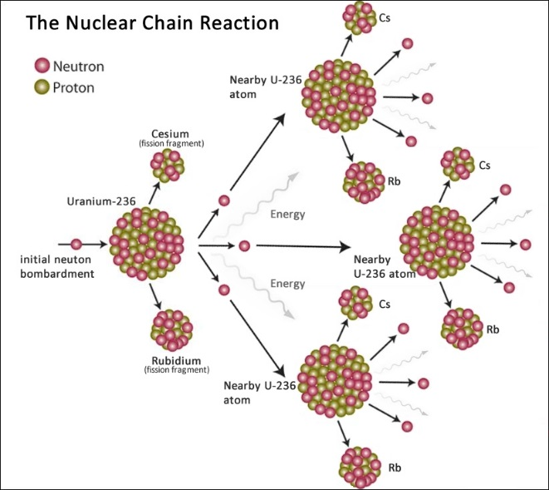
Nuclear power is produced by splitting atoms, not by burning fuel. When the nucleus of a large atom splits in two, energy is released. This is called nuclear fission. There are currently more than 400 nuclear power stations around the world. Together, they generate approximately sixteen percent of the world’s electricity. There are currently 104 nuclear power plants in the United States, 69 Pressurized Water Reactors (PWRs) and 35 Boiling Water Reactors (BWRs), which generate about 20% of the United States’ electrical use, mostly on the East Coast. (NRC ’11).
Nuclear power generation is clean, but there are major concerns about its safety and cost. The fuel source is the metal uranium. Only a tiny amount is needed because 15.5 ounces (500 grams) of its metal produces the same quantity of heat as 1,400 tons of coal. The uranium atom is large and unstable. Its instability means that neutrons are given off by the nucleus. These neutrons move fast and may bump into other uranium atoms, causing them to split and release heat energy. This sets off a chain reaction, with nucleus after nucleus splitting. When this occurs, vast amounts of energy are released. But this chain reaction has to be controlled or a massive explosion will result. This is exactly what happened in early atomic bombs. Fission reactions can be controlled if some of the neutrons are absorbed.
A process called nuclear fusion powers the sun. The high temperature of the sun causes small nuclei to collide into each other with such force that they fuse to form one heavier nucleus. At the same time energy is released. Scientists are hoping that the next generation of nuclear power stations will be powered by nuclear fusion. The fuel will be heavy hydrogen, called deuterium, and the waste material will be water. When to nuclei of heavy hydrogen fuse, their combined masses are slightly less than the mass of the original particles. This tiny amount represents the energy. The energy can be harnessed and used to generate electricity. The problem is that the fuel has to be heated to temperatures of up to 212 million °F (100 million °C) and has to be contained by very powerful magnets. Scientists have built small prototype reactors and have even managed to make the nuclei fuse. But it only worked for a few seconds and used far more energy than was released by the fusion. To make electricity commercially, a fusion reactor will have to work consistently for decades. A fusion reactor will not be available for decades. The atomic bombs that fell on Japan at the end of World War II were based on the fission reaction. Atomic bombs contain uranium or plutonium, which is split to release vast amounts of energy and radioactive particles. The hydrogen bomb, also known as a thermonuclear bomb, is different. It relies on the fusion reaction, and its fuel is a special form of hydrogen. The explosion of a hydrogen bomb creates an extremely hot zone near its center, which vaporizes nearly all matter present to form a gas at extremely high pressure (Morgan ’03: 44, 45). Construction of the International Thermonuclear Experimental Reactor facility began in 2007, but the project has run into many delays and budget overruns. The facility is now not expected to begin operations until the year 2027 – 11 years after initially anticipated.

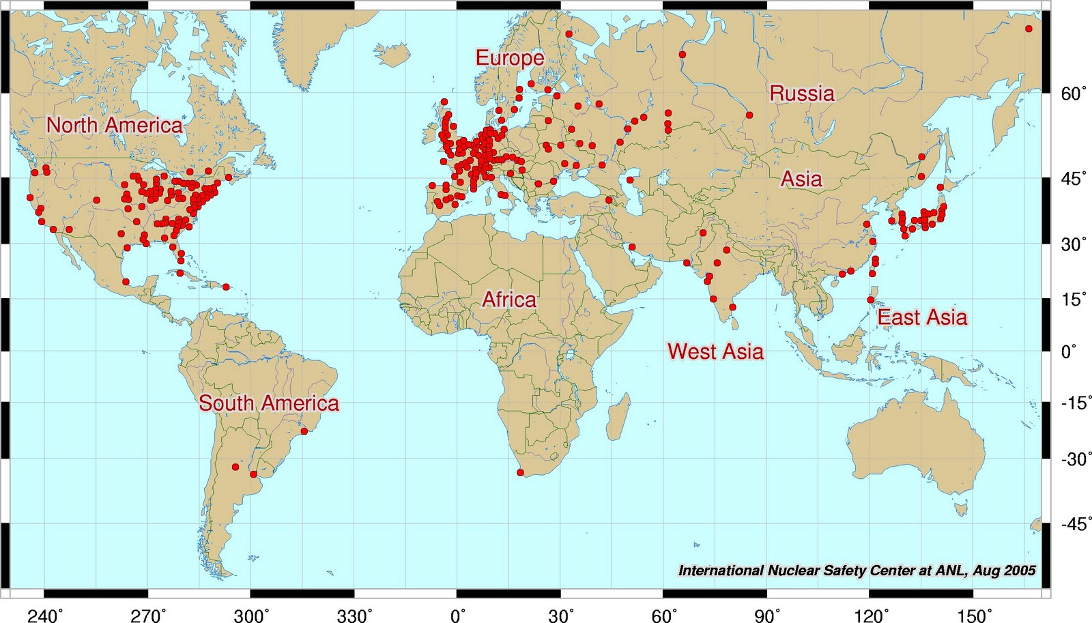

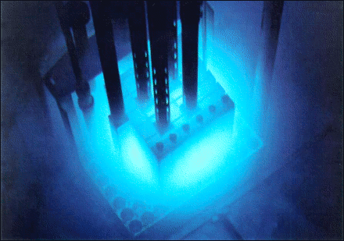
Nuclear fission takes place inside a reactor that is surrounded by a thick layer of concrete or steel. One of the more advanced designs for a nuclear power station is the advanced gas-cooled reactor. The uranium is spread out in thin fuel rods and lowered into the reactor. Control rods are between the fuel rods. They are made of a material called boron, which absorbs neutrons. By lowering and raising the control rods, it is possible to control the chain reaction. If the control rods are lowered, more neutrons are absorbed and the chain reaction slows down. Both the fuel and control rods are surrounded by a moderator. This is a substance, such as graphite, that does not change during the reactions but helps to slow down the neutrons. Carbon dioxide gas is pumped around the reactor to take up heat from the reaction within the reactor. The hot carbon dioxide is used to heat water to produce steam. There are major problems with nuclear power. When uranium atoms split, they produce smaller particles, which are radioactive. These radioactive particles can cause cancer and even death. Therefore, the thick layer of concrete or lead around the reactor is essential to prevent these particles from entering the environment. However, once the uranium is used up, the fuel rods have to be replaced. Used fuel fords are highly radioactive, as are the control rods. The reactor has a life of up to 50 years, after which time it can no longer be used. Careful disposal is needed for all of these radioactive materials, but there are no guaranteed safe disposal methods. High energy radioactive particles can pass deep into the body, where they damage or kill cells. Exposure to a large dose of radiation will kill a large number of cells. The long-term damage can include cancer. Damage to cells in the reproductive system can cause birth defects in children, such as missing limbs and brain damage (Morgan ’03: 42, 43).

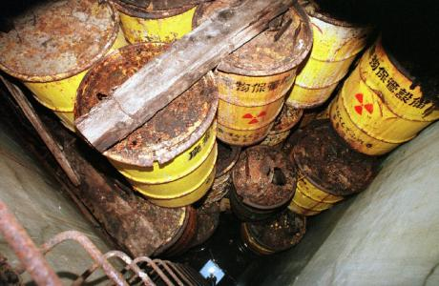
The most important waste stream from nuclear power plants is spent nuclear fuel. It is primarily composed of unconverted uranium as well as significant quantities of transuranic actinides (plutonium and curium, mostly). The actinides (uranium, plutonium, and curium) are responsible for the bulk of the long-term radioactivity, whereas the fission products are responsible for the bulk of the short-term radioactivity. High-level radioactive waste management concerns management and disposal of highly radioactive materials created during production of nuclear power. The technical issues in accomplishing this are daunting, due to the extremely long periods radioactive wastes remain deadly to living organisms. Of particular concern are two long-lived fission products, Technetium-99 (half-life 220,000 years) and Iodine-129 (half-life 15.7 million years), which dominate spent nuclear fuel radioactivity after a few thousand years. The most troublesome transuranic elements in spent fuel are Neptunium-237 (half-life two million years) and Plutonium-239 (half-life 24,000 years). Consequently, high-level radioactive waste requires sophisticated treatment and management to successfully isolate it from the biosphere. This usually necessitates treatment, followed by a long-term management strategy involving permanent storage, disposal or transformation of the waste into a non-toxic form. Reprocessing can potentially recover up to 95% of the remaining uranium and plutonium in spent nuclear fuel, putting it into new mixed oxide fuel. This produces a reduction in long term radioactivity within the remaining waste, since this is largely short-lived fission products, and reduces its volume by over 90%. Reprocessing of civilian fuel from power reactors is currently done in Britain, France and (formerly) Russia, soon will be done in China and perhaps India, and is being done on an expanding scale in Japan. The full potential of reprocessing has not been achieved because it requires breeder reactors, which are not commercially available. France is generally cited as the most successful reprocessor, but it presently only recycles 28% (by mass) of the yearly fuel use, 7% within France and another 21% in Russia. Reprocessing is not allowed in the U.S. The Obama administration has disallowed reprocessing of nuclear waste, citing nuclear proliferation concerns. In the U.S., spent nuclear fuel is currently all treated as waste. Presently, waste is mainly stored at individual reactor sites and there are over 430 locations around the world where radioactive material continues to accumulate.

Fukushima fused international will to terminate the construction of nuclear power projects and transition to alternative energy sources. The area surrounding the leak will need to be evacuated for thousands of years (Sanders ’11) it is proposed to plant the area(s) surrounding Fukushima and other sites of concern with Purple spiderworts. Purple spiderworts (Tradescantia bracteata) are natural radiation detectors, the stamen hairs on these sensitive wildflowers change from blue to pink when exposed to as little as 150 millirems of radiation, 1.5 millisieverts (mSv) (Weiss et al ’91: 169). Lower levels of radiation than are detectable by scientific instruments. The stamens of the Spiderwort flower are usually blue or blue-purple. Within a couple weeks of being exposed to 1.5 mSv radiation, the stamens turn pink. Spiderwort is found from Montana to Kansas eastward to Michigan and Indiana. Spiderworts are very distinctive late spring/early summer prairie wildflowers. Growing knee-high, their (usually) blue flowers stand out among the green of the new grass. Each blossom lasts only one day. The stems, leaves and flowers of spiderworts are edible. The herbage may be eaten raw or added to stews. The flowers may be pink, blue or rose-purple and make an attractive edible garnish for salads. Spiderworts may be easily propagated from stem cuttings or seeds (Mason ’11)
Human radiation exposure as a result of reactor accidents is generally characterized in three ways: total or partial body exposure as a result of close proximity to a radiation source, external contamination, and internal contamination. Acute radiation sickness can be categorized into three phases: prodrome, latency, and illness. Patients with modest whole-body doses (<2 Gy) may require only symptomatic support for nausea and vomiting. In patients with whole-body doses of more than 2 Gy, the treatment of the consequences of bone marrow depletion is paramount. Strategies include management of infections with antibiotics and antiviral and antifungal agents, the use of hematopoietic growth factors, and possibly bone marrow transplantation. The use of bone marrow transplantation is controversial, since outcomes after radiation accidents have been poor. After Chernobyl, only 2 of the 13 patients who underwent bone marrow transplantation survived long term. Among increased risk for thyroid neoplasm remains elevated for at least 40 years after exposure to iodine-131,that has an 8 day half-life. Potassium iodide tablets prevent iodine-131 absorption. Internal exposure to Caesium-137, that has a 30 year half-life, through ingestion or inhalation, allows the radioactive material to be distributed in the soft tissues, especially muscle tissue, exposing these tissues to the beta particles and gamma radiation and increasing cancer risk. Prussian blue helps the body excrete caesium-137. Internal exposure to Strontium-90 is linked to bone cancer, cancer of the soft tissue near the bone, and leukemia. Plutonium-239 is particularly long-lived and toxic with a half-life of 24,000 years and remains hazardous for tens of thousands of years (Christodouleas et al ’11).

The Chernobyl nuclear reactor that occurred on 26 April 1986 was the most serious accident ever to occur in the nuclear power industry. The reactor was destroyed in the accident, considerable amounts of radioactive materials were released to the environment and many workers were exposed to high doses of radiation that had serious, even fatal, health consequences (see below).Among the residents of Belarus, the Russian Federation and Ukraine, well over a thousand cases of thyroid cancer (about 1,800) have been reported in children. The accident at the Chernobyl reactor happened during an experimental test of the electrical control system as the reactor was being shut down for routine maintenance. The operators, in violation of safety regulations, had switched off important control systems and allowed the reactor to reach unstable, low-power conditions. A sudden power surge caused a steam explosion that ruptured the reactor vessel, allowing further violent fuel-steam interactions that destroyed the reactor core and severely damaged the reactor building. Average doses to those persons most affected by the accident were about 100 mSv for 240,000 recovery operation workers, 30 mSv for 116,000 evacuated persons and 10 mSv during the first decade after the accident to those who continued to reside in contaminated areas. It is noteworthy that an earlier accident in 1979 at the Three Mile Island reactor in the United States of America also resulted in serious damage to the reactor core but without a steam explosion. The containment building surrounding the reactor however prevented the release of all but trace amounts of radioactive gases (UNSCEAR ’00: 13-15).

The meltdown of several reactors at the Fukushima Daiichi and Daiini plants after the 2011 Tōhoku earthquake and tsunami, that killed 14,000, were rated at level 7 on the International Nuclear Event Scale. The total amount of iodine-131 and caesium-137 released into the atmosphere has been estimated at 6.3 x 10¹⁷ Bq around 10% of the emissions from the Chernobyl accident estimated at 5.2 x 10¹⁸ (TEPCO ’11) A zone within 20-30 km from the plant was evacuated. Some agricultural products and seafood within 50 km were irradiated beyond the legal limit. Removal of debris reduced the radiation measurements from localized highs of up to 900 mSv/hr to less than 100mSv/hr at all exterior locations near the reactors. Radiation levels in Tokyo on 15 March were at one point measured at 0.809 μSv/hour although they were later reported to be at "about twice the normal level", later, that day, the wind direction changed and radiation levels were lower and the average radiation dose rate over the whole day was 0.109 μSv/h. Drinking water in Tokyo, Fukushima and Ibaraki was above regulatory safe level for iodine-131 and caesium-137 in drinking water in Japan, 100 Bq/kg and 200 Bq/kg respectively, between 16 and 21 March, until falling to undetectable levels on 27 April. By 18 March radioactive fallout including isotopes of iodine-131, iodine-132, tellurium-132, iodine-133, caesium-134 and caesium-137 was detected in air filters at the University of Washington, Seattle, USA until dropping to undetectable levels after 28 April. Worldwide measuring stations ranged from 10 PBq to 700 PBq. This estimate was 1% to 40% of the 1,760 PBq of I-131 estimated to be release at Chernobyl (Wotawa ’11). The maximum permissible dose for Japanese nuclear workers was 100 mSv per year, but on 15 March 2011, the Japanese Health and Labor Ministry increased that annual limit to 250 mSv, for emergency situations. This level is below the 500 mSv/year considered acceptable for emergency work by the World Health Organization. The skeleton crew of volunteer contractors suffered at least 19 exposures in excess of 100 mSv.
In light of the fukushima catastrophe, the global community has resolved to phase out, abolish and replace nuclear reactors with alternative energy sources, that do not threaten present and future generations (Ramdas ’11)(Weeramantry ’11)(Joint Statement on the Japanese Nuclear Disaster ’11), namely solar (Ramdas ’11). The Atomic Energy Commission established by the Atomic Energy Act of 1954, 42USC(23)§2011 et seq until it was terminated in the Disposal of Atomic Energy Communities 42USC(24)§2301. The Nuclear Regulatory Commission was established by the Energy Reorganization Act of 1974, 42USC(73)§5841 et seq.

The cost of nuclear power has followed an increasing trend whereas the cost of electricity is declining for wind power. In about 2011, wind power became as inexpensive as natural gas, and anti-nuclear groups have suggested that in 2010 solar power became cheaper than nuclear power. Data from the EIA in 2011 estimated that in 2016, solar will have a levelized cost of electricity almost twice that of nuclear (21¢/kWh for solar, 11.39¢/kWh for nuclear), and wind somewhat less (9.7¢/kWh). However, the US EIA has also cautioned that levelized costs of intermittent sources such as wind and solar are not directly comparable to costs of “dispatchable” sources (those that can be adjusted to meet demand). From a safety stand point, nuclear power, in terms of lives lost per unit of electricity delivered, is comparable to and in some cases, lower than many renewable energy sources. There is however no radioactive spent fuel that needs to be stored or reprocessed with conventional renewable energy sources. A nuclear plant needs to be disassembled and removed. Much of the disassembled nuclear plant needs to be stored as low level nuclear waste. The normal cost for dismantling a nuclear power plant is about one and a half times the cost of the project after the normal life of a reactor of 40 years (Ramdas ’11).

I. Biofuel, Geothermal, Water and Wind
Renewable energy comes from continually available supplies such as sun, wind, moving water, and geothermal heat. In 2011 the IEA claimed that most of the world’s electricity could be provided by solar power within 50 years. According to a new report released by the Intergovernmental Panel on Climate Change (IPCC), renewable energy should account for 80% of all electricity generation within 40 years (Scheffran ’11). Many nations that once relied on a fuel mix akin to America’s have made tremendous strides to replace fossil fuels with cleaner energy over the last two decades. While the United States generated 12.3 percent of its power with renewable in 2013 other nations got at least 30 percent of their power from renewables, and are aiming for even better results. Iceland generated 100 percent of its electricity from hydroelectric and geothermal supplies; Norway got 97 percent of its power from hydro plants; Canada got 63.4 percent of its electricity from hydro and wind power; Portugal got 47 percent from renewables; and Spain got 30 percent from renewables (Prud’homme ’14: 124, 125). Alternative energy sources represent only fifteen percent of all energy uses. Most of this comes from biofuels. Only a small percentage comes from wind and solar energy. In the future, it is likely that this figure will be reversed, with alternative energy sources providing 85 percent of the energy, and fossil fuels only 15 percent. The alternative energy sources will need to conform to the increasingly strict emission requirements of many countries (Morgan ’03: 53).
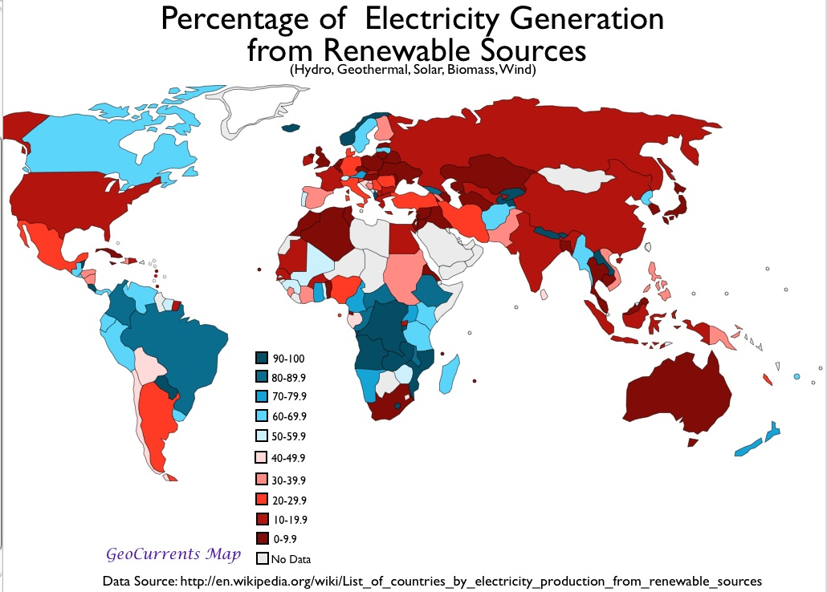
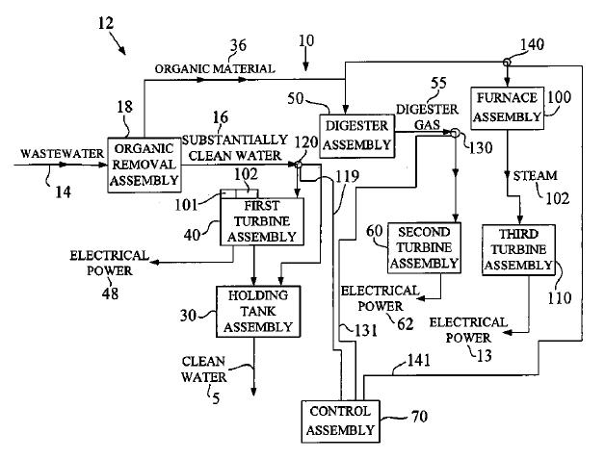
Gas generated in sewage treatment plants is commonly used to generate electricity. For example, the Hyperion sewage plant in Los Angeles burns 8 million cubic feet (230,000 m³) of gas per day to generate power. New York City utilizes gas to run equipment in the sewage plants, to generate electricity, and in boilers. Using sewage gas to make electricity is not limited to large cities. The city of Bakersfield, California, uses cogeneration at its sewer plants. California has 242 sewage wastewater treatment plants, 74 of which have installed anaerobic digesters. The total biopower generation from the 74 plants is about 66 MW. In the United States over 100 biomass power plants are generating more than 11,0000 MW in the United States. In the U.S. the states producing the most electricity from biomass are California, Maine, Michigan, Wisconsin, Virginia, Vermont, Florida, New York, and Washington. Municipal solid waste provides around 15 percent of the electricity generated from biomass in the U.S. Some of today’s most active users of biomass for electrical generations are Brazil, Canada, China, western Europe, Finland, India, Japan Mexico, Russia and the U.S. Burning plastics and petroleum products results in emissions of dioxin – a potent carcinogenic toxin. Federal regulations have reduced dioxin emission by 99 percent since 1990. Holland claims the world’s largest plant running exclusively on methane produced from poultry manure. It used a third of the nation’s chicken waste to generate 36.5 MW of electricity Many dairy farmers across the US are using cow manure to produce methane gas to drive small biomass powerplants, generating electricity for their farm. Switchgrass grows quickly to heights up to 10 feet and one planting can be harvested for 10 to 20 years. Coal and woodchips combine with chipped tires (among other things) to provide fuel for a cofiring power plant (Nemzer ’10: 45, 48).
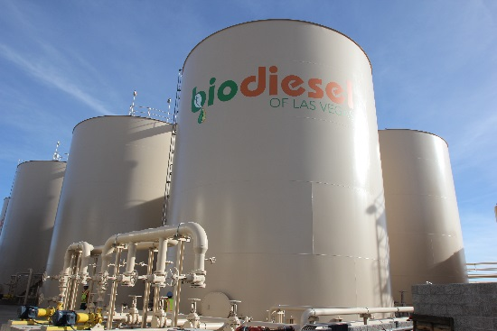
Each year plants trap enough energy to meet the world’s energy demands up to eight times over. Energy crops are plants grown just to generate energy. The plants, such as willow, sugar cane, bananas, and Miscanthus (a tall bamboo-like grass), are fast-growing and can be harvested within a short time. Their energy content is approximately half that of coal and one-third that of oil. Grasses are harvested annually, while willow is harvested at intervals of four or five years. Sugar cane and Miscanthus row to heights of up to ten feet (three meters) in a single season. The woody stems are harvested at the end of the growing season, and new shoots appear the following spring. Willow plants are cut down to a stump and left to regrow. Approximately 99 acres (40 hectares) of willow will generate power for thousands of homes. Many plants produce oils that can be used to fuel cars. This fuel is called biodiesel. Different oil crops around the world can be used, such as oils seed rape in Europe and North America, coconut oil in the Philippines, sunflower oil in South Africa, and palm and castor oil in Brazil. Ethanol is another fuel. Ethanol is produced from crops such as sugar cane and sugar beet, corn, and even organic wastes. The Clean Air Act of 1990 requires that gas sold in polluted cities be at least two percent oxygen by weight. The oxygen ensures complete combustion of the fuel when it burns, especially when the engine is cold. It also reduces the levels of pollutants such as carbon monoxide. Gas is modified by adding either six percent ethanol by volume or eleven percent of an additive called MTBE which was found to contaminate water sources across the United States. Gasohol is another fuel that contain ethanol. Gasohol is 80 to 90 percent gasoline and 10 to 20 percent ethanol. A gallon of gasohol produces less air pollution than a gallon of gasoline (Morgan ’03: 46-49).

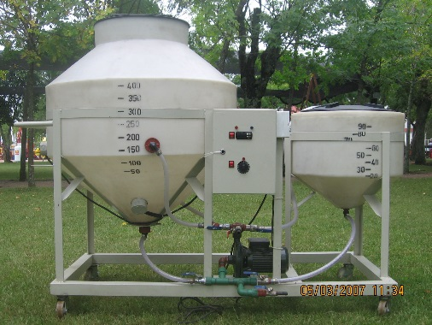
Biogas is a gas that is produced when animal and plant wastes rot. Bacteria ferment the waste under anaerobic, or oxygen-free conditions. The products of this fermentation include carbon dioxide and methane. Methane is produced in landfills, where the buried waste decays and generates this gas. Often, methane is allowed to escape into the atmosphere. However, it could be collected and piped to local industries where it could be burned to release heat. Biogas can also be produced under more controlled conditions in pits in the ground or in tanks called biogas digesters. All forms of human and animal waste can be put into the digester. The rotting mass releases gases, such as methane, that can be piped away and burned as a fuel for heating and cooking (Morgan ’03: 50). Methanogenic archaea are responsible for all biological sources of methane. Some live in symbiotic relationships with other life forms, including termites, ruminants, and cultivated crops. Other sources of methane, the principal component of natural gas, include landfill gas, biogas, and methane hydrate. When methane-rich gases are produced by the anaerobic decay of non-fossil organic matter (biomass), these are referred to as biogas (or natural biogas). Sources of biogas include swamps, marshes, and landfills (see landfill gas), as well as agricultural waste materials such as sewage sludge and manure by way of anaerobic digesters, in addition to enteric fermentation, particularly in cattle. Landfill gas is created by decomposition of waste in landfill sites. Excluding water vapor, about half of landfill gas is methane and most of the rest is carbon dioxide, with small amounts of nitrogen, oxygen, and hydrogen, and variable trace amounts of hydrogen sulfide and siloxanes. If the gas is not removed, the pressure may get so high that it works its way to the surface, causing damage to the landfill structure, unpleasant odor, vegetation die-off, and an explosion hazard. The gas can be vented to the atmosphere, flared or burned to produce electricity or heat. Biogas can also be produced by separating organic materials from waste that otherwise goes to landfills. This method is more efficient than just capturing the landfill gas it produces. Anaerobic lagoons produce biogas from manure, while biogas reactors can be used for manure or plant parts. Like landfill gas, biogas is mostly methane and carbon dioxide, with small amounts of nitrogen, oxygen and hydrogen. However, with the exception of pesticides, there are usually lower levels of contaminants. Landfill gas cannot be distributed through utility natural gas pipelines unless it is cleaned up to less than 3 per cent CO₂, and a few parts per million H₂S, because CO₂ and H₂S corrode the pipelines. The presence of CO₂ will lower the energy level of the gas below requirements for the pipeline. Siloxanes in the gas will form deposits in gas burners and need to be removed prior to entry into any gas distribution or transmission system. Consequently it may be more economical to burn the gas on site or within a short distance of the landfill using a dedicated pipeline. Water vapor is often removed, even if the gas is burned on site. If low temperatures condense water out of the gas, siloxanes can be lowered as well because they tend to condense out with the water vapor. Other non-methane components may also be removed to meet emission standards, to prevent fouling of the equipment or for environmental considerations. Co-firing landfill gas with natural gas improves combustion, which lowers emissions. Biogas, and especially landfill gas, are already used in some areas, but their use could be greatly expanded. Using materials that would otherwise generate no income, or even cost money to get rid of, improves the profitability and energy balance of biogas production.

Geothermal power uses energy generated from within the earth’s core. In volcanic areas, such as Iceland, New Zealand, and parts of the United States, hot rocks lie close to the earth’s surface. The heat warms the surface waters, creating hot springs. In addition, the sun heats the surface layers of the ground. Geothermal heat can be used in two ways. One method is simply to pump out the hot water and use it to heat buildings or to produce steam to generate electricity. Geothermal power stations are built close to hot springs, so they can use the natural sources of steam to spin their turbines. The world’s largest geothermal power station in the Geysers, near San Francisco. More than 250 wells have been drilled into the rocks, and they carry steam directly from the ground into the power station. Some of the deepest wells reach nearly 2.5 miles (4 kilometers) into the earth. In modern geothermal plants once the water has cooled down it is pumped back into the ground to replace the water that was extracted. The water is reheated b the hot rocks near the earth’s surface. The second method is to pump cold water through a bore hole into the rocks that are highly fractured. The cold water seeps through the cracks in these hot rocks and is heated by them. Then, the hot water is pumped up to the surface through a second bore hole. Prototypes have been built, but this method has not been used on a commercial scale. Although geothermal energy is a very clean energy source, it must be used properly to prevent possible environmental damage. New geothermal systems re-inject water into the earth after its heat is used. This preserves the resource and contains the gases and heavy metals that are sometimes found in geothermal fluids. Care must be taken in planning geothermal projects to ensure that they do not cool nearby hot springs or cause intermixing with ground water. Geothermal projects can produce some carbon dioxide emissions, but these are a fraction of those produced by the cleanest fossil fuel power plants of the same size (Morgan ’03: 38-40).
Rainwater and melted snow can seep miles below the surface, filling the pores and cracks of hot underground rock. This water can get really hot. It can reach temperatures of 500°F (260°C) or higher – well above the normal boiling point of 212°F (100°C). Geothermal reservoirs can be found from a few hundred feet deep to two miles or more below Earth’s surface. To reach them, we drill wells and then insert steel pipe (casing). With an open passageway to the surface, the hot geothermal water or steam shoots up the well naturally or is pumped to the surface. From here it’s piped into a geothermal power plant. Flash steam plant use really hot geothermal reservoirs of 350°F (177°C) or higher. From the well, high-pressure hot water rushes through pipes into a “separator” where the pressure is reduced. This causes some of the water to vaporize vigorously (flash) to steam, the force that drives the turbine-generators. After the steam does its work, it is condensed back into water and piped back down into the geothermal reservoir so it can be reheated and reused. Most geothermal power plants in the world today are flash plants. The power plants that run on steam are called “dry stream” power plants. In some geothermal reservoirs, the water is hot (usually over 200°F, or 93°C), but not hot enough to produce steam with the force needed to turn a turbine-generator efficiently. Heat exchanges are used in electricity generation when the heat source is hot, but not quite hot enough to bring water to a boil to create forceful steam. A heat exchanger transfers heat (thermal energy) from a hotter liquid to a cooler one by conduction. The heat is conducted from the first (hotter) liquid into the second liquid (the working fluid) through metal pipes or plates that keep the two liquids separated. The second liquid is usually one with a lower boiling point than water, so it vaporizes, or “flashes” to vapor, at a lower temperature than does water. Sometimes, such as in certain solar thermal power plants, where the first liquid is oil or another material, the second liquid can be water. The force of the rapidly expanding vapor or steam spins the turbine blades that drive a generator. The vapor or steam and then be condensed back to a liquid and used over and over again (Nemzer ’10: 51, 53).
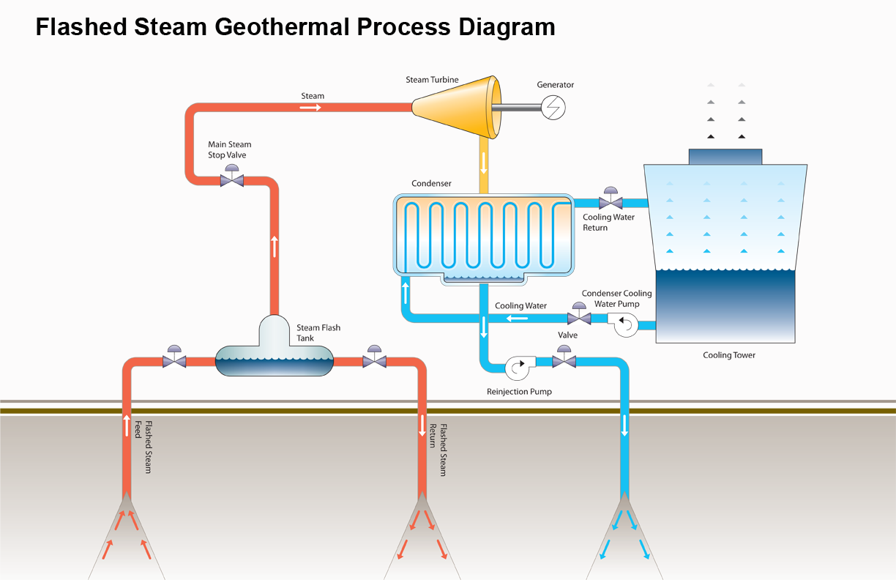

Geothermal power plants come small (200 kW to 10MW, medium (10MW to 50 MW) and large (50 MW to 100 MW and larger). A geothermal power plant usually consists of two or more turbine-generator “modules” in one plant. Extra modules can be added as more power is needed. Binary plants are especially versatile because they can use relatively low reservoir temperatures. Small binary modules can be built quickly and transported easily. The U.S. produces more electricity from geothermal energy than does any other country. Six states now have geothermal power plants. California has the most, followed by Nevada, Utah, Hawaii, Idaho, Alaska, Oregon, Wyoming and New Mexico. Hawaii’s geothermal plants provide about 20 percent of the electricity used on the Big Island. Geothermal generates about one-fourth of the electricity. A geothermal field in the northern California, named the “Geysers” although it has only fumaroles, was once the site of a famous resort. Today it is the world’s largest single source of geothermal electrical power. The Geysers’ 21 power plants still reliably generate enough electricity to power a city the size of San Francisco, about 900 MW. Enhanced geothermal systems (EGS) or “hot dry rock” involve drilling a well into hot rocks and injecting high-pressure cold water to expand natural cracks (fractures) or make new ones. The heat from the rock transfers to the water and the now-hot water is pumped up a separate well to generate electricity in a binary plant. Geothermal power plants produce no smoke. What comes out of the top of a geothermal plant cooling tower is steam (water vapor) with only trace amounts of natural minerals and gases from the geothermal reservoir. Geothermal power plants operate safely in sensitive habitats, in the midst of crops, and in forested recreation areas. However, they must be built at the site of the geothermal reservoir. Geothermal well are sealed with steel casing, cemented to the sides of the well along their length. The casing protects shallow, cold groundwater aquifers from mixing with the deeper geothermal reservoir waters (Nemzer ’10: 54-57).

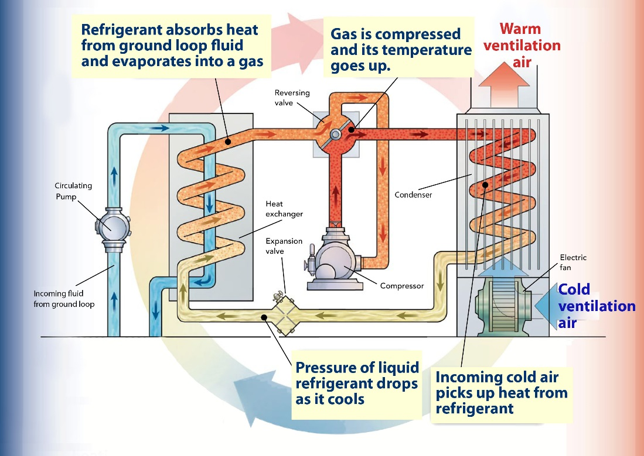

The temperature of the ground is remarkably constant all year round. Although there may be temperature variations in the top layer of soil, deeper down the temperature stays the same all year, approximately 43°F (6°C). Ground heat pumps can be used to provide eating and air conditioning in homes. These pumps are highly efficient and make use of the temperature difference between the air and the ground. In the winter, heat is removed from the ground and transferred into a building for heating. In the summer, heat is removed from the building to provide air conditioning or cooling and pumped into the ground. On either cycle, water is heated for washing, cooking and so on. The heat pump unit takes the place of a boiler inside the home or building. In a typical installation, a loop of plastic pipe is placed in a nearby vertical drill hole that may reach down 99 feet (30 meters) or more. Then the hole is filled with clay. A water-anti-freeze solution is circulated through the loop and the heat pump. In winter, a cod solution passes along the pipe and picks up heat from t ground. When it enters the home again, it is several degrees warmer. In summer, the hot air in the house heats the solution, which enters the loop in the ground where it loses its heat. A cooler solution returns to the house. More than 100,000 heat pumps have been installed in buildings in the United States (Morgan ’03: 40, 41).

By the first century B.C. waterwheels were working in many parts of the world. For centuries waterwheels in many countries provided the energy to grind grain and saw lumber. By the 1700s more than 10,000 waterwheels were hard at work in colonial New England alone. During the Industrial Revolution, waterwheels were also used to run textile mills and other factories. By the late 1800s water turbine were driving a new device – generator – to produce electricity. The hydropower resource is the force of flowing water. The force of the flow of a medium-size river is equal to several million horsepower. One million horsepower, if converted to electricity, would equal the power of 746 MW). The amount of force that water can impart depends on two factors: the head –t eh vertical distance of water falls; and the flow – the volume (amount or mass) of the water per second. The greater the head and the flow, the more water energy is available. So hydropower systems work best with a steep drop (high head) and a large flow. One gallon (3.8 liters) of water falling 100 feet (30 meters) in one second can generate about 1 kW of electric power. All hydropower plants, large or small, use a water turbine and a generator to produce electricity. The water turbine is the heart of the hydroelectric system. The first model is still in wide use, its bucket-like metal paddles are enclosed in a shell into which the water flows. Today’s water turbines are designed for maximum efficiency, they come in many shapes and sizes to work in varying conditions of head and flow. Hydropower generators resemble those used in many other electric power plants. Most hydropower systems use some type of water passageway, channel, or pipe, called a penstock. The passageway concentrates the water’s force by increasing the pressure as it approaches the turbine. That force turns one or more turbine-generators, which are usually enclosed in a powerhouse. Water leaving the turbines is channeled downstream through ha tailrace, back to the river. There are two ways that hydropower facilities use the force of flowing water: storage and run-of-river (diversion) systems. Storage hydropower systems used a dam to hold back water, creating a reservoir and an artificially steep drop (high head). The dam is placed across a river causing it to back up to form a reservoir or lake. The water is held back until it is needed. U.S. hydropower plants produce almost 95,000 MW or power. About 60 percent of all the electricity in the Pacific Northwest is generated from hydropower. The Grand Coulee Dam, on the Columbia River, alone produced over 6,000 MW, making it the fifth largest storage hydropower facility in the world. The Tennessee Valley Authority (TVA) brought electricity to many rural homes and farms in the 1930s. Hoover Dam, near the Grand Canyon, helps control flooding along the mighty Colorado River and provides power to the southwest. The U.S. Bureau of Reclamation oversees multipurpose hydro projects nationwide for flood control, recreation, irrigation, and electricity. China has the world’s largest hydropower project on the Yangtze River to control flooding while producing 22,500 MW of electricity (Nemzer ’10: 61-64).


Hydroelectric power provides about ten percent of the world’s electricity. It is a particularly important source of energy in mountainous areas and developing countries. The Itaipu Dam in Brazil is currently the largest hydroelectric power source in the world and can generate the same amount of power as twelve nuclear power stations. Not all dams, however, are used to generate electricity. The vast majority are built to provide water for irrigation and flood control. Dams on rivers create reservoirs, or large lakes, that store water until t is needed. The stored water is released through pipes that lead to the turbines deep inside the dam. The falling water moves the turbines, which drive generators. The taller the dam, the farther the water falls, and the more electricity produced. When there is excess electricity, water can be pumped back up in the reservoir so that it can be released when there is a high electricity demand. Unlike other types of power generation, hydroelectric power is very efficient – about 90 percent of the water’s energy is converted into electricity (Morgan ’03: 32). Dams built across a river or an estuary and tidal barrages have severe environmental implications, as they interfere with the flow of water. Dams on rivers create reservoirs that flood large areas of land. For example, the Balbina Dam in Brazil flooded 926 square miles (2,400 square kilometers) of rain forest. Water entering the reservoir dumps its silt, and this causes a buildup of silt in the reservoir, which eventually has to be dredged. Normally, this silt would be dumped in the rivers’ flood plain providing a source of nutrients for the soil. Silt increases the nutrient content of the water. Algae use the nutrients and rapidly increase in number, producing an algal bloom over the surface of the water. As the algae die, they are decomposed by bacteria. This increases the number of bacteria, which use up the oxygen in the water. The lack of oxygen causes fish and other organisms in the water to die. Tidal barrages also have a number of environmental consequences. They reduce the tidal range so that there are no extreme low or high tides. Low-lying mud flats and salt marshes could become permanently flooded, resulting in a loss of habitat for wading birds, which are abundant in estuarine areas. The flush time – the time it takes for water to move out of the estuary could increase causing pollutants in the water to remain there for longer before draining out and being diluted in the open sea. The slat concentration could decrease and harm marine organism (Morgan ’03: 37).

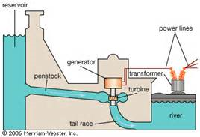
Today’s hydropower systems range from those that provide energy for one home to mammoth, multi-megawatt installations. A large-scale hydropower facility is one that generates more than 30 MW of electricity. Small-scale hydropower projects are often divided into small-scale hydro and micro-hydro. Small-scale projects range from 100 kW to 30 MW, while micro-hydro projects usually produce 100 kW or less. Hydropower produces no air pollution, it is very efficient and once installed inexpensive. Run-of-river systems are easier on the environment but the flow in the rivers and streams fluctuates by season and in low rainfall or drought years, less electricity can be produced. Large-scale storage hydropower projects are expensive to build, but can provide many megawatts of electricity to an area for decades. The installation of a dam across a river can cause the river water to back up over hundreds of thousands of acres, impacting water quality fish and wildlife. The large Three Gorges project in China has created a lake 400 miles (644 kilometers) long and required the relocation of 1.2 million people. Sixteen countries get about 90 percent of their electricity form hydropower including Norway, Brazil, Paraguay, Albania, Ethiopia, Ghana and Zambia. Fewer than 3 percent of dams in the United States have hydropower plants (Nemzer ’10: 68-70).

Winds blowing across the surface of the ocean create waves. The energy from the movement of the waves can be harnessed to produce electricity. There are two main types of wave energy generation devices: fixed and floating. Fixed generating devices are usually located on the seabed or the coast. One fixed device is called the Oscillating Water Column. Waves enter at the bottom of the column and force the air within the column through a turbine. Pressure increases within the column. As the wave retreats, the air is drawn back past the turbine due to the reduced air pressure on the ocean side of the turbine. The TAPCHAN, or tapered channel system, is similar to the system used in hydroelectric power stations. It consists of a channel connected to reservoir in a cliff. This channel gets steadily narrower causing the waves to increase in height. Eventually, the waves are high enough to pour over the walls into the reservoir. Then the stored water in the reservoir is fed through a turbine. Unfortunately, TAPCHAN systems are not suitable for all coastal regions. The ideal location is one with consistent waves, good wave energy, and a tidal range of less than three feet (one meter). Floating wave energy devise generate electricity when they rise and fall with the motion of waves. One design consists of ten floating tubes placed end to end, forming a flexible tube 394 feet (120 meters) long. Each tube moves up and down independently. Its movement drives pumps that produce electricity, but none have been used commercially. The tidal barrage is a huge dam-like structure built across an estuary, with a series of sluice gates and turbines at the base. When the tide rises, the water fills the estuary and pushes through the turbines. It then becomes trapped behind the dam. When the tide falls, the water passes through in the opposite direction, turning the turbines again. There are a number of barrages around the world (Morgan ’03: 34-36).

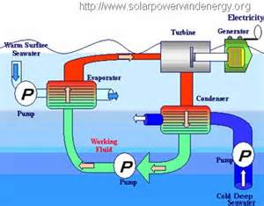
Within the 30 degree latitude on either side of the equator, there is a thermocline in the ocean. This means there is a temperature difference between the water at the surface and at depths of 3,282 feet (1,000 meters). The temperature of the surface layer of water is 77°F (25°C), while the water at 3,282 feet (1000 meters) is only 41°F (5°C). The warm surface water can be used to evaporate liquids with a low boiling point, such as chlorofluorocarbons (CFCs) and ammonia. This produces a vapor that can be used to drive a turbine attached to a generator. Cold seawater passing through a condenser turns the vapor back to liquid to restart the system (Morgan ’03:53).The temperature difference between sun-warmed surface water and near-freezing deep water is great enough to be used to produce electricity. The sun’s rays are not able to penetrate extremely deep water but down to about 200 feet (61 meters) they can be an effective warming source. Deeper water, by contrast is very cold, near freezing ad depths greater than 3,000 feet (914 meters). The difference needs to be at least 36°F (22°C), so some of the best global locations are the sun-drenched ocean surfaces of the tropics including Hawaii, Florida, and many other places. Ocean thermal energy conversion (OTEC) power plants are usually either closed-cycle OTEC and open cycle OTEC. In closed cycle OTEC system, warm ocean water is piped into a heat exchanger that causes another liquid with a lower boiling point (the working liquid to flash to vapor or vaporize. The force of the rapidly expanding vapor drives a turbine. Cold water form eh ocean depths is brought up in a different set of pipes to cool the vapor, causing it to condense back into a liquid. The working liquid is contained in a closed pipe system. In an open cycle OTEC system the arm seawater is the working liquid. It is piped into a chamber in which the pressure has been reduced by creating a partial vacuum. The lower pressure allows the warm water to flash to steam. Cold seawater is used to condense the steam after it has passed through the turbine. Closed cycle OTEC is most useful for producing large amounts of electricity and can be used with already existing turbine designs. Open cycle OTEC, which needs modified turbines, may be best suited for places such as island nations that need some fresh drinking water as well as electricity. Ocean electricity generating systems can turn saolty seawater into fresh drinking and irrigation water. For example, an open cycle OTEC power plant in Hawaii at one time produce d up to 7,000 gallons (24,498 liters) of fresh drinking water every day while generating electricity (Nemzer ’10: 76, 79).
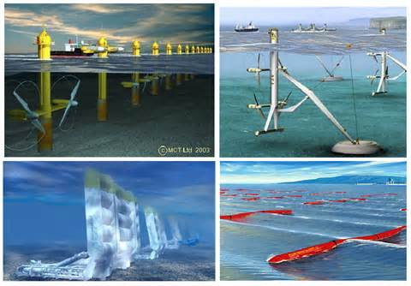
Some of the older tidal power plants use a dam, or barrage, stretched across the opening of a bay or strait. At high tide, water rushes, through openings, or sluices, into a reservoir, bay or estuary. The water is held there until the tide drops (ebbs), and then it’s let out through turbines that drive electrical generators. A variation of this technique is a system that uses generators working at both low (outgoing) and high (incoming) tides. A tidal fence, is a series of underwater turbines resembling a row of giant turnstiles, set up in any kind of channel. Far more common is a tidal turbine that works like an underwater wind turbine mostly submerged in the sea. China began using tidal power in the mid-1950s. At one point as many as 40 small tidal power plants were generating electricity there. China still has at least 7 tidal power stations that altogether generate about 11 MW of power. Shorelines that experience steady, powerful wave action ore good places for stationary Wave Energy Devices. One type uses forced air to spin a turbine. Wave enter a column and force air past the turbine, making it spin,. When the waves recede, the air pressure drops, also causing the turbine to spin. Far more common types of wave energy generators are offshore floating devices. These dot the ocean’s surface, attached to the seafloor with anchors. Some types use the bobbing motion of the eaves to cause pumps or pistons to move up and down, converting the force to spin the turbines. In other systems, the turbines are powered by the surge of the waves as they pass through. Wave and tidal energy produce no polluting emissions. OTEC produces a small amount of carbon dioxide, but only 4-7 percent of that produced by a traditional power plant (Nemzer ’10: 76-78, 80).
As early as 5000 B.C. boats propelled by wind sailed along the Nile River. Windmills may have been used in China by 200 B.C. and by 900 A.D. large windmills were grinding grain on the plains of Persia. The windmill spread to England as early as 1100 A.D. and was a common sight throughout medieval Europe. In the 1800s the American West was settled with the help of thousands of water-pumping windmills. The first wind turbines for generating electricity were designed in Europe around `1910. Beginning in the late 1930s, the widespread installation of power lines made these small wind turbines obsolete. Today the wind turbine is a familiar sight on open plains, along mountain passes, and off windy coastlines. Experts who study wind patterns have developed a scale of 1 to 7 to classify wind power (wind speed, wind height, and other factors. Class 1 has the least power and Class 7 the highest. The basic machinery that converts wind power to electricity is called a wind turbine. The force of the wind spins blades attached to a hub that turns as the blades turn. Together, the blades and hub are called the rotor. The turning rotor spins a generator, producing electricity. There is also a controller that starts and stops the rotation of the turbine blades. The generator, controller and other equipment are found inside a covered housing (nacelle) directly behind the turbine blades. Outside, an anemometer measures wind speed and feeds this information to the controller. Modern wind turbines are “variable speed” and automatically shut off at high wind speeds. The most common types of wind turbines have three fan-like blades that are usually placed at the top of a high tower (Nemzer ’10: 97, 98).
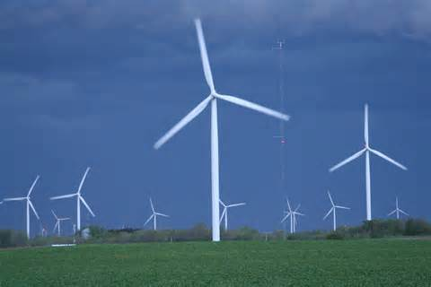
There are more than a quarter of a million wind turbines around the world. However, only 25 percent of these turbines are used to generate electricity. The rest are used to pump water from the ground. Worldwide, wind power has been growing at 30 percent per year and now generates the equivalent of twenty coal-powered power stations. Wind power uses no fuel ad does not produce harmful emissions or wastes. Wind turbines come in two basic designs. The key difference is in the drive shaft. This is the part of the turbine that connects the blades to the generator. The most common design is the horizontal axis turbine, with two or three blades. Horizontal axis turbines have a horizontal drive shaft. Vertical axis turbines have vertical drive shafts. The blades re long and curved and are attached to the tower at the top and bottom. More recently, shrouded wind turbines have appears. These have a hood around the rotor to funnel the wind over the blades. This causes the wind to move faster over the blades and spin them more quickly. Wind turbines are increasing in size. The tallest are now more than 394 feet (120 meters) high. The wind is stronger higher above the gro0und, so taller wind turbines bring the blades are getting longer too, reaching lengths of 263 feet (80 meters) or more. They are built from light but strong composite materials, so they can withstand gusty winds. If they are paced too close together, they block the wind from neighboring turbines. If the wind is too strong, the blades are either turned out of the wind or brakes are applied. Many people are opposed to tis source of energy because of the large number of wind turbines that must be built in the countryside and off coastlines. In 2000, 3,800 megawatts of new wind energy generating capacity was installed worldwide, most of which was in Europe. Germany has more than 9,000 wind turbines in operation. They produce three percent of the country’s electricity. Large wind farms in Texas, Iowa and Minnesota are generating energy at about three cents per kWh (Morgan ’03: 18, 19). .
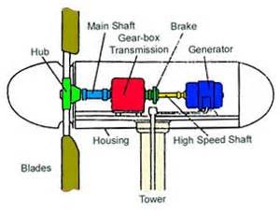
Wind turbines are usually divided into two categories: small-scale and large-scale. Small-scale turbines generate less than 100 kW. These can be the principal power source in a remote location with some type of back-up power. A home-sized rotor has blades that range from 8 to 25 feet (2 to 8 meters), Found on towers reaching up to 120 feet (36.6 meters), most small-scale wind turbines can provide plenty of power for an average-size home, farm, or small business. The U.S. is the world’s largest producer of wind-generated electricity. Wind power capacity in the U.S. has increased by over 50 percent since 2008. Texas, Iowas and California are the largest producers of wind energy in the United States. California produces close to 2800 MW of wind power. Texas currently has over 9,000 MW wind-generating capacity. Other states producing notable amounts of wind power include Washington, Oregon, Wyoming, Colorado, and New Mexico. One widely publicized concern is the issue of birds flying into spinning wind turbines, although other structures such as building, transmission lines and communication towers pose more threats to birds than wind turbines. Large-scale turbines range from 100 kW to the new multi-megawatt machines. The most common large-scale turbines, often called “utility scale” turbines –each generate from 1 to 3 MW (and even 6 MW). The most common utility scale turbine in the U.S. is 1.5 MW in size, but wind turbine as large as 10 MW are being researched. On average, wind turbines operate at about 30 percent of their full capacity. The U.S. is the world’s top wind power producer with over 29,400 MW of total installed capacity – enough to power more than 7 million homes. The U.S., China, Germany, Spain, Denmark, and India are the tope consumers of wind energy. In Denmark, wind generate more than 20 percent of the nation’s electricity (Nemzer ’10: 99- 101).
J. Solar
All of the Sun’s energy is made by a process called nuclear fission. Nuclear fusion occurs when the nuclei (central parts) of atoms combine. It takes place deep within the Sun’s core, where incredible pressure forces atoms together. When the atoms join, they release energy. The joining of two atoms does not release a lot of energy. But countless trillions of atoms merge every second in the Sun’s raging center. The energy created by all these tiny reactions builds up and starts to travel outward form the core. Soon the energy reaches the Sun’s fiery surface, where it is released mostly as heat and light. The rays speed off into the cosmos, carrying the Sun’s power throughout the solar system and beyond. In the vastness of space, Earth is just a speck. Most of the Sun’s rays miss Earth entirely. But a tiny fraction of the rays – an estimated two-billionths – do find their way to Earth’s surface. Two-billionths of the Sun’s power may not sound like a lot, but it is actually a huge amount of energy. The Sun is the ultimate source of nearly all energy on our planet. Scientists estimate that the sunlight falling on Earth in one hour is as powerful as all the gas, oil, electricity, and other energy sources used on the planet in an entire year. Currently energy consumption in the United States is 39% oil, 24% natural gas, 23% coal, 8% nuclear/electric and 6% renewable - hydroelectric, wind, geothermal, and solar power. Of these solar power is considered the most promising. Solar power is virtually pollution free. Manufacturing solar panels and other solar products does produce some pollution. But once a solar power system is installed and operating, it is perfectly clean. In 2002 solar power supplied less than one-half of 1 percent of the world’s energy. Just three countries – Japan, Germany and the United States – generated about 85 percent of this power. Industry experts believe that solar technologies will improve as the years go by, and better technology will lead to cheaper solar power (Hirschmann ’06: 5, 6, 10-12). In the Netherlands all new houses are required to have solar panels included in the mortgage loan. In 2005 California Governor Arnold Schwarzenegger unveiled the Million Solar Roofs Initiative (MSRI). Among other things, this plan would require builders to offer solar options to all new-home buyers in the state of California. It would also create a fund to help consumers pay for solar homes (Hirschmann ’06: 16).


Solar energy provides almost 1 percent of the electricity consumed in the United States. In the U.S. the top solar electricity-producing states are California, Texas and Arizona. Over 15,000 M of the world’s electricity comes from solar. PV production is doubling every three years. Some areas making wide use of solar energy are India, Japan, Europe, Indonesia, Australia, Mexico, northern Africa and the United States (Nemzer ’10: 91). Light energy can be used to generate electricity. One of the major advantages of solar power is that this free source of energy can be used in remote locations. Solar collectors trap the sun’s heat energy. Photovoltaic power systems were originally developed for use in space, where they could make use of a free source of energy, the sun. They still power most satellites circling Earth because they operate reliably for long periods and require virtually no maintenance. Photovoltaic power systems do not burn fuel and have no moving parts, so they are clean and silent. Once installed, photovoltaic power systems can operate continuously with little upkeep and low operating costs. Photovoltaic cells are quite small, so they ae easy to transport to remote places to produce electricity. For example, a few panels about three feet (one meter) in height are sufficient to power communications stations on mountaintops or navigational buoys at sea. Buildings can have special roofs made of photovoltaic panels, which generate electricity to pump water, charge batteries, power road signs, and run weather stations. Tiny photovoltaic cells are found in some pocket calculators. Large numbers of photovoltaic cells can be used together to generate substantial amounts of electricity. These cells on the roof of a solar-powered car supply its power. The most important parts of a photovoltaic cell are the thin layers of silicon inside it. Silicon is a semiconductor. When light hits the cell, electrical charges move between the layers and produce and electric current. The more light there is, the more electricity can be produced. There is a glass cover or similar transparent material that seals the cell and keeps rain out. A non-reflective coating prevents light from being reflected away from the cell (Morgan ’03: 24, 25).

Photovoltaic (PV) devices turn sunlight into electricity on a smaller scale. PV devices contain crystals that “excited” by sunlight. This means that when the Sun’s rays fall on these crystals, some electrons break free. The loose electrons can be directed through an electrical circuit. The resulting current can be used to power light bulbs, appliances, or anything else that runs on electricity. As long as the Sun shines the PV device will continue to generate power. Tiny PV devices are commonly used in small devices such as calculators and watches. Larger PV panels can provide backup power for traffic signals and other electronics. PV devices can also generate energy for objects that will be placed in remote hard-to-service areas. Buoys far at sea, for example, are equipped with PV-powered sensors. Space satellites depend on PV panels for all their power needs. Homeowners can benefit from PV technology by placing solar panels on their roofs. The panels are usually mounted on the southern side of the roof, and they are carefully angled to catch the maximum amount of sunlight. Once installed these panels pump electricity directly into the house below, thus reducing the amount of “grid” power (electricity provided by a utility company) a homeowner must purchase. In early 2005 consumer demand was much greater than the supply of PV devices (Hirschmann ’06: 18-20).

High electric bills, of course, are not a concern for the estimated 2 billion people who do not have access to electricity. Many of these people live in rural areas that may never be connected to a power grid. For remote families and communities like these, PV panels can generate enough electricity to power lightbulbs, pump water from wells, run small appliances and computers, and generally make life easier. PV is being used to bring power to villages in the developing countries of Africa, Asia, and South America. One of the largest projects undertaken so far has brought electricity to three entire villages in Nigeria’s Jigawa state and is plans to bring PV electricity to 30 additional villages. Run by a charitable organization called the Solar Electric Light Fund (SELF), this project today is turning the Sun’s rays into electric light, refrigeration, water pumping, computer access, and much more for 7,500 villagers. Many of the villages’ new electrical devices, including water pumps and streetlights, use built-in PV panels to create their own electricity. Other electrical devices, such as lights and refrigerators inside hospitals and other buildings, draw their energy from large PV systems on top of buildings. Battery banks store extra electricity during the daytime so the systems can work at night or even during bad weather (Hirschmann ’06: 24-26).

Traditional PV panels are ideal for creating electricity in remote areas. The panels can be mounted on poles wherever it is convenient. Scientists have developed new types of PV devices that will blend into the design of just about any structure. Roof shingles with a thin PV coating are one such product. PV shingles look just like regular shingles, but they behave in a very different way. From the moment they are installed, PV singles produce a steady flow of electricity. In good conditions, they can generate enough power to pay for themselves sin decreased power bills. Some users even make a profit from their solar roofs. Homeowners in England, for example have reported that the solar shingles on their roofs generate more power in a year than they need to run their homes. Shingles are not the only PV building products on the market. Tiles, aluminum siding, and other materials can also be turned into collectors for solar energy. They do this with the help of a thin PV film that can be molded onto any surface. The film does not generate as much electricity as traditional PV panels do, but for many people, the convenience of this technology makes up for the loss of efficiency. Since 1991, radio station KTAO 101.9 FM near Taos, New Mexico has drawn every bit of its power from the Sun. The transmitter is equipped with 140 PV panels. At night, the transmitter pulls energy form the batteries so it can keep pumping music out to its listeners. According to station officials, the system has performed flawlessly since the day it went online. Another group of solar pioneers gathers every other Jul to compete in the North American Solar Challenge (NASC), formerly called the American Solar Challenge. The NASC is a competition to design, build and a race solar-powered cars across 2,500 miles (4,023 km) of varied terrain, under changing weather conditions (Hirshmann ’06: 26-30).

One of the greatest benefits of solar power is that it can be generated by individuals as well as by power plants. Anyone who is willing to install solar devices on his or her home can capture the Sun’s energy and put to use. It can cost more than $20,000 to install a full PV system on a home. Even under ideal conditions it is unlikely that the system will save a homeowner that much money during its lifetime. Because the costs outweigh the benefits, there is not much incentive for consumers to install solar systems on their homes. Most people, however, will not spend money on solar power devices until the rewards are greater than the expenses. Solar does not work at night, and it works poorly under shadows or in cloudy conditions. A long rainy spell can stop solar plants and panels from creating electricity, and gray winter weather that lingers for months on end can have the same effect. Expensive solar power systems can be nearly useless for days or weeks at a time. It is not practical for businesses and homes to go without power when conditions prevent their solar devices from working, so most solar-powered buildings are connected to public utility lines. This lets them use regular electricity if they need to. Many solar systems also include batteries that store extra power during sunny times and release it at night or when conditions are otherwise poor. Unless a home or business has an unusually large and expensive solar system, there is typically not enough stored power to meet all of a building’s electricity needs (Hirschmann ’06: 35, 36). One of the most common uses of solar power is heating swimming pools. Cold water from a swimming pool is pumped up to the roof and through the hot panels. When the water returns to the pool, it carries some of the Sun’s heat with it. For most homes, the prices ranges from about $3,000 to $5,000, depending on the size of the pool. In comparison, electric pool heaters cost anywhere from $2,500 to $5,500 to install. And after installation these units can use thousands of dollars of electricity in a single year (Hirschmann ’06: 22-24).

The Short Course on Solar Energy Conversion and Application which takes place annually at the University of Southampton was submitted to the United Nations Educational, Scientific and Cultural Organization (UNESCO) in 1992 and 2000 editions. The unit of energy in solid-state physics is the electronvolt (eV). This unit is also commonly used when discussing semiconductor solar cells. The unit watthour (Wh) and its derivatives (k Wh, etc), which are in common use in power engineering, have been used for solar irradiation. Conversion factor: 10⁻⁶ micro µ; 10⁻³ milli m; 10⁻² centi c; 10³ kilo k; 10⁶ mega M; 10⁹ giga G; 10¹² tera T; 10¹⁸ exa E. 1 W s = 1 J; 1 Wh = 3.6 kJ; 1 EJ = 278 TWh; 1 eV = 1.602 x 10⁻¹⁹ J. The energy supply form the Sun is enormous: on average, the Earth’s surface receives about 1.2 x 10¹⁷ W of solar power. In less than one hour the sun supplies enough energy to the Earth to satisfy the entire energy demand of the human population in the whole year. The Sun acts as a perfect emitter of radiation (black body) at a temperature close to 5800 K. The resulting average energy flux incident on a unit area perpendicular to the beam outside the Earth’s atmosphere is known as the solar constant (S = 1367/m²). The total power from a radiant source falling on a unit area outside the atmosphere is called irradiance (S/4 = 342 W/m²). The amount of radiation that reaches the ground is variable. When the solar radiation enters the Earth’s atmosphere, a part of the incident energy is removed by scattering or absorption by air molecules, clouds and particular matter usually referred to as aerosols. The radiation that is not reflected or scattered and reaches the surface directly in line from the solar disc is called direct or beam radiation. The scattered radiation which reaches the ground is called diffuse radiation. Some of the radiation may reach a receiver after reflection from the ground, and is called the albedo. The total radiation consisting of these three components is called global. Global irradiance can be as high as 1 kW/m², but the available irradiance is usually considerably less than maximum value because of the rotation of the Earth and adverse weather conditions. The design of a photovoltaic system relies on a careful assessment of solar radiation at a particular site. In some systems (for example those connected to the grid) the paramount consideration is to collect the maximum energy over the year. It can be seen that the optimum angle which maximizes the yearly average irradiation lies between 30° and 40°. In general, it is usually close to the latitude angle. In many stand-alone systems which rely on energy storage by batteries, the principal consideration may not be the total energy received by the daily irradiation during the month with the least sunshine (December). In this instance, one should choose an angle between 60° and 70°. Solar electricity is best suited for applications where peak consumption occurs during the summer (for example, crop irrigation). Here, a panel angle close to 20° would be the best option (Markvart ’00: 1, 7, 9, 18).

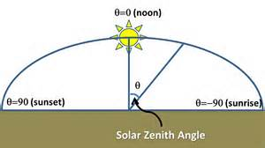
The Earth revolves around the Sun in an elliptical orbit (very close to a circle) with the Sun in one of the foci. The plane of this orbit is called the ecliptic. The time taken for the Earth to complete this orbit defines a year. The relative position of the Sun and Earth is conveniently represented by means of the celestial sphere around the Earth. The equatorial plane intersects the celestial sphere in the celestial equator, and the polar axis in the celestial poles. The motion of the Sun in the ecliptic which is tilted at 23.45° to the celestial equator. The angle between the line joining the centres of the Sun and the Earth and the equatorial plane is called the solar declination and denoted by δ. This angle is zero at the vernal (20/21 March) and autumnal (22/23 September) equinoxes. One these days, the sun rises exactly in the east and sets exactly in the west. At the summer solstice (21/22 June), δ = 23.45°and at the winter solstice (21/23 December), δ= -23.45°. The Earth rotates at the rate of one revolution per day, about the polar axis. The instantaneous position of the sun is described by the hour angle ω: the angle between the meridian passing through the sun and the meridian of the site. The hour angle is zero at solar noon and increases towards the east. For an observer on the Earth’s surface at a location with geographical latitude ɸ, a convenient coordinate system is defined by a vertical line at the site which intersects the celestial sphere in two points, the zenith and the nadir, and the subtends the angle ɸ with the polar axis. The great circle perpendicular the vertical axis is the horizon. The angle between the Sun’s direction and the horizon is the elevation α whose complement to 90° is the zenith angle ϴ_{z.} The other coordinate in this system is the azimuth ψ which is zero at solar noon and increases towards the east. During the daily motion the solar declination δ can usually be assumed constant and equal to its value at midday. The amount of solar radiation falling on an inclined surface, solar declination in radians, δ = π 23.45/180 sin (2π 284 +n / 365) where n is the number of the day in the year (n = 1 on January 1st). Solar elevation αor zenith angle ϴ_{z}: sin α = sin δ sin ɸ + cos ɸ cos ω = cos ϴ_{z}. Solar azimuth ψ: cos ψ = (sin α sin ɸ - sin δ)/ cos α cos ɸ. These equations can be used to determine the sunrise hour angle ω_{s}: ω_{s} = cos ⁻¹ (- tan ɸ tan δ). The sunset hour angle is then simply - ω_{s} (Markvart ’00: 10-13).
The history of photovoltaics began in 1839 when Alexandre-Edmund Becquerel observed that ‘electrical currents arose from certain light-induced chemical reactions’. A similar effect was observed in solid (selenium) several decades later. It was however bot until 1954 that a silicon solar cell with 6% efficiency, the first usable solar cell, was announced. Today, the direct conversion of light into electricity, or photovoltaics, is becoming accepted as an important form of power generation. Some 200 W₄ of photovoltaic power modules were produced in 1999. The production rate has been increasing at almost 20% annually over the last decade, and is likely to reach the scale of gigawatts in the early decades of the millennium. Photovoltaic power generation is reliable, involves no moving parts, and the operation and maintenance costs are very low. The operation of photovoltaic system is silent, and creates no atmospheric pollution. Photovoltaic systems are modular, and can be quickly installed. Power can be generated where it is required, without the need for transmission lines. providing important social benefits to rural communities around the world (Markvart ’00: 1-4).
Solar cells represent the fundamental power conversion unit of a photovoltaic system. They are made from semiconductors, and have much in common with other-solid-state electronic devices, such as diodes, transistors, and integrated circuits. Solar cells are usually assembled into modules. Devices with efficiency exceeding 30% have been demonstrated in the laboratory, the efficiency of commercial devices, however, is usually less than half this value. Crystalline silicon cells hold the largest part of the market. To reduce costs, these cells are now often made from multicrystalline material, rather than from the more expensive single crystals. Crystalline silicon cell technology is well established. The modules have a long lifetime (20 years or more) and their best production efficiency is approaching 18%. Cheaper (but also less efficient) types of silicon cells, made in the form of amorphous thin films, are used to power a variety of consumer products such as solar-powered watches and calculators, but larger amorphous silicon modules are also available. The market share of the principal photovoltaic technologies in 1998 was 44% multicrystalline silicon, 39% monocrystalline silicon, 13% amorphous silicon and 4% other. Other technologies include crystalline silicon cells for concentrator systems, cells based on ribbon silicon, cadmium telluride and silicon on low-cost substrates. A variety of compound semiconductors can also be used to manufacture thin-film cells (for example, cadmium telluride or copper indium diselenide) are used in specialized applications, such as to power satellites or in systems which operate under high-intensity concentrated sunlight. The solar cell operation is based on the ability of semiconductors to convert sunlight directly into electricity by exploiting the photovoltaic effect. In the conversion process, the incident energy of light creates mobile charged particles in the semiconductor which are then separated by the device structure and produce electrical current (Markvart ’00: 25, 26).
Silicon is a group 4 elemental semiconductor. The silicon crystal forms the so-called diamond lattice where each atom has four nearest neighbors at the vertices of a tetrahedron. The four-fold tetrahedral coordination is the result of the bonding arrangement which uses the four outer (valence) electrons of the each silicon atom. Each bond contains two electrons. Most other industrially important semiconductors crystallize in closely related lattices, and have a similar arrangement of the bonding orbitals. According to quantum theory, the energy of an electron in the crystal must fall within well-defined bands. The energies of valence orbitals which form bonds between the atoms represent just such a band of states, the valence band. The next higher band is the conduction band which is separated from the valence band by the energy gap, or bandgap. The width of the bandgap E_{c} – E_{v} is a very important characteristic of the semiconductor and is usually denoted by E_{g}. A pure semiconductor (which is called intrinsic) contains just the right number of electrons to fill the valence band, and the conduction band is therefore empty. Electrons in the full valence band cannot move. A pure semiconductor is therefore an insulator. Semiconductors can only conduct electricity if carriers are introduced into the conduction band or removed from the valence band. One way of doing this is by alloying the semiconductor with an impurity. This process is called doping. Suppose that some group 5 impurity atoms (for example, phosphorus) are added to the silicon melt from which the crystal is grown. Four of the five outer electrons are used to fill the balance band and the one extra electron from each impurity atom is therefore promoted to the conduction band. For this reason, these impurity atoms are called donors. The electrons in the conduction band are mobile, and the crystal becomes a conductor. Since the current is carried by negatively charged electrons, this type of semiconductor is called n-type. A similar situation occurs when silicon is doped with group 3 impurity atoms (for example, boron) which are called acceptors. Since four electrons per atom are needed to fill the valence band completely, this doping creates electron deficiency in this band. The missing electrons – called holes – behave as positively charged particles which are mobile, and carry current. A semiconductor where the electric current is carried predominantly by holes is called p-type. The prevailing charge carriers in a given semiconductor are called majority carriers. Examples of majority carriers are electrons in an n-type semiconductor and holes in the p-type. The opposite type of carriers whose concentration is generally much lower, are called minority carriers (Markvart ’00: 27-29).

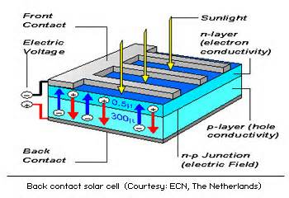
The operation of solar cells is based on the formation of a junction. Perhaps the simplest is the p-n junction, an interface between the n and p regions of one semiconductor. A layer of intrinsic material is sometimes incorporated between the n- and p-type regions, resulting in a wider transition zone. In contrast with these homojunctions, a heterojunction is formed by two different semiconductors. An interface between a metal and a semiconductor may also form a junction, called the Schottky barrier. In general, the properties of metal contacts with a semiconductor depend on the actual materials in question. For each semiconductor, some metals form a Schottky barrier but some form an ohmic contact where the barrier is absent. These contacts are used to extract electrical current from the device. The important feature of all junctions is that they contain a strong electric field. Photovoltaic energy conversion relies on the quantum nature of light whereby we perceive light as a flux of particles – photons – which carry the energy E_{ph} (λ) = hc / λ where h is the Planck constant, c is the speed of light, and λ is the wavelength of light. On a clear day, about 4.4 x 10¹⁷ photons strike a square centimeter of the Earth’s surface every second. Only some of these photons – those with energy in excess of the bandgap – can be converted into electricity by a solar cell. When such a photon enters the semiconductor, it may be absorbed and promote an electron from the valence to the conduction band. Since a hole is left behind in the valence band, the absorption process generates electron-hole pairs. Each semiconductor is therefore restricted to converting only a part of the solar spectrum. Immediately after creation, the electron and hole decay to states near the edges of the respective bands. The excess energy is lost as heat and cannot be converted into useful power. A solar cell transforms electron current, also called the generation current, into real electric current across the device. Each photon then contributes one electron charge to the generation current. The electric current is then equal to I_{ℓ} = qNA where q is the electron charge, N is the number of photons in the highlighted area of the spectrum, and A is the surface area of the semiconductor that is exposed to light. For example the current density J_{ℓ} = I_{ℓ}/A that corresponds to the terrestrial spectrum is about 1.6 x 10⁻¹⁹ x 4.4 x 10¹⁷ = 70mA/cm₂. Of this, a silicon solar cell can convert at most 44mA/cm² (Markvart ’00: 29-34).

Light generates electron-hole pairs on both sides of the junctions, in the n-type emitter and in the p-type base. The generated minority carriers – electrons from the base and holes from the emitter – then diffuse to the junction and are swept away by the electric field, thus producing electric current across the device. The efficiency η of a solar cell is defined as the power P_{max} produced by the cell at the maximum power point under standard test conditions, divided by the power of the radiation incident upon it. Most frequent conditions are: irradiance 100 mW/cm², standard reference AM1.5 spectrum, and temperature 25°. The transmission of electric current produced by the solar cell involves ohmic losses that reduce the maximum theoretical efficiency of a silicon cell to about 48%. Additional voltage losses (≈36%), current losses (≈10%) and losses associated with fill factor (≈20%) then explain the efficiency of about 23% for the best silicon cell today. Higher efficiencies have been obtained under concentrated sunlight, in devices from other materials or in tandem structures. The typical production silicon cell has an efficiency of about 14%. However, new devices with efficiency approaching 18% are beginning to appear on the market. Temperature has an important effect on the power output from the cell. The most significant is the temperature dependence of the voltage which decreases with increasing temperature (its temperature coefficient is negative). The voltage decrease of a silicon cell is typically 2.3 mV per °C. The solar cell is a semiconductor device that converts the quantum flux of photons into electric current. When light is absorbed, it first creates electron-hole pairs. These mobile charges are then separated by the electric fields at the junction. The electrical output form the cell is described by the I-V characteristics whose parameters can be linked to the material properties of semiconductors. The efficiency of commercial modules made with silicon solar cells lies in the range of 10-15% (Markvart ’00: 42-46).

The electrical current generated in the semiconductor is extracted by contracts to the front and rear of the cell. The top contact structure which must allow light to pass through is made in the form of widely-spaced thin metal strips (usually called fingers) that supply current to a larger bus bar. The cell is covered with a thin layer of electric material – the antireflection coating or ARC – to minimize light reflection from the top surface. About 36 cells are typically interconnected in series and encapsulated to form a module. Different module sizes are manufactured for different applications, the largest are for grid connected power plants and measure 2 m². A reliable module construction has the following components: (1) front cover: tempered glass recently treated with cerium oxide to reduce the possible degradation of the encapsulating materials; (2) encapsulant: a transparent, electrically insulating, thermoplastic polymer. The most widely used is EVA (ethylene vinyl acetate). The typical thickness is 0.46 mm; (3) the solar cells and the metal interconnects; and (4) back cover, usually foil of Tedlar, Tefzel of Mylar (polyester). A very thin aluminum foil can be included in the sandwich to provide a barrier against humidity. All these layers are laminated by applying heat (at approximately 150 °C and pressure under vacuum. Primers are used to improve adhesion between the layers. The edges are sealed with a neoprene gasket and, in some cases, protected with an aluminum frame. A specialized capsulation scheme is needed for bifacially sensitive modules, which have a transparent back cover (for example, transparent tedlar) and can collect up to 30-50% extra light from the albedo (background reflection). Once finished, the modules are tested and rated according to their power output ((Markvart ’00: 35, 37, 60, 61).

The cost of a PV module is about $4/W_{p}. The cost is roughly made up of three approximately equal contributions: 1/3 from the silicon material itself (in wafer form), 1/3 from the fabrication of the solar cells, and 1/3 from the ecapsulation and construction of the module. Some authors give an even greater weight to the cost of the silicon wafers (50% of the total). The supply of silicon is practically endless, although pure silicon does not occur in nature, 60% of the Earth’s crust is sand, for the major part, quartzite of silicon dioxide (SiO₂). Silicon is produced in large amounts, more than 600,000 tonnes a year world-wide, to make special steel and alloys. This metallurgical-grade silicon (MG-Si) is obtained by reducing quartzite with coke (coal) in electric-arc furnaces. Its purity is only 98-99% - insufficient for electronic applications – but both the energy input (about 50kWh/kg) and cost (about $2/kg) are relatively low. The semiconductor industry purifies this metallurgical-grade silicon until the impurity concentration is less than 0.1 ppma (parts per million atomic). An alternative way of expressing the 0.1 ppma purity is as relative silicon concentrations equal to 99.99999% specification for semiconductor-grade silicon. Since 1 cm³ of crystalline silicon contains 5 x 10²² atoms, this purity implies that the total number of foreign atoms must be less than 5 x 10¹⁵/cm³. Semiconductor-grade silicon is widely believed to be more pure than is required to make industrial solar cells. Although there is no universal definition to its purity, the so-called solar-grade silicon may contain up to about ten times more impurities (i.e. 1 ppma) and still permit reasonably efficient cells. It is relatively common in the PV industry to use discarded polysilicon from the semiconductor industry. The most common techniques produce silicon ingots with either a cylindrical or a square shape that need to be subsequently sliced into wafers. The price of discarded silicon is approximately $15/kg but its availability is subject to the internal demand of the microelectronic market (Markvart ’00: 46, 47).

The conventional purification process used by the semiconductor industry starts with the chemical transformation of Si into a liquid compound (trichlorosilane, SiHCl₃, or silicon tetrachloride, SiCl₄, as an alternative) which allows the desired purity to be reached by multiple distillation. Finally, the trichlorosilane vapour is reduced with hydrogen to obtain the desired ultrapure elemental silicon in solid form through a technique generically called chemical vapour deposition (CVD): the reaction between the silicon compound and hydrogen takes place in the presence of a thin (0.5 cm diameter) silicon rod that is heated to high temperature (about 1100°C). As a product of the reaction, elemental silicon deposits onto the 2m long rod, increasing its diameter to about 12.5 cm. The silicon rod is subsequently broken into chunks and packaged. This technique, which is known as the Siemens process, is very energy intensive (about 200 kWh/kg). The resulting material is not meant to meet any particular specification in terms of crystallographic structure and is commonly called polysilicon (or poly-crystalline silicon) to indicate that it is composed of an aggregate of micro-crystals. The present world production of semiconductor grade polysilicon is 20,000 tonnes and its price is approximately $50/kg. The thin-film silicon approach avoids the Siemens process and the consequent crystallization and wafering steps. The most common crystallization method used by both the microelectronic and photovoltaic industries is the Czochralksi (CZ) method although the PV industry is increasingly shifting towards directional solidification techniques. In the CZ crystal growth, silicon chunks are fist melted at 1414°C in a graphite crucible lines with high purity quartz. A small polysilicon crystal properly cooled is used as a seed to start the crystallization process. The seed is carefully brought into contact with the melt and then pulled out very slowly. The temperature is tightly controlled so that silicon solidifies at the interface between the seed and the melt and the atoms arrange themselves according to the crystallographic structure of the seed. The crystal grows both vertically and laterally, aided by a rotational movement, yielding a cylindrical ingot of single-crystal silicon. A controlled amount of boron or phosphorus is usually added to the melt to dope the silicon p- or n- type. The growth rate in the CZ method is about 5 cm/h and the cylindrical ingots are typically 1m long, 20 cm in diameter and 75 kg in weight. The presence of oxygen in the crystal has been held responsible for a degradation mechanism in CZ silicon solar cells when they are first exposed to sunlight. CZ silicon is typically 14% efficient for cells made commercially by screen printing, and 15.5% for the more advanced buried contact technology. Higher efficiencies, up to 20% for 100 cm² cells and 22% efficiency for 4 cm² cells have been demonstrated in the laboratory (Markvart ’00: 47-50).
Conversion efficiency of solar cells made with different qualities of crystalline silicon, including Float Zone, Czochralski and multicrystalline silicon
Material | Cell Structure | Organization | Area (cm²) | Efficiency (%)
FZ | Local P and B diffusions (PERL | UNSW, Australia | 4 | 24.7
CZ | Local BSF | ISE, Germany | 4 | 22
CZ | Screen printing, selective emitter | IMEC, Belgium | 95 | 16.7
CZ | Laser grooved buried grid | BP Solar, Spain | 143 | 16.7
CZ | Industrial | several | 100-140 | 13-15.5
mc-Si | Phosphorus + boron diffusions | UNSW, Australia | 1 | 19.8
mc-Si | Textured surface | Sharp, Kyocera, Japan | 100, 225 | 17.2
mc-Si | industrial | several | 100-225 | 11-13
Source: Markvart ’00: 50
The highest quality silicon crystals are obtained by using the float-zone process. In this method, the starting polysilicon is first given the shape of a cylindrical bar. The bar is then locally melted by a coil using radio frequency induction. By moving the coil, and hence the molten zone, along the bar starting from the seed end, the silicon adopts the crystalline structure. The typical growth rate is 15-30 cm/h, and the typical ingot is 15 cm in diameter and 1 m in length. FZ silicon is the preferred material for the fabrication of high-efficiency cells, which have attained a 24.7% for a 4 cm² device. The most successful new crystallization technique is multicrystalline silicon (mc-Si). It is possible to grow silicon ingots by simply melting the starting material, typically silicon scrap, into a crucible and carefully controlling the cooling rate. Alternatively, molten silicon can be poured into square-shaped solidification crucible from a second container. Upon cooling, a directional solidification takes place and relatively large crystals grow in a columnar way. Each grain is several millimeters to centimeters across, and internally it has the same structure as single crystalline silicon. Crystallographic defects and impurities mean that Si typically has a lower electronic quality than the material produced by the CZ method, leading to a typical loss of efficiency of 1% absolute. Several manufacturers use different directional solidification and casting methods to produce blocks of 45 x 45 cm2 (up to 60 x 60 cm2) cross-sectional area and 100-200 kg in weight. The typical crystallization rate is 3.5 kg/h and the growth cycle of a complete 160 kg ingot takes 46 h. Energy needed is 10-15kWh/kg compared with about 100 kWh/kg for the CZ technique. The silicon ingots have to be sliced into wafers. Cylindrical CZ ingots are usually reduced to a quasi-square shape, losing about 25% of material. The large case silicon parallelipeds are sawn into smaller bricks. Typical wafer sizes are 10 x 10 cm², 11.4 x 11.4 = 130 cm² or even 15 x 15 – 225 cm². The inner diameter saws used by the microelectronic industry have been replaced in the photovoltaic industry by multi-wire saw machines that can cut simultaneously whole blocks. An abrasive slurry helps the steel wires cut through silicon, a very hard material. The cutting is very slow, with eight hours being typically needed to cut through a 10 x 10 cm2 block. Slicing is one of the most costly steps of the whole silicon solar cell fabrication. Even if very thin wires are used approximately 30% of the silicon is wasted as saw dust, or kerf loss. Wafer thickness is typically 300µm. One half of the total wafer production in 1998 for solar cells was multicrystalline silicon (including ribbon) technologies, with the rest being monocrystalline silicon produced by the Czochralski method (Markvart ’00: 50-55).
Wafers grown by ribbon growth technologies have so far had a relatively small impact on the market (1-2%) although their share is likely to increase. In the EFG (Edge-defined- Film-fed Growth) method molten silicon ascends by capillary action through a thin slot in a graphite die. The crystallization is initiated with a seed that is pulled upwards, thus growing a ribbon several meters long (up to 4.6 m) and 300µm thick. In commercial production a tubular octagon is grown using the appropriate die shape, and eight ribbons, each 10 cm wide, that are subsequently cut with a laser. Sheet-growth techniques have a high production rate, for example, 160 cm²/min for the EFG method. Experimental cells made with EFT silicon have reached 16% efficiency, with average commercial cells being 11-13% efficient. There are other approaches to circumvent the problems associated with the crystallization and sawing steps. One of them is based on the epitaxial growth of silicon layers from a liquid phase. This method starts by alloying silicon chunks with a metal like tin or indium at a temperature of about 900°C. The melting point of the alloy is significantly lower than that of pure silicon). Controlled cooling makes the silicon precipitate form the liquid phase on top of a substrate, which can be a silicon wafer (from which the grown layer is subsequently detached) or a foreign substrate such as a low cost ceramic. The thickness of the epitaxial silicon layer ranges between 25-250 µm the aim being to obtain high efficiencies in the thinner layers, thus reducing the use of silicon material by approximately 20 times compared to wafer technologies. Commercial size silicon film cells on foreign substrates have already demonstrated over 10% efficiencies (Markvart ’00: 54, 55).
Best results for thin-film solar cells (efficiencies in % under standard AM 1.5 illumination)
Material | Commercial products | Best large area (0.1m2) | Best R&D small area | Theoretical limit
Amorphous silicon | 5-8 | 10 | 13 | ~20
Thin-film silicon | 11 | 12 | 16 | ~25
Copper indium diselenide | 8 | 14 | 16 | ~21
Cadmium telluride | 7 | 11 | 16 | ~28
Source: Markvart ’00: 63
Photovoltaic systems have large initial capital costs but small recurrent costs for operation and maintenance. The present PV modules based on silicon wafers exhibit lifetimes of 20-30 years and the target for thin-film cells is similar. The annual rate of production of PV modules will reach a few million square metres by 2000 and a few hundred million square metres in the next 40-50 years. Cells which contain scarce materials could thus be subject to severe constraints due to the availability of these materials at a reasonable price. Four types of thin-film cells have emerged – amorphous silicon cell, in a multiple-junction structure, thin multicrystalline silicon films on a low-cost substrate, the copper indium diselenide/cadmium sulphide heterojunction cell (or variants of it) and the cadmium telluride/cadmium sulphide heterojunction cell (Markvart ’00: 62). Solar cells convert sunlight into electricity by exploiting the photovoltaic effect. The maximum conversion efficiencies observed in laboratory devices have exceed 30% but the typical efficiencies for production cells are 10-15%. Crystalline silicon solar cells represent the largest part of the market. Thin-film solar cells hold the promise of inexpensive technology with acceptable conversion efficiencies (Markvart ’00: 74).
Solar cells generate direct current. Since most available appliances work with alternating current, some form of power conditioning is usually required. There are two main categories of systems, grid-connected and stand-alone. Grid connected systems can be subdivided into those in which the grid merely acts as an auxiliary supply (grid back-up) and those in which it may also receive excess power from the PV generator (grid interactive). In PV power stations, all the generated power is fed into the grid. The photovoltaic generator consists of photovoltaic modules which are interconnected to form a DC power-producing unit. The physical assembly of modules with supports is usually called an array. Most frequently the cells in a module are interconnected in series. A typical 4 inch diameter crystalline silicon solar cell or a 10 cm x 10 cm multicrystalline cell, will provide between 1 and 1.5 W under standard conditions, depending on the cell efficiency. This power is usually supplied at a voltage of 0.5 to 0.6 V. Since there are very few appliances that work at this voltage, the immediate solution is to connect the solar cells in series. The number of cells in a module is governed by the voltage of the module. The nominal operating voltage of the system usually has to be matched to the nominal voltage of the storage subsystem. Most photovoltaic module manufacturers therefore have standard configurations which can work with 12 V batteries for which 36 solar cells in series ensures reliable operation. The power of silicon modules thus normally falls between 40 and 60 W. The three most important electrical characteristics of a module are the short-circuit current, open-circuit voltage and the maximum power point as functions of the temperature and irradiance. The temperature coefficient for the open-circuit voltage is approximately equal to – 2.3mV/°C for an individual cell. The voltage coefficient of a module is therefore negative and large since some 36 cells are connected in a series. The current coefficient, on the other hand, is positive and small – about +6µA/°C for a square centimeter of the module area (Markvart ’00: 83-88).
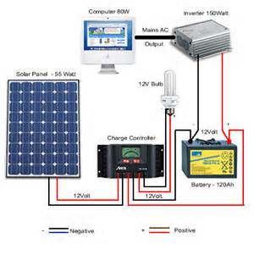
Batteries in PV systems operate under specific conditions which must be allowed for in the system design. The most prominent feature is cycling. During the daily cycle, the battery is charged during the day and discharged by the nighttime load. The depth of discharge in the daily cycle fro systems without back-up is always fairly shallow. Superimposed on the daily cycle is the climatic cycle, due to the variable climatic conditions. This cycle occurs anytime when the daily load exceeds the average energy supply from the PV generator. The battery may act as a seasonal buffer. Lead-acid batteries provide the most common means of energy storage in PV systems today. To prevent the night-time operation of a photovoltaic generator from providing a discharge path for the battery the simplest solution is to separate the generator and battery by a blocking diode when the voltage at the battery exceeds the voltage at the generator. Charge regulators avoid excessive discharge by monitoring the battery voltage and disconnecting the load form the battery if the voltage falls below a pre-set minimum value, typically about 10.8 V per cell for a lead-acid battery. The regulator will not reconnect the load until the battery voltage has risen to a value significantly higher than this minimum value. A shunt regulator has a variable resistance element in parallel with the battery. As the resistance is reduced more of the current from the PV array is diverted through the resistor and less through the battery. DC/DC converters, or switching power converted are widely used to transform DC power between one voltage and another. The buck converter reduces the voltage while the boost converter increases it. Inverters convert power from DC to AC. The majority of inverters for PV applications can be classified into three main categories. Variable frequency inverters are used to stand along drive/shaft power applications, almost exclusively in PV pumping systems. The other two are suitable for the grid connection of PV power plants. Self-commutating fixed-frequency inverters are able to feed an isolated distribution grid. Line-commutated fixed-frequency inverters are able to feed the grid only where the grid frequency is defined by another power source connected in parallel. The power conditioning and control elements make it possible to convert the generated DC power to AC, protect the battery against overcharge or excessive discharge, and optimize the energy transfer between the PV generator and the battery or load (Markvart ’00: 94, 95, 98-108).
Data for typical loads
Appliance | Nominal power (W) | Nominal voltage (V)
Light appliance 1 | 15 | 24
Light appliance 2 | 20 | 24
Washing machine | 100/800 | 220 rms
Refrigerator | 70/150 | 220 rms
Small electric appliances | 250 | 220 rms
Water pumping | 100 | 24
TV set | 60/100 | 24
Others (radio emitter/receiver) | 120 | 24
Source: Markvart ’00: 111
Siting of a PV system, particularly a stand-alone one, is an important part of design. Since the capital equipment cost is the major component of the price of solar electricity, oversizing the plant has a very detrimental effect on the price of the generated power. Undersizing a stand-alone system, on the other hand, reduces the supply reliability. Radiation data (when available) for a particular site is usually given in the form of global irradiation on a horizontal surface. The size of the PV installation depends on the number and hours of operation of each of appliance. Type A is a simple system providing energy to power five light appliances (at an average of 1.65 h per day), a TV set in operation for 4 h per day, and the use of small electrical appliances. Type B is a small but sufficient installation to power 12 light appliances, a DC washing machine (2 kg) with cold water, small electrical appliances, TV and water pumping. Type C is a size more adequate for housing and small agricultural needs. More energy is therefore allocated for water pumping and more light appliances. A washing machine (220 V AC) can also be powered. In addition to the average power demand of the load, the load profile – both annual and daily – also has an important effect on the design of the system. In some systems, the load can be adjusted to respond to the energy input to the system. An example can be a stand-alone domestic system where a washing machine is allowed to be used only when there is enough sun. The system design can be based on the yearly energy balance between radiation and the load where the variation of solar radiation during the year is not too pronounced. In regions with large seasonal variability of solar radiation input or for high reliability applications, the sizing procedure should be based on the month with the lowest irradiance. The operating voltage of one module, should be taken as 12V for a module of 36 cells. Increasingly, hybrid energy systems are recognized as a viable alternative to grid-electricity or conventional, fossil fuel-based remote area power supplies (Markvart ’00: 110, 111, 113).
Typical loads for housing
System type | Energy supplied (Wh/day) | Charge at 24 V (Ah/month)
A | 500 | 625
B | 1000 | 1250
C | 1500 | 1875
Source: Markvart ’00: 111
Production of solar cells and modules has been growing steadily throughout the 1990s, and the growth has accelerated towards the new millennium. The most significant increases have been in the grid-connected applications, particularly photovoltaics in buildings. This market sector is gaining government assistance in a number of industrialized countries, notably Japan, Germany, Switzerland, The Netherlands and USA. Several government programmes that drive this expansion – the Japanese 70,000 Roofs Programme, US One Million Solar Roofs Initiative and German 100,000 Roofs Programme – are intended to provide the necessary volume for price reduction. The other grid-connected sector – central power stations – is more sensitive to the installed system price. There are 10 million small (less than 200 kW) diesel generators serving base loads throughout the sunbelt region of the world. Two million generators are sold every year. Photovoltaic systems are now economical for very small generators of less than 5 kW. Typical applications include water pumping, medical refrigeration, water purification and small village power. Photovoltaic modules have proven to be the most reliable power source for remote unattended applications – particularly communications – throughout the world. This market is growing at a rate of 20-30% a year and is relatively inelastic to price. Crystalline silicon solar cells will continue to serve this important sector owing to its proven reliability. Tis sector is not dramatically affected by world energy prices or policy, and thus PV will continue to serve it as the most effective energy source (Markart ’00: 141).
Stand-alone PV domestic supply systems are commonly encountered in developing countries and remote locations in industrialized countries. The size range varies from 10 W_{p} (for a single lamp) to 5 kW depending on the existing standard of living. Typically larger systems are used in remote locations or island communities of developed countries where household appliances include refrigerator, washing machine, television and lighting. In developing regions large systems (5 kW) are typically found for village supply while small systems (20-200 W) are used for lighting, radio and television for individual houses. In the developing world it is now estimated that there are at least 400,000 small Solar Home Systems which means that some 2 million people now rely on solar energy for their electricity. Vaccination programmes throughout the developing world require refrigeration to keep the vaccine between 0°C and 8°C. Over the past five years, over 2000 photovoltaic refrigerators have been installed in Africa. A solar photovoltaic refrigerator is likely to cost around $3,000-$4,000, more than a kerosene unit ($600-$800) that will use 0.5 to 2 liters of fuel a day, require frequent maintenance and have a shorter lifespan and the total cost over 20 years is about equal. The use of low-voltage DC fluorescent lamps, rather than filament lamps, is important for efficient use of the electricity. (Markvart ’00: 158-160).

In remote locations, batteries are often used as the main source of electricity. Ordinary car batteries are used not only in vehicles but also to power light, televisions and radios. The usual method for charging batteries has been to use diesel or gasoline generators at battery-charging stations in the nearest village. A PC battery-charging system, consists simply of a PV array with support structure and charge controller. They are usually suitable for insolation levels above 3.0 kWh/m² day. Photovoltaic systems provide a natural means for rural electrification. More than 10,000 PV-powered water pumps are known to be successfully operating throughout the world. Solar pumps are used to pump from boreholes, open wells, rivers and canals to provide water for villages and irrigation supplies. Less-common applications include drainage pumping and water circulation for fish farms. The largest number of solar pumps in one country is in India where more than 500 systems have been installed for village water supplies. A solar-powered pumping system consists of a PV array powering an electrical motor which operates a pump, in most cases without need for battery storage of the generated electricity due to the reserves of a storage tank. For example, in the Sahel region of Africa the storage needs to be 3-5 days of demand. The peak demand (during the irrigation seasons) is often more than twice the average demand. Submerged multistage centrifuigal motor pumpsets are probably the most common type of solar pump used for village water supply. The most commonly employed system consists of an AC pump and inverter with a PV array of less than 1500 W, but DC motors are also used. The sizing of solar pumps is determined by the hydraulic energy required: Hydraulic energy (kWh/day) = Volume required (m³/day) x head (m) x water density x gravity = 0.002 725 x volume (m³/day) x head (m). Solar array power required (kWp) = Hydraulic energy required (kWh/day)/ Average daily solar irradiation (kWh/m²/day) x F x E. where F is the array mismatch factor, equal to 0.85 on average, and E is the daily subsystem efficiency, typically between 0.25 and 0.4. A PV system pumping 25m₃/day through a 20m head requires a solar array of approximately 800 W_{p} in the Sahel region of Africa. Such a pump would cost approximately $6,000. A range of prices is to be expected, sine the total system comprises the cost of modules, pump, motor, pipework, wiring, control system, array support structure and packaging. Systems with larger array sizes generally have a lower cost per w. The cost of the motor pumpsets varies according to the application and duties; a low-lift suction pump may cost less than $800 whereas a submersible borehole pumpset costs $1,500 or more. In general, photovoltaic pumps are economic compared to diesel pumps up to approximately 3 kW_{p} for village water supply and to around 1kW_{p} for irrigation (Markvart ’00: 162-167).

Photovoltaic systems have had more commercial success in telecommunications and remote monitoring than in other remote power applications. They can be effective at relatively low insolation levels compared to other applications. Data collection from remote monitoring stations usually takes place by UHV/VHF radio transmission, when the central computer contacts the remote system for data, for example gas pressure and state of charge of the battery. Primary batteries are still the most commonly seen power source for remote systems. Initial cost comparisons with PV look attractive only until the long term costs such as regular battery replacement, and related personnel and vehicle costs, are accounted for. To operate unattended for long periods, various hazards must be avoided, including theft or vandalisms of the system, damage by animals or falling branches, shading by growing vegetation, and snow covering. Since the reliability of these systems is paramount, the sizing method used is based on radiation data for the worst month of the year (usually December in the northern hemisphere) rather than on the average daily irradiation over the year. In addition, the sizing often uses date for the worst year in ten. Cathodic protection is a method for shielding metalwork from corrosion, for example, pipelines and other metal structures. Corrosion is a chemical reaction between metal, usually iron, and water, which turns the iron into iron oxide (i.e. rust). Oxidation involves electron transfer to the metal. If an electricity source is connected to the metalwork which sets it at a negative voltage (thus making it a ‘cathode’), the iron is prevented from oxidizing. The positive terminal of the source must be connected to an anode, often a piece of scrap metal, which will corrode instead. M Even is cathodic protection is used, the piepeline or structure must still be protected in the normal way with weather-resistant paint. Otherwise the PV array would have to very large to cope with the high rate of corrosion (Markvart ’00: 168-170, 180).


Photovoltaic solar generators have been and will remain the best choice for providing electrical power to satellites in an orbit around the Earth. Indeed, the use of solar cells on the US satellite Vanguard 1 in 1958 demonstrated beyond doubt the first practical applications of photovoltaics. Since then, the satellite power requirements have evolved from a few watts to several kilowatts. After years of moderate growth o the space PV market the evolution of large-scale applications has accelerated significantly in the late nineties. The main market segment is dominated currently by telecommunication satellites with individual power levels above 10 kW. Another large market segment is dominated by constellation programmes which provide multimedia, navigation and other electronic services. Another aspect of the orbital missions, particularly important for arrays designed for long life, are the Sun/eclipse thermal cycles which may cause fatigue of solar cell interconnections. The space solar cells must have high operation efficiency, high resistance to irradiation by energetic particles (mainly electrons and protons) and a good power-to-weight ratio. Following the early Si cells based on n-type substrates and p-type diffused emitters, the cells in use since the early 1960s have been based on p-type substrates because of their higher radiation resistance. Subsequent developments include the incorporation of the black-surface field (BSF), back-surface reflector (BSR), the use of a shallow emitter (the ’violet cell’), and top surface texturing (the ‘black cell’). Monocrystalline silicon solar cells have been further improved towards higher efficiency and more particle radiation-resistant devices. High efficiency silicon (hi-eta) cells with 16% beginning-of-life efficiency and more are now available at reduced costs. However, the monoculture of silicon cells has, in the last few years, been replaced by a variety of different cell concepts and materials. GaAs-on –Ge monojunction cells have been successfully used in many applications, boosting efficiency above 19%. Multijunction GaInP/GaAs cells have been in production for more than a year, with efficiencies between 22% and 24% (Markvart ’00: 180-188).

The fundamental parameters of public electricity supply are alternating three-phase current, frequency 50 to 60 Hz, transmission voltage between 400 and 800 kV, distribution voltages between 11 and 132 kV, and a supply voltage of 110-240 V. Because the purpose of the high-=voltage transmission system is to interconnect all points of generation (power stations) and distribution (substations) it has the appearance of a grid, giving rise to the popular name for the transmission system. The lower voltage distribution system are supplied by the transmission grid and have had little in-built generation. The ability to connect any electricity generator to the supply network greatly enhances its usefulness, and photovoltaic generators are no exception. It is into the low-voltage distribution network that the majority of photovoltaic generators will be connected. Their size (most frequently between 1 and 100 kW) is usually accommodated adequately on the 440 V supply network. However, because this network is normally radial in nature and not interconnected, the connection may at times present some problems. Although the term ‘grid-connection’ is now firmly established it is worth remembering that photovoltaic generators are rarely connected to the high voltage ‘grid’. PV arrays mounted on rooftops and facades offer the possibility of large-scale power generation in decentralized medium-sized grid-connected units. The PV system supplies the electricity needs of the building, feeds surplus electricity into the grid to earn revenue, and draws electricity from the grid at low insolation (Markvart ’00: 188-189).
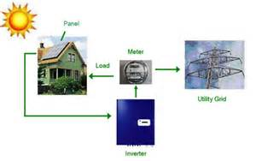
Most buildings with architecturally integrated photovoltaic systems have been partly financed by public subsidies, or belong to companies that are associated with photovoltaic industry such as local electric utilities or construction companies. Germany, Switzerland and the Netherlands are among European countries that off the most promising financial schemes. Many analysts believe that photovoltaic prices will halve in the next ten to 15 years (from 2000 when BIPVS prices range between £620 and £790 per square metre, which his competitive with other expensive façade elements, such as polished stone. The ‘1000 Roofs Programme’ was initiated jointly by the German Federal and State Governments on 23 September 1990. From the 4000 applications, 2250 systems were approved: 100 systems in each of the City States, and 150 systems in each of the other States. BMFT subsidized 50% of the costs in the western states and 60% in the east. The States made an additional contribution f 20% and 10% respectively, bringing the total subsidy to 70% with the exception of Saarland which considered 50% subsidy to be sufficient. The program was narrowed down to systems with peak power between 1 and 5 kWp which were to be mounted on the roofs of single or duplex houses mounted to the grid (Markvart ’00: 201-204).

The commercially standard PV module uses solar cells made from wafers of silicon, usually 0.3 mm thick and 10 cm x 10cm in area. Every step is hazardous. The standard mining operation with associated hazards to the miners and inputs of diesel fuel and machinery. Metallurgical grade silicon is made in large quantities for the steel industry, with a small fraction going as input to the semiconductor industry. The major emission of this manufacture is a silica dust which can cause lung disease, and there is a substantial energy input. The purification of silicon can involve hazardous materials such as silane, whilst the doping of the silicon involves toxic chemicals such as diborane and phosphine, although only in small quantities diluted in inert gas. These materials are used in the microelectronic industry and their monitoring and control is well established. The materials for construction of the complete PV system, other than the PV modules, are steel, aluminum, copper, concrete and electronic equipment, with which are associated the standard industrial hazards. The energy content of PV modules using silicon wafers has been measured at 235 kWh(e)/ m² for 1990 technology at 1.5 MW_{p} per annum production rate. Thus for the 1990 crystalline silicon PV technology in small-scale production, the CO₂ emission is around 400,000 tonnes per gigawatt-year of energy output. This compares with the CO₂ output from the most modern and efficient coal-fired plant of 9 million tonnes per gigawatt-year (1991). Boiling water reactors have been estimated to emit about 75,000 tonnes of CO₂ per gigawatt-year.

The CO₂ emissions estimated for the various current PV cell technologies varies by cell material and production scale. The environmental impacts of the thin-film silicon cell are similar to those of the wafer silicon cell, but reduced in magnitude because of the smaller volume of silicon used. The CIS cell has a potential hazard in the hydrogen selenide used in its manufacture. Both CIS and CdTe cells have a window layer of cadmium sulphide, so both types of cell could potentially present a hazard from cadmium. Cadmium hazards arise in the refining stage, with emissions of cadmium oxide dust, emissions of cadmium during manufacture, or during a fire in which cadmium-containing PV modules were involved, and from possible leaching of cadmium from modules discarded at the end of their working life. In CIS modules, the amount of cadmium used is about 0.04 g/m2 equivalent to 400 g per MWp of output. The amount of cadmium contained in the CdTe modules needed to generate energy of, say, 1 GWh over their lifetime is about equal to the cadmium emitted form the smoke-stack of a typical coal-fired station whilst generating the same 1 GWh of electrical energy. Photovoltaic systems are almost entirely benign in operation, and potential environmental hazards occur at the production and disposal stages (Markvart ’00: 215-219).

Carbon dioxide emitted in the production of PV modules (in units of kilotonnes per gigawatt-year)
Cell material | Production scale | Efficiency (%) | Lifetime (years) | CO2 ktGW⁻¹yr⁻¹
Monocrystalline silicon | Small  large | 12  16 | 20  30 | 400  150
Multicrystalline silicon | Small  large | 10  15 | 20  30 | 400  100
Thin-film silicon | Small  large | 10  15 | 20  30 | 130  50
Thin-film polycrystalline materials | Small  large | 10  14 | 20  30 | 100  40
Future (2020) multijunctions | large | 30 | 30 | 24
Source: Markvart ‘00

There is little doubt that, at present, large PV projects are generally not competitive with the conventional power sources. Investment costs are much higher, leading to much higher unit cost of generated electricity. Large PV power plants require skilled personnel for their management and maintenance unlike small-scale PV systems. Conventional power facilities take advantage of the economy of scale, i.e. the larger the facility the lower the specific production cost (the cost of a unit of generated electricity). Large PV plants, on the other hand, do not present similar advantages, since, under given climatic conditions, the required active surface of PV modules, support structures, and other facilities is simply proportional to the energy output of the plant Large thermal power plants require a capital investment of $1.5W and unit cost of $0.06 kWh. Diesel power plant requires $0.5-1.0 investment and unit cost of $0.2-0.5 kWh. Large PV power plants cost $12-15Wp at a unit cost of $0.8-1.0kWh. Large PV plants are generally characterized by the high-voltage DC bus (typically 200-600 VDC) and large scale PV plants are generally AC systems which employ one or more inverters for the conversion of DC power generated by the PV array to standard AC power. As the result of the high DC bus voltage, large PV systems require specific safety measures which include personnel protection and grounding of all metal parts including PV module frames. The safety measures must bear in mind the principal consideration that the PV generator cannot be switched off effectively during daylight. (Markvart ’00: 228, 233).


Solar energy can be used as a source of heat for cooking and boiling water. The energy in sunlight is converted to electric energy by the photovoltaic cell. This can be used to power lights or electrical appliances. The proportion of sunlight energy that the photovoltaic cell converts to electric energy is called conversion efficiency. The first photovoltaic cells converted just one to two percent of sunlight energy into electric current. The latest cells have a conversion efficiency of up to seventeen percent. This means they can be used in places where it is not sunny all the time. In time, the cost of producing electricity from photovoltaic cells will be competitive with the cost of electricity produced using fossil fuels. Early photovoltaic cells consisted of a single crystal of pure silicon. The production of the crystals was very expensive. One of the latest developments in photovoltaic technology being research is called Epilift process, a silicon wafer is used as a production template. A semitransparent layer of high-quality silicon is laid on top of a template and then peeled off to produce solar cells. The original silicon wafer – the most expensive single item in solar panels – remains undamaged and can be used repeatedly. In addition to bringing the cost down, these cells have an energy conversion efficiency of up to twenty percent. Large solar thermal power stations are expensive to build, and the costs per megawatt of solar energy cannot compete with other sources of energy. More recent solar power stations have used photovoltaic technology (Morgan ’03: 26-29).

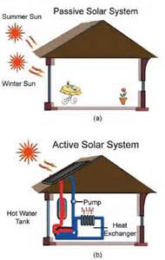
Solar heating comes in two forms: passive and active. In passive heating systems, homes are specially designed to absorb heat from the Sun’s rays. They are made from building materials such as stone and salt-soaked wood, which absorb heat during the daytime and release it throughout the cooler nighttime hours. In the Northern Hemisphere, solar windows are placed on a home’s south side. When the Sun shines these windows capture energy in the form of heat. At night, the windows are covered so the warmth trapped inside the house will not escape. A house that uses solar-friendly building techniques can stay warm on all but the coldest nights. In active heating systems, mechanical means are used to collect and store solar energy, then deliver it throughout a building. An active heating system usually includes liquid-filled solar plates on the roof. When sunlight hits these plates, it heats the liquid inside. The hot liquid is then pumped through tubes to different parts of the house to provide heat for air or water (Hirschamm ’06: 13, 14).

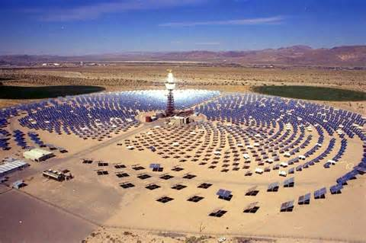
Concentrating solar power (CSP) devices can turn solar energy into electricity. In a SCP device, mirrors focus the Sun’s rays onto a small area. The focused rays are very intense, sometimes generating temperatures of 7,000°F (3,870°C). They heat a gas or liquid collecting agent, such as melted salt, which is then used to boil water. The steam from the boiling water turns a generator that produces electricity. The oldest type of CSP device is the power tower. In a power tower, a holding tank sits on top of a tall tower, while a large field of computer-controlled mirrors surround the tower and focuses sunlight onto the holding tank. The world’s first power tower was Solar One ear Barstow, California. Solar One operated from 1981 to 1988. It used more than 1,800 mirrors, each about 20 feet (6m) tall and 20 feet (6m) wide and produced 10 megawatts of power – enough to supply six thousand people with electricity. Another type of CSP device is the trough system. Trough systems include row after row of long, curved mirrors. A tube filled with a collecting agent runs along the center of each row. The mirrors reflect sunlight onto the tube, heating the agent inside. In California, trough systems currently supply more than 350 megawatts of power. As of early 2005, another 50-megawatt plant was in the planning stages for an area near Boulder City, Nevada. The last type of CSP device is the dish system. Dish systems use bowl shaped mirrors, similar to extra-large satellite dishes, to focus the Sun’s rays onto a central point. CSP systems do not heat a collecting agent. They reflect sunlight onto a heat-powered engine that generates electricity directly. Dish systems can be grouped together to form a power plant, or they can be used individually for specific tasks. Dish systems are still in the testing stages. When this technology becomes widely available, it is expected to be useful for utility-line backup systems or for bringing small amounts of power to remote areas (Hirschmann ’06: 17, 18). CSP plants like Solar One, the world’s first solar power plant, cost about $144 million to build and another $13 million to operate over its seven-year lifetime. In the early 1990s, Solar One was converted into Solar Two at an additional cost of about $40 million. Together, the two projects cost nearly $200 million. The price tags of other, more recent projects also top the $100 million mark. Today, electricity generated by solar power plants costs three to four times as much as traditional electricity, so solar electric power does not make sense on a dollars and cents basis alone (Hirschmann ’06: 32, 33).


Organizations around the world are working to make PV and other forms of solar technology affordable. Some government are playing an important role in this effort by helping people to pay for solar power systems. In California homeowners and businesses pay only about half the cost of a system. The state picks up the rest of the tab. In New Jersey, the government pays for up to 70 percent of a solar installation. Homeowners in Germany and Japan also get 70 percent. South Korea, Spain, Italy, China and many other countries offer smaller but still important incentives. These funding programs can make solar power affordable for people who cannot or will not pay the entire bill. In some areas, there is an extra benefit for consumers and businesses to install grid-tied systems. A grid-tied system produces solar electricity but is also connected to public utility lines. Homes and businesses that are “on the grid” can sell any extra electricity they produce to their local utility companies. During the hot summer months, when solar energy is most intense, a grid-tied solar home may produce and sell enough power to pay its entire electric bill (Hirschmann ’06: 36-39). Single solar panel kits need to power normal electrical outlets.

Bibliography

Aristatek. The First Responder. Violent Self-Polymerization Reactions. October 1, 2008 - Vol. VII Issue 10

Chao, Elaine L.; Henshaw, John L. Controlling Electrical Hazards. Occupational Safety and Health Administration (OSHA). 2002

Christodouleas, JP; Forrest, RD; Ainsley, CG; Tochner, Z; Hahn, SM; Glatstein, E. Short-Term and Long-Term Health Risks of Nuclear-Power-Plant Accidents". N Engl J Med April 20, 2011

Diamond, Commissioner of Patents and Trademarks v. Chakarbarty 447 U.S. 303 (1980)

Ford, Michael; McManmon, Robert. Oil Net Imports have Declined Since 2011, with their Values Falling Slower than Volume. February 25, 2014

Giglio, Robert S. New Technologies Reduce Environmental Impacts of Coal-Fired Plants. Foster Wheeler Global Power Group. EngineerLive. 21 February 2013

Hirschmann, Kris. Solar Energy. Our Environment. Kidhaven Press. Thomson Gale. Farmington Hillsd, MI. 2006

International Court of Justice. Case Concerning Nationals of the United States of America in Morocco (France v. United States of America). 1950

International Energy Association. Key World Energy Statistics. 2014

King, Hobart. Coal What is Coal and How Does it Form. Geology. 2005

Majumdar, S.K.; Miller, E.W.; Brenner, F.J. Forests a Global Perspective. Pennsylvania Academy of Science. Easton, Pennsylvania. 1996

Boral, L.; Lyngdoh, T. Degradation of Ecosystems due to Coal Mining and their Restoration in India. Botany Department. School of Life Sciences. North-Eastern Hill University. Shillong, India. 1996

Griffith, James Jackson; Dias, Luiz Eduardo; Jucksch, Ivo. Rehabilitation of Mine Sites in Brazil Using Native Vegetation. Chapter 32. Forests – A Global Perspective. Department of Forestry Engineering. Universidade Federal de Vicosa. Minas Gerais, Brazil. 1996

Markvart, Tomas. Solar Electricity. 2nd Ed. UNESCO. John Wiley & Sons, Ltd. West Sussex, England. 2000

Mason, Jim. Spiderwort. Great Plains Nature Center. 2011

Mastrangelo, Erin. Overview of U.S. Legislation and Regulations Affecting Offshore Natural Gas and Oil Activity. Energy Information Administration, Office of Oil and Gas. September 2005

Miller, John W.; Sweet, Cassandra. Awash in Coal, U.S. Imports More. Power Plants Reap Benefits from Cheap Columbian Shipments As Mines in Appalachia Begin to Close. Wall Street Journal. August 13, 2014

Morgan, Sally. Alternative Energy Source. Heinemann Library. Reed Educational & Professional Library. Chicago, Illinois. 2003

National Research Council. Induced Seismicity Potential in Energy Technologies. National Academy of Science. June 2012

Nemzer, Marilyn; Page, Deborah; Carter, Anna. Energy for Keeps: Creating Clean Electricity from Renewable Resources. 3rd Ed. Energy Education Group. Tiburon, California. 2010

Nijhuis, Michelle. Coal: The Invisible Carbon. National Geographic. April 2014

Ramdas, L. The Japanese Tragedy – Nuclear Disaster: Lessons for India. 15 March 2011

Ravindran, Shruti. India’s Push for Renewable Energy: Is it enough? The new government faces pressure both to cut emissions and ramp up energy access. For now, coal remains king. National Geographic. September 19, 2014

Prud’homme, Alex. Hydrofracking: What Everyone Needs to Know. Oxford University Press. New York 2014

Sanders, Tony J. Deepwater Horizon Spill Response Solution HA-8-6-10
- Flood and Tornado Insurance from the Deepwater Horizon Overpayment HA-16-5-11
- Forestry. Hospitals & Asylums HA-29-5-14
- The 2010 World Atlas: MDGs 1990-2015 and the 2009 Factbook HA-31-5-10
- Weather Control Regulation HA-14-2-14

Scheffran, Jurgen. Climate Change, Nuclear Risks and Nuclear Disarmament. World Future Council Peace and Disarmament Working Group. May 17, 2011

Siggerud, Katherine; Director of Physical Infrastructure Issues. Highway Trust Fund: Overview of Highway Trust Fund Estimates. Testimony Before the Subcommittee on Highways, Transit, and Pipelines, Committee on Transportation and Infrastructure, U.S. House of Representatives. April 4, 2008

Tokyo Electric Power Company, Inc. The Great East Japan Earthquake and Current Status of Nuclear Power Stations. 2011

United Nations Scientific Committee on the Effects of Atomic Radiation. Report 2010. 2011

Volcovici, Valorie; Garner Timothy; Cho, Meeyoung. Exclusive: From Seoul to Mexico City, pressure mounts to ease U.S. oil export ban. Reuters. Washington. Seoul. September 1, 2014

Weiss, S.E. et al. Practical Problem Solver: Substitutes, Shortcuts and Ingenious Solutions for Making Life Easier. Radiation. Reader’s Digest. Pleasantville, New York. 1991.

Youngquist, Walter. Mineral Resources and the Destinies of Nations. National Book Company. Portland, Oregon. 1990

