Hospitals & Asylums

Chautauqua Homeless Campaign v. Mt. Ashland Defenders

Ashland Watershed Evaluation of Rogue Valley in Southern Oregon HA-20-3-12

By Anthony J. Sanders
sanderstony@live.com
Appendix: $25 Million One-Time Cost of Bear Creek Valley Sanitary Authority
Ashland’s antiquated Wastewater Treatment Plant treats an average of 2.2 million gallons of wastewater every day with a maximum daily capacity of 4 million gallons under Chapter 14.08 of Ashland Municipal Code (AMC). Environmental regulators are ordering that more changes be made. The latest reports are that even more upgrades are being demanded by the DEQ, and the final tab is going to top $60 million. Wastewater once treated is dumped back into Ashland and Bear Creeks polluting the water to the Rogue River and therefrom to the confluence with the Pacific Ocean ORS § 538.270. City Council unanimously rejected an expensive plan to upgrade both the water and wastewater systems by Ashland officials and citizens. At the forum examples of combined water and sewage bills were presented: A two-person family would pay $73 in 2012, $88 in 2014, $105 in 2016, $115 in 2018, $123 in 2020, and $127 in 2022. When you count in the $2.2 million in meals taxes every year (80% of which go to pay off the WWTP debt), the average household in Ashland pays $40 a month for sewer alone, in Medford they pay a little over $14 a month (Tweddell ’12). It would be negligent for Ashland not to request that the Environmental Protection Administration (EPA) Administrator Lisa P. Jackson pay the full cost of complying with Department of Environmental Quality (DEQ) requirements under Federal Share statute 33USC(26)(II)§1282(a)(3) &(4). However, for the second time a cost effectiveness study indicates the life cycle cost of the treatment works exceeds the life cycle cost of joining Bear Creek Valley Sanitatary Authority (BCSA) and closing the Ashland Wastewater Treatment Facility, by more than 15 per centum, for the purpose of 33USC(26)(II)§1281(j).
Ashland’s Wastewater utility is expected to generate an estimated $3.5 million in revenues in 2012 and $3.9 million in 2013 at a cost of $3.7 million in 2012 and $3.9 million in 2013. 80%, $1.8 million, of the $2.2 million (2012) meal tax, is dedicated to the debt on the wastewater treatment plant. In 2012 the City of Ashland received $2.3 million in federal and $2.2 million in state grants with $17 million carrying over from the previous year and expects to receive $4.5 million in federal and $2.5 million in state grants in 2013. Utilities generate 16% of city revenues totaling an estimated $95.6 million in 2012 and $102.5 million in 2013. City expenses are estimated at $94.6 million in 2012 and $102.5 million in 2013 (City of Ashland ’11: VI , VIII). The editor of Ashland News and Report Ashland proposed the alternative sign up with the Bear Creek Valley Sanitary Authority (BCVSA) and remove the wastewater treatment plant, which is the biggest financial albatross Ashland has ever experienced, to the tune of $60 million over the past 40 years at a cost of $2 million a year to operate and $2 million a year for debt payments. Sign the petition www.goodbyewwtp.com

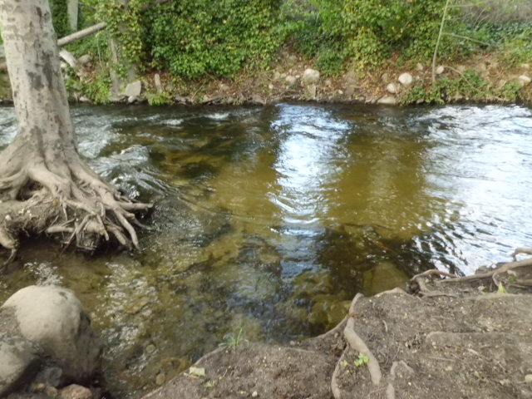
Credit: Clear water of Bear Creek right before WWTP near the dog park. Note the dead tree that needs to be removed because it poses a flood hazard.

Estimated Cost of Joining the BCVSA
- Join BCVSA: Cost $9 million.
- Build a pump station & sewer line to Talent: $2 million.
- Remove the WWTP: $1 million.
- Maintain pump station: $200,000 a year.
Coming up with $12.2 million sounds like a lot until you take into consideration the savings:
- Maintenance at WWTP costs us $2 million a year, so in five years we would save $10 million.
- Sell the equipment at WWTP for approximately $2-4 million.
- Sell the Imperatrice property across the Interstate, which was bought to spray the effluent and which never panned out: $5 million.
- Turn the property into a mobile home park of 100 units and collect $3.6 million a year in rent ($300/month x 100 units x 12 months). We would thus solve both the wastewater problem and affordable housing all in one fell swoop.
Over five years, this plan would make $36 million plus each year the meal tax would bring in $1.4 million bringing the grand total of savings to city revenues to $43 million, more than enough to recoup the BCSA startup costs of $12.2 million.
- $10 million (savings on maintenance costs).
- $2-4 million (sale of equipment) … let’s take the average of $3 million.
- $5 million on Imperatrice property.
- $18 million (rent at mobile home park).
In five years costs would be $200,000 a year for the pump station (and whatever dues that BCSA charged us), as opposed to the $4 million it requires today ($2 million for maintenance and $2 million for paying off the debt). In conclusion: Sewer bills in Ashland could be drastically reduced, and the City would be saving so much money that a) taxes could be reduced and b) underfunded programs could be saved. In 1992 the City paid a consultant $400,000 for some advice on how to handle the DEQ’s mandate that the WWTP’s “water” be cleaned up to protect the fish. The consultants told them to either a.) Go with BCVSA in Medford and save yourself a lot of anxiety and money, or b.) Spend upwards of $40 million to upgrade the WWTP. Joining BCVSA would cost $9 million. Building the pump station and sewer line: $2 million. Removing the WWTP: $1 million. Maintaining the pump station: $200,000 a year. That’s a grand total of $12.2 million to get started, but once it’s in place, the costs to consumers would be $200,000 a year plus whatever BCVSA charges (and I assume it would come to $14 a month per household like everywhere else in the valley). Maintenance at the WWTP: currently costs $2 million a year, paying off the debt costs another $2 million a year. That debt could keep going up forever as the Department of Environmental Quality (DEQ) keeps adding more requirements (Hayden ’12).

During the Neolithic period (c. 10,000B.C.E. the waste created by human activities was redressed by the movement of nomadic tribes. In the ancient world cultures developed waste treatment technologies. The City of Ur, by 3,500 B.C.E. had an average population of 65,000 people per square mile. The populace dealt with their waste by sweeping it into the streets. This caused the street levels to rise and would requires, every so often the raising of the house doors. These practice were not suitable for an urban environment. Cities in the Indus basin, in current day Pakistan, from 2,500 -1,500 B.C.E. developed a high level of sanitation and had some houses with bathrooms with flushing toilets and rubbish shoots and places for rubbish were made available in public places. In the Egyptian city of Herakopolis (B.C.E 2,100) the people threw their wastes in the street but the elite made a deliberate effort to remove all wastes, organic and inorganic. Mosaic law (B.C.E. 1,300) tells “remove his own refuse and bury it in the earth”. Nehemiah tells of rebuilding Jerusalem where there was a refuse gate where the city wastes were dumped and the Talmud called for the city streets to be washed daily.

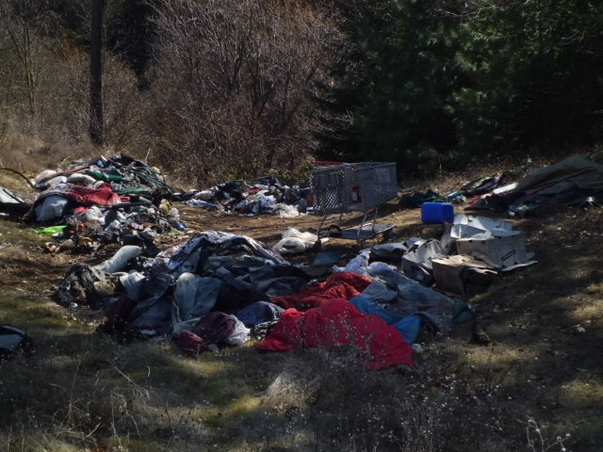
Credit: Last trash pile on the abandoned Railroad Tracks whose cleanup effort was stalled when the Jackson Wellsprings CEO prohibited limited use of his dumpster in order to get media attention and donated dumpster that has not yet manifested after several months HA-8-3-12

In the island of Crete between 1500-1700 B.C.E. had a highly developed waste management system. They had very advanced plumbing and designed places to dispose of organic wastes. Knossos, the capital city, had a central courtyard with baths that were filled and emptied using terra-cotta pipes. They had flushing toilets, with wooden seats and an overhead reservoir. Excavations reveal four large separate drainage systems that emptied into large sewers built of stone. The Minoan royals were the last group to use flushing toilets until the re-development of that technology in 1596. The first dumps were developed by the Greeks in Athens circa 500 B.C.E. In 320 B.C.E. Athens passed the first known edict banning the disposal of refuse in the streets. By 300 B.C.E. one of the responsibilities of the Greek city-state was the removal of waste. The expenses of waste removal were covered by levees on landowners. This system lasted 800 years, until a general breakdown in civil order. Greeks understood the relationship between water quality and public health and passed this concern to the Romans.

The early Roman Republic extended the city’s water supply and constructed aqueducts. By 125 B.C.E. the city’s water supply had been doubled to meet the rapid expansion. In every part of their Empire they built aqueducts, mostly underground. In Rome they used water to flush their sewers into the River Tiber by open sewers as early as 6th century B.C.E. and by 3rd century B.C.E. the sewers in Rome were vaulted underground networks called the Cloaca Mixima. These building projects continued and by the 4th century C.E. Rome had 11 public baths over 1,300 public fountains and 856 private baths. In 315 C.E. Rome had 144 water flushed toilets.
At the fall of the Roman Empire the west turned an urban society into a rural one. By 500 C.E. the taps were being turned off all over Europe and would not be turned on again for nearly a thousand years The reduced population density rendered traditional methods of waste disposal, tossing it out of the house, more viable. Without monitoring the sewers and streets, hygienic conditions fell below the Imperial Roman Standards. This brought back the outhouse, open trenches and the chamber pot, at all levels of society. As the middle ages went on, changes did occur. Near Milan, the Cistercians introduced the use of city refuse and sewer water as fertilizers on their land about 1150 C.E. Even during the unwashed period many abbeys in Britain had piped water before 1200 C.E. The Christchurch Monastery at Canterbury, for example, had running water, purifying tanks, and wastewater drainage from toilets, and the monastery was spared from the Black Plague in 1349.

Credit: City of Ashland Evolution of Sewage Treatment

By the end of the 12th and beginning of the 13th centuries, changes began to take place. Following the major plagues of the 12th century, waste management became a priority. In 1372 Edward the Third of England proclaimed that “throwing rushes, dung, refuse, and other filth and harmful things in to the Thames river shall no longer be allowed”. In 1388 an act of Parliament “forbade the throwing of filth and garbage into ditches, rivers and water”. By late 14th century London had an organized scavenger system of people who would go around and pick up dead animals, yet ultimately, legislation and scavenging tended to be relatively ineffective and except in heavily polluted areas popular opinion was very much against such measures. The cesspool was one of the technical developments of the Renaissance. It is a simple pit which allowed solids to settle and the liquid to seep into the ground. Periodically, the cesspools would have to cleaned out. As the 15th century came to a close, Henry the VI established a Commission of Sewer, which “provide for severe penalties for the pollution of streams and made special provisions for the disposal of tanner and brewers waste”. Henry VII outlawed slaughterhouses in cities and towns because of the danger of disease to humans.

In the early modern period wastes were still disposed of in rivers and water sources were being contaminated. These practices were brought to the New World. As developments grew into cities, the Colonies had to address the waste issues. In 1644 eighteen years after taking control of Manhattan Island “residents were directed to take all wastes out of the fort” and in 1648 a law was passed prohibiting hogs and goats from running in the streets. The major changes in waste treatment came in the 19th century. In 1860 Louis Moureas invented the septic tank however, it would not be given this name until 1895. Septic tanks at this stage were large and were used to treat sewage from communities. “the main purpose of these tanks was to removed gross solids before discharge into the nearest stream or river”. Nevertheless, “effluent was largely untreated and caused pollution of rivers and streams”. Even with pre-treatment the need for disposal technology was evident. In 1869 Edward Frankland developed trickling sand filter technology. He devised a system consisting of six-foot high, ten-inch wide cylinders, filling each with different medias like sand and soil. He then ran sewage at different doses through the different tanks. He calculated the capabilities of the different media in purifying the wastewater. The Experimental Station at Lawrence, Massachusetts, created in 1887, by the State Board of Health worked on disposal issues. At the station in 1893 a sand bed was first used to filter effluent from a septic tank, reducing the land areas needed for sewage disposal, and the land acceptance rates were established to maintain an efficiently working sand filter.

The relationship of cholera to water was discovered by the English physician John Snow who traced this disease from its origins in India and the path it took to Europe. Snow traced the contamination to public wells, that were bring contaminated by privy vaults in the epidemic of 1854 in London. Thus, the sewer was developed. The British engineers led the way in sewer construction and separation of wastes from drinking water (City of Ashland ’12). Towards the end of the 19th century governments acted to close the gap between water and sanitation. In Great Britain public investment financed an expansion of sewerage systems. Life expectancy increased in the four decades after the 1880s by an astounding 15 years. By one estimate water purification alone explains half the mortality reduction in the United States in the first third of the 20th century. No other period in US history has witnessed such rapid declines in mortality rates. By 1920 almost every big city in today’s industrial world had purified water. Within another decade most had built large sewage treatment plants that removed, treated and disposed of human waste in areas where it would not contaminate drinking water (HDR ’06: 31).

Since the previous sanitary sewer master plan (Sewerage Study Final Report by CRS SIRRINE, September 1986), the City has completed most of the recommended collection system improvements. Prior to the 1986 study, the last collection system master plan was completed in 1971 (City of Ashland ’05: 1.1). The City currently operates and maintains a sewer collection system with original construction dating back to the early 1900’s and maintains eight pump stations (City of Ashland ’05: 7.2, 3.2). The City’s collection system service area is approximately 6.5 square miles and services 7,514 connections of which there are 6,336 residential, 1,093 commercial and 85 restaurant connections. The collection system contains almost 105 miles of pipeline ranging in diameter from 4 inches to 24 inches, 3,367 manholes, and eight pump stations. The pipelines are constructed primarily of vitrified clay pipe (VCP), concrete pipe (RCP and CP) and plastic pipe. Installation of the collection system dates back to the early 1900’s. The primary trunk sewer, which transports wastewater to the treatment plant, is the Bear Creek interceptor. Other major sewers are located along “A” Street, Helman Street, N. Mountain Avenue, Wightman Street, Walker Avenue, and the Railroad Trunk Sewer (City of Ashland ’05: 3.1). In 2003, the City spent approximately 1,350 labors hours for mechanical and hydraulic cleaning and approximately 700 labors hours on CCTV inspection (City of Ashland ’05: 7.4.2.2).

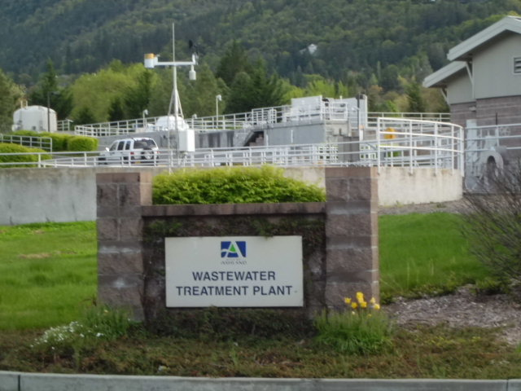
Credit: Ashland Wastewater Treatment Facility HA-3-5-12

Sanitary sewer flow generated within the City is approximately 2.0 million gallons per day
(mgd). In addition, during the winter and spring wet weather season, additional baseflow from groundwater infiltration can increase flow as much as 0.40 mgd. Also, during the summer tourist season, sanitary sewer flows can increase as much as 0.30 mgd. The baseflow projected for the 20-year plan and ultimate build-out are 2.58 mgd and 4.26 mgd, respectively. A sanitary sewer system receives two flow components: dry weather flow (DWF) and wet weather flow (WWF). The dry weather flow component (baseflow) is flow generated from routine water usage by residential, commercial, business and industrial users. Baseflow typically varies throughout the day with peak flows occurring in the morning, between 8 a.m. and 10 a.m., and in the evening between 6 p.m. and 8 p.m. Baseflow will also vary from weekdays to weekends, during holidays, and seasonally (City of Ashland ’05: 2.4).

The City of Ashland's wastewater treatment plant operates as a secondary treatment system for five months (December 1-April 30), and as a tertiary system the remaining seven months (May 1- November 30). Both processes discharge into Ashland Creek approximately 1/4 of a mile above the confluence of Bear Creek and generate biological control issues aggravated by financial insolvency. The City of Ashland's Wastewater Treatment Plant uses a biological nutrient removal (BNR) process to treat wastewater. In a biological process, oxygen is dissolved into the wastewater to drive the treatment process. Microbial growth is initiated in the system which feeds upon the organic material in the wastewater. Nutrients, mainly organic nitrogen, are removed from the wastewater through the BNR processes of nitrification and denitrification.
The Carrousel Oxidation Ditches and secondary clarifiers are the major unit processes responsible for removing the carbonaceous biochemical oxygen demand (CBOD), total suspended solids (TSS) and nutrients from the wastewater. The Carrousel Oxidation Ditches are a process invented by DHV and licensed from Eimco Process Equipment Company, now known as Baker Process. The Carrousel Oxidation Ditch process is a variation of the traditional oxidation ditch activated sludge process. The unique features of the Carrousel include basin configuration and the device used to provide aeration and mixing. The Carrousel basins are typically deeper than standard oxidation ditches and turbine aerators are used instead of brush aerators. The biological treatment operation of the oxidation ditch depends upon a population of organisms in the oxidation ditches which convert the organic material in the wastewater to new cells, and the subsequent settling and removal of the organisms in the secondary clarifiers. Each part of the process must operate well to achieve good treatment.

The population of microorganisms, referred to as mixed liquor (ML), is maintained in the oxidation ditches and is responsible for the wastewater treatment and nutrient removal. These microorganisms feed on the soluble and suspended matter in the wastewater. Organic material is used to provide energy for the organisms and create new cells. Nutrients are also required for new microorganism growth. Nitrogen and phosphorus are primarily required along with other nutrients in smaller or trace quantities. Mixed liquor organisms are "aerobic" organisms, requiring the presence of oxygen for life. Oxygen is introduced in the aerobic portion of the oxidation ditch by the aerators. The aerators agitate the surface of the water, thereby entraining air into the water. Agitation also insures proper mixing while the rotation of the aerators maintains channel velocity. The aerobic basin treats the organic material in the wastewater and is also designed to provide nearly complete oxidation of the influent ammonia (nitrification).

A portion (up to three times the influent flow) of the nitrified mixed liquor is returned from the aerobic basin to the anoxic basin where the microorganisms in the return activated sludge (RAS) metabolize the organic material in the incoming wastewater using the nitrate in the recycled mixed liquor as a source of oxygen. The result is denitrification and the release of nitrogen gas during agitation in the aerobic basin. The nitrified oxidation ditch flow continuously bleeds from the oxidation ditches back through a gate into the anoxic basin to maintain the process. The anoxic basin on each Carrousel Oxidation Ditch consists of a 0.35 million gallon concrete tank at the head end of each ditch. Each anoxic basin is equipped with a 15-hp submerged turbine mixer to keep the solids in suspension. Raw sewage mixed with RAS enters the anoxic basin at the southern end through the tunnels from the splitter box. In the anoxic basin, the influent is mixed with the nitrified mixed liquor suspended solids (MLSS) to provide conditions for denitrification. Bacteria in the mixed liquor feed on the carbon-rich influent, using molecular oxygen from the abundant nitrate to drive metabolic reactions. Here nitrate is reduced to nitrite. The MLSS from the anoxic basin enters the oxidation ditch through a channel at the inside wall of each basin. The MLSS flows completely around the basin before reaching the overflow structure where a portion of the flow is diverted to the secondary clarifiers. It is during this time in the oxidation ditch that the nitrogen gas is stripped and released to the atmosphere. A manually-controlled bypass gate adjacent to the overflow box controls the amount of recycle flow that is permitted back into the anoxic basin.

Each oxidation ditch consists of a 1.7 million gallon racetrack-shaped concrete basin. Each of the basins is equipped with two 100-hp surface aerators. The impeller blades of the aerators throw mixed liquor above the water surface and downstream, entraining oxygen and maintaining sufficient water velocity to keep the contents of the basin mixed. The amount of oxygen transfer depends upon the relative speed and submergence of the aerator blades. The submergence of the blades is controlled by the weir gate on the overflow structure, which varies the water depth in the oxidation ditch. The deeper the submergence, or the higher the water level in the basin, the more oxygen delivered. A deeper submergence also draws more electrical power and decreases the oxygen transfer efficiency. Probes for dissolved oxygen, pH, and alkalinity display the values for each basin and transmit the values to the SCADA system for automatic control. The dissolved oxygen value is used to activate, deactivate, increase, or decrease the operation of the aerators. The pH and alkalinity values are used for process control and to determine the need for caustic addition.

Mixed liquor from the oxidation ditches flows in a common 30-inch diameter pipe to the mixed liquor (ML) splitter box where it is distributed to the three secondary clarifiers. The secondary clarifiers perform several functions simultaneously: clarification; settling; thickening; and solids removal as part of the secondary treatment process. The perimeter of each clarifier is fitted with a baffle to prevent the scum from exiting the tank over the weir. The secondary effluent V-notch weirs are positioned nine inches outside the scum baffle. The secondary clarifiers provide calm conditions for settling the solids present in the mixed liquor. The mixed liquor solids settle out of the liquid stream lowering the TSS and CBOD of the secondary effluent. Sludge that accumulates on the bottom of the clarifier flows by gravity to the return activated sludge/waste activated sludge (RAS/WAS) Pump Station. The secondary treatment process requires that a certain amount of biomass be present in order for the biological activity to take place. To satisfy this, the secondary sludge consists of a colony of cells which are returned to the head of the oxidation ditch process by the RAS system. Biomass not required in the secondary system is wasted through the WAS system. This waste activated sludge is then dewatered, using centrifuges. Operators haul an average of one 12 yard dump truck load of dewatered solids a day to Dry Creek Landfill in White City.

The clarified secondary effluent flows from each clarifier to the ultraviolet (UV) Influent box where the flow from the three clarifiers is combined. It is then distributed in the UV disinfection process. The function of the disinfection system is to reduce the number of disease-causing organisms such as viruses, bacteria, spores, mold, yeasts, algae and certain protozoa, in the plant effluent prior to discharging it to the receiving water body or pumping it to the membrane filter system. Disinfection is achieved with ultra-violet (UV) light. This process does not add any chemicals to the water that would require subsequent removal or produce potentially harmful by-products. Of the current methods of disinfecting water, UV disinfection can be considered the most effective, safest, sustainable, and pollution free. The water is exposed to UV light generated by using a series of medium pressure, high intensity lamps. The secondary effluent flows over the submerged surface of quartz lamp sleeves, which emit intense UV light to disinfect the microorganisms suspended in the water. The lamps contain a small amount of mercury gas and emit UV light due to a combination of gas pressure and electrical current in a wavelength of 254 nm. Radiation emitted from UV light 8 at this wavelength penetrates the cells of the organisms and causes a transformation of the genetic material of the organism, killing it or making it unable to reproduce.

Once the clarified effluent has been disinfected through the UV system, it is aerated prior to being released to Ashland Creek. This completes the secondary treatment requirements for discharging to Ashland Creek. The WWTP discharges secondary effluent to Ashland Creek for five months (December 1-April 30) out of the year. During the rest of the year (May 1-November 30), the secondary effluent is pumped to a series of membrane filters for further treatment. While the secondary treatment system is a biological process (needs to be kept alive), the tertiary system is a barrier process. In other words, it provides a physical barrier that will not allow anything past it. The membrane microfiltration system is located immediately downstream of the secondary clarifier. This tertiary treatment system is designed to provide a high quality effluent for direct discharge to Ashland Creek. The tertiary system is operational seven months out of the year, from May 1st until November 30th.

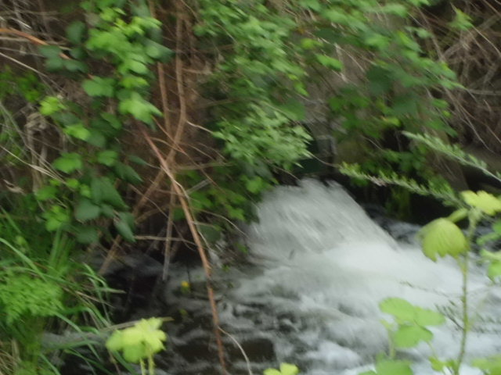
Credit: WWTP Pipe Releasing Effluent Into Bear Creek

The Department of Environmental Quality (DEQ) has established a very strict phosphorus discharge limit of 1.6 lbs/day. The membrane filtration system has been tested and shown to successfully remove alum-coagulated CBOD, TSS, and phosphorus from the secondary effluent to below NPDES permit limits. The system has four membrane treatment trains immersed in open tanks which operate in parallel. The feed water comes directly from the secondary clarifiers, and enters the membrane tank inlet distribution channel. Aluminum Sulfate (Alum) is introduced just upstream of the secondary clarifiers to precipitate the phosphorus. The remaining water is moved through each membrane under a low differential pressure vacuum by use on a permeate pump. In order to prevent an excessive amount of particle accumulation in the membrane, a backpulse pump is periodically used to reverse the flow and dislodge these trapped particles. This reject water is pumped back through the secondary treatment process. Typically, laboratory results on the membrane system shows a non-detect for total phosphorus and e-coli (Pathogens). The CBOD and TSS results are very near 100% removal also. As of May 2002 when the tertiary system was completed, the Ashland Wastewater Treatment Plant was the only plant in North America using this process. Both the secondary and Tertiary systems discharge an effluent that is well under regulatory standards as established in our National Pollutant Elimination Discharge System (NPDES) permit.

Municipal sanitary sewer collection systems with discharges to waters of the United States
are required by the Clean Water Act of 1972 to have a National Pollutant Discharge
Elimination System (NPDES) permit. In response to the increasing frequency of sanitary
sewer overflows in the United States, the EPA has developed the proposed SSO rule
focused on the capacity, management, operation, and maintenance (cMOM) of sanitary
sewer collection systems. cMOM is intended to be a proactive approach for reducing the
public health and environmental impact of overflows, extending the life of sanitary sewer
collection systems, and improving customer service. Sufficient legal authority must be provided to implement an effective cMOM program. The proposed SSO Rule identifies five areas where legal authority is necessary for implementing an effective cMOM program: (1) Controlling inflow and infiltration, (2) requiring sewers and connections to be properly designed and constructed, (3) ensure proper installation, testing, and inspection of new and rehabilitated sewers, (4) addressing flows from municipal satellite collection systems, and (5) implementing the general and specific prohibitions of the national pretreatment program under 40 CFR 403.5. (City of Ashland ’05: 8.2; 8.1.1.3).

The EPA has provided an initial timeframe upon which to complete each of the program
components based on the quantity of wastewater generated from the City. For collection
systems with an average daily flow between 1 and 5 mgd, the EPA has set the following
proposed program implementation schedule: cMOM Program Summary – 2 years after permit issuance. Overflow Response Plan - 1 year after permit issuance. Complete & Submit Program Audit - 2 years after permit issuance. SECAP – completed within 3-5 years, if required.
City may need to develop for compliance with the pending SSO regulations. These program
elements are: Program Goals – the City needs to establish program goals. The program goals will
establish and define the purpose and anticipated results of the overall cMOM program. Formal Training Program – the City currently provides on-the-job training but does not
have a formal written training program in place. Water Quality Monitoring Program – the City is currently not obligated to perform water quality monitoring on their collection system or overflow events. If this changes in the future, the City will be required to implement a water quality monitoring program. Hydrogen Sulfide Monitoring & Control Program - the City currently does not have a formal program in place for hydrogen sulfide monitoring & control program. Flow Monitoring Program – the City does not currently have a formalized flow
monitoring program. However, the City does conduct temporary flow monitoring as
part of their collection system master plan updates, and also has a permanent flow
meter at the WWTP (City of Ashland ’05: 8.3).

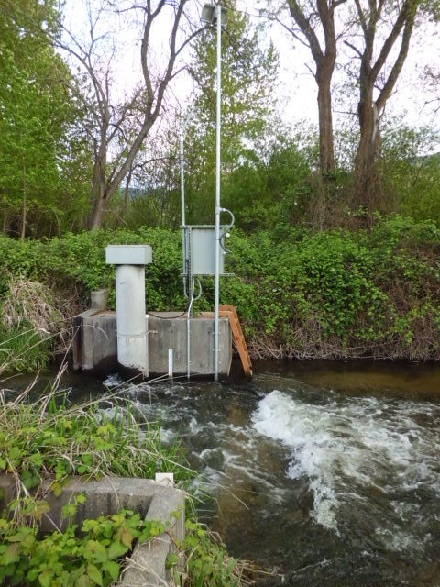
Credit: More turbulent and murky waters at the Bear Creek water monitor just downstream from WWTP shortly before it rejoins with the larger branch of Bear Creek.

The City of Ashland Sewer Master Plan of 2005 anticipated that the current annual growth rate of 1.5% will remain relatively consistent over the next 20 years. This 1.5 % annual growth rate yields a 20-year planning (Year 2023) population of approximately 27,100 (City of Ashland ’05: 2.3.2). This however does not prove to be correct. Census 2010 reports the population in Ashland has only increased 2.8% in the 10 years since 2000, from 19,522 to 20,078 while Oregon, has grown 12% in the same amount of time (Sanders ’11:5). The City of Ashland indicates that in 2001-2002 19,770 people lived in Ashland and after reaching a high of 21,800 people in 2007-2008 the population has declined to 21,460 in 2010-2011 and 20,255 in 2011-2012 (City of Ashland ’11: IX). The City of Ashland’s urban growth boundary (UGB) encompasses approximately 4,861 acres within Jackson County. The City resides in the southern most portion of the Interstate 5 (I-5) corridor. Ashland is considered a tourist destination in Oregon, especially in the summer months during the Shakespeare Festival. Also residing in Ashland is one of seven public universities within the Oregon University System. Southern Oregon University occupies approximately 100 acres in the southeastern section of the City. There are several main transportation routes within Ashland’s UGB: Interstate 5, Highway 99, Main Street, Siskiyou Boulevard, and Ashland Street/Highway 66 (City of Ashland ’05: 2.1). The rational explanation for the population decline is that in Ashland housing prices have a very high median value of $393,300, a whopping $149,000, 61% more than the state median of $244,200. As a result homeownership is only 51.1%, 13.2% less than 64.3% in the rest of the state. Although the median per capita income of $26,918 is $1,025, 4%, more than the state average of $25,893 there are a lot of rich people with little money to share after beautifully landscaping their home, with the 18.3% of the Ashland population who are poor compared with 13.6% in the rest of Oregon (Sanders ’11:5). People simply cannot afford to live in Ashland and every increase in the cost of living, such as sewer rates drives people out of town, and Ashland clearly needs to be more affordable.

Since its construction in the late 1960’s, The City of Medford's Regional Water Reclamation Facility has provided high levels of wastewater treatment to protect the Rogue River Basin. The treatment facility has undergone a number of upgrades and expansions, keeping pace with advancing technologies, regulatory requirements, and the changing needs of the community. As a regional facility, flows are treated from the cities of Central Point, Jacksonville, Phoenix, Talent, Eagle Point, and other unincorporated Jackson County areas. The Process Control, Source Control, Laboratory, Maintenance, and Construction Management departments are fully staffed with dedicated professionals committed to protecting both the environment and the investment of the rate payers we serve. If the City of Ashland has questions regarding the facility, please contact BCSA at (541) 774-2750. Tours are available. The regional sewage arrangement is governed by the Regional Sewer Agreement (Agreement), dated September 15, 1985. The Agreement establishes a Regional Committee (Committee), comprised of one representative from each of the five participants. Each representative has one vote. Medford operates the sewage treatment plant that receives sewage from the participants through pipes called interceptors. Bear Creek, a joint water and sanitary authority, operates the interceptor system. The interceptor system was built 27 years ago, and has had two major capital improvements since then. The Agreement between the five parties was created expressly under the authority of ORS 190.010 “to provide for the operation, maintenance and expansion of the regional sewage treatment facility and interceptor system.” Under the Agreement, each party “is vested with all the powers, rights and duties relating to those functions and activities that are vested by law in each separate party to the agreement” under ORS 190.030(1). Each of the cities is authorized to collect a “sewage charge” by ORS 224.510 and each of their respective city charters for the purpose of “planning, constructing, or operating a sewage disposal system.” Bear Creek is similarly authorized to collect a “sewer service fee” by ORS 450.880 for the purpose of “financing the improvement, operation, and maintenance of a sewage disposal or drainage system.” Bear Creek may manage funds for expansion of the interceptor system so long as it keeps those funds separate see… City of Medford v. Bear Creek Valley Sanitary Authority. Or. App. 97-0086-E3; CA A98721. August 05, 1998

Waste treatment management plans and practices must apply the best practicable waste treatment technology before any discharge into receiving waters, including reclaiming and recycling of water, and confined disposal of pollutants so they will not migrate to cause water or other environmental pollution and shall provide for consideration of advanced waste treatment techniques under 33 USC(26)(II)§ 1281(b) A project for waste treatment and management undertaken with Federal financial assistance under this chapter by any State, municipality, or inter-municipal or interstate agency shall be considered as an overall waste treatment system for waste treatment and management, and shall be that system which constitutes the most economical and cost-effective combination of devices and systems used in the storage, treatment, recycling, and reclamation of municipal sewage or industrial wastes of a liquid nature to implement section 33USC(26)(II)§1281 or necessary to recycle or reuse water at the most economical cost over the estimated life of the works, including intercepting sewers, outfall sewers, sewage collection systems, pumping power, and other equipment, and their appurtenances; extension, improvements, remodeling, additions, and alterations thereof; elements essential to provide a reliable recycled supply such as standby treatment units and clear well facilities; and any works, including site acquisition of the land that will be an integral part of the treatment process (including land use for the storage of treated wastewater in land treatment systems prior to land application) or which is used for ultimate disposal of residues resulting from such treatment; water efficiency measures and devices; and any other method or system for preventing, abating, reducing, storing, treating, separating, or disposing of municipal waste, including storm water runoff, or industrial waste, including waste in combined storm water and sanitary sewer systems; to meet the Cost-effectiveness requirements of this chapter under 33USC(26)(II)§1298.

The Administrator of the Environmental Protection Agency (EPA) shall encourage waste treatment management which results in the construction of revenue producing facilities providing for— (1) the recycling of potential sewage pollutants through the production of agriculture, silviculture, or aquaculture products, or any combination thereof; (2) the confined and contained disposal of pollutants not recycled; (3) the reclamation of wastewater; and (4) the ultimate disposal of sludge in a manner that will not result in environmental hazards. The Administrator shall encourage waste treatment management which results in integrating facilities for sewage treatment and recycling with facilities to treat, dispose of, or utilize other industrial and municipal wastes, including but not limited to solid waste and waste heat and thermal discharges. Such integrated facilities shall be designed and operated to produce revenues in excess of capital and operation and maintenance costs and such revenues shall be used by the designated regional management agency to aid in financing other environmental improvement programs under 33USC(26)(II)§1282(d) & (e).

In any case in which a dispute arises with respect to the awarding of a contract for construction of treatment works by a grantee of funds and a party to such dispute files an appeal with the Administrator for resolution of such dispute, the Administrator shall make a final decision on such appeal within 90 days of the filing of such appeal under 33USC(26)(II)§1298(p). In Oregon a district shall offer to employ every person who, on the date the district takes over a function of a public corporation, city or county in the district, is employed by the corporation, city or county to carry on the function. Where the district employs such a person, the employee shall remain an employee of the corporation, city or county for purposes of any pension or retirement plan the employee has been included in by the corporation, city or county and shall continue to have rights and benefits thereunder as if the person had remained an employee of the corporation, city or county, until the district provides a similar plan for its employees and the employee is included in the plan. Until the employee is so included, the district shall deduct from the compensation of the employee the amount the employee is required to pay under the plan of the corporation, city or county; shall pay that amount to the corporation, city or county, which shall credit the amount to the employee under the plan; and shall make whatever payments the plan calls for the employer to make under ORS 268.220.

In conclusion, preliminary research indicates that it would be cost-effective for the City of Ashland to close its Wastewater Treatment Plant, which operates on a deficit that must be offset with 80% of the meals tax, and construct a pipeline to connect to the Bear Creek Sanitation Authority (BCSA) interceptor in Talent, only four miles away that would carry the waste to the main Wastewater Treatment Plant in Medford, that is actually located in White City, and pollutes the Rogue River. Transferring sewage functions from Ashland to BCSA would be cost-effective for both the city and consumer and the environmental liability for water pollution would shift from the City of Ashland to the City of Medford, that seems better able to defend itself against environmental regulators, and would spare Bear Creek. The primary environmental grievance in the Wastewater Treatment Plant design of both of these facilities is that they release effluent into the watershed instead of disposing of the wastewater into the ground like is done in homes with private septic systems that drain into underground ditches. The City of Ashland is simply too small to afford its own sewage treatment plant and the costs are driving away residents. The BCSA provides a cost-effective alternative that would spare Bear Creek a significant amount of water pollution. BCSA would enjoy even greater economy of scale and Rogue Valley consumers would enjoy equally reasonable wastewater treatment rates. The City of Ashland would cut costs and ease their high cost of homeownership that is theoretically causing the population to decline.

The Administrator of the EPA is authorized to pay 100% of the costs of modification or replacement of treatment works under Federal Share statute 33USC(26)(II)§1282(a)(3) &(4) and 33USC(26)(III)§1314 (d)(3), if the Administrator determines it is in the public interest and if in the cost effectiveness study made of the construction grant application for the purpose of evaluating alternative treatment works, the life cycle cost of the treatment works for which the grant is to be made does not exceed the life cycle cost of the most cost effective alternative by more than 15 per centum under 33USC(26)(II)§1281(j). Before the Administrator approves any grant to any State, municipality, or inter-municipal or interstate agency for the erection, building, acquisition, alteration, remodeling, improvement, or extension of any treatment works the Administrator shall determine that the facilities plan of which such treatment works are a part constitutes the most economical and cost-effective combination of treatment works over the life of the project to meet the requirements of this chapter, including, but not limited to, consideration of construction costs, operation, maintenance, and replacement costs under cost-effectiveness statute 33USC(26)(II)§1298(b). The plan to transfer Ashland wastewater to the BCSA certainly qualifies. The Administrator of the EPA should be interested in financing this plan to help the HUD Secretary liquidate a significant portion $47 billion in “distressed homeowner” funds, by upgrading public works and protecting watersheds and environmental quality under the TARP Winter Shelter Close-out HA-31-12-11.

Ashland has already dumped $50 million into the wastewater treatment plant, and closure is estimated to cost a one-time fee of $25 million, but afterwards the City sewer bill would be only $200,000, easily paid with less than 10% of the $2.2 million meals tax. If the plant was closed without full federal coverage of transition costs the City would have to forego $3.5-$4 million in annual utility payment revenues, and would theoretically still have to pay $2 million a year toward retiring the $33 million debt in its entirety by 2023, an outstanding balance that can be estimated around $13-15 million as of 2013. The cost of joining the BCSA is estimated to cost $12 million, (1) $9 million to join Ashland sewers to the BCVSA, (2) $2 million to build a pumping station, (3) $1 million to remove WWTP, and $200,000 annually for the City to maintain the pumping station. To pay the total one time transition cost of $25 million the City could generate one time revenues of around $8 million by (1) selling the equipment at WWTP for $3 million and (2) selling the Imperatrice property which was bought to spray the effluent for $5 million, leaving Ashland $17 million in debt, $4 million of it to cover necessary construction costs. Presuming the $2 million annual cost of debt service would not increase the City could finance this transition themselves in one decade by continuing to spend 80% of the meals tax on sewage and residents would have an efficient sewage disposal system that would cost the average household $14 a month.

EPA Administrator Lisa P. Jackson and HUD Secretary Suan Donovan are requested to pay $45 million in 90 days if satisfied with the environmental and economic efficiency of the following plans (1) 100% of the $25 million costs of Ashland joining BCVSA (2) Replacing aging water pipes, projected cost is $6.6 million (3) Building a water storage tank for firefighting purposes, projected cost is $8.7 million. (4) Enclosing the Talent Irrigation District ditch (T.I.D) that flows from mountain lakes in order to prevent evaporation and to prevent contaminated water flowing in Ashland, projected cost is $1.1 million. (5) Building the Talent/Ashland/Phoenix line (TAP Intertie) for access to potable water during emergencies, projected cost is $2.1 million. (6) 75-85% of the cost of Dredging Reeder Reservoir twice to insure against environmental degradation by the ski resort that has been ineptly permitted by the Forest Service to develop on a watershed where camping is prohibited $1 million. (7) $10,000 of $100,000 for flood hazard mitigation to immediately remove dead trees from Ashland and Bear Creeks and reserve a sufficient number of large backhoes to defend every bridge when a flood strikes. (8) Ashland Homeless Shelter $20,000 annually; $400,000 over 20 years. Having exercised their original jurisdiction to return more than $375 billion of TARP repayments to the federal General Fund the EPA will have set precedence to do the lion’s share of liquidating the $47 billion of un-administrated TARP “distressed homeowner funds” at a rate of up to $153 per capita (ie. $31 million for Jackson County) otherwise transferred entirely to the National Housing Trust Fund (NHTF) by the HUD Secretary under 24CFR§0.1 as directed by the TARP Winter Shelter Close-out HA-31-12-11 and led by Chautauqua Homeless Campaign v. Mt. Ashland Defenders: $45 Million Ashland Watershed Evaluation of Rogue Valley in Southern Oregon (index linking to this appendix, bibliography and summary) HA-20-3-12.

Medford and Eagle Point Irrigation (100 cubic feet per second) Districts have a right to waters of Big Butte (1) creek and (2) spring under ORS § 538.430
Two reasons for the plan are that water may be difficult to come by if a flood or natural disaster knocked out the water treatment plant, and upgrades to the wastewater treatment plant are needed to stay in tune with environmental regulations. In the floods of 1974 and 1964 residents had to drink bottled water for two weeks and many people got sick and died. “If we lose the plant, it could be a few months before we get a portable plant in place” said Mike Faught, the Ashland Public Works director who spoke at a community forum in mid-March. The flood hazard argument is not immediately worth more than $10,000-$20,000 to hire Jackson County Fuel Committee to remove dead trees from Ashland and Bear Creek.

