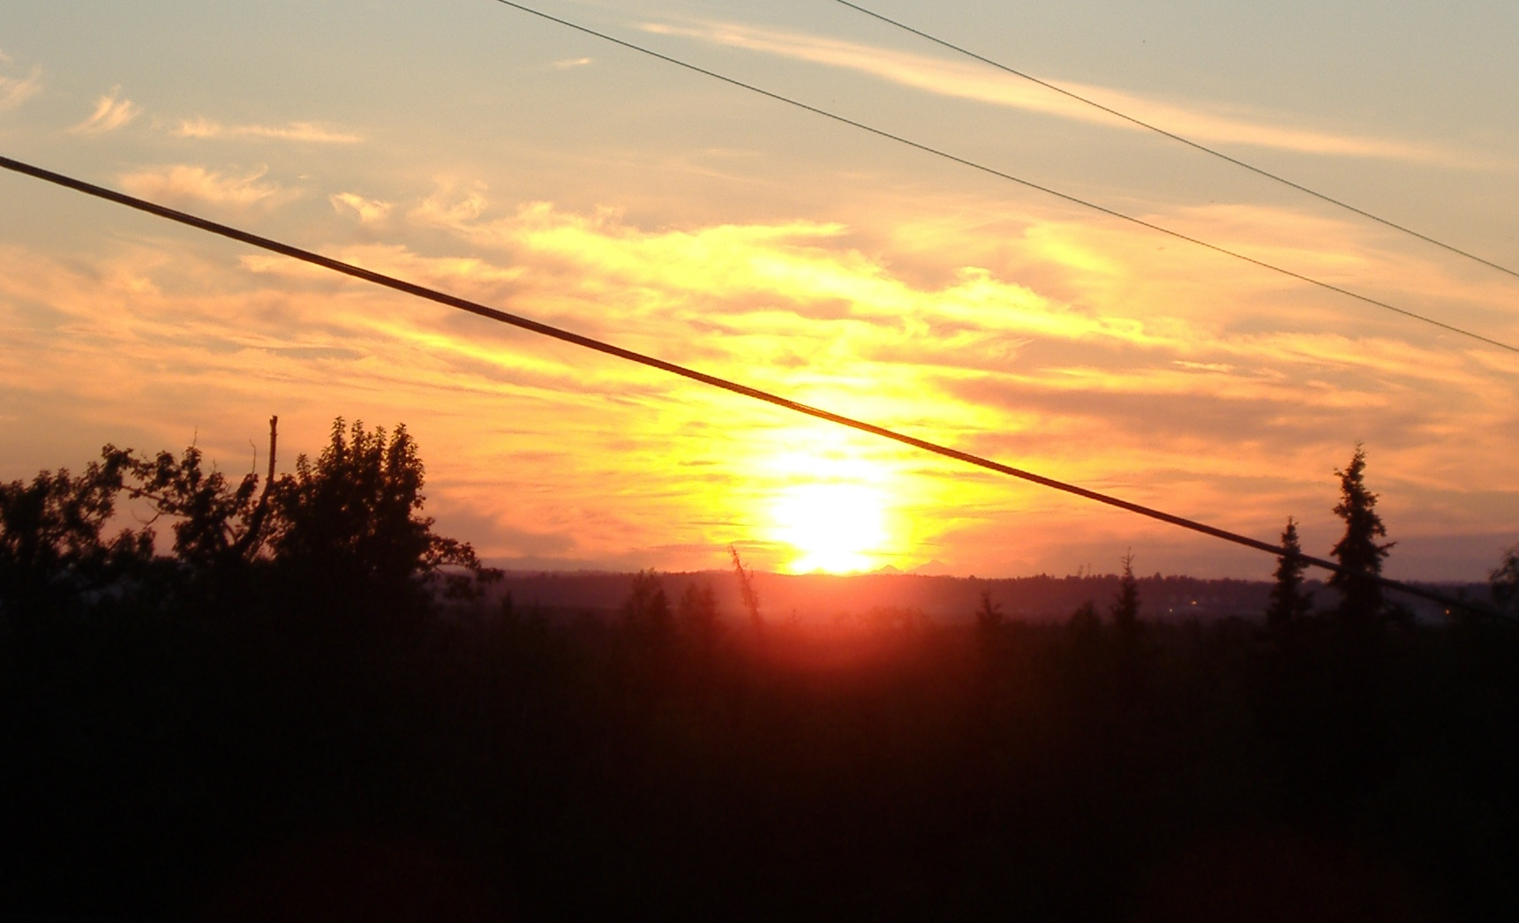

The Valley Times

From the Upper One to the Lower 48

***Note: the Editor and/or Ivy Fink took all photos. The above photo was taken at 11:45 pm June 22nd (close to the Summer Solstice).
Headlines: Arrival to the land of the
Midnight Sun!!
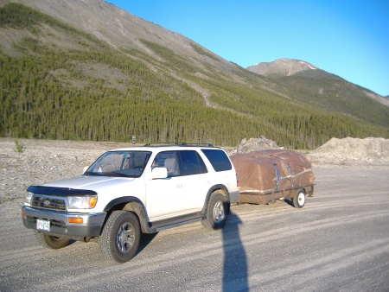
We arrived in Anchorage after 6 days of driving; we traversed across Oregon, Washington, British Columbia, Yukon Territory and Alaska. The ability to drive all “night” long almost made up for the terrible road conditions. It took many nights of bad sleep before we got used to the lack of night.

One of the low points of the trip was paying $16 for a six-pack of beer in the Yukon Territory. Ouch! One of the highlights of the trip was drinking that six-pack and going trail jogging at midnight.

The truck (above) did great, even with 12” diameter wheels on the trailer.
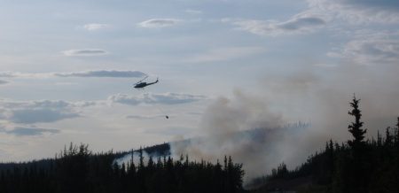
Minutes after crossing the border into Alaska we were greeted by a wildfire that had just started, due to lightning. We were the first ones stopped on the highway. That’s a helicopter dropping water from a bucket that they dipped into a nearby pond (right).

A few hours later we experienced our first earthquake! That was neat. It felt like a big semi-truck rumbling down the highway.

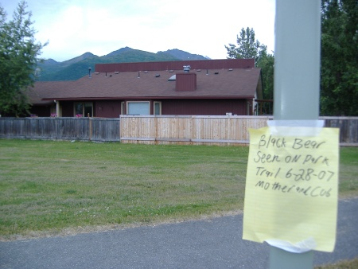
A few days after coming to our new home our furry neighbors paid us a visit. The photo (left) was taken from the park next door; that’s our house and that’s the Chugach Mountains behind us. Our subdivision is literally on the edge of an urban-wilderness interface.

Our neighbors posted this sign around the park that reads “Black Bear seen on park trail, 6-28-07, Mother and Cub”.

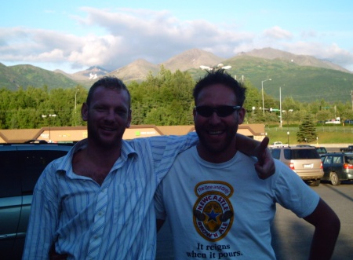

A few days later we were paid a visit by a different sort of wildlife. Like the bears, Crazy Chad only paid a short visit (right). But we had a great time checking out the myriad of bike trails available in Anchorage.

Chad is bound for Bettles, AK aboard a tiny prop plane because there are no roads to get there! He’s working there for the summer and he’ll be back in September – hopefully we’ll be checking-out Denali National Park.

Pink Hippo Steals the Hearts of Many
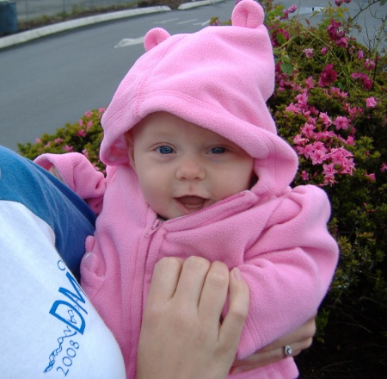
Baby Rosemary was really well behaved during the road trip. The ground freezes during winter and when it thaws in the spring it makes the highway buckle and heave; this made it a challenging drive.
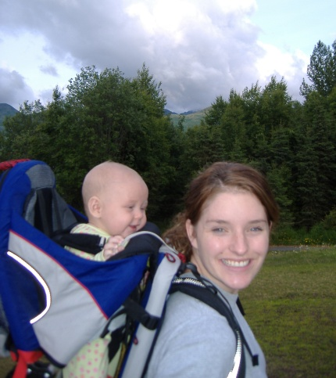
Rosemary made her first little giggle yesterday and has just started nibbling at solid food, although Ivy will continue to breastfeed for as long as possible.

Happy Hikers! (photo right) Ivy starts her internship at the hospital today; likewise, I start my stint as Mr. Mom today too.
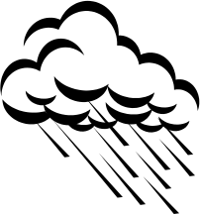
Weather: Missing Oregon Already
For the most part it has been cloudy and cool with highs in the 60’s. There is plenty of clean water for swimming, but not the weather to merit a day at the beach. And until this Eskimo puts on a little more blubber, there won’t be any dipping in the ocean either!

Employment: Moose Herding Wanted
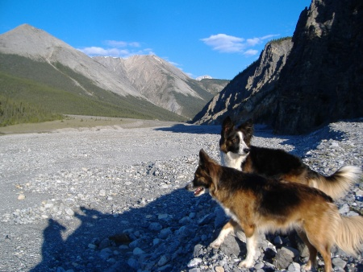
In addition to bear visitors, we also see a lot of moose. If you want landscaping in your yard, you must fence it off or else the moose will make quick work of it.

While initially interested, the little border collies have now learned to keep a respectable distance from the long-legged moose. Nonetheless, there’s nothing like the thrill of the chase!

Contact Info: Everything but the email has changed!
Steve and Ivy Koller
8208 Race Circle
Anchorage, AK 99504
(907) 332 – 3663
Save this valley times on your hard drive so you know where to send us a Christmas card, dammit!!!

Travel: Liard River Hot Springs, British Columbia
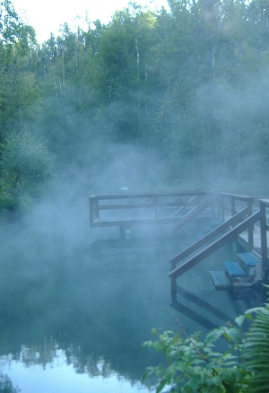
We tented one night at Liard River Hot Springs – arguably, in my opinion, the king of springs. True to form, the dogs vanished off into the forest, chasing after something. Thank goodness, they returned hours later that night (and I use the term “night” loosely). Next morning we had an excellent soak.
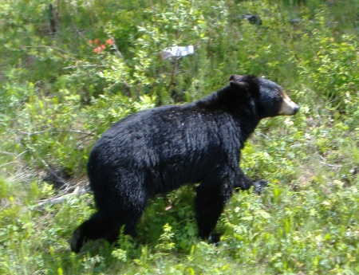
When we arrived in Alaska, we watched a National Geographic documentary on a certain black bear (typically docile) who went psycho and mauled 4 people, in 4 separate attacks in one day! Turns out it happened at the same hot springs! Yikes! Luckily, it didn’t happen not on our day. I guess every paradise has its serpent.

Parting Shots: Although the trip was long, this Valley Times should not. Here are some parting shots along the way. Make sure to write back!! Later – the Editor.


